American Society of Exercise Physiologists

Newsletter
April 2018
ISSN 1097-9743

To Think About  So, here we are April 2018 and the world seems to be moving along as usual. Interestingly, ASEP is on the same path, but slower for sure. Change is important in exercise physiology, particularly among our doctorate level EPs who are intensely engaged in research. If you are reading this, the ASEP leadership would ask that take a moment and think about how you could reach out to your colleagues and help promote a change in how we individually and collectively think about what is exercise physiology. Here is a question to think about. Is exercise physiology a research discipline or is it a healthcare profession? You may also want to ponder one more question: Who is the rightful owner of exercise physiology? Is it sports medicine? Is it exercise science? Or, is it kinesiology? |  | Recent Inquiry  Question: How can I get help in studying for the EPC exam?  Answer: There are at least three things you can do. First, get a copy of the Introduction to Exercise Physiology text. The EPC questions are taken from the content in the book. In fact, it was written specifically to help people study for the exam. Second, if you cannot locate an answer to a specific subject area, you can send an email asking for clarification to Dr. Boone (tbooneasep@gmail.com) and, third, if you are just starting college, then be sure to major in “exercise physiology” if at all possible.

ASEP...  has worked on behalf of Exercise Physiologists since 1997. |  |  | In This Issue  - From the CEO  - ASEP Books  - The ASEP Vision  - JEPonline Abstracts  - JEMonline Abstract  - EPC Registry  - PEPonline  - JPEPonline  - Exercise Medicine/Business
From the CEO  Dear ASEP Members: “What is ASEP?”  The American Society of Exercise Physiologists (ASEP) is committed to the advancement of exercise physiologists as healthcare professionals. Founded in 1997 as a national non-profit professional organization in the state of Minnesota, ASEP provides a forum for leadership and exchange of information to stimulate discussion and collaboration among exercise physiologists active in all aspects of the profession. The Society works to set standards for exercise physiologists through ASEP-approved curricula in universities and colleges in the United States.  Mr. Shane Paulson, MA, EPC, FASEP  The ASEP Vision  The ASEP Vision generates hope and motivation for the discouraged. The ASEP Vision answers three questions:  - What the organization wants to be? To be recognized as the leading professional organization of American scholars and practitioners in the study and application of exercise physiology to fitness, health promotion, rehabilitation, and sports training.  - What it wants to accomplish? The Society of Exercise Physiologists is dedicated to unifying all exercise physiologists in the United States and worldwide to promote and support the study, practice, teaching, research, and development of the exercise physiology profession.  - Whom it wants to serve? Through proactive and creative leadership, the Society empowers its members to serve the public good by making an academically sound difference in the application of exercise physiology concepts and insights. |  |  |  | ASEP Books  When you are ready to study for the EPC exam, this is the book.  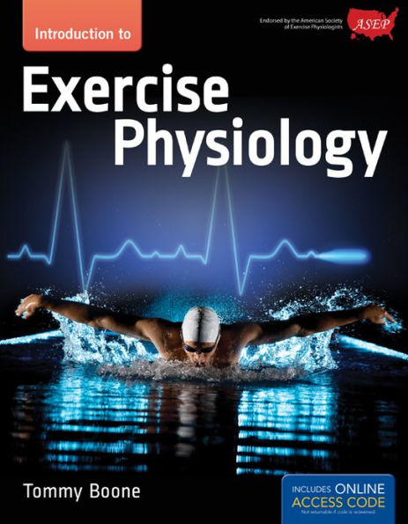  Shouldn’t Board Certified Exercise Physiologists know anatomy when working with clients?  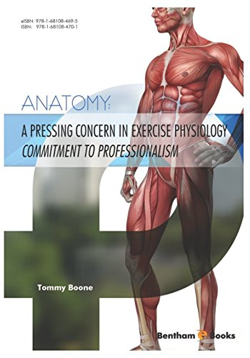
What is the Optimal FIT of Sedentary Interruption Bouts to Improve Cardiometabolic Health?

Shawn M. Keeling, Christina A. Buchanan, Lance C. Dalleck

High Altitude Exercise Physiology Program, Western State Colorado University, Gunnison, CO USA

Keeling SM, Buchanan CA, Dalleck LC. What is the Optimal FIT of Sedentary Interruption Bouts to JEPonline 2018;21(2):1-18. The purpose of this study was to quantify differences in markers of cardiometabolic health with different frequency, intensity, and time (FIT) parameters to reduce sedentary behavior. The subjects consisted of 7 men and 6 women (with a mean age ± SD of 74.2 ± 7.8 yrs >6 hrs of sedentary behavior per day) who performed 4 treatments of sedentary interruption bouts (SIB) lasting one week each. The FIT of the SIB differed across each program. There were 1-wk long washout/control periods between each of the SIB treatments. Cardiometabolic risk factors were measured weekly. The subjects performed a consistent exercise training program throughout the intervention to permit examination of the independent effect of reducing sedentary behavior through different SIB programs on cardiometabolic health. SIB1 (every 60 min, 2 METs, 5 min) elicited a significant increase (P<0.05) in plasma HDL by 21.2%, decrease in plasma triglyceride by 24.6%, and decrease in blood glucose by 6.1%, compared to the control. SIB4 (every 120 min, 2 METs, 10 min) resulted in a significant increase (P<0.05) in plasma HDL by 18.4%, decrease in plasma triglyceride by 23.0%, and a decrease in blood glucose by 7.8%, compared to the control. Lastly, SIB2 (every 120 min, 2 METs, 5 min) and SIB3 (every 120 min, 3 METs, 5 min) elicited no significant (P>0.05) cardiometabolic changes when compared to the control. More frequent bouts of SIB (every 60 min) is most beneficial to cardiometabolic health. If the SIB is less frequent (such as >60 min), a longer duration of interruption bout activities (i.e., 10 min) is more likely to be favorable to cardiometabolic health.

Effects of a Translational Community-Based Multimodal Exercise Program on Sleep Quality in Breast Cancer Survivors: A Pilot Study

Michael P. Foley¹, Scott M. Hasson², Bryan M. Gee¹

¹Idaho State University, Department of Physical and Occupational Therapy, Pocatello, Idaho, USA, ²Augusta University, Department of Physical Therapy, Augusta, Georgia, USA

JEMonline 2018;3(2):1-14. The purpose of this single-arm pilot study was to examine the translational effects of a 12-wk community-based multimodal exercise program on sleep quality in breast cancer survivors (BCS). Thirty-nine female BCS participated in a twice weekly supervised 90-min multimodal exercise session (aerobic conditioning, resistance strengthening, and balance and flexibility training). The primary outcome measure for this study was global sleep quality from the Pittsburg Sleep Quality Index (PSQI). Pre- and post-exercise program global sleep quality and domains of PSQI were statistically analyzed for differences (P<0.05). The main results of this study were significant (P<0.05) improvements in post-exercise program global sleep quality (23%, effect size (ES) = 0.42), as well as significant improvements in: (a) sleep disturbance (12%, ES = 0.42); (b) sleep dysfunction (31%, ES = 0.41); and (c) sleep quality (37%, ES = 0.52). We found that the BCS were “poor sleepers” at baseline. After completing 12 wks of the community-based multimodal exercise, the BCS sleep quality was significantly improved, though they were still classified as “poor sleepers”. However, moderate effect size improvements in sleep quality were found. This study provides evidence that supports exercise physiology applications for front-line community-based exercise programming for cancer survivors.

Professionalization of Exercise Physiologyonline  ISSN 1099-5862  April 2018  Vol 21 No 2 | EPC Registry  The American Society of Exercise Physiologists endorses those individuals who have successfully challenged the EPC Board Certification Exam and maintained their professional member status. ASEP now requires individuals to sustain their membership with ASEP to be listed on the EPC Registry and be endorsed by ASEP.
Changing the Thinking of Exercise Physiologists  Tommy Boone, PhD, MPH, MAM, MBA  Change is the single most important thing exercise physiologists need to do. This thought is very simple, but obviously very complicated. With change a whole new life is possible for the students of exercise physiology. Without change, there is very little to no hope of transforming exercise physiology from a research discipline to a healthcare profession. This is especially so in academia where restructuring and new strategies are not common.  The most turbulence the college teachers experience centers on their department meetings, faculty politics, and writing end of the year reports. The faculty understand what they must do to survive in the academic system and, frankly, it is as simple as publishing research papers. Publishing is a big deal. Publish more than your colleagues will separate you from the less published and less popular. The entire process is not very complicated.  What is complicated is rejecting status quo. Yet, no one is willing to win big by being different and by questioning the standard practice. It is a scary place to be. The core problem with thinking differently is the reality of creating uncomfortable thoughts that stop EPs from changing… | Contact Us  ASEP provides academic EP program accreditation and individual EP Board Certification as the only exclusive professional organization for Exercise Physiologists in the United States. Our National Office is in Minnesota. You may contact the ASEP office at the following address:  ASEP  P.O. Box 515  Osakis, MN 56360-0515  (320) 491-9662  Email: info@asep.org  Visit us on the web at www.asep.org/

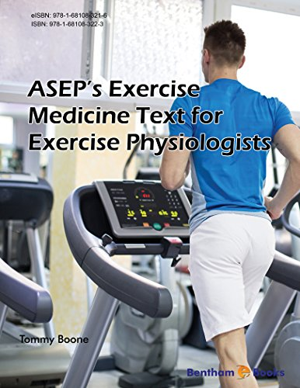 | 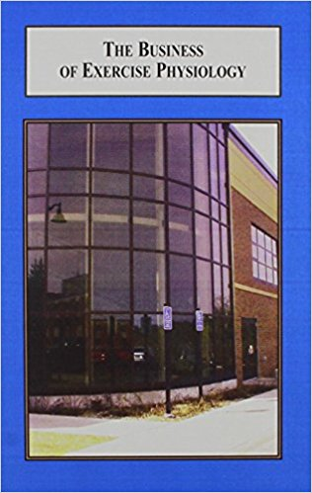
Here is the question: Which of the two books above should be read first? The book that indicates how to prescribe exercise medicine or the book that lays out the specifics of how to start an exercise medicine clinic? What do you think? Perhaps, it is the wrong question to ask. A Board Certified Exercise Physiologist could very well come to understand what it takes to start his or her own business and, then the product to be sole is his or her knowledge and hands-on laboratory experiences in prescribing an individualized exercise program to individuals of all ages and sex to prevent and/or treat chronic diseases and disabilities. Would this approach to using the academic degree in exercise physiology be better than having to transition to a different field of study (such as a personal trainer or a fitness instructor) or, perhaps, spend more tuition dollars, and end up outside your dream looking in? You have the right to your dream. You can be a Board Certified Exercise Physiologist with your own Exercise Medicine Clinic from which you can earn a living to put icing on your dream. Don’t give in to the thinking of status quo. Don’t give up your dream. These books and others like them can help you. They were written to help you as a credible healthcare professional.

