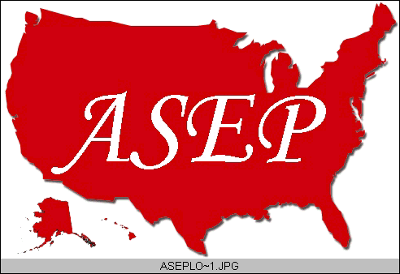ASEPNewsletter
ISSN 1097-9743

February 2015
Vol 19 No 2

Dr. Frank Wyatt, EPC
Editor, ASEPNewsletter
Board Certified Exercise Physiologist
Professor of Exercise Physiology
Department of Athletics and Exercise Physiology
Midwestern State University
Wichita Falls, TX 76308

Exercise Medicine
A big part of being a professional Exercise Physiologist, regardless of your setting, is to stay current within the field. Generally speaking, this means one must read the latest research that is being produced in relation to the health benefits of exercise or performance enhancement made possible through training techniques. I understand that one can become bogged down with the numerous new publications that are available each and every month. So, if you are like me, I sift through them and basically read the manuscripts that seem pertinent to my particular situation. Specifically, I tend to focus on myocardial research or sport performance research associated with cycling.
Recently, I have been coming across article after article on new research reporting the association of exercise with brain function. I think I can say with some level of confidence that we all want “good” brain function throughout our lives. So of course, these articles are fascinating to read. As you continue to browse through the literature, you may notice the plethora of research articles where exercise, training, and increased physical movement are associated with greater human function. Who doesn’t want that? I often point out to my students that to have greater function allows us to be more independent and to participate in more daily activities. I don’t know about you but I want to be able to walk up a flight (or more) of stairs, carry in my own groceries, get off the toilet, walk from my car unassisted or just get out of bed without it being a struggle. These are the daily challenges that are reduced to an afterthought if one is regularly active.
I want to function easily in this realm not to mention my two hour bike rides, martial art sparring (with 20 year olds), lifting weights, skiing during Winter break or body surfing in the Summer time. As an Exercise Physiology mentor of mine once said: “let your lifestyle determine your fitness level. Do not let your fitness level determine your lifestyle.” The research is clear on this point. Regular exercise and physical activity improves our psycho-physiological system. We feel mentally and physically better. Interestingly, there is more to the research with exercise than improved function.
The literature is unequivocal, especially in regards to exercise acting as a preventative measure in many pathological conditions. Anything from certain cancers to cardiovascular disease to neuromuscular disorders, exercise and movement per se, act to prevent these conditions. Additionally, exercise can be used in the treatment of certain disorders and diseases, and as a rehabilitative tool during post-treatment to promote a faster recovery. Taking all this into account, it is not a far stretch to make the statement that “exercise is medicine”.
You may or may not be aware that the term “Exercise is Medicine” has been around for while. Before the inception of The American Society of Exercise Physiologists (ASEP), back in the early and mid-1990s, The American College of Sports Medicine (ACSM) used the phrase “Exercise is Medicine”. In fact, I bought a t-shirt with this printed on the front. It has recently been revived to some extent within ACSM and, as expected, you can probably buy a t-shirt with this phrase on it today.
However, there is something beyond this catch phrase and the ensuing t-shirts that speak to our profession and to our approach to health and well-being: “Exercise Medicine”. I first heard this term from the founder of ASEP, current Board member and friend, Dr. Tommy Boone. It is an interesting twist in the concept of exercise being utilized to do what the research shows it can do (i.e., treat pathological conditions). By taking out the “is” from “Exercise is Medicine” and stating “Exercise Medicine”, we are placing movement and prescriptions of movement on par with pharmacological treatments currently employed by the medical profession.
I see this small, but significant change in wording as rather monumental in the perception that while exercise can be considered medicine, exercise can be utilized as a medical treatment. “Exercise Medicine” speaks to the prevention, treatment, and rehabilitation of a disease through an exercise prescription. Of course, this statement is predicated on the last word in the previous sentence: prescription.
Prescription is a powerful word that takes some generalized program and addresses the specifics of the condition. It is one thing to write a program of exercise based on generalized outcomes. It is quite another to write a prescription where a dose-response through exercise is taken into account. To do this, one must be competent in the knowledge base of Exercise Physiology and current in the research pertaining to the body’s responses to specific components of stress (i.e., frequency, duration, and intensity).
It should come as no surprise that classes offered in programs associated with Exercise Physiology (i.e., Exercise Science, Kinesiology, and Exercise Physiology among others) generally incorporate a “Testing & Prescription” class. This is a course that should be required within any Exercise Physiology curriculum. I have seen this class evolve over the years at different institutions to an extremely clinical application of exercise as a prescription to health, wellness, and even sport performance. This is a defining class in any Exercise Physiology program, and it is considered a “capstone” class in many programs (which is as it should be).
Why? Very simply, to consider “Exercise Medicine” and the application therein requires much more than a video tape of the latest fitness fad or the latest trainer certification. It requires a considerable knowledge base in Exercise Physiology academic courses and, yes, an academic program that lives up to the high standards of the ASEP accreditation process.
Exercise is Medicine. I agree. But beyond that we must recognize as Dr. Boone did that “Exercise Medicine” is what we provide as Exercise Physiologists. The requirements to provide the prescriptions based on this are many and rigorous. The curricular programs and eventual degrees should be held accountable through academic and governing bodies comprised of Board Certified Exercise Physiology professionals within the field. The ASEP standards are high. The outcome is “Exercise Medicine”.

