Journal of Exercise Medicine online

ISSN 2378-4083

August 2023
Volume 8 Number 2

American Society of Exercise Physiologists
The Professional Organization of Exercise Physiologists

The Professional Organization of Exercise Physiologists

The Professional Organization of Exercise Physiologists

Exercise Medicine and

ASEP Exercise Physiologists

Tommy Boone, PhD, MPH, MAM, MBA

ASEP Board Certified Exercise Physiologist,

D

id you know that Exercise Medicine is a branch of medicine? That is exactly what I read in Wikipedia (1) on the Internet. Given that is the case, it is reasonable to conclude that exercise physiologists are medical professionals. In fact, the ASEP leadership has believed for a long time that exercise physiologists are exercise medicine professionals. Personally, I am convinced that it is true regardless of what some exercise physiologists as college professors may say. They want everyone to think exercise physiology is all about doing research and presenting their papers at various meetings at the end of the academic year.

Please appreciate that I am writing about a topic that only a few academic exercise physiologists are willing to talk about. Obviously, doing research and publishing research papers are important whether the exercise physiologist is a professor or owns his or her exercise medicine business. Understandably, there is a time and a place to rethink one’s priorities when it comes to supporting the development of the profession of exercise physiology. But it should be clear that continuing to do what has always been done by academic exercise physiologists without engaging in and supporting the need to take exercise by exercise physiologists to the next step is a huge problem that needs to change. Also, there must be a rigorous change in how exercise physiologists in general think about the role of exercise physiology in healthcare. The power of exercise when implemented by exercise physiologists as exercise medicine is understood as something different in the twentieth-first century versus the twentieth century. After all, according to the World Health Organization, physical inactivity is the 4th leading cause of death worldwide.

Having said that, many college professors are happy to be working and making a salary. Hence, it is unfortunate that so many are willing to avoid saying or doing anything that might upset status quo thinking. They may want to join the American Society of Exercise Physiologists (ASEP) and support the ASEP perspective regarding the professionalization of exercise physiology. But, instead, they believe it is better for them to join some sports medicine, kinesiology, or exercise science organization. While thinking differently can be a straight forward concept, it usually takes time to emotionally move from what has been a common everyday way to think. The ASEP leaders anticipate that eventually the academic exercise physiologists will get the message and they will support the ASEP development of the profession of exercise physiology. After all …

We become what we think, what we talk about, and what we do. If we think our work is for the right reason, if we think that our actions will bring forth positive results, and if we start living as professionals, we will become our vision.

Why is this statement true? The short answer is that exercise physiology is not sports medicine, which is concerned with the functioning of the human body during physical activity and with the prevention and treatment of athletic injuries. Also, it is especially important to understand that exercise science, which is the study of the human body and the way it adapts, and how it impacts physical fitness is not exercise physiology. Similarly, exercise physiology is not kinesiology, which is primarily concerned with the mechanics of movement in the human body, including how exercise influences fitness and health. Yes, sports medicine, exercise science, kinesiology, and exercise physiology students study similar academic courses, and although an argument can made that each of the four academic degrees are interrelated, each one of the degree programs has a different scope of focus that creates a major distinction that results in different career opportunities.

The ASEP definition of exercise physiology is indicated on the ASEP.org website, which states that it is the identification of physiological mechanisms underlying physical activity, the comprehensive delivery of exercise medicine treatment services concerned with the analysis, improvement, and maintenance of health and fitness, rehabilitation of heart disease and other chronic diseases and/or disabilities, and the professional guidance and counsel of athletes and others interested in sports training and human adaptability (2).

No! I have no interest in speaking negative about college professors who are comfortable in graduating exercise science students. However, the fact is they should not tell their students that they can refer to themselves as exercise physiologists. Such behavior is entirely unprofessional. Also, I have no desire to run down any organization and/or its members. But, if they are kinesiologists who refer to themselves as exercise physiologists, it is wrong, misleading, and hurtful to the students who are unaware of these issues. What I do know is that exercise physiology is defined by ASEP and not by any organization or any person with a degree in exercise science or sports science. Exercise physiologists are healthcare professionals who are responsible for prescribing exercise medicine, not exercise is medicine (just as physical therapy is not physical is therapy). Also, should an exercise physiologist want to work in a fitness program or develop his or her own exercise medicine clinic, it does not mean that he or she is a personal trainer. He or she is an exercise physiology healthcare professional.

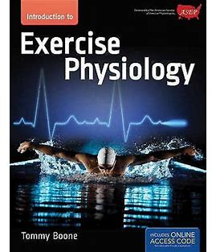

The ASEP Board Certified Exercise Physiologist is a member of a healthcare specialty with the signature treatment of prescribing exercise medicine. It is scientifically clear that the exercise prescription itself is a medical treatment to prevent and treat individuals with high blood pressure, high cholesterol, heart attack, stroke, cancer, obesity, sarcopenia, osteoporosis, low back pain, type 2 diabetes, as well as insomnia, headaches, and the symptoms of depression, including sadness and feelings of being worthless in young men and women, adults of all ages, and gender. Regular exercise is very helpful in relaxing the arteries and preventing arterial stiffness and the risk of premature death.

Just as the medical doctor is educated to prescribe a medication to help a patient with a physiological dysfunction and/or disease, the ASEP Board Certified Exercise Physiologist is educated to use an exercise-specific prescription to decrease the negative effects of an elevated blood pressure and/or a high cholesterol level to avoid the development of heart disease. Likewise, the exercise physiologist’s prescription is a well-researched treatment for patients and/or clients to avoid symptoms of over doing the exercise to optimize health and well-being. Fortunately, the exercise physiology academic degree is very heavy in science-based academic courses that helps in passing the ASEP certification, which is important for the patient and/or client’s protection, as well as for the professional well-being of the exercise physiologists’ position in healthcare.

Increasingly, it is becoming more apparent to other healthcare professionals that the ASEP Board Certified Exercise Physiologist has the academic knowledge, the exercise physiology laboratory skills, and the anatomical understanding of the human body to work safely and effectively with individuals who need a safe and individualized exercise prescription program based on the patient and/or client’s physical concerns and issues. Patients and/or clients may be students, adults, males, and females who are sedentary and/or obese with chronic health issues or they may be athletes who want to safely increase their athletic performance skills and/or abilities.

Developing an exercise prescription specific to each patient and/or client’s medical history and physical health is best determined by the exercise physiologist who graduates from an ASEP accredited academic program. The education and laboratory training, particularly with respect to the ASEP exercise laboratory testing procedures, the training protocols, and professional skills are important to establishing a connection with the local healthcare system and/or the medical community in promoting a healthy lifestyle. Also, increasingly, college teachers are placing less emphasis on anatomy and more on biomechanics. While biomechanical principles are important, they should not replace applied anatomy. Students should not graduate without the knowledge to apply anatomical concepts, and it is also important that they know the origins, insertions, and functions of all the major muscles in the upper and lower limbs. In fact, knowledge of anatomy is critical to the practice of exercise physiology. Hence, students should learn to explain why the brachialis, for example, is a stronger elbow flexor than the biceps brachii. The goal is not to learn just that the brachialis flexes the elbow (i.e., what to think), but why the brachialis is the powerhouse of the elbow flexors (i.e., how to think).

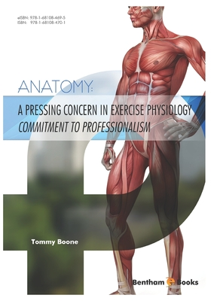

Although contacting and/or meeting with other healthcare providers who are not likely to know the difference between the brachialis and biceps brachii, it is nonetheless a professional necessity. The process requires the exercise physiologists to be professionally prepared with flyers that describe his or her healthcare services. Also, a short face-to-face meeting is often critical to establishing a personal and a professional connection. When it is possible, healthcare providers may be contacted for a few minutes for lunch or by way of an invitation at an open house meeting at a specific healthcare facility. A business packet can be provided that includes business cards, flyers for patients, and a resume or a concise marketing piece that highlights professional credentials (that includes the title of the academic degree and key professors who are willing to support the ASEP’s approach to professional entrepreneurial healthcare, along with a copy of the ASEP Board Certification, and other professional documents).

It is important to have a document that describes the healthcare specifics of the exercise physiology degree program and/or interests in helping others live a healthier lifestyle, especially the exercise medicine services, such as (when necessary) carried out at the patient’s home or at a specific healthcare facility. It is also appropriate to include one or two brief testimonials from satisfied patients/clients. These documents may also be of interest to patients and/or clients at the time of their medical appointments. If the medical doctor and his or her practice keeps a list of community resources for patients, find out what is required to get contact information on the list as an ASEP Board Certified Exercise Physiologist who is trained in prescribing exercise medicine. There may be an opportunity to provide small group exercise and/or individualized exercise medicine services to participants who have been diagnosed with one or more chronic diseases, such as diabetes, obesity, hypertension, and/or a combination of different cardiovascular risk factors.

The myriad of benefits of regular exercise are recognized by the ASEP leadership as being equally as good as a drug in some disease conditions and even better in others. Given the ASEP leaderships' understanding of the power of exercise to save lives, they are increasingly recognized as healthcare professionals throughout the medical community who support regular exercise in health and well-being. They understand regular exercise consists of aerobic exercise, such as: (a) 30 to 50 minutes of walking at least 3 days a week to improve the cardiorespiratory system and the metabolic function within the active muscles; (b) strength training to help improve musculoskeletal strength and endurance; and (c) range of motion exercises to increase flexibility. Also, it is clear from research throughout the world that regular exercise improves cognition in individuals with dementia, lowers high blood pressure, triglyceride levels, and cholesterol while also increasing high density lipoprotein, and lowering the risk of dying from breast cancer, colorectal cancer, and prostate cancer.

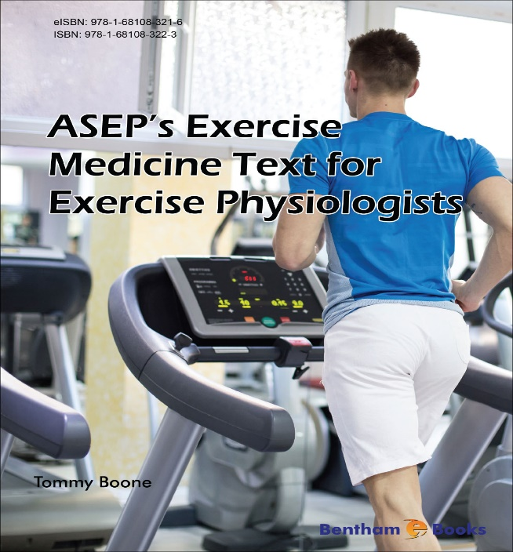

Exercise physiologists are educated in the specifics of testing the effects of therapeutic exercise to help patients and/or clients to live better with chronic diseases or to avoid the diseases altogether, whether it is cardiorespiratory, myocardial, and/or musculoskeletal. They understand that the exercise program must be adapted to cope with the specifics of the individual’s physical health and mental status. As ASEP Board Certified Exercise Physiologists, they are healthcare professionals who prescribe medicine in the form of an individualized exercise prescription. Thus, collectively, we are now in an era where the importance of the exercise physiology leadership and the medical community need to work together to promote exercise medicine for a variety of common mental and physical health reasons.

Please appreciate that I am writing about a topic that relatively few academic exercise physiologists are willing to talk about. Obviously, doing research and publishing research papers are important whether the exercise physiologist is a professor or owns his or her exercise medicine business. However, there is a time and a place to rethink one’s priorities when it comes to supporting the development of the profession of exercise physiology. Exercise to increase physical fitness and exercise to prevent disease are not new concepts, although many non-professionals and some professionals think that is the case. Christobal Mendez wrote the Book of Bodily Exercise in 1553. He stated that “if we use exercise under the conditions which we will describe, it deserves lofty praise as a blessed medicine that must be kept in high esteem” (5).

Also, William Buchan, a Scottish medical doctor, wrote and published in 1769 the Domestic Medicine book of which he concluded that “of all the causes which conspire to render the life of man short and miserable, none have greater influence than the want of proper Exercise” (4). Buchan also believed that exercise would prevent many diseases when medicine is ineffective. For an excellent historical perspective regarding the reform of American medicine, the problems and reform of physical education, exercise returning to the medical arena, and exercise and public health, refer to the 2010 article by Jack W. Berryman, which is entitled Exercise is Medicine: A Historical Perspective (3). It is an excellent history of exercise recognized as medicine for dozens of health concerns and diseases.

Given that exercise physiology is a rather practical field of study that applies science to health and fitness, the academic major in exercise physiology should emphasize the importance of numerous subject areas if the students are to thoroughly understand and evaluate the human body. This thinking applies to psychophysiology, self-management, cognitive skills, and power of a person’s thinking to keep the mind and body healthy. Failure to understand the role that psychophysiology plays in lifestyle diseases and/or disabilities is unacceptable, as is the case with mind-body interconnectedness and self-management skills and procedures. Similarly, a variant of this thinking is to teach the exercise physiology students the significance of being a member of their own professional organization. But unfortunately, as I have stated earlier in this paper, there is little to no discussion about the American Society of Exercise Physiologists even though the truth is the ASEP leadership created the EPC exam and certification before any organization had done so.

Think about what Albert Einstein said, “Problems cannot be solved by thinking within the framework in which they were created.” Does the quote sound familiar? There is another famous quote that goes something like this, “When you find yourself in a hole, stop digging.” Both quotes should be self-evident in regards to the theme of this paper, but the reality is that one cannot assume that is the case. So, how about an explanation for each? First, the point of Einstein’s quote with respect to exercise physiology is that exercise physiologists can no longer solve their problems while trying to do so from within a non-ASEP organization. Second, if exercise physiologists were to continue trying to solve their career problems in the usual ways they have tried, then they will continue to find their problems getting worse. Most exercise physiologists can appreciate that the hole is deep enough and will only get deeper and more problematic with the continued reliance on failed thinking.

Regardless of the challenges of failed thinking that seek to impose constraints on the future of the ASEP perspective of exercise physiology, there is always a systematic way to articulate what needs to be done. Why not consider the following strategies in promoting the exercise physiologist’s capacity to think better. First, look at exercise physiology from the ASEP perspective. This means that if exercise physiologists are to gain knowledge about the importance of ASEP, then they should begin by considering why exercise physiology is a healthcare profession and not a fitness profession. Also, they should begin by believing that if they continue to think as they have, it is unlikely that they will come to an understanding of the ASEP perspective. Second, use the power of imagination to visualize the new exercise physiology. Even if exercise physiologists have not used visualization before to see things differently, it is possible to do so with a little work. Why not put what can be visualized on paper, as in illustrations, diagrams, or other ways of connecting the dots so to speak, such as definitions, visions, goals, objectives, credibility, board certification, accountability, standards of professional practice, and bylaws?

Third, why not write an article that is evidence of the power to think differently and with a purpose beyond just another publication? Writing is an excellent means of coming to terms with what exercise physiologists are thinking or what they think will work. They should not be afraid of what they write, but instead just do it anyway. Even if it is not as good as other works they have done, all they need to do is keep writing because the future is anticipated to be full of surprises. Fourth, look for ideas in everything the exercise physiologist’s see, hear, or read. No matter what the subject matter may be, there is always something that is said or written that has a direct application to some aspect of exercise physiology. There are always new combinations of existing information that can be arranged and rearranged in countless ways to generate new ideas of looking at the same subject matter. This applies to making connections between “dissimilar” subjects, such as math, psychology, ethics, philosophy, business, art, technology, religion, spirituality, critical thinking, professionalism, leadership, and so forth. Fifth, think with the determination and belief that exercise physiologists are as able to develop and perform as well as other healthcare professionals. Exercise physiologists must learn the power in believing in themselves. They must learn to believe that they can control their own thoughts, to discipline themselves, and to get rid of anxiety and/or confusion. Also, they must not forget that determination and persistence are powerful weapons in realizing the future of their choice.

The point of these suggestions is simple. By applying them, exercise physiologists will begin the “how to think” lesson, which obviously is not easy to learn. Power and politics are very emotional words. Everyone seems taken by the power of others and even their power over them! Yet, every single person has the ultimate power to change his or her thinking. All they need to do is shape their perceptions of exercise physiology in accordance with their own professional organization. To some students, this is not a lot to ask. To others, the road to success is entirely a different path. However, the answer, regardless of the different path to success, is the ability to act based on relevant and sound knowledge.
Michael Korda said, “Desire, determination and a good sense of timing are the common denominators of success….” It helps to have a professional organization and members who believe they are exercise physiologists with the desire and determination to be terrific healthcare professionals. No matter how you may want to think about it, these are powerful words, and nothing succeeds better than members speaking and writing the right words. Once again, why not dare to write an article or speak at an ASEP national meeting. Dare to try ASEP, to take a risk, and to grow in ASEP exercise physiology perspective. Dare to experience the power in the words, “To be successful, one must rise to the occasion.” Doing so breathes hope into enhancing self-worth and the desire for one’s rightful place in healthcare by advancing the profession of exercise physiology.

References

- Exercise medicine - Wikipedia

- https://www.asep.org/about-asep/definition/

- Berryman JW. Exercise is medicine: A historical perspective. Current Sports Medicine Reports. 2010;9(4):195-201.

- Buchan W. Domestic Medicine: Or, A Treatise on the Prevention and Care of Diseases, by Regimen and Simple Medicines. Boston: Joseph Bumstead, 1813, p. 43,86.

- Mendez C. Book of Bodily Exercise. New Haven: Elizabeth Licht, 1960, p. 6-7,22.

