Journal of Professional Exercise Physiology

ISSN 1550-963X

December 2019
Volume 16 Number 3

American Society of Exercise Physiologists
The Professional Organization of Exercise Physiologists

The Professional Organization of Exercise Physiologists

The Professional Organization of Exercise Physiologists

Never Give Up Your Beliefs
Tommy Boone, PhD, MPH, MAM, MBA, FASEP
ASEP Board Certified Exercise Physiologist

T
his brief article is for college students who want to be an exercise physiologist. It contains the challenges and hopes of many eras. To read it is to transition from the old way of looking at exercise physiology as exercise science or kinesiology to the new ASEP way. Hopefully, it will inspire you and move you to support the American Society of Exercise Physiologists (ASEP). Always remember that you and all others who want to be an exercise physiologist must undergo the inevitable work of being recreated through the renewing of how we have been taught to think about exercise physiology.
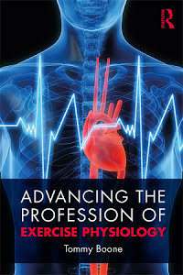

We must individually and collective demonstrate our passion for a new 21st century view of exercise physiology. After reading this article, the reader will see the importance of beginning the work towards a unique experience to promote a radically new way of being that will compel a revolution in their consciousness. After all, those of us who are exercise physiologists, not exercise science men and women, understand the many reasons for clarity and truth in a professional title. We are exercise physiologists who are healthcare professionals. I believe that today is the right time to help other exercise physiologists and in advancing the profession of exercise physiology to grow and position ourselves to help young people and adults live a healthier lifestyle.

Every profession and evolving professions must look forward to the day when individual members are recognized as professionals who are educated to deal with the untold issues of living and aging. In fact, this thinking is the birthright of every person who lives to justify his or her existence as a teacher and/or a researcher to enable others to achieve their dreams of better health and well-being. This point is accepted and promoted by the ASEP organization. Yet, it is more than obvious that in dealing with many academic exercise physiologists they just don’t get it. They are so caught up in the academic status quo that it seems impossible for them to break free. Hence, nothing will change for them. This means that they will live the profound loss of opportunity. Why not approach, perhaps, even with awe but certainly not with fear that exercise physiologists should be free to think about their education, who they are (as determined by their academic degree and/or professional certification), and also what their responsibilities are throughout their communities and, if so, they should be free to establish their own professional relationships.

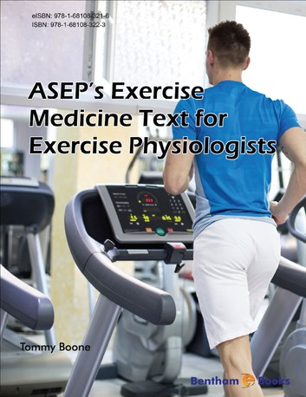
What is exercise physiology? Remember that for certain it is not exercise science or kinesiology or one of a dozen more academic majors. Exercise physiology is clearly to the thinking person the servant of the community who understands the scientific aspects of why exercise is important and how to engage the process safely. Yet, it is strange that so many individuals through the various age groups fail to look to the profession of exercise physiology for help in healing their minds and bodies. Learning why it is critical to connect with an exercise physiologist is a failure in knowing the truth. In short, they fail to understand the power of their own minds to live the road of better health and freedom from most diseases. The most direct and simplest way to state my feelings in this regard is to say that we have an conscious mind of yesterday’s thinking that keeps us from expanding our career options for all exercise physiologists.

The founding of the American Society of Exercise Physiologists is the road to freedom and opportunity. It is largely a reaction to failing for decades to encompass and/or understand the work of enlarging the students’ career opportunities and their capacity to know and to understand the necessity of applying exercise as medicine. Also, without question, when other healthcare professionals learn this truth, it will free them to support ASEP. They will say that the ASEP Board Certified Exercise Physiologists are critical to helping with the prescription of exercise physiology as a healthcare medicine. This is a very important point of view. If society fails to understand the role of a safely prescribed exercise program in redirecting how they live, then society will continue to be at risk of a significant increase in chronic diseases and disabilities.

Always remember that the work required to grow the professional of exercise physiology should not be with anxiety but with expectancy and conviction. It is simply what it is, and the process begins with the discovery that there are steps to solve a problem. The power to think the right thoughts is critically important. By changing our thoughts, we can create new in-roads into discovery of our knowledge and the application to a great cause, such as improving the healthcare of others. Our reality as exercise physiologists is not running with generic organizations, but rather it is within us. Hence, what we are to become depends upon what we are thinking. For example, read the following quote:

“We become what we think, what we talk about, and what we do. If we think our work is for the right reason, if we think that our actions will bring forth positive results, and if we start living as professionals, we will become our vision.”

Exercise physiologists must stop limiting their view of themselves based on past experiences. The ASEP leadership can be heard saying more than once at their annual meetings that “It is not a question of ASEP failing or succeeding. It is simply a question of sticking to the ASEP goals and objectives until they become the reality of all exercise physiologists.” Never give up your beliefs for they have power to change from what is to what should be. So, know what you want and stay the course by thinking what you wish to be. Ernest Holmes, the author of The Science of Mind, said it this way: “We should also erase the thoughts of yesterday that would rob us of today’s happiness.” Equally important is that exercise physiologists must not fear the future and changes that must come about.

In closing, it is important to think about the following each and every day. If exercise physiologists don’t start today taking control of exercise physiology, somebody else will and that “somebody” will be the big generic organizations looking to make more money off of our students. These organizations are well-known with the common expression of “status quo” that is Latin for “the mess we are in”. The members of these organizations represent the majority who are people without the desire to hang on while saying good-bye to the past. In fact, the past is holding them back from being forward-focused and investing in the future for themselves and others.

Exercise physiology professors must take the initiative to engage ASEP and move from neutral to thinking on the offensive not just for their sense of respect, but also for their students who are paying unreal amounts of money to get a college degree. It is not impossible to think differently. We must simply start doing so and stop with the excuses. Winston Churchill said it best, “The price of greatness is responsibility.”



