Journal of Professional Exercise Physiology

ISSN 1550-963X

February 2019
Volume 16 Number 1

American Society of Exercise Physiologists
The Professional Organization of Exercise Physiologists

The Professional Organization of Exercise Physiologists

The Professional Organization of Exercise Physiologists

The Quest of Exercise Physiology Professionalism
Tommy Boone, PhD, MPH, MAM, MBA
Board Certified Exercise Physiologist

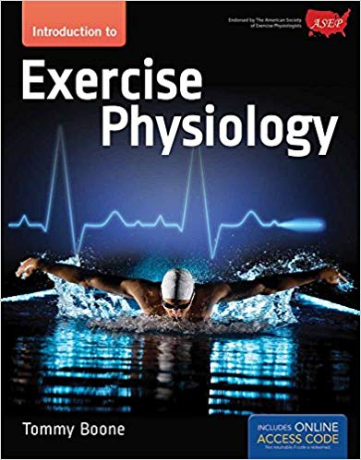
What is the right path to the professionalization of exercise physiology? Is it the exercise science major? Is it kinesiology? Or, is it sports medicine? What is the right organization for exercise physiologists? Is it a human performance organization or should it be an exercise physiology organization? Should a person with an interest in exercise physiologist get a degree in exercise science or exercise physiology? Is an exercise physiologist a personal trainer? Is an exercise physiologist a healthcare professional? Certainly, the right answer to each of these questions is important to the professional recognition and success of all exercise physiologists.
If I had to identify one important reason for a person’s success, it would be the power of one’s thoughts. To think the right thoughts regardless of what others may say is the beginning of something special. Yes, I am cognizant of the fact that it is much easier to simply go along with the flow. After all, there are powerful forces at work in diverse ways to encourage the turning of a deaf ear to an individual’s initiative and thinking that is believed to be contrary to status quo. That is why some exercise physiologists who support the popular generic organizations instead of the American Society of Exercise Physiologists (1) think that the ASEP exercise physiologists have missed the mark.
I have witnessed many different ways to think about this topic during my 44 years of college teaching. In my early days as a doctorate prepared exercise physiologist I was impressed with many individuals. I am familiar with why they continue today infused with the past dynamics and separation from physical education. Much of what I still experience after all these years is nonsensical if not strangely selfish given the obvious path to take and the work required of it.
Frankly, what I continue to live with is the following question: Why not step out of the past and believe in your own right to define exercise physiology as a profession? That is what I did when I wrote the 2014 Introduction to Exercise Physiology college textbook. Belief is all powerful. It begins with the attitude of independence backed by the determination and will to endure to the end. After all, there is magic in setting a goal and staying the course. Is it hard work? Yes, of course, but the end product is worth it. So, always keep trying and never quit.
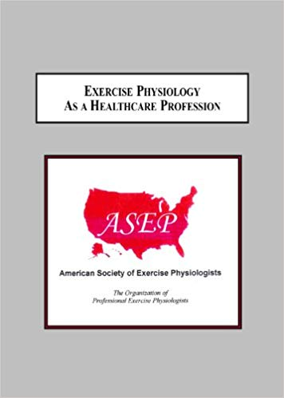
More often than not, persistence and perseverance builds character and, frankly, it builds hope too. I can tell you that since the founding of ASEP in 1997, thinking as an exercise physiologist has unleash new ideas and ways of thinking that I had forgotten from years earlier when I was an athlete in high school and later in college as a gymnast. As a matter of fact, I decided to become a football player during my transition into the 10th grade at 114 pounds. It was unlikely to happen, but what I learned was that persistence pays off. In fact, I became an All American high bar gymnast without having knowledge of the same prior to college. My point is simple: Refusing to give up and staying the course are all powerful. No doubt you have had experiences in your life, whether it is in athletics or the pursuit of a career after college.
An old Latin proverb says it best, “Believe that you have it, and you have it.” Belief is without question one of the most important forces that empowers each of us to achieve our goals. For example, I believe that ASEP is the professional organization for exercise physiologists. Certainly, exercise physiologists can be members of a sports medicine or an exercise science organization, but their professional membership should be ASEP. This is simply straight thinking just as physical therapists are members of their own professional organization, APTA. But, unfortunately too many exercise physiologists (including strangely enough most college professors) are not interested in learning how to think differently about exercise physiology. They want to keep it as a research discipline and not a healthcare profession.
That is why I wrote the 2012 book in the box to the left. I believe it is imperative that academic exercise physiologists embrace ASEP as their organization. It is just as Claude M. Bristol said, “You must know where you are headed, and you must keep a fixed goal in view.” He also said, “Just believe you can do it and you can!” This is true regardless of what others think is impossible. The quote by Clavin Coolidge highlights this point as well: “Nothing in the world can take the place of Persistence. Talent will not; nothing is more common than unsuccessful men with talent. Genius will not; unrewarded genius is almost a proverb. Education will not; the world is full of educated derelicts. Persistence and determination alone are omnipotent. The slogan ‘Press On’ has solved and always will solve the problems of the human race.”
It is important to repeat this point again, persistence is omnipotent. It is the winner’s way of thinking. No, it doesn’t mean there will not be challenges and trials. There will be obstacles and setbacks. But, when your colleagues, friends, and others create inevitable difficulties in your life, learn from each encounter, forgive them, move on and begin again. There is no reason to give up in despair, especially if you really believe that exercise physiology is a healthcare profession and members of the profession need their own professional organization.
Stay positive and motivated regardless of what non-ASEP exercise physiologists are likely to say. Think beyond today and see tomorrow and what exercise physiologists will be. Keep your mind set on your goal. That is what the ASEP leaders are doing. They are keeping their mind set on the prize of something better for all exercise physiologists and not just for a few. They understand that persistence is the means to conquering their adversities and living a professionally satisfying and fulfilling life. They know what they want and by God’s grace, they have what is critically important for the success of exercise physiologists as healthcare professionals.

Why not take a moment to read the 2004 Editorial – Show Some Backbone! It was published in the Professionalization of Exercise Physiology-online journal? You can read it via the following URL:
https://www.asep.org/asep/asep/ShowSomeBackbone.html

I hope it comes across in the article that I am concerned about two points. First, what is exercise physiology under the sports medicine and exercise science leadership? Second, what is exercise physiology when the leadership comes from within the profession of exercise physiology? The first is an excellent example of status quo and the reason the movement away from ACSM isn’t easy, which is the case for many professions at work to overcome their past relationships. At this point, it is safe to say that the problem is not just the ACSM organization versus the ASEP organization, but rather the ACSM leadership (many of whom are not exercise physiologists) and the ASEP exercise physiologists who need the support of their friends and colleagues. There is a major divide in the two groups in terms of improvement and advancement of the profession of exercise physiology.

Both college students and professionals need clarification regarding whether exercise physiology is a research discipline or a healthcare profession? The ASEP perspective is the latter. The ASEP leadership is interested in promoting and encouraging the growth of the profession of exercise physiology and doing so within the context of “what is a profession”. Of course, to do so requires a major change in how academic exercise physiologists think about themselves, their students, and how exercise physiology can be used to benefit society. All of the above requires courage and taking a chance that a colleague will understand your decision to support ASEP or at least not interfere. But, unfortunately, that isn’t always the case. That is why thinking outside the box more often than not avoided.

Yet, how can exercise physiology move from being average to being fantastic if exercise physiologists are not willing to try the impossible, to venture out, and to take a stand for what they believe? For certain, a person cannot do a handstand on the parallel bars while continuing to stand alongside the apparatus and just look at it. While this thinking is not new, it is hard for many to overcome due to the fear of trying. As an example, have you ever caught yourself saying, “What if I fall and hurt myself?” Or, “What if a colleague doesn’t like my thoughts about ASEP and tells someone in a power position who is also interested in something other than ASEP?” Well, if that is the case, I believe the most powerful force in life is the power of prayer. “All things are possible to him that believeth” (Mark 9:23). So, stop with the negative thinking and start looking at ASEP to see the solutions.

Whether it is fear of trying or looking foolish or, perhaps, the understanding that the misdirected majority is going to act in some negative manner, few people of the simple and profound yesterday’s thinking get involved even when it is obvious that something must change. The power and disposition of the status quo keeps the majority from taking a different path even though they may want to see a change for obvious reasons, but are afraid to try. In other words, it is more than the effort put forth by the ASEP leadership to help the average exercise physiologist to rise to a higher level of expectation especially when they are supported and/or controlled by the inner workings of people who prefer not to change. However, they can speak with an ASEP exercise physiologists to help them deal with the challenges of present day thinking. After all, exercise physiology is just one more profession undergoing changes to help its members as well as the public’s understanding of what is exercise physiology.

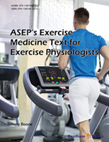
As an example, I recently read that counselors have licensure in every state. Sounds good, right? Well, guess what, Bradley T. Erford (2), past president of the American Counseling Association said in 2012, “…there are over 40 different titles for professional counselor licensees and trainees. How can we expect the public to understand who counselors are and what counselors do when we do not even agree on what to call ourselves?” My point is that it should be obvious that ASEP exercise physiologists are not alone in their efforts to develop a unified profession and promote a core identity for all exercise physiologists. The ASEP leaders understand this point. They get that the road taken to deal with the professional challenges is a hard one. Remember though, “All things are possible….” That is why they created early on the first-ever exercise physiology Academic Accreditation guidelines (3), Board Certification (4), Code of Ethics (5), and Standards of Professional Practice (6). The point of creating the documents years ago was to protect the public, advocate for the exercise physiology profession, and unify the identity of the ASEP exercise physiologists as credible 21st century healthcare professionals.

But, and it is a huge hurdle to jump because the majority of the doctorate prepared exercise physiologists continue to place their political and personal agendas above the interest of the students of exercise physiology and the profession. They do it under the guise of respect for status quo, yet they continue to slow the change process and, in so doing, it is difficult (not impossible) for ASEP to build a strong, vibrant profession. This doesn’t mean it isn’t being accomplished. I believe ASEP is a successful organization, and that the actions of the majority many will not disrupt or break the will of the ASEP members or their intention to follow the 21st century path to its destination. Their force for change is the commonsense reality that every discipline evolving as a profession requires an upgrade in thinking, behavior, and actions to produce different results.

What ASEP did years ago is an action of new thinking that is moving exercise physiology forward to a new tomorrow for exercise physiologists. After all, ASEP is the professional organization serving exercise physiologists. The leaderships’ empathy for the students’ success is a major driving force behind their work. It encourages them to be risk-takers on behalf of every person who wants to be an exercise physiologist. Also, they understand the mission is greater than any one thing they may be interested in because the big picture is an act of commitment beyond the out-dated assumptions of the 20th century thinking. It is imperative that we individually and collectively overcome the idea of being too safe and cautious while stepping up to the plate and embracing the change that will not only help exercise physiologists, but also everyone in the real world who needs a healthcare professional to prescribe exercise medicine to prevent and/or treat adults with chronic diseases.

References

- American Society of Exercise Physiologists. (2019). Home Page. (Online). https://www.asep.org/

- Erford, BT. (2012). What the Future Holds for the Counseling Profession? Comments compiled by Lynne Shallcross. Counseling Today. (Online). https://ct.counseling.org/ 2012/03/what-the-future-holds-for-the-counseling-profession/

- American Society of Exercise Physiologists. (2019). Accreditation. (Online). https://www.asep.org/professional-services/accreditation/

- American Society of Exercise Physiologists. (2019). EPC Mission and Purpose. (Online). https://www.asep.org/epc-online/epc-missionpurpose/

- American Society of Exercise Physiologists. (2019). Code of Ethics. (Online). https://www.asep.org/organization/code-ethics/

- American Society of Exercise Physiologists. (2019). Standards of Practice. (Online). https://www.asep.org/organization/practice/



