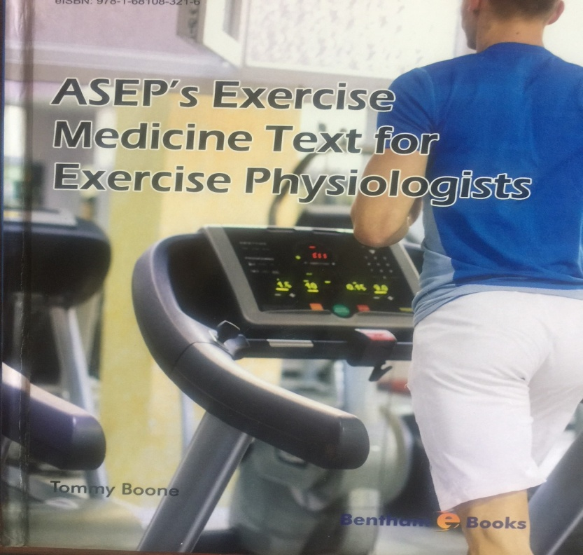

Journal of Exercise Medicine online
ISSN 2378-4083
August 2019
Volume 4 Number 2

American Society of Exercise Physiologists
The Professional Organization of Exercise Physiologists

Lopez AC, Wyatt FB. The Effect of Aerobic and Resistance Training on Glycemic Control in Type 2 Diabetes Mellitus: Meta-Analytic Study. JEMonline 2019;4(2):1-13. Word PDF

Malamassam OH, Nusdwinuringtyas N, Paramita N, Kekalih A. Use of the Six-Minute Step Test in the Evaluation of the Health of Indonesian Adults. JEMonline 2019;4(2):14-23. Word PDF

“Every great dream begins with a dreamer. Always remember, you have within you the strength, the patience, and the passion to reach for the stars to change the world.”
-- Harriet Tubman
Copyright © 2016 All Rights Reserved

