Professionalization of Exercise Physiologyonline

ISSN 1099-5862

October 2022
Volume 25 Number 4

American Society of Exercise Physiologists
The Professional Organization of Exercise Physiologists

The Professional Organization of Exercise Physiologists

The Professional Organization of Exercise Physiologists

Potential Benefits of Using Exercise as a Treatment Strategy for Duchenne Muscular Dystrophy (DMD)

Jonathan H. Anning, PhD, FNSCA, CSCS*D
Slippery Rock University, Exercise Science and Athletic Training, Slippery Rock, PA 16057

ABSTRACT

Anning JH. Potential Benefits of Using Exercise as a Treatment Strategy for Duchenne Muscular Dystrophy (DMD). PEPonline 2022;25(4):1-16. Duchenne muscular dystrophy (DMD) is a genetic terminal disease in boys that lacks a dystrophin protein complex (DPC) to maintain muscle structural integrity. Without the DPC, structural damage progresses beginning with a porous sarcolemma and high blood levels of creatine kinase. As a result, a cascade of pathophysiological events occurs, leading to complete body system failure and death by late teenage years or early adulthood. Current treatments focus on specific problems attributed to DMD, yet exercise may offer a comprehensive option to prolong functional capabilities while maintaining quality of life since there is no current cure available. Therefore, the purpose of this article will be to explore the pathophysiology of DMD along with potential benefits exercise may offer in addressing treatment side effects and pathologies associated with the disease.

Key Words: Ambulatory, Pathology, Pathophysiology, Physical Activity, Quality of Life

As health professionals, designing safe and effective exercise programs requires addressing individual needs. If an individual has a special need such as Duchenne muscular dystrophy (DMD), it is likely the initial encounter will require persuasion that exercise is beneficial for their quality of life. Conversely, prescribing exercise that causes muscle damage and fatigue without an understanding of DMD will exacerbate the disease progression. In other words, the value of exercise in the treatment of DMD should be emphasized to maintain function and quality of life, which must begin with a foundational knowledge of the disease.

DMD is a genetically degenerative disease that is incurable with a fatal outcome. Individuals diagnosed with DMD progressively lose strength because of a maternally inherited genetic disorder leading to an inadequate structural protein called dystrophin in muscle cells. Since dystrophin is essential for cell structure integrity, this protein deficiency in boys with DMD exhibits constant muscle damage indicators that lead to gradual functional losses and eventual death.

Although there is no cure for DMD, many therapeutic strategies have been developed to delay gradual functional losses, specifically the maintenance of ambulatory capabilities as long as possible while improving quality of life throughout the lifespan. Regardless of the treatment options, the main focus is to manage neuromuscular, fibrotic, orthopedic, body composition, and cardiorespiratory functions. Although often overlooked or approached with apprehension as a treatment option, the value of exercise as a therapeutic strategy needs to be considered. Exercise may provide a comprehensive approach for treating the neuromuscular, skeletal, metabolic, and cardiorespiratory systems simultaneously. Relative to exercise mode considerations, aquatic therapy is a well-accepted option for treating persons with DMD since movements occur using weight-bearing and multi-directional concentric phase resistance training without the risk of falling (27). Coincidentally, respiratory muscles are also challenged with breathing requirements associated with avoiding water intake. Recently, Lott and associates (28) found that mild to moderate intensity home-based isometric resistance training that emphasized the lower body improved knee strength and stair climbing capabilities. In addition, persons with DMD have shown the potential to maintain skeletal system posture by avoiding spinal muscle damage following whole-body vibration training that improved cardiorespiratory 6-minute walk distance as well (43). Regarding body composition, fat accumulation in DMD muscle correlates with lower skilled and timed function scores (47). Based on a systematic review and metanalysis (23), it appears exercise improves muscular strength and cardiorespiratory endurance with potential DMD functional benefits.

Given most therapeutic strategies (e.g., medications, respiratory training, surgeries, etc.) are limited to treating specific body systems that primarily address skeletal muscle, the purpose of this article is to explore potential comprehensive benefits of using exercise as a treatment option for improving function and quality of life in persons with DMD. This will be accomplished by providing a pathophysiology overview of DMD along with potential exercise contributions to address therapeutic strategy side effects and disease progression pathologies. In the end, the health professional will have a fundamental understanding of DMD pathophysiology as a basis for promoting exercise as a comprehensive treatment approach while also acknowledging its limitations.

Pathophysiology Overview
Dystrophin is an integral structural protein of muscles, specifically maintaining the integrity of the skeletal and cardiac muscle cell membrane known as the sarcolemma. Underlying the sarcolemma is the structurally significant dystrophin protein complex (DPC). The structural role of the DPC is to connect the sarcolemma to the actin cytoskeleton within the muscle fibers (Figure 1), which stabilizes contractions (37).

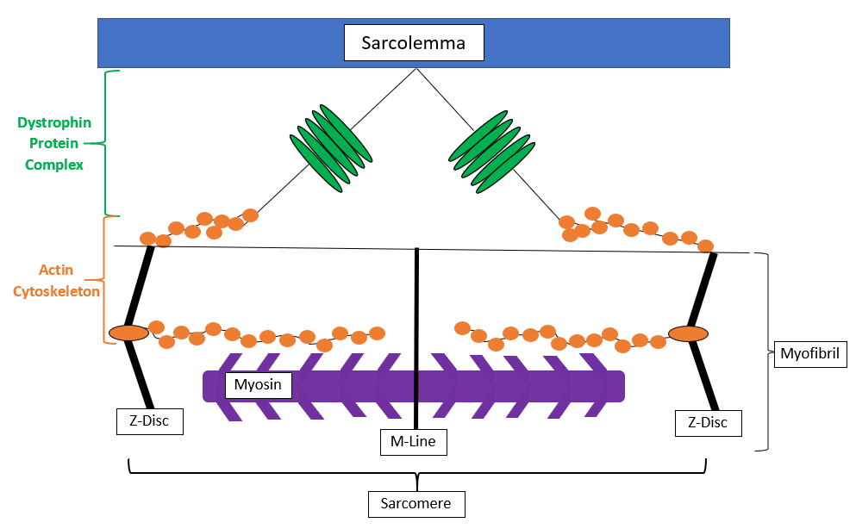

Figure 1. Dystrophin Protein Complex Stabilizes during Contractions by Connecting the Sarcolemma to Actin Cytoskeleton.

In persons with DMD, the DPC is weakened by a deficiency in dystrophin, resulting in an inability to sustain repeated muscle fiber contractile forces. Subsequently, the sarcolemma becomes porous allowing a cascade of cell signals that eventually lead to necrosis of the muscle cell’s structural integrity.

As highlighted in Figure 2A, excessively high serum creatine kinase (CK) levels in the blood are attributed to the porous sarcolemma associated with DMD. As a major enzyme of metabolism within the muscle fiber, damage to the sarcolemma results in high amounts of CK leaking into the bloodstream. Therefore, a CK test is used in the early stages of diagnosing DMD.

DMD concerns associated with a porous sarcolemma continue to escalate with mechanical weakening of supporting structures. Each muscle fiber is surrounded by elastic connective tissue (e.g., endomysium) with internal contractile myofilaments within the sarcomere providing structural support at the early onset of DMD. However, the degenerative characteristics of the disease result in plastic connective tissue insufficiently replacing the DPC deficiency combined with a lack of contracting myofilaments to minimize the size of porous gaps in the sarcolemma. Consequently, ineffective myofilaments combined with mechanical weakening of the connective tissue is associated with fibrosis and contractures, reducing the muscle’s ability to function efficiently (Figure 2B).

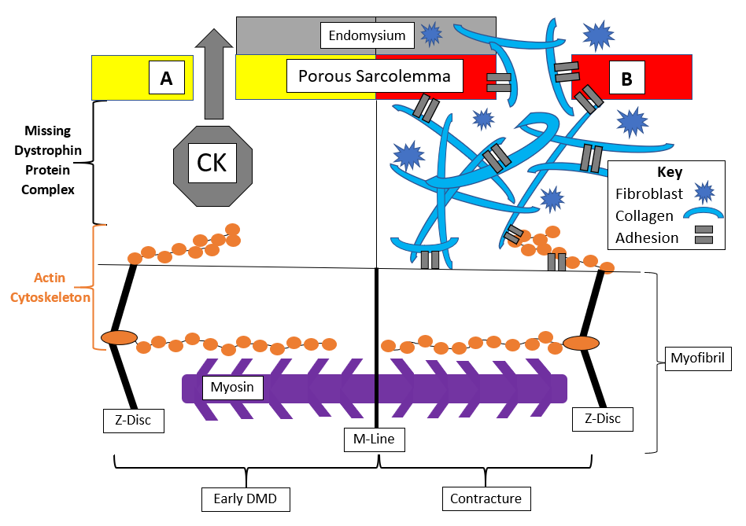

Figure 2A and 2B. Absence of the Dystrophin Protein Complex Results in a Porous Sarcolemma, Which Starts with (A) Creatine Kinase Leaking from Muscle into Bloodstream that Eventually Leads to (B) Contractures Attributed to Fibrotic Connective Tissue Structural Support Inhibiting Myofilament Function.

Along with a porous sarcolemma, there are multiple signaling problems that arise within a DMD muscle fiber. The impact of these signaling problems on the metabolic and inflammation systems causes sarcolemma and cytoskeleton protein degradation (Figure 3).

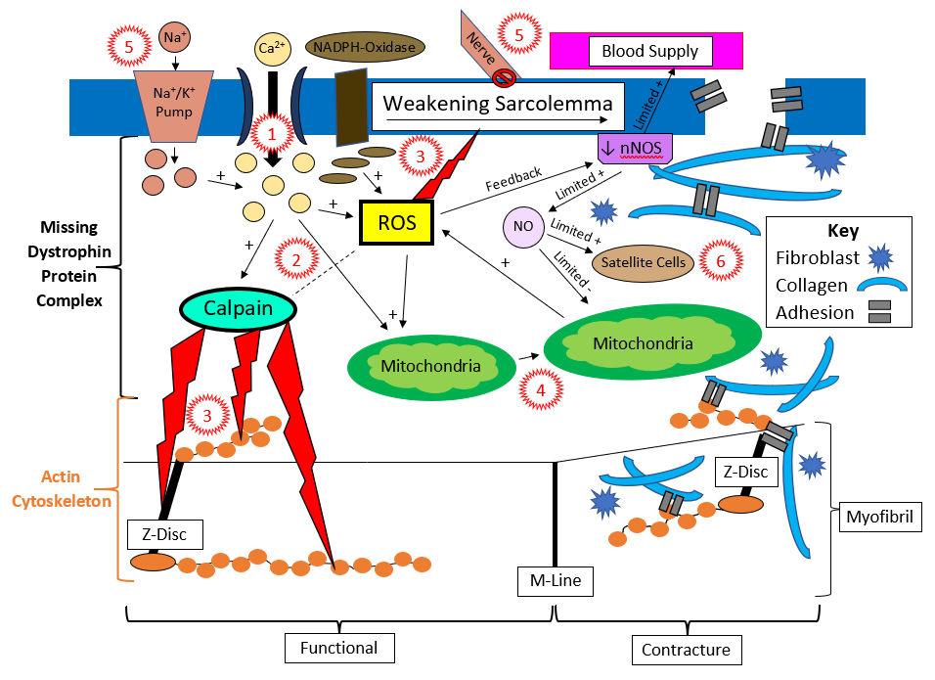

Figure 3. Schematic of Sarcolemma Without Dystrophin Stabilization Leads to (1) Influx of Calcium, (2) Elevated Reactive Oxygen Species (ROS) and Calpains, (3) Destruction of Sarcolemma and Cytoskeleton, (4) Swelling of Mitochondria, (5) Poor Vascularization and Neural Activation, and (6) Inactive Satellite Cells.

According to Whitehead, Yeung, and Allen (45), the porous sarcolemma appears to increase calcium influx primarily through stretch-activated cation (SAC) channels, which elevates calpain activity and the production of reactive oxygen species (ROS). As a consequence of elevated calpain and ROS, further sarcolemma damage occurs along with degradation of muscle fiber cytoskeleton proteins (45). In addition, inflammatory pathways are activated in response to mitochondrial calcium overload combined with stretched sarcolemma nicotinamide adenine dinucleotide phosphate oxidase (NADPH-oxidase) induced ROS elevations (4, 45). Unfortunately, activation of the inflammatory system stimulates the mitochondria to produce more ROS (5, 45). Altogether, stretching or injury of the sarcolemma triggers SAC calcium influx and NADPH-oxidase activation, leading to a high amount of ROS and oxidative stress with the potential of damaging skeletal muscle through protein degradation or inflammation in boys with DMD (38).

In order to counteract excess ROS, nitric oxide (NO) arising from sarcolemma neuronal nitric oxide synthase (nNOS) serves as an antioxidant while contributing to vascular homeostasis and stimulating muscle growth (24,41). Yet, DMD dystrophin deficiency is associated with a loss of sarcolemma nNOS, reducing NO production (41). Therefore, the lower NO availability is limited to antioxidant reactions with the mitochondrial byproduct, superoxide, to produce peroxynitrite, a potential pro-atherogenic molecule (24). Simultaneously, poor vascularization and ischemia diminishes metabolic functions of the mitochondria while increasing muscle fiber fatigability due to a lack of NO production (24,41). So, greater demands are placed on the mitochondria metabolic functions in response to immune system reactions triggered by high ROS levels combined with excess intracellular calcium stimulation (41). Interestingly, although there is a greater amount of sarcoplasm calcium to activate nNOS, the enzyme deficiency prevents NO synthesis to stimulate satellite cell activation for muscle growth or repair as well (41). It should be noted that the absence of nNOS appears to be applicable to skeletal muscle alone, but even the presence of the enzyme in cardiomyocytes is considered nonfunctional relative to DMD (39).

As the sarcolemma and cytoskeleton experience more degradation from metabolic and inflammation responses, the damaged muscle membrane influences the electrical conduction capabilities of the muscle. There is an increase in resting intracellular sodium levels, which impacts sodium-potassium pump (NaKP) activity while causing muscle weakness (1,14). Even more significant than potential skeletal muscle weakness and fatigue, Gonzalez and associates (19) identified a greater concern with impaired cardiomyocyte membrane electrical conduction resulting in cardiac arrhythmias among boys with DMD. These arrhythmias were suggested to occur because typical gap junctions were replaced with nonjunctional hemichannels along the cardiomyocyte sarcolemma that elevated sodium influx (19).

In summary, the pathophysiology of a DMD muscle begins with a dystrophin deficiency and porous sarcolemma that impairs the electrical stimulation along with other muscular physiological functions. For instance, oxidative metabolism within the mitochondria is weakened by excess calcium, poor vascularization, and inflammatory responses. Furthermore, the inflammatory system assists with sarcolemma and cytoskeleton protein degradation attributed to ROS accumulation without NO regulation and satellite cell activation combined with calpain stimulation from excess calcium. Consequently, myogenesis within a DMD muscle is replaced by fibrosis and eventual immobility.

Exercise Contributions to Current Therapeutic Strategies
As expected with DMD, exercise becomes less prevalent with age while other therapeutic strategies accumulate. Initially after the diagnosis, medications are introduced to the treatment plan to address muscle dystrophy and cardiomyopathy concerns. Eventually, persons with DMD start experiencing non-ambulatory functions, requiring more aggressive forms of treatment such as pulmonary training and spinal surgeries. Altogether, the focus of these DMD therapeutic strategies is to prolong life while maintaining body function quality even though there is a poor prognosis. Unfortunately, many of the therapeutic strategies become less efficient as DMD progresses, yet concerns associated with provoked muscle damage combined with unawareness of the value in counteracting the disease progression and medication side effects prevents offering exercise as a treatment option.

In order to appreciate the value of exercise, it is important to understand its benefits relative to the DMD pathologies and therapeutic strategy side effects. While there are many treatments available, corticosteroids are one of the most popular medications prescribed to offset the muscular and cardiovascular conditions that arise with the progression of DMD. Unfortunately, it also has the most side effects, which is why exercise should be considered as an additional therapeutic strategy.

Corticosteroids are commonly prescribed immediately after receiving a DMD diagnosis. The primary purpose of administering corticosteroids for DMD is to maintain muscle size. There is stronger evidence for long-term strength gains related to Prednisone than Emflaza (Deflazocort) (17,33). Even more significant, there is some evidence corticosteroids maintain ambulation in boys with DMD, yet Deflazocort appears to have better long-term potential because of higher dosing and adherence (6). Since corticosteroids are commonly prescribed for most persons with DMD, it is important to consider how they influence muscular strength and performance. Although healthy men have the ability to heal during a recovery compared to persons with DMD following a resistance training session, research has shown greater improvements in bench press and squat strength observed when exercise was included with testosterone administration (9). In other words, complete reliance on corticosteroids without exercise to treat DMD is more likely to result in pseudohypertrophy along with nonfunctional muscle. In addition, when bodybuilders combined resistance exercises with testosterone intake, it is important to recognize greater cardiovascular problems and muscle damage developed in comparison to only participating in a resistance training program (35), which needs to be considered when treating DMD. Specifically, side effects of corticosteroids, independent of other treatments, are associated with weight gain, osteoporosis, hypertension, metabolic abnormalities, and cortisol suppression; whereas, exercise has been shown to reduce the obesity, musculoskeletal, and cardiometabolic risk factors (12,20,48). Ultimately, chronic corticosteroid intake is a primary DMD treatment option for maintaining ambulation, yet there are many side effects and limitations to its benefits without the inclusion of exercise. Therefore, counteracting corticosteroid prescription concerns alone is enough of a reason to consider exercise as part of the therapeutic remedies for DMD.

Instead of addressing the benefits of exercise relative to each DMD treatment, this article will transition its focus to the pathologies associated with the disease. Yet, whenever these pathologies arise, whether attributed to DMD or treatment side effects, Table 1 offers a reference for addressing them individually or in combination as the disease progresses.

Table 1. Exercise Benefits Reference for Duchenne Muscular Dystrophy Treatment Side Effects and Pathologies.
Pathology Progressions associated with Treatment and Duchenne Muscular Dystrophy | Exercise Benefits
Loss of Strength  Fatigue  Pseudohypertrophy (Iatrogenic Myopathy)  Weight Gain  Osteoporosis  Hypertension  Metabolic Abnormalities  Cortisol Suppression  Nonambulation  Instability  Excess Sarcoplasm Calcium Influx  Decreased Satellite Cells  Myofiber Necrosis  Muscle Fibrosis  Mitochondrial Dysfunction  Increased Anaerobic Metabolism  Metabolic Acidosis  Poor Blood Supply  Inflammatory Myopathy  Oxidative Damage  Sodium/Potassium Pump Downregulation  Hyperkalemia  Cardiac Muscle Damage  Cardiac Arrhythmias  Breathing Difficulties  Inflexibility  Poor Posture | Maintain Strength  Improves Exercise Tolerance  Modulates Muscle Atrophy  Weight Control  Maintains Bone Mineral Density  Lowers Blood Pressure  Improves Blood Glucose Levels  Increases Circulating Cortisol  Ambulation  Provides Balance Stability  Enhanced Calcium Handling  Promotes Satellite Cell Activity  Myofilament Production  Enhances Extracellular Matrix Remodeling  Aerobic Mitochondrial Adaptations  Maintains Oxidative Capabilities  Buffers with Efficient Aerobic Metabolism  Capillary Dilation/Blood Vessel Expansion  Reduced Inflammatory Response  Antioxidant Production  Sodium/Potassium Pump Upregulation  Reduces Hyperkalemia  Maintains Cardiac Function  Lower Heart Rate  Greater Respiratory Muscle Efficiency  Improves Mobility  Posture Maintenance

Since DMD is associated with a porous sarcolemma and its corresponding SAC leaks (36), there is a greater amount of intracellular calcium in the sarcoplasm. Unfortunately, sarcolemma damage during exercise has a similar calcium influx result, but DMD diminishes the membrane’s ability to rapidly heal without a structurally functional DPC. Ohlendieck (36) further describes how the excess sarcoplasm calcium amplifies the excitation-contraction (E-C) triggers sarcoplasmic reticulum (SR) release of the mineral along with disrupting formation of terminal cisternae regulatory proteins that stop the process. Although predominantly found in fast-twitch muscle fibers, parvalbumin can offer ion-buffering capabilities since it binds and returns calcium to the SR to facilitate muscle relaxation. Ultimately, the leaky sarcolemma SAC combined with an inability to stop the SR release are responsible for excessively high sarcoplasm calcium levels (36).

Calcium influx activates calpain enzymes. Interestingly, activated calpains may be responsible for reducing the release of calcium from the SR while maintaining muscle integrity (34). Calpains appear to remove damaged myofilaments to facilitate the remodeling process (13), and exercise could be used to promote an optimal environment for satellite cell maintenance for optimizing muscle growth in persons with DMD (10,22). However, addressing the prolonged high calcium sarcoplasm levels because of DMD leaky sarcolemma SAC and poor SR recovery capabilities is essential (36). So, properly monitored cardiorespiratory exercise may improve excess sarcoplasm calcium management (16).

The benefit of handling the high sarcoplasm calcium levels with exercise is multidimensional, beginning with calpains. If prolonged cardiorespiratory exercise training is done with an appropriate intensity and volume, benefits of acute elevations in calpains and the ubiquitin-proteasome systems (UPS) followed by an adequate recovery permit effective remodeling, and potentially hypertrophy (13). It should be noted persons with DMD appear to self-regulate physical activity, but there are no current exercise guidelines to ensure proper recovery (2,7,8). When monitoring exercise, persons with DMD are commonly prescribed angiotensin-converting enzyme (ACE) inhibitors, beta-blockers, and aldosterone antagonists (eplerenone) to delay cardiomyopathies (30). While aldosterone antagonists do not affect exercise responses, ACE inhibitors improve cardiac functions reduced by cardiomyopathy as the heart rate capacity is diminished by beta-blockers (15). Altogether, cardiomyopathy medications highlight a need to monitor and regulate exercise intensity in persons with DMD. Furthermore, there may be as much as a seven-fold difference in movement efficiency between DMD and healthy boys (3), which should be considered when prescribing cardiorespiratory intensity and volume combined with ensuring adequate recovery. Although calpains increase with aerobic exercise (13), fast twitch fibers may start with double the number of calpain-3 enzymes, which when absent or nonfunctional reduce myogenesis toward muscular dystrophy as opposed to overexpression causing muscle necrosis (34). With an appropriate cardiorespiratory exercise prescription, it is hypothesized properly maintained calpains will remove any damaged myofilaments that UPS breakdown into smaller peptides or amino acids for reassembly into actin or myosin (18).

Sarcoplasm calcium management occurs with exercise. Based on the calpain and UPS remodeling cycle (18), newly developed myofilaments would enable the extra sarcoplasm calcium to be utilized by the troponin-tropomyosin contraction regulatory proteins. The contracting myofilaments then could potentially help surrounding connective tissue to reduce fibrosis, sarcolemma tears, inflammatory responses and calcium SAC leaks. Interestingly, hypertrophy was observed after cardiorespiratory training in fast anaerobic fibers with increased calpains and UPS (13), highlighting an opportunity to maintain myofilaments in all fiber types with exercise. In addition, Ferreira and associates (16) found cardiorespiratory exercise has a positive effect on calcium release and reuptake regulatory proteins associated with the sarcolemma, T-tubules, and SR regardless of the fiber type. Since cardiorespiratory training also improves mitochondrial functions and pathways with an increased blood supply (13,26), it is likely exercise would minimize inflammation triggered by mitochondria calcium overload. Yet, excessive ROS accumulation attributed to mitochondria metabolism and inflammatory responses contributes to fatigue by reducing myofilament contractility and sensitivity to calcium, and cardiorespiratory exercise elevations in antioxidant capacity could potentially lower this oxidative stress (16). Exercise training also appears to increase NaKP availability, which facilitates the removal of sarcoplasm potassium when there is poor blood circulation, essentially reducing fatigue (11). Relative to blood circulation, increased functional NaKP and sarcolemma SAC are critical in maintaining proper cellular potassium, sodium, and calcium levels while minimizing the potential for increased blood-potassium levels (hyperkalemia) leading to cardiac arrhythmias (44).

By managing the sarcoplasm calcium levels with exercise, myofilament integrity is maintained through regulated calpain and UPS activity to stabilize the porous sarcolemma and SAC without as much fibrosis. Calcium homeostasis in the sarcoplasm is also facilitated by efficient NaKP, E-C coupling, mitochondrial functions, inflammatory responses, and reduction-oxidation. Overall, properly prescribed cardiorespiratory training improves exercise tolerance by potentially addressing many skeletal muscle DMD pathologies simultaneously.

Even though respiratory muscles are skeletal, they are often overlooked as benefiting from exercise. Williamson and associates (46) explored the benefits of respiratory muscle training on DMD. Although not statistically significant, their meta-analysis discovered inspiratory respiratory training had an effect that was large on muscular endurance and moderate on strength, demonstrating the potential to maintain breathing capabilities among persons with DMD. Specifically, cardiorespiratory exercise generally improves inspiratory muscle endurance, but strength in these muscles only appears to occur after prolonged training (23).

Intriguingly, cardiorespiratory muscle functions are easier to maintain in an upright position, which requires sustaining skeletal muscle strength and flexibility. By maintaining muscular strength and flexibility, persons with DMD have a better ability to prolong ambulation in an upright posture. Coincidentally, ambulation also reduces the need for spinal surgery by limiting non-ambulatory postures that cause scoliosis (25). So, ambulatory functions are dependent upon maintaining muscular strength and flexibility, and the most common detriment to ambulation is muscle contractures in the extremities. In order to prevent these muscle contractures, Skalsky and McDonald (40) recommend regularly scheduled walking, standing, stretching, and splinting on a daily basis along with bracing and surgery when necessary. Furthermore, exercises that utilize the extremities to minimize DMD muscle degeneration and weakness may prolong lower and upper body functional capabilities (23). Nonetheless, ambulation in persons with DMD involves mobility utilizing an upright posture that requires musculoskeletal strength and flexibility, resulting in optimal vertebral alignment and cardiorespiratory functions.

In summary, quality and longevity of life for a person with DMD is associated with maintenance of functional abilities, especially relative to ambulatory activities. As a person with DMD ages, the ambulatory functions diminish while therapeutic strategies accumulate to sustain vital organs for human life. Ultimately, these current therapeutic strategies utilize medications, pulmonary training, and surgeries to maintain quality and longevity of life, but exercise has the potential to enhance these treatment benefits while reducing side effects and mortality risk factors.

Conclusions

Since there is apprehension associated with exercise and DMD, this article focused on gaining an understanding of the disease pathology along with promoting physical activity as a therapeutic strategy while recognizing its limitations. In a muscle that lacks dystrophin, weakening of the sarcolemma lowers the overload threshold needed to induce damage, especially following eccentric contractions (31). Yet, aquatic concentric contractions, isometric resistance exercises, and whole-body vibration training have been shown as appropriate modes for improving function in DMD clients (27,28,43). Furthermore, inspiratory muscle training during the early stages of DMD has been shown to improve respiratory functions (29,31,32,42), suggesting that self-regulatory capabilities may be developed through age-related volitional or pathophysiological imposed exercise experiences (31). In other words, Markert and associates (31) proposed a reason for promoting exercise to persons with DMD, that is, reverse the mechanical weakening of the sarcolemma by participating in exercise and gaining an awareness of appropriate training workloads that avoid fatigue while maintaining functional abilities.

Relative to DMD pathophysiology, it should be noted that exercise does not eliminate the dystrophin and DPC deficiency causing a porous sarcolemma. However, exercise may enable sarcolemma connective tissue to remain compliant, slowing the progression of fibrosis and contractures. Maintenance of a supported porous sarcolemma also sustains an electrical conduction system that may minimize fatigue and arrhythmias. During muscle contractions experienced during exercise, the troponin-tropomyosin complex may also eliminate excess calcium from the E-C stimulated SR and porous sarcolemma SAC. Interestingly, maintaining active satellite cells by implementing continuous exercise could potentially produce higher quantities of myofibrils for strength and hypertrophy, which would increase the amount of calcium requirements to keep the muscle contracting. Subsequently, aerobic metabolism within the mitochondria would be more efficient along with additional antioxidants available, decreasing inflammatory responses that destroy the muscle’s DPC and sarcolemma. Along with more utilization of the mitochondria, a greater demand for oxygen may even expand the local capillaries while improving cardiorespiratory functions.

Although the pathophysiology of DMD demonstrates limitations, cellular level benefits of prescribing exercise as a therapeutic strategy highlight a need for further consideration. Current therapeutic strategies provide specific benefits with varying degrees of side effects, but exercise provides more general advantages with a greater potential for improving multiple systems simultaneously. Unfortunately, research is limited concerning appropriate exercise prescription guidelines relative to dose-response relationships between optimal frequency, intensity, duration, type, and recovery (23,28,31). Therefore, more effective collaboration efforts regarding exercise prescriptions are necessary through persons with DMD and their families, physicians, patient registries, clinical trials, research studies, and therapeutic specialists (21,31). Nonetheless, based on the information explored in this article, a strong case can be made to support using exercise as a therapeutic strategy for addressing the pathophysiology of DMD. In addition, when communicating with families and caregivers, the term exercise should be replaced with physical activity to emphasize movement therapy as a means of maintaining quality of life instead of achieving performance driven goals.

References

- Allen DG. Skeletal muscle function: Role of ionic changes in fatigue, damage and disease. Clin Exp Pharmacol Physiol. 2004;31(8):485-493.

- Anning J, Feltman M, Sweeney D, Yuhas M, Bendixen R. Pilot study: Monitoring physical activity level and sleep pattern relationships among boys with Duchenne muscular dystrophy using a fitness band. J Strength Cond Res. 2017;(31):233-234.

- Anning J, Feltman M, Yuhas M, Sweeney D, Bendixen R. Case study: Using raw data from a portable fitness-tracking device gyroscope to identify stair climbing movement patterns among boys with Duchenne muscular dystrophy. J Strength Cond Res. 2017;(31):94.

- Baig MS, Bakhshi F, Richard DY, et al. Role of nNOS in the progression of systemic inflammatory response induced by lipopolysaccharide. The FASEB J. 2012;26(1):546-546.

- Baldelli S, Barbato DL, Tatulli G, et al. The role of nNOS and PGC-1α in skeletal muscle cells. J Cell Sci. 2014;(127):4813-4820.

- Bello et al. Prednisone/prednisolone and deflazacort regimens in the CINRG Duchenne Natural History Study. Neurology. 2015;(85):1048-1055.

- Bendixen R, Anning J, Kelleher A, et al. Exploring physical activity levels and sleep efficiency relationships among boys with Duchenne muscular dystrophy. Neuromuscul Disord. 2017;(27):234-35.

- Bendixen R, Kelleher A, Anning J. Monitoring physical activity levels and sleep pattern relationships in boys with Duchenne muscular dystrophy. Am J Occup Ther. 2018;72(4 Supplement 1):7211500024p1 2018.

- Bhasin S, Storer TW, Berman N, et al. The effects of supraphysiologic doses of testosterone on muscle size and strength in normal men. N Engl J Med. 1996;(335):1-7.

- Boldrin L, Zammit PS, Morgan JE. Satellite cells from dystrophic muscle retain regenerative capacity. Stem Cell Res. 2015;14(1):20-29.

- Clausen T. Quantification of Na+,K+ pumps and their transport rate in skeletal muscle: Functional significance. J Gen Physiol. 2013;142(4):327-345.

- Cosman F, de Beur SJ, LeBoff MS, et al. Clinician’s guide to prevention and treatment of osteoporosis. Osteoporos Int. 2014;25(10):2359-2381.

- Cunha TF, Moreira JBN, Paizao NA, et al. Aerobic exercise training upregulates skeletal muscle calpain and ubiquitin-proteasome systems in healthy mice. J Appl Physiol. 2012;(112):1839-1846.

- Dunn JF, Bannister N, Kemp GJ, Publicover SJ. Sodium is elevated in mdx muscles: Ionic interactions in dystrophic cells. J Neuronol Sci. 1993;114 (1):76-80.

- Ehrman JK, Gordon PM, Visich PS, Keteyian SJ. Clinical Exercise Physiology. (3rd Edition). Human Kinetics, Champaign, IL, 2013.

- Ferreira JC, Bacurau AV, Bueno CR, Jr, et al. Aerobic exercise training improves calcium handling and redox status of skeletal muscle in mice. Exp Biol Med (Maywood). 2010;(235):497-505.

- Gloss D, Moxley RT, Ashwal S, et al. Practice guideline update summary: Corticosteroid treatment of Duchenne muscular dystrophy. Neurology. 2016;(86):465-472.

- Goll DE, Neti G, Mares SW, Thompson VF. Myofibrillar protein turnover: The proteasome and the calpains. J Anim Sci. 2008;(86):19-35.

- Gonzalez JP, Ramachandran J, Xie L-H, et al. Selective connexin43 inhibition prevents isoproterenol-induced arrhythmias and lethality in muscular dystrophy mice. Sci Rep. 2015;(5):13490.
- Gordon-Larsen P, Boone-Heinonen JE, Sidney S, et al. Active commuting and cardiovascular disease risk: The CARDIA study. Arch Intern Med. 2009;169(13):1216-1223.

- Grange RW, Call JA. Recommendations to define exercise prescription for Duchenne muscular dystrophy. Exerc Sport Sci Rev. 2007;35(1):12-17.

- Gundersen K. Muscle memory and a new cellular model for muscle atrophy and hypertrophy. J Exp Biol. 2016;(219):235-242.

- Hammer S, Toussaint M, Vollsaeter M, et al. Exercise training in Duchenne muscular dystrophy: A systematic review and meta-analysis. J Rehabil Med. 2021;(54):985.

- Hsieh H-J, Liu C-A, Huang B, Tseng A-H, et al. Shear-induced endothelial mechanotransduction: The interplay between reactive oxygen species (ROS) and nitric oxide (NO) and the pathophysiological implications. J Biomed Sci. 2014;(21):3.

- Hsu JD, Quinlivan R. Scoliosis in Duchenne muscular dystrophy (DMD). Neuromuscul Disord. 2013;23(8):611-617.

- Huertas JR, Casuso RA, Agustin PH, Cogliati S. Stay fit, stay young: Mitochondria in movement: The role of exercise in the new mitochondrial paradigm. Oxid Med Cell Longev. 2019;(2019):1-18.

- Ilzecka J. Hydrotherapy in nervous system diseases. J Educ. 2019;9(1):55-60.

- Lott DJ, Taivassalo T, Cooke KD, et al. Safety, feasibility, and efficacy of strengthening exercise in Duchenne muscular dystrophy. Muscle Nerve. 2021;63(3):320-326.

- LoMauro A, D’Angelo MG, Aliverti A. Assessment and management of respiratory function in patients with Duchenne muscular dystrophy: Current and emerging options. Ther Clin Risk Manag. 2015;(11):1475-1488.

- Mah JK. Current and emerging treatment strategies for Duchenne muscular dystrophy. Neuropsychiatr Dis Treat. 2016;(12):1795-1807.

- Markert CD, Ambrosio F, Call JA, Grange RW. Exercise and Duchenne muscular dystrophy: Toward evidence-based exercise prescription. Muscle Nerve. 2011;(43):464-478.

- Matecki S, Topin N, Hayot M, Rivier F, Echenne B, Prefaut C, Ramonatxo M. A standardized method for the evaluation of respiratory muscle endurance in patients with Duchenne muscular dystrophy. Neuromuscul Disord. 2001; 11(2):171-177.

- McDonald CM, Sajeev G, Yao Z, McDonnell E, et al. Deflazacort vs prednisone treatment for Duchenne muscular dystrophy: A meta-analysis of disease progression rates in recent multicenter clinical trials. Muscle Nerve. 2020;61(1):26-35.

- Murphy RM. Calpains, skeletal muscle function and exercise. Clin Exp Pharmacol Physiol. 2010;37(3):385-391.

- Nasseri A, Nadimi A, Nikookheslat SD. Effects of resistance exercise and the use of anabolic androgenic steroids on hemodynamic characteristics and muscle damage markers in bodybuilders. J Sports Med Phys Fitness. 2016; (56):1041-1046.

- Ohlendieck K. The pathophysiological role of impaired calcium handling in muscular dystrophy. Madame Curie Bioscience Database [Internet]. Austin, TX: Landes Bioscience, 2013.

- Petrof BJ, Shrager JB, Stedman HH, et al. Dystrophin protects the sarcolemma from stresses developed during muscle contraction. Proc Natl Acad Sci. 1993;(90):3710-3714.

- Powers SK, Kavazis AN, DeRuisseau KC. Mechanisms of disuse muscle atrophy: Role of oxidative stress. Am J Physiol Regul Integr Comp Physiol. 2005;288(2):337-344.

- Ramachandran J, Schneider JS, Crassous P-A, et al. Nitric oxide signaling pathway in Duchenne Muscular Dystrophy Mice: Upregulation of L-arginine transporters. The Biochem J. 2013;449(1):133-142.

- Skalsky AJ, McDonald CM. Prevention and management of limb contractures in neuromuscular diseases. Phys Med Rehabil Clin N Am. 2012;23(3):675-678.

- Tidball JG, Wehling-Henricks M. Nitric oxide synthase deficiency and the pathophysiology of muscular dystrophy. J Physiol. 2014;592(Pt 21):4627-4638.

- Topin N, Matecki S, Le Bris S, et al. Dose-dependent effect of individualized respiratory muscle training in children with Duchenne muscular dystrophy. Neuromuscul Disord. 2002;12(6):576-583.

- Vry J, Schubert IJ, Semler O, Haug V, et al. Whole-body vibration training in children with Duchenne muscular dystrophy and spinal muscular atrophy. Eur J Paediatr Neurol. 2014;18(2):140-149.

- Weiss JN, Qu Z, Shivkumar K. The electrophysiology of hypo- and hyperkalemia. Circ Arrhythm Electrophysiol. 2017;10(3):1-21.

- Whitehead NP, Yeung EW, Allen DG. Muscle damage in mdx (dystrophic) mice: The role of calcium and reactive oxygen species. Proceedings of the Australian Physiological Society. 2005;(36):111-117.

- Williamson E, Pederson N, Rawson H, Daniel T. The effect of inspiratory muscle training on Duchenne muscular dystrophy: A meta-analysis. Pediatr Phys Ther. 2019;31(4):323-330.

- Yin L, Xie Z-Y, Xu H-Y, et al. T2 mapping and fat quantification of thigh muscles in children with Duchenne muscular dystrophy. Curr Med Sci. 2019;39(1):138-145.

- Young DR, Coleman KJ, Ngor E, et al. Associations between physical activity and cardiometabolic risk factors assessed in a Southern California health care system, 2010-2012. Prev Chronic Dis. 2014;11:140196.

