Journal of Professional Exercise Physiology

ISSN 1550-963X

June 2019
Volume 16 Number 2

American Society of Exercise Physiologists
The Professional Organization of Exercise Physiologists

The Professional Organization of Exercise Physiologists

The Professional Organization of Exercise Physiologists

The Exercise Physiology Challenge
Tommy Boone, PhD, MPH, MAM, MBA, FASEP
Board Certified Exercise Physiologist

The challenge is to always improve, to always get better, even when you are the best.
-- James Kerr

I
t was in 1997 that the American Society of Exercise Physiologists (ASEP) was founded in Duluth, MN while I was the Chair of the Department of Exercise Physiology at The College of St. Scholastica. It was a creative and fun year, and even more exciting things happened along the way. I made new friends both within and outside the College. Some still remain committed to professional development and organizational change that the ASEP leadership believes is necessary for the successful of all exercise physiologists. Others have gone their own way or have fallen back into the grips of status quo. I have heard some of my colleagues say, “I don’t want to do the work of changing how exercise physiologists think” or “Yes, I understand the need to change, but until the majority agrees that change is necessary I don’t want to be that person sharing the ASEP message.”

What do you say to a friend who isn’t interested in supporting the case for change that will help the students of exercise physiology? I wish that I had the answer. The fact that exercise physiologists are apparently comfortable with the exercise science transition from physical education begs the questions: “Why continue publishing about professionalism?” “Why not stop with all the articles about ‘the power to choose’ or ‘dealing with groupthink’ or ‘the price of change’ and move on to a less stressful life?” My answer is this: What ASEP is doing is the right thing to do, regardless of the present-day environment that benefits everyone but exercise physiology students. It is frustrating to see what the academic PhD exercise physiologists continue to do year after year to ensure their success. But, strangely enough, as smart as many of them are, they are not comfortable with developing a culture change within exercise physiology. Hence, how do the exercise physiologists interested in professional development create interest and the environment that will encourage exercise physiologists and the students of exercise physiology to want to join ASEP and promote it as their professional organization? How do we get more non-doctorate exercise physiologists to sit for the ASEP Board Certified Exercise Physiology exam (i.e., the EPC)?

If exercise physiologists do not support ASEP and its work to recognize exercise physiology as a healthcare profession, it is my belief that exercise physiology will rot from the inside and disappear except for the few doctorate- prepared college professors who continue to prepare their students to apply to physical therapy, athletic training, nursing, etc. Yes, I understand that it is tempting to say “no way that will ever happen”, but it is already taking place. Unless exercise physiologists refuse to accept the current way of academic thinking about themselves as their final outcome, they are not going to change. Unfortunately, I believe this view is the painful norm and yet, the majority of the exercise physiologists are indifferent to it. In short, they are almost too afraid or paralyzed to think differently, to act, and to demonstrate the backbone to care enough.

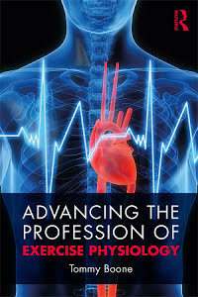
Fortunately, the ASEP members have feelings for something better. Their thinking is not compromised by apathy or the fear of thinking differently. They are willing to engage the change process. They are willing to look to the future for something better than “giving in” to the inaction of failed behaviors. If only the non-ASEP exercise physiologists were willing to combat their indifference, they would gain an awareness of the needs and problems that are keeping exercise physiology from becoming recognized as a healthcare profession. Yes, it is disappointing that the daily routines of the professors of exercise physiology are seized by the need to do research and publish. Wow, how different it would be if they were to take the bull by the horns and recognize their responsibility is to their students’ success. If only they would raise their barrier of indifference toward the ASEP organization. How, by changing their mind set, which means getting beyond the influence of non-exercise physiology personalities and/or organizations and focus specifically on how to advance the profession of exercise physiology.

The bottom line is that I am not going to accept the way many academic exercise physiologists are acting towards the American Society of Exercise Physiologists. Personally, I believe it is wrong. It is misdirected, and it is selfish. That is why I will always do what I can to encourage exercise physiologists to join ASEP and support the members and their beliefs and willingness to be recognized as ASEP exercise physiologists. The ASEP leadership believes there is room for professional and financial opportunities for members of the profession. Yes, exercise physiology is an evolving healthcare profession. It is not an academic research discipline with an interest only in the personal enrichment and success of those with a doctorate degree.

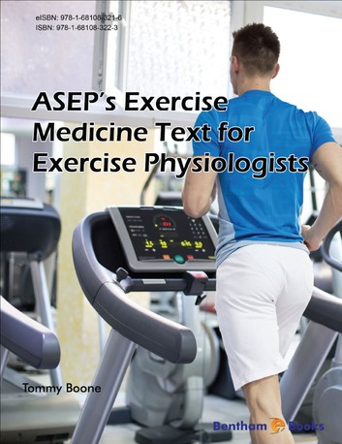
Understandably, the challenges faced by exercise physiologists are part of everyday life that must be dealt with. In fact, it is an absolute necessity to face up to the challenges of indifference. Continued avoidance of what must be done will only keep exercise physiologists from learning about themselves. But, on the other hand, there is a solution to moving the profession of exercise physiologists forward so they can learn to take care of themselves. The solution is moving beyond being concerned about what other people and colleagues in particular might say or think. After all, it is pastime to learn of new opportunities in healthcare, exercise physiology, and exercise medicine. With discipline, dedication, and hard work, the profession of exercise physiology will become embedded in healthcare and momentum will build with the growth of the aging population and the frailty syndrome.

Always remember that a different view of exercise physiology cannot be built by indifferent exercise physiologists. Therefore, it is critical that exercise physiologists acknowledge the importance of being responsive to change. It is important to our students and our profession that those who are at the top of the big non-exercise physiology organizations that want exercise physiology membership will decline and continue to fail in meeting the needs of the exercise physiologists. Thus, regardless of the challenges and the indifference, the key to future growth is the expectation and requirement of the ASEP members to gain momentum and not lose it by thinking quickly and decisively in grasping and seizing the significance of the healthcare competitive advantage in prescribing exercise medicine to the aging population as an ASEP healthcare professional. This means looking ahead with a timely vision that helps to fix both the profession of exercise physiology and the broken health problems throughout the United States. Naturally, updating the exercise physiology degree with a purpose from which key insights are applied to support the ASEP vision and standards of practice to emphasize a culture of professionalism and professional development.

I believe exercise physiologists understand that doing research and publishing articles are important, especially for college teachers. But even the teachers know there is always the need to engage in worthwhile purpose-driven causes to serve their students. In time, with the transition from passivity to caring personality, more college teachers will be interested in being part of something bigger than themselves (such as helping their students become successful after they graduate). They will want to be part of a profession that everyone can be proud of, and they will be willing to work relentless to realize the core values and dreams of all exercise physiologists.



