Professionalization of Exercise Physiologyonline

ISSN 1099-5862

June 2022
Vol 25 No 2

American Society of Exercise Physiologists
The Professional Organization of Exercise Physiologists

The Professional Organization of Exercise Physiologists

The Professional Organization of Exercise Physiologists

Challenges and Issues Faced by Exercise Physiologists
Tommy Boone, PhD, MPH, MAM, MBA, FASEP
ASEP Board Certified Exercise Physiologist

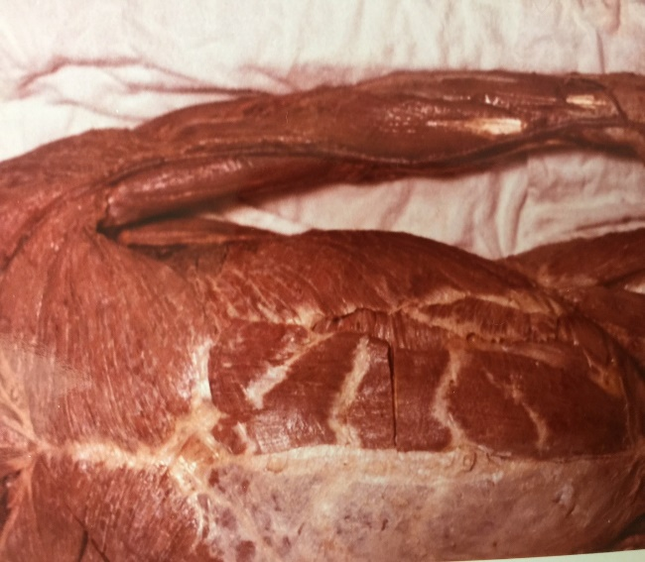
When I was teaching at Wake Forest University, I had numerous conversations with colleagues as to why our students didn’t have the opportunity to learn anatomy from dissecting cadavers. Ten minutes away was the Wake Forest Bowman School of Medicine. After meeting with the Director of the Anatomy Laboratory, he agreed that our department could be provided cadavers for the students to dissect and learn anatomy. Later, I developed second and a third anatomy laboratory with cadavers for the exercise physiology students at the University of Southern Mississippi in Hattiesburg, MS and at the College of Saint Scholastica in Duluth, MN.

Why? Because the students in physical therapy, nursing, and athletic training have the opportunity to dissect cadavers. I believed then and still do that exercise physiology students should have the same academic opportunity as the students of other healthcare professions. However, that is not the case and, unfortunately, when I left those academic institutions, the cadaver labs were discontinued.

I wrote the following book hoping that an academic exercise physiologist would experience a special revelation and justification for helping his or her students learn
anatomy as they should. Yes, this topic is a pressing concern for our profession.
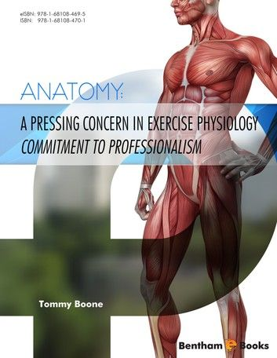
Can you imagine understanding the significance of oxygen consumption without having the opportunity to determine VO₂ in your Exercise Physiology Laboratory? No, of course not. Imagine also the difficulty in understanding cardiac output, stroke volume, and arteriovenous oxygen difference when students are not taught how to use the CO₂ rebreathing method to non-invasively determine cardiac output.

The students of exercise physiology should be educated to be healthcare professionals: (a) who understand the ANATOMY and the PHYSIOLOGY of the body during different exercise conditions; and (b) the power in exercise medicine to promote health and well-being. However, finding agreement as to what is exercise physiology so that our students can have the expectation of success after college is a reality only within the mindset of ASEP exercise physiologists such as Dr. Frank Wyatt and the other faculty members who are ASEP accredited exercise physiology programs.

Exercise physiology is not exercise science. It is not kinesiology. It is not human performance. It is not sports medicine. Our future is linked to exercise physiologists who understand the truth, which is, Exercise Physiology is a Healthcare Profession that can help correct the growing public health crisis of a sedentary lifestyle and physical inactivity.

While most books and articles say that exercise physiology is the study of the body’s physiologic responses to exercise. Such a definition is simply wrong. Why? Because, while it is true that academic exercise physiologists understand the importance of research and their exercise physiology students are taught the specifics of the physiologic responses to different types of exercise or the failure to exercise, a profession requires a greater understanding of the career opportunities after college. Simply knowing the “physiology” does not address the importance of healthcare career concerns of non-PhD exercise physiologists.

In fact, the ASEP accredited college graduates with an undergraduate degree in exercise physiology who were taught that physical inactivity is the 4th leading risk factor for global mortality understand the importance of working with clients and/or patients to improve their quality of life. Their role in healthcare is extremely important, given the projected shortage of 139,000 primary care physicians by 2033.

Also, I am not saying that students should not earn a master’s degree if that is their desire or apply to a different area of study altogether should they wish to do so. However, they should not have to complete an application to athletic training, nursing, or PT just because their academic advisor isn’t doing what he/she can do to help the students by promoting the profession of exercise physiology.

That’s right! To repeat, exercise physiology is a healthcare profession, and ASEP Board-Certified Exercise Physiologists are healthcare professionals with the education and laboratory skills to implement exercise medicine for the treatment and prevention of chronic diseases and a host of other health conditions. Hence, it is important that the students understand the challenges of developing a profession and their role in doing so.

Also, think with me … are the students taught about what it means to say, “I am a clinical exercise physiologist” versus “I am an exercise physiologist” (as though exercise physiologists do not work in clinical settings). Exercise physiologists work in many different careers, from non-clinical (such as fitness centers, community organizations, and corporate and/or private fitness facilities) to clinical settings such as hospitals, nursing homes, a doctor’s office, private healthcare practices, and much more.

One thing for sure is that an exercise physiologist can also be a personal trainer, but the majority of the personal trainers are not exercise physiologists and they do not have the ASEP Board-Certification and, therefore, they are not an exercise physiologist). Also, contrary to some department websites that conclude a college graduate with a kinesiology degree can say he or she is an exercise physiologist is 100% an incorrect statement. If, on the other hand, should the kinesiology degree require students to pass the “ASEP list of academic courses” he or she also passes the ASEP Board Certification exam, then that person can refer to him- or herself as an exercise physiologist.

I believe what I have shared with you are the truths that are not understood by many college professors who are still embracing the sports medicine/exercise science 20th century status quo. Why? Because the cost is high to deal with: (a) resistance from the faculty; (b) opposition by the Chair and/or administrators; and (c) difficulties that result from being different from the average. But, those of us with the passion to advance the profession of exercise physiologists are willing to pay the price.

Do you know that physical therapy is doing what it can to be recognize as the healthcare profession that prescribes exercise medicine? It can’t be difficult to understand what this means for the future of exercise physiologists. Who is going to refer their patients to an exercise physiologist to prescribe a tailored exercise program when there is so much confusion regarding who we are and what we do?

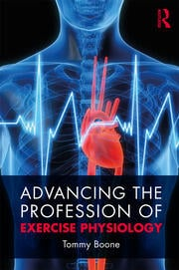

However, from the ASEP perspective, working together we can fulfill the ASEP vision. So, what is stopping us? Is it because many academic exercise physiologists have not given their support? Is it indifference? Is it politics among different organizations? The ASEP Board of Directors believe we must work to be recognized as a unified professional organization of exercise physiologists in the professional study, promotion, and application of exercise medicine by exercise physiologists. After all, a new federal report estimated that one-quarter of Americans over 50 years of age do not exercise. Their risk for heart disease, diabetes, dementia, cancer, and a dozen other diseases and disabilities increases every day.

The political philosopher, John Schwartz said, “The future is not some place we are going to but one we are creating.” ASEP exist to create the profession of exercise physiology. After all, ASEP has already developed the:

- First Code of Ethics for exercise physiologists, as well as the
- First Academic Accreditation Guidelines, the
- First Board-Certification (the EPC exam), the
- First Standards of Practice, and
- Much more, such as the “4” ASEP journals

The leadership of the American Society of Exercise Physiologists believes that it is a successful organization, even though it is only 25 years old. If you believe ASEP is in your future, then become a member and prepare to sit for the Board Certification exam? Why, because we within ASEP believe that if you plan to: (a) analyze a patient or clients’ medical history to assess risk during exercise; (b) perform a stress test, measure blood pressure, oxygen consumption, heart rhythm; and (c) provide an individualized treatment plan, you need to be ASEP Board-Certified.

I believe the American Society of Exercise Physiologists is a professionally successful organization, even though it is just 25 years old. If you believe ASEP is in your future, become a member and sit for the Board-Certification exam? Why, because we within ASEP believe that if you plan to: (a) analyze a patient or clients’ medical history to assess risk during exercise; (b) perform a stress test, measure blood pressure, oxygen consumption, heart rhythm; and (c) provide an individualized treatment plan, you need to be ASEP Board-Certified.

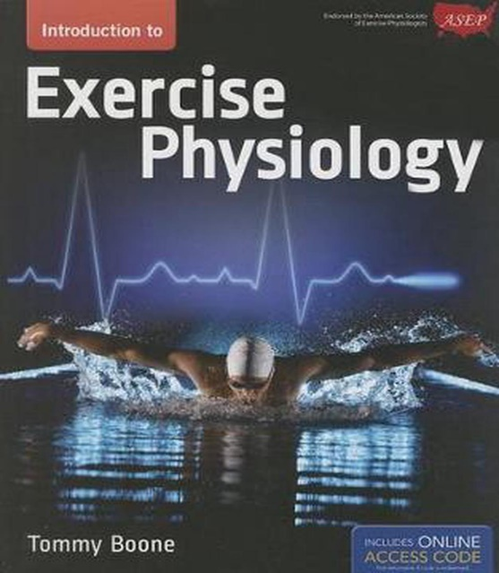
This is true regardless of whether you are the owner of your own exercise medicine business, work in a clinical setting and/or hospital, a primary physician’s office, or alongside a physical therapist, or some other healthcare professional, you need a bachelor’s degree in exercise physiology and you need the ASEP Board-Certification for profession-specific recognition and/or legal reasons.

Prior to 1997, exercise physiologists did not have a professional definition of exercise physiology. Now we do. The ASEP definition is the following: Exercise Physiology is the comprehensive delivery of healthcare services concerned with the analysis, improvement, and maintenance of the physiological mechanisms underlying physical and mental health and fitness through regular exercise, the prevention and/or treatment of chronic diseases and/or disabilities with exercise medicine, and the professional guidance of athletes and others interested in athletics and sports training.

After all, sedentary behavior and physical inactivity are among the leading modifiable risk factors worldwide for cardiovascular disease and all-cause mortality. Also, as you know, sedentary behavior is either insufficient physical activity or excessive sitting, and an estimated two-thirds of the American adult population engage in insufficient physical activities due to their daily duration of sedentary behavior that is essentially 8 hours a day. The bottom line is that most people sit for hours every day and never leave the house or work to walk even a mile much less lift weights to maintain their musculoskeletal system.

Naturally, as they grow older, they are prone to disabilities, metabolic disorders (such as impaired glucose metabolism), and cardiovascular disease mortality along with an increase in cancer risk and cognitive impairment. The adoption of a physically active lifestyle remains low because of personal barriers from perceived physical limitations, lack of time due to television viewing, playing video games, using a computer, sitting at school or work, cell phone usage, misconceptions of what type of exercise and how to exercise, and whether exercise is necessary to improve health and fitness.

Yet, it is scientifically clear that exercise medicine: (a) Improves lung capacity, heart rate variability, blood pressure, myocardial function, lean muscle mass, capillary density, high-density lipoprotein (HDL) cholesterol, and immune function; and (b) Decreases triglyceride blood levels, insulin resistance, the risk of obesity, type 2 diabetes, osteoporosis, osteoarthritis, psychological stress, depression, and the risk of different types of cancer (e.g., breasts, colon, colorectal, endometrial, and epithelial ovarian cancer). The bottom line is that exercise medicine is a very effective treatment for people suffering from mental illness, with some studies suggesting that regular exercise is as effective, if not better than many of the pharmacological interventions.

Increasingly, it is evident that ASEP Board-Certified Exercise Physiologists are key healthcare professionals in prescribing exercise medicine to delay and reverse the anatomical and physiological changes that characterize aging and frailty that increases the risks of illness, falls, dependency, disability, and death.

Fortunately, Board-Certified Exercise Physiologists can help in the prevention and management of chronic diseases, and they can assist in restoring mental and physical functions. The scope of responsibilities for the ASEP exercise physiologist includes diagnostic and functional testing, exercise prescription, and exercise supervision, patient counseling, education, and outcomes analysis. ASEP exercise physiologists may also address barriers to maintaining exercise compliance, including psychological factors, musculoskeletal limitations, and other deterrents to regular exercise.

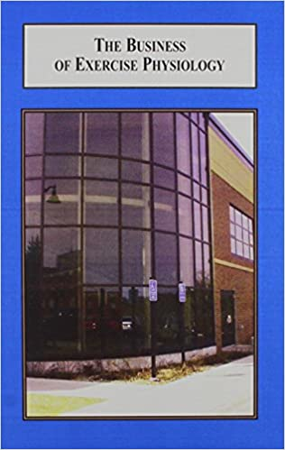
The world is changing, and it is not going to slow down. New thinking is required of exercise physiologists. The expectation of the ASEP leadership is that exercise physiologist will prepare in earnest for the changes they will encounter during their professional career.

One way, and it is certainly not the only way to be financially successful as a Board-Certified Exercise Physiologist is to develop your own Exercise Medicine business. This is something to think about, especially if you are still in college or a university in the United States. So, why not take a course or even two or three that will help to develop an exercise medicine business plan; and also help to understand different patient recruitment strategies?

