Journal of Professional Exercise Physiology
ISSN 1550-963X
February 2020
Volume 17 Number 1

American Society of Exercise Physiologists
The Professional Organization of Exercise Physiologists

The Professional Organization of Exercise Physiologists

The Professional Organization of Exercise Physiologists

Why I Am an Exercise Physiologist
Tommy Boone, PhD, MPH, MAM, MBA
ASEP Board Certified Exercise Physiologists

Never give up.

D
uring my senior year in High School in Leesville, LA, my speech teacher said, “Tommy, you are going to do a demonstration speech in 2 weeks.” Well, as life happens, the Northwestern State University gymnastics team put on a gymnastics exhibition at my high school. Out of the blue, I decided to teach myself how to do a handstand and then I would talk about the muscles involved. So, I checked out an anatomy book from the Vernon Parish Library in Leesville so I could talk about the muscles involved in the handstand. The speech went well, and it was no doubt the reason I passed the class. Little did I know that later I would be speaking before college students in 6 different colleges and universities across 44 years!

When I graduated from high school, I decided to go to Northwestern State University in Natchitoches, LA and major in Health and Physical Education. One class in particular that I enjoyed was Physiology of Exercise of which I concluded there must be “Exercise Physiologists” as well as Physical Educators”. The difference between the two majors is that exercise physiologists major in “exercise physiology”. Yet, it didn’t occur to me to ask the question: “Do exercise physiologists major in exercise physiology?” Much later, it became clear to me that the majority of the exercise physiologists had academic degrees in exercise science, human performance, kinesiology, or whatever degree and simply referred to themselves as an exercise physiologist? Also, talk about being slow to get the big picture. It never occurred to me that exercise physiologists did not have their own professional organization. Instead, early on the small number of academically prepared exercise physiologists had been convinced to become members of several generic organizations. Please appreciate that by “early on” I am referring to the 1960s.

To back track for a moment, as a student at Northwestern State, I decided to be a gymnast. With determination and a lot of work during my freshman year, I became a gymnast and graduated as an All-American gymnast on the high bar (although I loved performing on the parallel bars and rings just as much). I have always appreciated that the gymnastics coach, Fred Martinez, gave me the opportunity to learn gymnastics along with the other gymnasts (such as Richard Loyd, the person standing to my left. I am in the center of the three). Richard was the first gymnast at Northwestern State to be inducted into the NAIA Gymnastics Hall of Fame. He represented the United States in the 1967 Pan American team and the 1968 United States Olympic team. In the following picture, Fred Martinez is on your left as you are looking at the picture was the Coach.

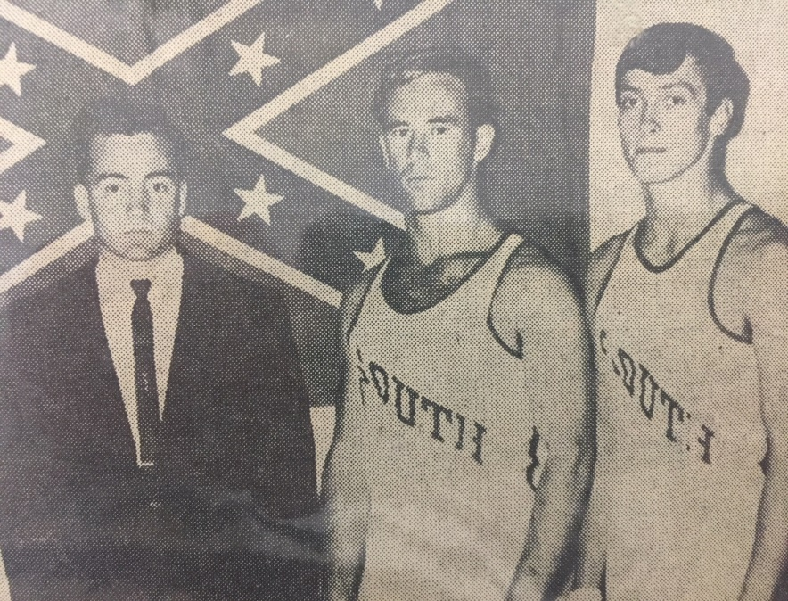 | After completing the MEd degree in Health and Physical Education at NSU, I was hired to coach men’s gymnastics for a 9-month period at Northeast Louisiana State University in Monroe, LA. Then, I was hired by the University of Florida to teach gymnastics and other physical activities. After 3 years, I decided to leave UF to earn the doctorate degree in exercise physiology. I enrolled in Florida State University in Tallahassee, FL. As it turned out, it was a great academic experience.

In particular, the anatomy class included the opportunity to dissect cadavers. It was an amazing experience working on the PhD degree at FSU. In fact, it helped me later when I was teaching at Wake Forest University in Winston-Salem, NC to gain approval from the Anatomy Department at Bowman Grey School of Medicine to procure several cadavers that I transported to the WFU campus. There, I created the first-ever Anatomy Laboratory in the Exercise Science Department for the students who had a great time with dissecting the cadavers. When I left Wake Forest and accepted the Graduate Coordinator position in the Human Performance Department at the University of Southern Mississippi (USM) in Hattiesburg, MS, I started another Anatomy Laboratory with cadavers procured from the Medical School in Jackson, MS for the graduate students to dissect. Why, because they needed the opportunity to learn anatomy from their personal experiences in their own cadaver laboratory.

Why not take note of the sternal and clavicular parts of the pectoralis major? The dissection allows for a visual and hands-on understanding of the functions that each part is responsible for with respect to the upper limb. Also, look at the tendinous inscriptions that divide the rectus abdominis into three to five functional parts. The opportunity to dissection skeletal muscles and nerves should be no different from the opportunity the students already have to measure oxygen consumption and other important physiological responses. | 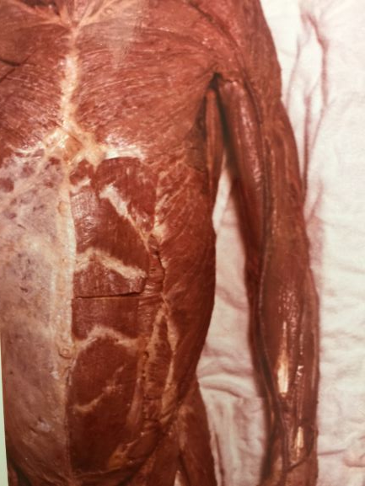
The conclusion is that without hands-on experience in cadaver dissection, the students of exercise physiology are at a major disadvantage in numerous ways (especially when compared to physical therapy students). For example, they would be hard pressed to identify the muscles innervated by the musculocutaneous nerve. Forget about an exercise physiology professor carrying out the dissection requirements of the brachial plexus or the lumbosacral plexus. Why is this the case? Simply stated, academic exercise physiology doctoral programs do not have professors who are educationally prepared to teach anatomy and cadaver dissection because their emphasis has always been on applied physiology, research, ECG, and metabolism.

The evidence is not in dispute that the four academic courses just mentioned are important for the students of exercise physiology. But, since they will eventually graduate and look for career opportunities beyond research and academia, they will need to understand anatomy (1) just as they have been taught physiology. After all, health and well-being are interrelated, and all exercise physiologists need to understand not only the role of regular exercise but also anatomy and the power of the mind and spirituality in the prevention and treatment of chronic diseases (2,3,4,5).
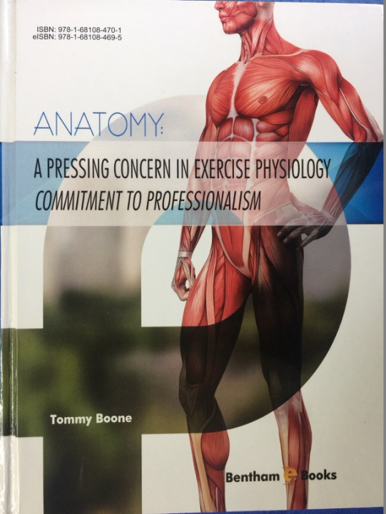
It is a complex and powerful concept, but without considering the role of spirituality in health matters, the result is an unbalanced delivery of healthcare. Unsurprisingly, the directives from the ASEP leadership is to uphold the integrity of ASEP Board Certified Exercise Physiologists. As agents of change and in accordance with the commitment to uphold the ASEP vision, understanding anatomy is required for fulfillment of professional development of every exercise physiologist (6). Why, because the leaders are committed to honesty and integrity. After all, if exercise physiology students are going to spend thousands of dollars in tuition and living expenses during college, they should be informed about career opportunities and the distinction between financial considerations and those of other healthcare professionals.

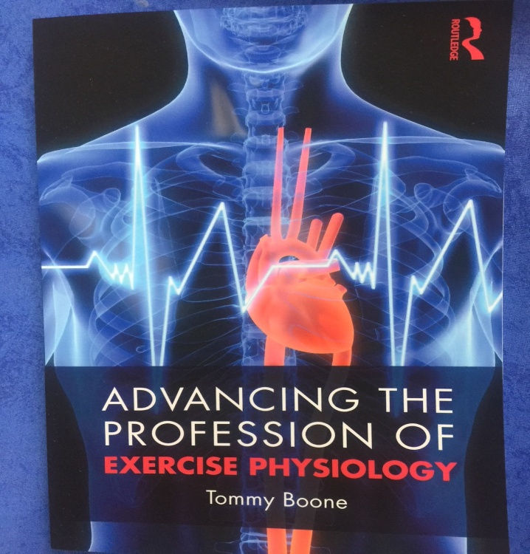 | Perhaps, it should be said that the ASEP leaders have the ASEP story to share with all exercise physiologists to help everyone understand the challenges before them and why. As leaders, they are not interested in living out their lives promoting sports medicine and exercise science. Victor Frankl said it best in Man’s Search for Meaning, “the striving to find meaning is the primary motivational force in man”. A research abstract or a generic life without a reliable income just simply doesn’t make it. The ASEP exercise physiologists think as other healthcare professionals do. That is why they have their own specific vocation and/or mission in life.  It is not a coincidence that the ASEP organization exists. It is a natural part of the process of crossing the threshold from a discipline into a place where professionalism means everything.
In fact, it is a beautiful and mysterious moment that exercise physiologists at various levels of academic preparation are going forward with the fundamental tenet of professionalization of exercise physiology. That is, exercise physiologists don’t own exercise physiology, they are just the professional members at a point in time. It is their job to continue the legacy and add to the underlying truths of exercise physiology as a healthcare profession that leaves exercise physiology in a better place.
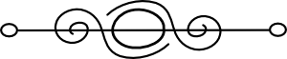

References
- Boone, T. (2017). Anatomy: A Pressing Concern in Exercise Physiology – Commitment to Professionalism. Bentham Science Publishers. [Access Online]. https://benthambooks.com/book/9781681084695/

- Boone, T. (2003). Spirituality, Faith, and Exercise Physiology as Healthcare Professionals. Professionalization of Exercise Physiologyonline. 6:11 [Access Online]. http://www.asep.org/asep/asep/SpiritualityFAITHexercisePhysi ologists. html

- Boone, T. (2004). The Spiritual Care of Patients in Exercise Physiology. Professionalization of Exercise Physiologyonline. 7:9 [Access Online]. http:// www.asep.org/asep/asep/SpiritualCare.html

- Boone, T. (2007). Integrating Spirituality into Exercise Physiology. Professionalization of Exercise Physiologyonline. 10(1). [Access Online]. https://www.asep.org/asep/asep/ IntegratingSpirituality.html

- Boone, T. (2010). Integrating Spirituality and Exercise Physiology: Toward a New Understand of Health. Lewiston, NY: Edwin Mellen Press. [Access Online]. https://mellenpress.com/book/Integrating-Spirituality-and-Exercise-Physi ology-Toward-a-New-Understanding-of-Health/8105/

- Boone, T. (2019). Advancing the Profession of Exercise Physiology. New York, NY: Taylor & Francis. [Access Online]. https://www.taylorfranciscom/book s/ 9780429031144

