Journal of Exercise Physiologyonline
(JEPonline)

Volume 12 Number 4 August 2009



Nutrition and Exercise
Managing Editor
Tommy Boone, PhD, MPH
Editor-in-Chief
Jon K. Linderman, PhD
Review Board
Todd Astorino, PhD
Julien Baker, PhD
Tommy Boone, PhD
Larry Birnbaum, PhD
Eric Goulet, PhD
Robert Gotshall, PhD
M. Knight-Maloney, PhD
Len Kravitz, PhD
James Laskin, PhD
Derek Marks, PhD
Cristine Mermier, PhD
Chantal Vella, PhD
Ben Zhou, PhD

Official
Research Journal of
the American Society of Exercise Physiologists (ASEP)

ISSN 1097-975

Moderate to High Dose of Maltodextrin Before Exercise Improves Glycogen Availability in Soleus and Liver After Prolonged Swimming in Rats

ANGELA RUFFO, RAUL OSIECKI¹, Luiz Fernandes², CARLA FELIPE, ANA OSIECKI, CARLOS MALFATTI³

¹Departamento de Educação de Física, Universidade Federal do Paraná, UFPR, Curitiba, PR, Brazil
²Departamento de Fisiologia, Universidade Federal do Paraná, UFPR, Curitiba, PR, Brazil
³Departamento de Educação Física, Universidade Estadual do Centro-Oeste, UNICENTRO, Irati, PR, Brazil.

ABSTRACT

Ruffo AM, Osiecki R, Fernandes LC, Felipe CS, Osiecki AC, Malfatti CRM. Moderate to High Dose of Maltodextrin Before Exercise Improves Glycogen Availability in Soleus and Liver After Prolonged Swimming in Rats. JEPonline 2009;12(4):30-38. Maltodextrin is a carbohydrate polymer utilized preferentially as diet recourse in exercise. The gastric emptying for glucose polymer is faster than glucose solutions, avoiding a sudden drop in blood glucose and hyperinsulinaemia induced hypoglycaemia during exercise. The ideal dose by which maltodextrin causes improvement in glycogen storage is not certain. Therefore, we investigated the effect of different doses of maltodextrin supplementation on liver and muscle glycogen availability after swimming. Adult male wistar rats were submitted to oral supplementation with different doses of maltodextrin (0.7; 1.4; 2.1 and 2.8 g/kg) or placebo group (distilled water) twenty minutes before exercise. In the session, all the groups of animals were submitted to a single 90 min-swimming challenge. Immediately after the exercise, samples were colleted for biochemical analysis. Maltodextrin improved the glycogen available only at moderate to high doses in the soleus (dose/glycogen: 2.1 g/kg: 35.9 μmol/g; 2.8 g/kg: 35.5μmol/g vs placebo: 26.7μmol/g) and liver (dose/glycogen: 1.4 g/kg =106.7μmol/g; 2.1 g/kg:102.5 μmol/g; 2.8 g/kg: 102.8μmol/g vs placebo: 58.9μmol/g) but not in gastrocnemius. The study reported a pre-exercise effect of maltodextrin only in moderate to high doses.

Key Words: Exercise, Glycemia, Diet.

INTRODUCTION

Pre-exercise CHO feeding is proposed as an effective means of enhancing muscle glycogen availability and improving endurance performance (1). Such a muscle glycogen supercompensation regimen increases muscle glycogen stores approximately 20-40% above normal and benefits athletes participating in endurance exercise. In addition to glycogen loading for competition, athletes should ensure their diet contains sufficient CHO to allow for muscle glycogen resynthesis between strenuous training sessions. It is suggested that some of the feelings of tiredness associated with overtraining are related to reduced CHO reserves (2). In addition, carbohydrate (CHO) feedings during prolonged exercise can delay the onset of fatigue and enhance exercise performance (3,4,5). The observed improvements in performance with CHO ingestion have been attributed to maintenance of plasma glucose and glycogen availability (6). In this context, CHO supplementation has been shown to increase the amount of work that can be performed (7,8,9) as well as increase the duration of aerobic exercise (10,11). The elevation of blood glucose (BG) associated with supplementation is suggested to improve aerobic performance through reduction of muscle glycogen use (11,12) or through the use of BG as a predominant fuel source as glycogen becomes depleted (3,8). The reduction in muscle glycogen can potentially result in reduction in performance. Decreased isokinetic force production (13), and accentuated muscle weakness (11) have been reported in the scientific literature in response to reductions in muscle glycogen. In fact, the daily maintenance of glycogen stores appears to be directly related to the CHO in the diet (14).

Carbohydrate supplementation during exercise has been shown to enhance performance and muscle glycogen recovery after different protocols of exercise in cycling (9) and running (15). However, the pre-exercise supplementation with different doses of maltodextrin and glycogen availability in different muscle fibers and liver after prolonged swimming has not been reported. Therefore, the present study was undertaken to investigate the effects of different doses of maltodextrin ingested pre-exercise on the ability to increase muscle and liver glycogen available following prolonged low intensity swimming.

METHODS
Subjects
The study was performed with thirty-four adult male wistar rats (12 week old). The rats were housed four per cage (40 x 25 x 18 cm) and maintained on a 12:12 h light/dark cycle in constant temperature of 23ºC, with free access to tap water and standard lab chow (Guabi, Santa Maria, RS, Brazil). Animal utilization protocols were in compliance with the policies established by American Physiological Society and have been conducted in accordance with the Policies on the Use of Animals and Humans approved by the University Ethics Committee (protocol n. 30233/04-01). All reagents were purchased from Sigma (St. Louis, MO, USA) and all solutions were prepared with type I ultra pure water.

Procedures
Adaptation of animals
The rats were handled 4 to 5 times per week and were submitted to gavages stress and adaptation to exercise (ten minutes per day) in water during the 4 weeks before the experiments. The time and volume of exercise is not sufficient to fitness adaptation, where the rats are characterized as untrained.

Oral supplementation
The oral supplementation with different doses of maltodextrin (DNA - Design Nutrition Advanced) or placebo (water distilled) was performed in 5 experimental groups, where group 1 (M1; maltodextrin 0.7 g/Kg; body weight (g) = 310.29 ±10.29; n=7), group 2 (M2; maltodextrin 1.4 g/Kg; body weight (g) = 313.57 ±11.34; n=7), group 3 (M3; maltodextrin 2.1 g/Kg; body weight (g) = 312.86 ±5.17), group 4 (M4; maltodextrin 2.8 g/Kg; body weight (g) = 312.14 ±5.91; n=7) and placebo group 5 (Pb; distilled water; body weight (g) = 321.0 ±5.67; n=7). The maltodextrin were dissolved in distilled water and administered by gavage procedure twenty minutes before exercise. The rats were fasted 12 hours before supplementations.

Protocol of exercise
The session of aerobic exercise was realized as follows: four rats swam together in a round swimming pool (75 cm in diameter, 40 cm deep) that had its temperature kept at 32 ± 1 ºC throughout the experiments. The dimensions of the pool allowed the animals to swim freely, and not float passively, as it was deep enough so that they could not rest upon an extended tail. In the session, all the groups of animals (maltodextrin and placebo) were submitted to a single 90 min-swimming challenge with a low intensity exercise (predominant aerobic workload), using 6% of body weight in accordance with protocol proposed by Gobatto et al. (16).

Biochemical analysis
Immediately after the swimming session the animals were sacrificed and approximately 3 to 4 mL of blood samples were colleted for plasma preparation. The liver tissue, soleus and gastrocnemius muscles were rapidly excised, placed in an ice-cold in equal time point of 15 s and dissected free of connective tissue, followed with biochemical analysis in laboratory.

The blood samples were centrifuged at 1500 rpm during 8 minutes for plasma separation.

The plasma glycerol and glucose were dosed by glycerol phosphate oxidase/peroxidase and oxidase/peroxidase assay, respectively. In both methods a kit of BioSystems register was used. The glycogen was measured by a modification of the Passenneau and Lauderdale method (17).

The plasmatic insulin was determined by chemiluminescence technique using the DPC immulite 2000R.

Statistical Analyses
All data are expressed as means ± SD. Statistical analysis was carried out by one-way analysis of variance (ANOVA) and F-values are presented only if P<0.05. Post-hoc analysis was carried out, whenever appropriate, by the Student-Newman-Keuls test.

RESULTS
Muscular and hepatic glycogen storage
Figure 1 shows that the maltodextrin supplementation significantly improved muscle glycogen storage for the soleus, but not in the gastrocnemius. The difference between the soleus and placebo group occurred only in high doses (maltodextrin in dose of 2.1 and 2.8 g/kg vs placebo group without maltodextrin) of maltodextrin supplementation [F(4,30)=4.1, P<0.05; Figure 1A-B]. Maltodextrin supplementation also significantly improved hepatic glycogen storage after swimming [F(4,30)=5.1, P<0.05; Figure 2] in the three major doses (maltodextrin in dose of 1.4, 2.1 and 2.8 g/kg vs placebo group without maltodextrin).

Plasmatic parameters
The triglycerides hydrolysis of adipose tissue during exercise can be determined for plasma glycerol concentration (18). In the present study, there was no statistical difference in plasmatic glycerol concentration between placebo and different doses of maltodextrin supplementation groups after exercise. The plasmatic glucose and insulin concentration (Table 1) showed no statistical different among groups.

DISCUSSION

In the current study we showed that maltodextrin supplementation before exercise increased muscle and hepatic glycogen storage after prolonged exercise in a dose dependent manner. In addition, we showed that the maltodextrin supplementation improved glycogen availability only in soleus muscle, an aerobic predominant fiber, but not in gastrocnemius. Preview studies showed that this beneficial effect of pre-exercise CHO feeding could be attributed to the increase in liver glycogen and alternatively may increase muscle glycogen for potential oxidation during exercise (19). However, several studies have not observed positive effects of pre-exercise CHO feedings (20,21). Differences in the training status of the subjects, amount of CHO ingested and the failure of the pre-exercise CHO feeding to alter glycogen metabolism may be some of the reasons for the discrepancy between these studies. Apparently, eating approximately 150 g of CHO 4 hr before exercise does not produce a marked elevation of muscle glycogen, blood glucose or CHO oxidation after 105 min of aerobic exercise (22), which may explain why some other authors did not observe an improvement in glycogen available and performance with this amount.
Table 1: Effect of different doses of maltodextrin on plasmatic biochemical parameters after a prolonged swimming protocol.
Maltodextrin  (g/Kg) | Pb (0) | M1 (0.7) | M2 (1.4) | M3 (2.1) | M4 (2.8)
Glucose (mg/dL) | 145.67 ±9.5 | 150.86 ±12.6 | 161.86 ±35.0 | 139.0 ±17.0 | 144.0 ±14.2
Glycerol (mg/dL) | 178.83 ±51.9 | 176.86 ±44.6 | 152.86 ±57.1 | 164.0 ±69.2 | 163.29 ±39.2
Insulin (UI/mL) | 6.9 ± 3.9 | 7.3 ± 2.1 | 7.8 ± 2.1 | 8.2 ± 2.6 | 7.5 ± 2.6

Values are means ± S.D. Pb, placebo; M1 (n=7), maltodextrin in dose of 0.7 g/kg (n=7); M2, maltodextrin in dose of 1.4 g/kg (n=7); M3, maltodextrin in dose of 2.1 g/kg (n=7); M4, maltodextrin in dose of 2.8 g/k g (n=7).*Significant difference P<0.05.

The type of CHO supplementation is very important. It has been suggested that because of their lower osmolalities, glucose polymer solutions (i.e., maltodextrins) would be preferable to isocaloric glucose solutions as a source of ingested CHO before and during exercise (23). Indeed, several studies have shown that the rates of gastric emptying for glucose polymer solutions are faster than those of isocaloric glucose solutions (24,25). In addition, it has been suggested that glucose feedings (75 g of glucose solutions) during 30 to 45 min before exercise in cyclists might impair exercise performance by causing a sudden drop in blood glucose and an accompanying acceleration of muscle glycogenolysis and glucose oxidation. This is due to the effects of the concomitant hyperinsulinaemia that increases glucose uptake by the exercising muscles, thus resulting in hypoglycaemia, decreasing lipolysis and free fatty acid availability at the start of and during exercise (26).

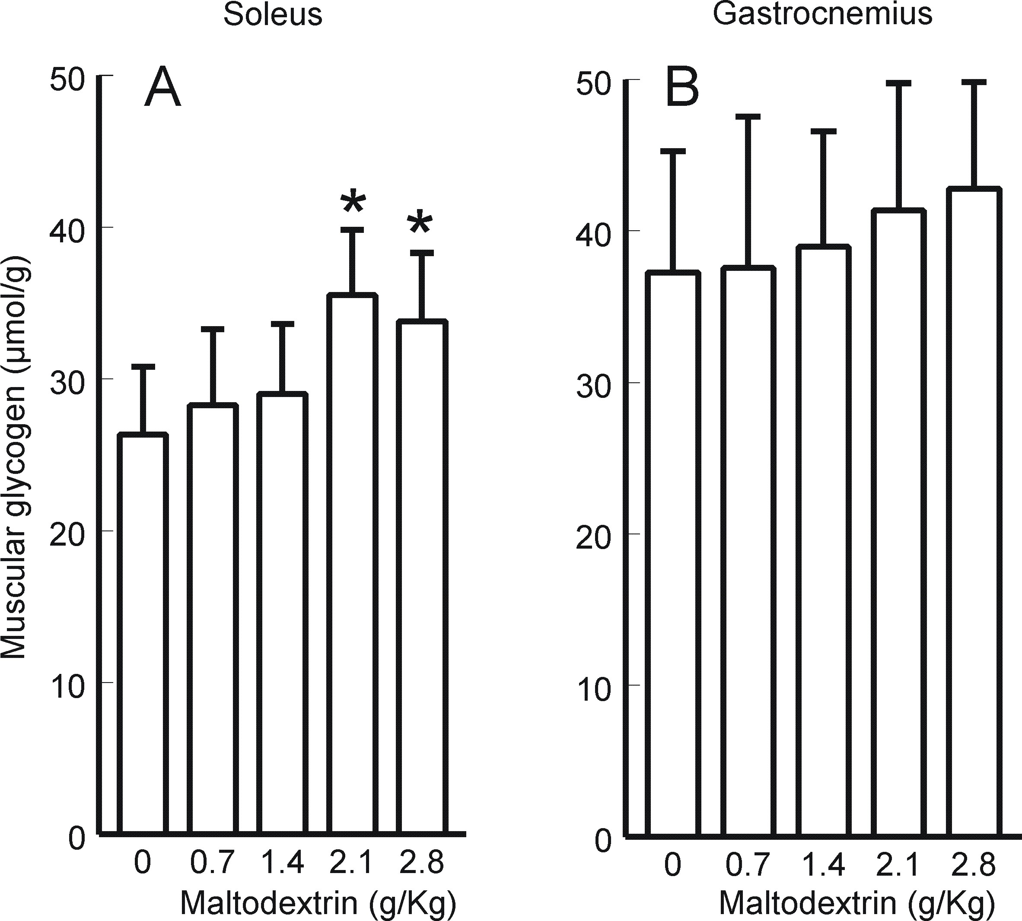
In the present study, plasmatic glucose concentration, insulin responses and fat acid mobilization (analyzed by blood glycerol concentration) was not statistical different between all of the groups analyzed after use of glucose polymer (maltodextrin) vs placebo group.

In fact, up to the present, no investigation has been conducted of the effect of pre-exercise supplementation with different doses of supplement maltodextrin (CHO polymer) in performance, insulin responses, glucose plasmatic, fat acid mobilization and glycogen storage in muscle and liver after prolonged exercise.

The study showed that maltodextrin improves glycogen available only in the soleus muscle, a predominantly aerobic fiber, signaling that fibers of slow strength, stimulated predominantly in this model of aerobic exercise, would benefit in a dose-dependent manner after supplement use.
Figure 1. Effect of different doses of maltodextrin supplementation on soleus (A) and gastrocnemius (B) glycogen storage after a prolonged swimming protocol. Data are mean + S.D., N= 7 in each group. *P<0.05 compared to control placebo group without maltodextrin (SNK Test).

However, this adaptation could not prevent the drop in the glycogen concentration in the gastrocnemius muscle, a glycolytic muscle less utilized if compared to aerobic fiber preferably utilized in this endurance protocol. It is consensus in the literature that in rat model the soleus muscle has a predominant slow-twitch fiber, showing a red muscle prevalently composed of oxidative metabolism, and in the gastrocnemius exists a characterized white muscle, prevalently composed of fast-twitch glycolytic fibers (type IIb) (27).

Tsintzas et al. (28) studied muscle glycogen breakdown during running at 70% of VO_{2max} and observed that with CHO feeding there was a reduction in net muscle glycogen breakdown in type I muscle fibers (predominantly aerobic fiber) after 60 min, whereas type II fibers (predominantly anaerobic fiber) seemed unaffected. In a follow-up study similar results were obtained (15). In addition, the CHO feeding during exercise “spares” liver glycogen (29). Hepatic glucose output is tightly regulated, ensuring a relatively constant glucose output in the presence or absence of CHO feeding. Although the total rate of appearance of glucose increases somewhat with increasing rates of CHO intake, there is a progressive decrease in endogenous glucose production (liver glycogenolysis and gluconeogenesis) with increasing rates of CHO intake (30). We showed that the pre-exercise supplementation with maltodextrin in three doses (1.4, 2.1 and 2.8 g/kg) enhanced the stores of glycogen in liver after prolonged exercised compared with placebo or minor dose administered (0.7 g/kg).
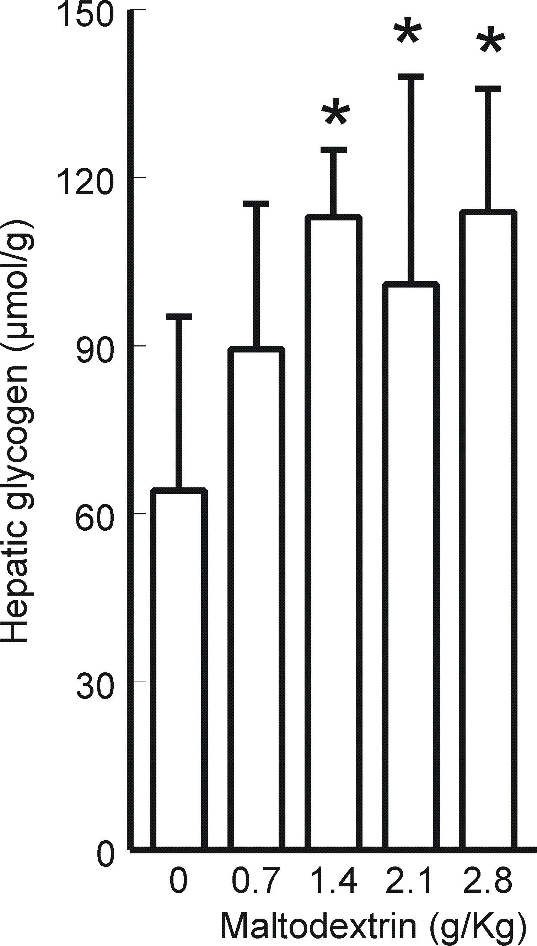
Some studies have reported that with high rates of CHO intake liver glucose production returns to its basal levels, whereas others have observed complete locking of hepatic glucose output by CHO feeding 30(19). This liver glycogen sparing means that there is still CHO in the liver toward the end of exercise, which could be beneficial if, for whatever reason, CHO intake cannot supply enough CHO to maintain plasma glucose concentrations and high rates of total CHO oxidation. However, up to the present, was not investigated the better dose for pre exercise supplementation with maltodextrin-induced improved glycogen available post swimming protocol. In contrast with the present study, some studies did not find beneficial results on performance or glycogen sparing with CHO supplementation. Although, these studies used CHO (glucose) in minor doses that did not exceed 1.0 g/kg body weight (31,32).
Figure 2. Effect of different doses of maltodextrin supplementation on hepatic glycogen storage after a prolonged swimming protocol. Data are mean + S.D., N= 7 in each group. *P<0.05 compared to control placebo group without maltodextrin (SNK Test).

CONCLUSIONS

In summary, the present study reports that maltodextrin supplementation before exercise significantly improved soleus and liver glycogen-availability only in moderate to high doses after prolonged swimming in rats. Future studies in humans should concentrate on developing individual dosage supplementations with this carbohydrate in different time points before endurance exercise models.

Address for correspondence: Malfatti CRM, PhD, Departamento de Educação Física, Universidade Estadual do Centro-Oeste, Irati, Paraná, Brazil, 84500-000. Phone (+55) 42-3421 3000; FAX: (+55) 42-3421 1090; Email. ricardo.malfatti@bol.com.br.

REFERENCES

- Karlsson J, Saltin B. Diet muscle glycogen and endurance performance. J Appl Physiol
1971, 3 (1), 203-206.

- Costill DL, Flynn MG, Kirwan JP, Houmard JA, Mitchell JB. Effects of repeated days of
intensified training on muscle glycogen and swimming performance. Med Sci Sports Exert
1988, 20, 249-254.

- Coyle EF, Coggan AR, Hemmert MK., Ivy JL.. Muscle glycogen utilization during prolonged
strenuous exercise when fed carbohydrate. J Appl Physiol 1986, 61, 165–172.

- Hargreaves M, Costill DL, Coggan A, Fink WJ, Nishibata I. Effect of carbohydrate feedings on muscle glycogen utilization and exercise performance. Med Sci Sports Exerc 1984,
16(3), 219-22.

Jeukendrup AE, Jentjens R. Oxidation of carbohydrate feedings during prolonged exercise:

current thoughts, guidelines and directions for future research. Sports Med 2000, 29(6), 407- 24.

- Coggan AR, Coyle EF. Reversal of fatigue during prolonged exercise by carbohydrate
infusion or ingestion. J Appl Physiol 1987, 63(6), 2388-95.

- Ivy JL, Costill DL, Fink WJ, Lower RW. Influence of caffeine and carbohydrate feedings on
endurance performance. Med Sci Sports 1979, 11, 6–11.

- Neufer PD, Costill DL, Flynn MG, Kirwan JP, Mitchell JB, Houmard J. Improvements in
exercise performance:Effects of carbohydrate feedings and diet. J Appl Physiol 1987, 62, 983–988.

- Wright DA., Sherman WM, Dernbach AR. Carbohydrate feedings before, during, or in
combination improve cycling endurance performance. J Appl Physiol 1991, 71, 1082–1088.

- Fielding RA, Costill DL, Fink WJ, King DS, Hargreaves M, Kovaleski JE. Effect of
carbohydrate feeding frequencies and dosage on muscle glycogen use during exercise. Med Sci Sports Exerc 1985, 17, 472–476.

- Yaspelkis BBD, Patterson JG, Anderla PA, Ding Z, Ivy JL. Carbohydrate supplementation
spares muscle glycogen during variable-intensity exercise. J Appl Physiol 1993, 75, 1477–
1485.

- Bagby GJ, Green HJ, Katsuta S, Gollnick PD. Glycogen depletion in exercising rats infused
with glucose, lactate, or pyruvate. J Appl Physiol 1978, 45, 425–429.

- Jacobs I, Kaiser P & Tesch P. Muscle strength and fatigue after selective glycogen depletion
in human skeletal muscle fibers. Eur J Appl Physiol 1981, 46, 47–53.

- Costill DL. Carbohydrate for athletic training and performance. Bol Asoc Med P R 1991, 83,
350–353.

- Tsintzas OK, Williams C, Boobis L, Greenhaff P.. Carbohydrate ingestion and single muscle
fiber glycogen metabolism during prolonged running in men. J Appl Physiol 1996, 81(2), 801-9.

16 Gobatto CA, Mello MAR, Sibuya CY, Azeredo RM, Santos LA, Kokubum E. Maximal lactate
steady state in rats submitted to swimming exercise. Comp Biochem Physiol 2001, 130:21-27.

- Passenneau JV, Lauderdaler VR. A comparison of three methods of glycogen measurement
in tissue. Anal Biochem 1974, 60, 404-412.

- Horowitz JF.. Fatty acid mobilization from adipose tissue during exercise. Trends
Endocrinol Metab 2003, 14 (8),386-392.

- Sherman WM, Costill DL, Fink WJ, Miller JM. The effect of exercise and diet manipulation
on muscle glycogen and its subsequent utilization during performance. Int J Sports Med
1981, 2, 114-118.

- Alberici JC, Farrell PA, Kris-Etherton PM, Shively CA. Effects of preexercise candy bar
ingestion on glycemic response, substrate utilisation, and performance. Int J Sports Nutr
1993, 3, 323-333.

- Hargreaves M, Costill DL, Fink WJ, King DS, Fielding RA. Effect of pre-exercise
carbohydrate feedings on endurance cycling performance. Med Sci Sports Exert 1987 19:33-36.

- Coyle EF, Coggan AR, Hemmert MK, Lowe RC, Walters TJ. Substrate usage during
prolonged exercise following a pre-exercise meal. J Appl Physiol 1985, 59, 429-433.

- El-Sayed MS, MacLaren D, Rattu AJ. Exogenous Carbohydrate Utilisation: Effects on
Metabolism and Exercise Performance. Comp Biochem Physiol 1997, 118(3), 789-803.

- Leese GP, Bowtell J, Mudambo S, Reynolds N, Thompson J, Scrimgeour CM, Rennie MJ.
Post-exercise gastric emptying of carbohydrate solutions determined using the “C acetate breath test. Eur J Appl Physiol 1995 71, 306- 310.

- Murray R, Eddy DE, Bartoll WP, Paul GL. Gastric emptying of water and isocaloric carbohydrate solutions consumed at rest. Med Sci Sports Exert 1994, 26, 725-732.

- Foster C, Costill DL, Fink WJ. Effects of preexercise feedings on endurance
performance.Med Sci Sports Exert 1979,2(1), 1-5.

- Masuda S, Hayashi T, Egawa T, Taguchi S. Evidence for differential regulation of lactate
metabolic properties in aged and unloaded rat skeletal muscle. Exp Gerontol 2009, 44,
280–288.

- Tsintzas OK, Williams C, Boobis L, Greenhaff P. Carbohydrate ingestion and glycogen
utilisation in different muscle fibre types in man. J Physiol 1995, 489 ( Pt 1):243-50.

- Bosch AN, Dennis SC, Noakes TD. Influence of carbohydrate ingestion on fuel substrate
turnover and oxidation during prolonged exercise. J Appl Physiol 1994, 76(6):2364-72.

- Jeukendrup AE, Wagenmakers AJ, Stegen JH, Gijsen AP, Brouns F, Saris WH.
Carbohydrate ingestion can completely suppress endogenous glucose production during
exercise. Am J Physiol 1999, 276(4 Pt 1):E672-83.

Anastasiou CA, Kavouras SA, Koutsari C, Georgakakis C, Skenderi K, Beer M, Sidossis LS.

Effect of maltose-containing sports drinks on exercise performance. Int J Sport Nutr Exers Metab 2004, 14(6), 609-25.

- Yaspelkis BB, Ivy JL. The effect of a carbohydrate—arginine supplement on postexercise
carbohydrate metabolism. Int J Sport Nutr 1999, 9(3):241-50.

Disclaimer
The opinions expressed in JEPonline are those of the authors and are not attributable to JEPonline, the editorial staff or ASEP.

