Journal of Exercise Physiologyonline

August 2013
Volume 16 Number 4

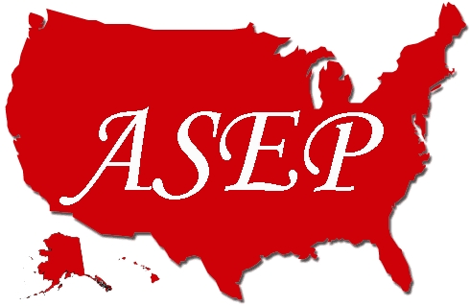

JEPonline
Editor-in-Chief
Tommy Boone, PhD, MBA
Review Board
Todd Astorino, PhD
Julien Baker, PhD
Steve Brock, PhD
Lance Dalleck, PhD
Eric Goulet, PhD
Robert Gotshall, PhD
Alexander Hutchison, PhD
M. Knight-Maloney, PhD
Len Kravitz, PhD
James Laskin, PhD
Yit Aun Lim, PhD
Lonnie Lowery, PhD
Derek Marks, PhD
Cristine Mermier, PhD
Robert Robergs, PhD
Chantal Vella, PhD
Dale Wagner, PhD
Frank Wyatt, PhD
Ben Zhou, PhD

Official Research Journal of the American Society of Exercise Physiologists

ISSN 1097-9751

Official Research Journal of the American Society of Exercise Physiologists

ISSN 1097-9751

Effect of Obesity and Passive Smoking on Biochemical
and Histopathological Changes in Rat Liver and the Protective Effect of Exercise

Noha I. Hussien, Abeer A. Shoman

Department of Physiology, Faculty of Medicine, Benha University,
Egypt

ABSTRACT

Hussien NI, Shoman AA. Effect of obesity and passive smoking on biochemical and histopathological changes in rat Liver and the protective effect of exercise. JEPonline 2013;16(4):101-111. Obesity has various effects on hepatic function. There is little information available for effects of exercise on biochemical and histopathological changes in the liver of obese rats. In addition the prevalence of cigarette smoking (CS) is increased among obese subjects, who are susceptible to develop fatty liver disease. The purpose of this study was to determine the effect of exercise and passive smoking on body mass index, serum lipid profile (LDL and HDL cholesterol), blood glucose, aspartate aminotransferase (AST), alanine aminotransferase (ALT), albumin level and liver histology in rats fed high-sucrose diet. The rats were classified into 5 main groups: Group I, Control Group; Group II, High Sucrose Untrained Group Not Exposed to Passive Smoking; Group III, High Sucrose Trained Group; Group IV, High Sucrose Group Exposed to Passive Smoking; Group V, High Sucrose Trained Group Exposed to Passive Smoking. The findings from this study indicate that obesity induced by high sucrose diet caused significant increase in body mass index, serum triglycerides, total cholesterol, LDL−C, blood glucose, AST, and ALT as well as a significant decrease in albumin and serum HDL−C with significant changes in liver histology. All these effects were counteracted by exercise and were ameliorated by smoking. Preventing and treating obesity will be a key measure in preventing and controlling this epidemic of fatty liver disease.

Key Words: Obesity - Passive Smoking- Exercise –Liver enzymes.

INTRODUCTION

Obesity is one of the major causes of fatty liver disease (FLD). Visceral adipose tissue secretes free fatty acids (FFAs) and hormones (adipokines) that appear to play a major role in the development of nonalcoholic fatty liver disease (NAFLD). Toxic FFAs can activate the intrinsic apoptosis pathway in hepatocytes in a process known as ‘lipoapoptosis’. In addition, reduced adiponectin levels commonly associated with obesity may establish a proinflammatory factor, thus increasing vulnerability to lipotoxicity, which promotes progression from simple steatosis (i.e., the accumulation of triglyceride inside hepatocytes) to nonalcoholic steatohepatitis (NASH) and even advanced hepatic fibrosis (22).

Nonalcoholic fatty liver disease covers a spectrum of liver disease ranging from simple hepatic steatosis to NASH (necrosis and inflammation), with some people ultimately progressing to liver cirrhosis and failure. The prevalence of NAFLD is high, especially since it is linked to obesity, diabetes mellitus, and hypertriglyceridemia (5).

While the pathogenesis of NAFLD has not yet been clearly defined, adipose tissue dysfunction, characterized by insulin resistance and disturbed adipokine production, is considered to be the central mechanism involved in the development of steatosis (20). Fat accumulation in the liver results from an imbalance among the uptake, synthesis, export, and oxidation of fatty acids (21).

Hepatic steatosis occurs when the rate of import or synthesis of fatty acids by hepatocytes exceeds the rate of export or catabolism. Accordingly, the following 4 mechanisms are possible causes of lipid accumulation within the liver: (a) increased delivery and uptake into hepatocytes of long-chain fatty acids (LCFA) due to excess dietary intake or release from adipose tissue; (b) increased de novo hepatic LCFA and triglyceride synthesis; (c) failure of very low-density lipoprotein (VLDL) synthesis and triglyceride export; and (d) failure of LCFA elimination due to impaired hepatic mitochondrial β-oxidation (19).

Exercise has a positive impact on the risk factors for NAFLD including obesity, metabolic syndrome, dyslipidemia, insulin resistance, and type II diabetes. Exercise helps patients achieve weight loss and also improves blood sugar control and improves muscular insulin sensitivity. Speciﬁcally, aerobic exercise prevents the development of steatosis independently of weight loss. Researchers assume that these results are achieved by increasing insulin sensitivity through a reduction of peripheral lipolysis, inhibition of lipid synthesis, and stimulation of fatty acid oxidation (1).

Smoking has been shown to increase the degree of oxidative stress and hepatocellular apoptosis in obese rats, but not in controls. Similarly, smoking has been shown to increase the hepatic expression of tissue inhibitor of metalloproteinase-1 and procollagen-alpha2 (I) in obese rats, but not in controls (13).

Materials and Methods
The present study was conducted on 40 adult male albino rats, 60 days of age, weighing approximately 225 g, in 8 /cage. The animals were kept at ordinary room temperature with a standard and modified diet and free access to water.

Composition of the Diets Used
Standard Chow Diet: In this type of diet, the fat represented 3.73% of the total caloric requirement. The carbohydrates represented 43.88% carbohydrate (40.75% starch and 3.13% sucrose) of the total caloric requirement. The protein represented 23.54% of the total caloric requirement. The fibers represent 13.85% of the total caloric requirement (9).

High Sucrose Diet: In this type of diet, the fat represented 6.40% of the total caloric requirement. Carbohydrates represented 49.85% (4.5% starch and 47.35% sucrose) of the total caloric requirement. The protein represented 23.60% of the total caloric requirement. The fibers represent 9.15% of the total caloric requirement. The high-sucrose diet was obtained mixing 600 g sucrose and 60 g of soy oil to 1000 g of a previously triturated standard chow. Casein was added to achieve the same protein content as the standard chow (23).

Experimental Groups
The rats included in this study were classified into 5 groups:

- Group 1. Control Group: Consisted of 8 rats that served as the Control Group. The rats received a standard diet in which sucrose represents 3% of the total caloric requirement for 5 wks and kept sedentary (untrained) until the end of the experiment.
- Group 2. High Sucrose Untrained Group Not Exposed to Passive Smoking (HSU): Consisted of 8 rats that received 47.35% sucrose in diet for 5 wks and kept sedentary (untrained) until the end of the experiment.
- Group 3. High Sucrose Untrained Group Exposed to Passive Smoking (HSS): Consisted of 8 rats that received 47.35% sucrose in diet for 5 wks and exposed to 6 cigarettes·d⁻¹, 5 d·wk⁻¹ for the last 4 wks.
- Group 4. High Sucrose Trained Group (HST): Consisted of 8 rats that received 47.35% sucrose in diet for 5 weeks and was submitted for exercise for 1 hr·d⁻¹, 5 d·wk⁻¹ for the last 4 wks before taking samples.
- Group 5. High Sucrose Trained Group Exposed to Passive Smoking (HSTS): Consisted of 8 rats that received 47.35% sucrose in diet for 5 wks and was submitted for exercise for 1 hr·d⁻¹, 5 d·wk⁻¹ for the last 4 wks and exposed to 6 cigarettes·d⁻¹, 5 d·wk⁻¹ for the last 4 wks before taking samples.

Adaptation to the Water
Sedentary and trained groups were first allowed to adapt to the water tank. The adaptation was performed for 15 uninterrupted days in the same tank in which the exercise training was performed, with water temperature maintained at 31 ± 1°C. The purpose of the adaptation was to reduce the stress of the animals without promoting the physiological changes that might arise from the physical training. The rats were initially placed in shallow water for 15 min during three consecutive days. The water level and the water exposure time were subsequently increased. On the 4th day, the rats swam in deep water for 2 min, and swam for an additional 2 min each day until the 10th day of adaptation. On the 11th day, the animals were submitted to swimming exercise for 5 min, with increases of 5 min every day. On the 15th day, the adaptation was concluded (10).

Physical Training
The trained animals were submitted to swimming exercise in Circular tanks 80 cm in diameter and 90 cm in height were filled to 60 cm water at 31 ± 1°C, 1 h·d⁻¹, 5 d·wk⁻¹ for 4 wks (2).

Assessment of Obesity
After 5 wks of dietary treatments, the animals were anaesthetized (0.1 ml intra peritoneal of 1% Thiopental Na) for the measurement of body length (nose-to-anus or nose-anal length). The body weight and body length were used to confirm the obesity through the obesity parameters body mass index (body weight / length, g·cm⁻²).

Exposure to Passive Smoking
Nine rats were divided into 3 groups the 1st group was exposed to 2 cigarettes·d⁻¹, the 2nd group was exposed to 4 cigarettes·d⁻¹ and the 3rd group was exposed to 6 cigarettes·d⁻¹. All groups were exposed to passive smoking for 5 d·wk⁻¹ for 4 wks. At the end of the duration all rats were examined for serum AST, ALT, and albumin. The most effective dose was 6 cigarettes·d⁻¹ (since all the rats in the 3rd group have the highest levels of AST, ALT, and the lowest level of albumin).

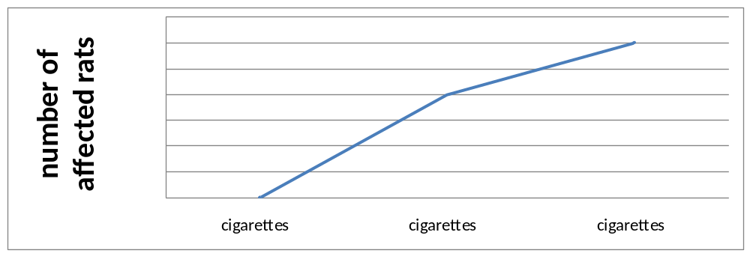

At the end of the experiments, the rats were left overnight to fast, then, they were anesthetized with diethyl ether. Blood samples were collected by intracardiac suction for serum separation, for the determination of the activity of hepatic transaminases AST and ALT, glucose, triglyceride, total cholesterol, LDL, HDL, and albumin.

Pathological Evaluation
A histological study was performed following a midline laparotomy to remove the liver. The liver was dissected and fixed in 10% formalin solution at room temperature. An experienced pathologist evaluated all samples. All fields in each section were examined and graded for necro-inflammation. The hepatic injury/inflammation was graded from 0 to 3; score 0 = no hepatocyte injury/inflammation, score 1 (mild) = sparse or mild hepatocyte injury/ inflammation, score 2 (moderate) = noticeable hepatocyte injury/inflammation, score 3 (severe) = severe hepatocyte injury/inflammation. The hepatocyte congestion/edema was graded from 0 to 3; score 0 = no congestion/edema hepatocyte, score 1 (mild) = mild congestion/edema hepatocyte, score 2 (moderate) = noticeable congestion/edema hepatocyte, score 3 (severe) = marked congestion/edema hepatocyte (4) (refer to Table 2).

Statistical Analysis
All data were expressed as mean ± SD following analysis by a one way analysis of variance (ANOVA). The calculations were performed by SPSS program version 17. Difference between groups were compared by Student's t-test with P<0.05 selected as the level of statistical significance.

RESULTS
Blood Biochemical Parameters
Levels of Serum glucose, ALT, AST, albumin, and lipid profile (triglycerides, total cholesterol, HDL−C, and LDL−C), and body weight index (BWI) were measured in all groups are shown in Table 1. The serum level of glucose, ALT, AST, triglycerides, total cholesterol, and LDL−C and the body weight index were significantly increased in the High Sucrose Untrained Group in comparison to the Control Group. Serum albumin and HDL were significantly decreased in comparison to Control Group. The serum level of glucose, ALT, AST, triglycerides, total cholesterol, and LDL−C were significantly decreased. Serum albumin and HDL were significantly increased in the High Sucrose Trained Group (HST) in comparison to the High Sucrose Untrained Group (HSU). The High Sucrose Group Exposed to Smoking (HSS) showed significant increase in serum level of glucose, ALT, AST, triglycerides, total cholesterol, LDL−C and the body mass index in comparison to the High Sucrose Untrained Group Not Exposed to Smoking (HSU) while serum albumin and HDL were significantly decreased. The serum level of glucose, ALT, AST, triglycerides, total cholesterol and LDL−C were significantly decreased in the High Sucrose Trained Group exposed to smoking (HSTS) in comparison to High Sucrose Group Exposed to Smoking (HSS), while serum albumin and HDL were significantly increased.

Table 1. Serum Glucose(mg·dl⁻¹), ALT(u/l), AST(u/l), albumin (mg·dl⁻¹), and lipid profile (triglycerides, total cholesterol, and HDL−C and LDL−C, mg·dl⁻¹) and Body Weight Index (g·cm⁻²). Results are expressed as the Mean ± SE (n = 8). High Sucrose Untrained Group Not Exposed to Smoking = HSU, High Sucrose Trained Group = HST, High Sucrose Group Exposed to Smoking = HSS, High Sucrose Trained Group Exposed to Smoking = HSTS.

Control HSU HST HSS HSTS
Group Group Group Group Group
Glucose (mg·dl⁻¹) 101 ± 1.55 150 ± 1.63* 109 ± 2.23# 174 ± 0.801$ 149.5 ± 1.35@

HDL (mg·dl⁻¹) 55 +1.34 36 ± 1.69* 57 ± 1.527# 22.8 ± 0.73$ 30.8 ± 0.67@

LDL (mg·dl⁻¹) 17 ± 1.69 40 ± 1.63* 19 ± 1.397# 65 ± 0.76$ 51 ± 0.79@

Trigylc. (mg·dl⁻¹) 85 ± 2.54 126 ± 1.75* 93 ± 2.02# 145.8 ± 0.96$ 123 ± 1.38@

T. choles. (mg·dl⁻¹) 90 ± 1.59 108 ± 1.90* 96 ± 0.98# 132 ± 1.34 $ 119.6 ± 0.8@

AST (u/l) 139.25 ± 1.36 250.38 ± 1.55* 204.38 ± 5.07# 280.88 ± 2.16$ 249 ± 1.3@

ALT (u/l) 41.75 ± 1.22 76.25 ± 0.79 * 61 ± 0.67# 98.88 ± 1.43$ 80.63 ± 1.18@

Albumin (gm·dl⁻¹) 3.98 ± 0.09 2.8 ± 0.12* 3.88 ± 0.075# 2.16 ± 0.09& 2.75 ± 0.13**

BWI (g·cm⁻²) 0.527 ± 0.030 0.818 ± 0.05* 0.545 ± 0.03# 0.87 ± 0.013$ 0.61 ± 0.015@

*Significant difference (P<0.001) compared with Control Group.
#Significant difference (P<0.001) compared with High Sucrose Untrained Group Not Exposed to Smoking.
@Significant difference (P<0.001) compared with High Sucrose Group Exposed to Smoking.
$Significant difference (P<0.001) compared with High Sucrose Untrained Group Not Exposed to Smoking.
&Significant difference (P<0.05) compared with High Sucrose Untrained Group Not Exposed to Smoking.
**Significant difference (P<0.01) compared with High Sucrose Group Exposed to Smoking.

Table 2. Effects of Exercise and Smoking on Liver Histopathology (scores of congestion, edema, and necroinflammation). High Sucrose Untrained Group Not Exposed to Smoking = HSU, High Sucrose Trained Group = HST, High Sucrose Group Exposed to Smoking = HSS, and the High Sucrose Trained Group and Exposed to Smoking = HSTS.
Group Number Level of Congestion and Edema Level of Necroinflammation

0 1 2 3 0 1 2 3
Control 8 8 - - - 8 - - -
HSU 8 - 1 5 2 - 2 6 -
HST 8 3 5 - - 4 4 - -
HSS 8 - - 2 6 - - 4 4
HSTS 8 - 2 4 2 - 3 5 -
The severity of congestion and edema is graded as follows: 0 = No congestion and edema, 1 = mild
Congestion and edema, 2 = moderate congestion and edema, 3 = severe congestion and edema.
The severity of necroinflammation was graded as follows. 0 = no hepatocyte injury/inflammation,
1 = sparse or mild hepatocyte injury/inflammation, 2 = noticeable hepatocyte injury/inflammation,
3 = severe hepatocyte injury/inflammation.

Histopathological Examination
The histological appearance of the liver in the control group was normal as in Figure (1). The group that received high Sucrose diet untrained and not exposed to passive smoking revealed liver congestion, hydropic degeneration and inflammation as shown in Figure (2-a) also this group showed sever necrosis as shown in Figure (2-b) and showed necroinflamatory focus as in Figure (2-c). The High Sucrose Trained Group showed improvement of congestion, edema and necroinflammation as shown in Figure (3). High Sucrose Group Exposed to Smoking showed hyaline degeneration, congestion and focal sclerosis as shown in Figure (4). Combination of exercise and smoking showed less improvement as shown in Figure (5).

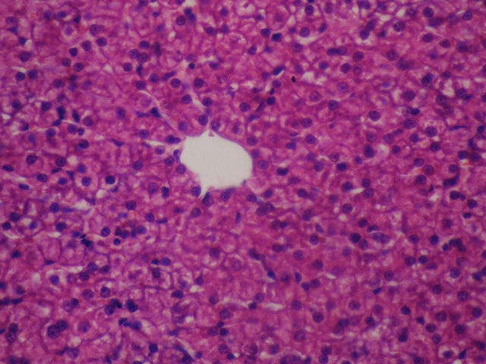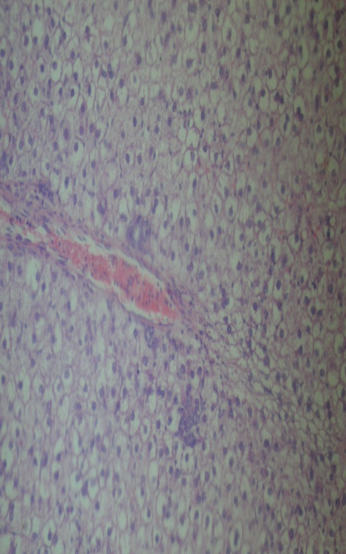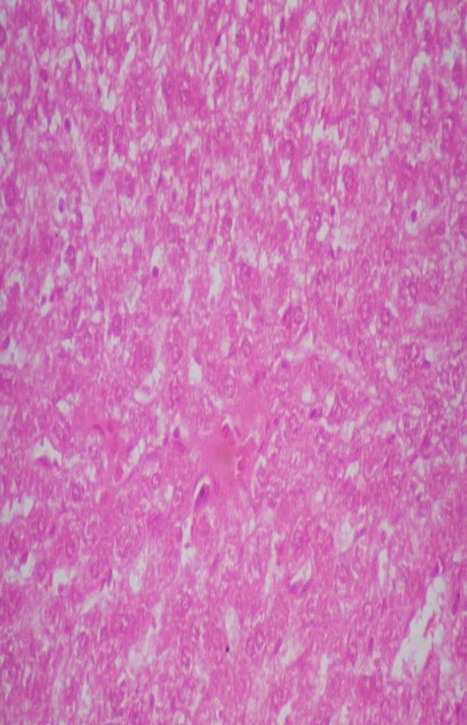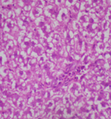

Figure (1). x 40 Figure (2-a). x 20 Figure (2-b). x 40 Figure (2-c). x 40

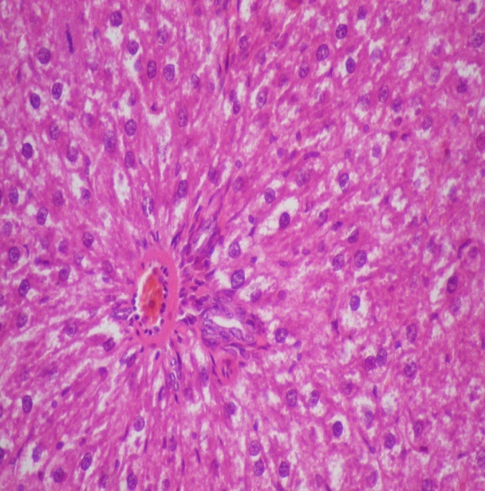 | 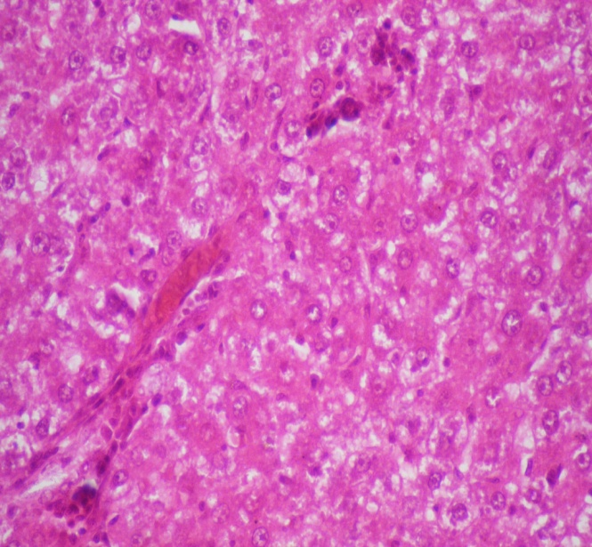 | 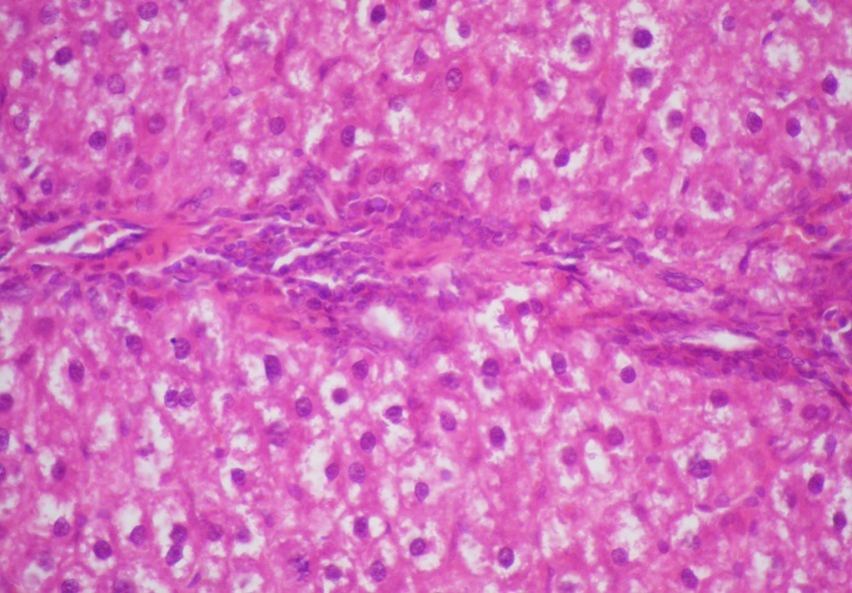
Figure (3). x 40 Figure (4). x 40 Figure (5). x 40

DISCUSSION

The increase in sucrose consumption as well as the decrease in physical activity has been identified as the main factors contributing to obesity and overweight individuals in many countries around the world. In addition, cigarette smoking is a preventable predisposing factor to many clinical conditions. It is associated with increased risk of cardiovascular and metabolic diseases such as alteration in the levels of plasma lipoproteins and accumulation of lipids in the liver (25).

This study was conducted to evaluate the effect of exercise on liver steatosis in obese rats as well as the effects of smoking as a risk factor on liver steatosis in obese rats. Our study revealed that the consumption of a high sucrose diet leads to an increase in body weight index of rats, serum levels of glucose, ALT, AST, triglycerides, total cholesterol and LDL−C with decrease in serum levels of HDL−C and albumin.

These results were in agreement with Koteish and Diehl (12). They reported that feeding rats a diet high in fat or sucrose leads to obesity, diabetes mellitus, and dyslipidemia. In addition, Bruce and colleagues (3) indicated that high dietary sucrose concentrations are responsible for the development of hepatic steatosis. Both the frequency and the severity of the steatosis were increased with higher concentrations of dietary sucrose.

Nagata et al. (15) reported that adult male Sprague-Dawley rats fed a sucrose-rich diet (70% sucrose) for 2 to 3 wk developed fatty livers and became obese. They suggested that fructose, not glucose, is the primary cause of hepatic changes after chronic ingestion of a high-sucrose diet. Diets enriched with a comparable amount of glucose instead of sucrose or fructose did not produce any overt hepatic abnormality. This finding may be mainly attributable to the unique metabolic properties of fructose, that is, its rapid uptake by the liver and its entry into the glycolysis pathway after bypassing the phosphofructokinase regulatory step. Stanhope and colleagues (18) found that dietary fructose, but not glucose increased de novo lipogenesis and promoted dyslipidemia, decreased insulin sensitivity, and increased visceral adiposity in overweight and obese adults.

Visceral adipose tissue secretes free fatty acids (FFAs) and hormones (adipokines) that appear to play a major role in the development of NAFLD. Toxic FFAs can activate the intrinsic apoptosis pathway in hepatocytes via a process known as ‘lipoapoptosis’. Not surprisingly, apoptotic cell death is a prominent feature in the progression of NAFLD to nonalcoholic steatohepatitis (NASH). In addition, reduced adiponectin levels commonly associated with obesity may establish a proinflammatory milieu that increases vulnerability to lipotoxicity, which promotes progression from simple steatosis to NASH and even advanced hepatic fibrosis (22).

The liver plays a role in the physiology of exercise. Our study showed that exercise leads to significant decrease in the body weight index of rats. Exercise also lead to a significant decrease in the serum levels of glucose, ALT, AST, triglycerides, total cholesterol, and LDL−C and a significant increase in serum levels of HDL−C and albumin. These findings are in agreement with Praphatsorna et al. (17). They revealed that exercise has various effects on liver function, enhancing both nutrient metabolism and antioxidant capacity. Physical exercise increases the blood flow in working skeletal muscles while it decreases blood flow in the liver. Exercise has a positive impact on the risk factors for nonalcoholic fatty liver disease.

Aerobic exercise prevents the development of steatosis independently of weight loss. Stewart and colleagues (19) assume that these results are achieved by increasing insulin sensitivity through a reduction of peripheral lipolysis, inhibition of lipid synthesis, and stimulation of fatty acid oxidation. In agreement, Mota et al. (14) suggested that chronic exercise is an important tool in the prevention and treatment of hepatic steatosis, insulin resistance and the regulation of circulating lipids. The main effect of physical exercise on the hepatocyte is the increase in lipid oxidation, which reduces the levels of TG stored.

Exercise results in an increase in insulin sensitivity and in insulin-like growth factor (IGF-1) that are potent activators of liver regeneration and anabolism. Eriksen and colleagues (7) indicated that physical exercise is a powerful weapon in combating insulin resistance, given that both late- and early-exercise protocols had beneficial effects on insulin sensitivity in fructose-fed rats. In fact, physical training improves insulin sensitivity in healthy subjects, in obese non-diabetics and in diabetic patients (type 1 and 2).

Our study revealed that histological appearance of the liver in the group that received high sucrose diet untrained and not exposed to smoking revealed liver congestion, edema and necroinflammation. The High Sucrose Trained Group showed improvement of congestion, edema and necroinflammation as shown in Table 2 and Figures 1 to 4. These results are in agreement with Kahn et al. (11) who reported that the section of the liver obtained from the high sucrose treated group had disrupted histological organization compared with the control group. Some of the deleterious effects seen in the section of the liver obtained from the high sucrose treated group included degeneration and disruption of the hepatocytes, degeneration of the cells lining the bile ducts, and occlusion of the central portal vein.

With these histological abnormalities, the anatomical, physiological, and biochemical functions of the liver could be compromised. Padmavathi and colleagues (16) reported an increase in the activities of ALT and AST, which are used as indicators of hepatocellular injuries. Necrosis, toxic and ischemic injuries of the liver cells result in the leakage of these enzymes into the blood circulation. Interestingly, the findings from the present study revealed that a combination of high sucrose diet and smoking resulted not only in a significant increase in ALT and AST, but also serum level of glucose, triglycerides, total cholesterol, LDL−C, and the body weight index in comparison to the High Sucrose Untrained Group not exposed to smoking (while serum albumin and HDL were significantly decreased).

These results are in agreement with Yuan and colleagues (26) who reported that long-term exposure to cigarette smoke caused permanent inflammation and an imbalance in lipid profile. This combination of factors stimulates the accumulation of lipid in the liver cells (hepatocytes), which leads to the development of non-alcoholic fatty liver disease. Fatty degeneration is one of the most common pathological changes in the liver due in most cases to excessive intake of alcohol. However, non-alcoholic fatty liver disease has been recognized and cigarette smoking is a risk factor (24).

While smoking increased alanine aminotransferase serum levels and the degree of liver injury in the obese rats, it only induced minor changes in the control rats. Importantly, smoking increased the histological severity of NAFLD in the obese rats. Smoking increased the degree of oxidative stress and hepatocellular apoptosis in the obese rats, but not in the controls. Similarly, Gabriel et al. (8) indicated that smoking increased the hepatic expression of tissue inhibitor of metalloproteinase-1 and procollagen-alpha2 (I) in obese rats, but not in the controls.

Damasceno et al. (6) reported that cigarette smoke exposure exacerbated the genotoxicity, negatively impacted the biochemical profile and antioxidant defenses, and caused early glucose intolerance. Thus, the changes caused by cigarette smoke exposure can trigger an earlier onset of metabolic disorders associated with obesity, such as diabetes and metabolic syndrome (6). The High Sucrose Group exposed to smoking showed hyaline degeneration, congestion, and focal sclerosis. Combination of exercise and smoking showed less improvement as shown in Table 2 and Figures 1−4.

These results are in agreement with Gabriel et al. (25) as they showed that Photomicrograph of the liver of animals exposed to cigarette smoke with degenerative changes and hypochromic staining, constricted central vein, and hepatocytes with smaller sized nuclei and nuclear spaces Although the enhancement of lipid peroxidation is part of the mechanism responsible for the tissue damage seen in non-alcoholic fatty liver disease, this study helped to establish the process of necrosis and fibrosis as part of the mechanisms underlying liver injuries following exposure to cigarette smoke.

CONCLUSION

From this study, we can conclude that obesity induced by a high sucrose diet caused a significant increase in body weight index, serum triglycerides, total cholesterol, LDL−C, blood glucose, AST and ALT as well as significant decrease in albumin and serum HDL−C with significant changes in liver histology. All these effects were counteracted by physical exercise and were ameliorated by passive smoking. Preventing and treating obesity will be a key measure in preventing and controlling this epidemic of fatty liver disease.

ACKNOWLEDGMENTS
Authors are deeply grateful to the Department of Pathology in the Faculty of Medicine, Benha University.

Address for correspondence: Noha I. Hussien, PhD. Department of Physiology, Faculty of Medicine, Benha University, Egypt, Phone: 01289845991; Email: drnohaibrahim79@gmail.com

REFERENCES

- Anstee QM and Goldin RD. Mouse models in non-alcoholic fatty liver disease and steatohepatitis research. Int. J. Exp. Pathol. 2006;87:1-16.

- Botezelli JD, Mora RF, Dalia RA, Moura LP, Cambri LT, Ghezzi AC, Voltarelli FA, Mello MAR. Exercise counteracts fatty liver disease in rats fed on fructose-rich diet. Lip. in Heal. and Dise. 2010;9:116.

- Bruce RB, Park CH, Elvin MF, Christine EM. Hepatic steatosis in rats fed diets with varying concentrations of sucrose. Toxicol. 2009;4(5):819-826.

- Brunt EM, Janney CG, Di Bisceglie AM. Neuschwander-Tetri BA, Bacon BR. Nonalcoholic steatohepatitis: A proposal for grading and staging the histological lessions. Am J Gastroenterol. 1999;94:2467-2474.

- Choudhury J, Sanyal AJ. Insulin resistance and the pathogenesis of nonalcoholic fatty liver disease. Clin Liver Dis. 2004;8:575-894.

- Damasceno DC, Sinzato YK, Bueno A, Dallaqua B, et al. Metabolic profile and genotoxicity in obese rats exposed to cigarette smoke. The Obes. Soc. 2012; Nov 6. doi: 10.1002/oby.20152.

- Eriksen L, Dahl-Petersen I, Haugaard SB, Dela F. Comparison of the effect of multiple short duration with single long-duration exercise sessions on glucose homeostasis in type 2 diabetes mellitus. Diabet. 2007;50:2245-2253.

- Gabriel O O, Bernard U E, Oluwole B A, et al. Lipid Profile and Liver Histochemistry in Animal Models Exposed to Cigarette Smoke. J of Bas. & Appl. Sci. 2012;8:12-17.

- Gisele A, Souza Ebaid, Fábio Seiva, Katiucha HR, Rocha et al. N-acetylcysteine an allium plant compound improves high-sucrose diet-induced obesity and related effects. Ecam/nen070. 2011;10:1093-1100.

- Gobatto CA, Mello MA, Sibuya CY, Azevedo JR, Kokubun E. Maximum lactate steady state in rats submitted to swimming exercise. Comp. Bioch.Phy. 2001;130:21-27.

- Kahn R, Buse J, Ferrannini E, Stern M. The metabolic syndrome: time for a critical appraisal. Diab. Care. 2005;48(Suppl 9):1679-1683.

- Koteish A, Diehl AM. Animal models of steatosis. Semin Liver Dis. 2001;21:89-104.

- Lorenzo A, Elisabet F, Leandra NR, et al. Cigarette smoking exacerbates nonalcoholic fatty liver disease in obese rats. Hepat. J. 2010;51(5):1567-1576.

- Mota CSA, Ribeiro C, Araújo GG, Araújo MB, Manchado FB, Voltarelli FA, Oliveira CAM, Luciano E, Mello MAR. Exercise training in the aerobic/ anaerobic metabolism transition prevents glucose intolerance in alloxan treated rats. BMC Endocrine Disorders. 2008;8:11. doi:10.1186/1472-6823-8-11.

- Nagata R, Nishio Y, Sekine O, Nagai Y, Maeno Y, Ugi S, Maegawa H, Kashiwagi A. Single nucleotide polymorphism (-468 Gly to Ala) at the promoter region of sterol regulatory element-binding protein-1c associates with genetic defect of fructose-induced hepatic lipogenesis. J Biol Chem. 2004;279:29031-29042.

- Padmavathi P, Reddy VD, Varadacharyulu N. Influence of chronic cigarette smoking on serum biochemical profile in male human volunteers. J Health Sci. 2009;55:265-270.

- Praphatsorna P, Thong-Ngama D, Kulaputanaa O, Klaikeawb N. Effects of intense exercise on biochemical and histological changes in rat liver and pancreas. Asian Biomed. 2010;4(4):619-625.

- Stanhope KL, Schwarz JM, Keim NL, Griffen SC, Bremer AA, Graham JL, Hatcher B, Cox CL, Dyachenko A, Zhang W, McGahan JP, Siebert A, Krauss RM, et al. Consuming fructose-sweetened, not glucose-sweetened, beverages increases visceral adiposity and lipids and decreases insulin sensitivity in overweight/obese humans. J Clin Invest. 2009;Doi:10.1172/JCI37385.

- Stewart KJ, Bacher AC, Turner K, et al. Exercise and risk factors associated with metabolic syndrome in older adults. Am J Prev Med. 2005;28:9-18.

- Tilg H, Hotamisligil GS. Nonalcoholic fatty liver disease: Cytokine-adipokine interplay and regulation of insulin resistance. Gast. 2006;131:934-945.

- Tuncman G, Hirosumi J, Solinas G, Chang L, Karin M, Hotamisligil GS. Functional in vivo interactions between JNK1 and JNK2 isoforms in obesity and insulin resistance. Proc Natl Acad Sci USA. 2006;103:10741-10746.

- Wree A, Kahraman A, Gerken G, Canbay A. Obesity affects the liver: The link between adipocytes and hepatocytes. Dig. 2010;83(1-2):124-133.

- Yoshihisa Takahashi, Yurie Soejima, Toshio Fukusato. Animal models of nonalcoholic fatty liver disease/ nonalcoholic steatohepatitis. World J Gastroenterol. 2012;18(19): 2300-2308.

- Yuan H, Shyy JY, Martins-Green M. Second-hand smoke stimulates lipid accumulation in the liver by modulating AMPK and SREBP-1. J Hepatol. 2009;51:535-547.

- Yuan H, Shyy JY, Martins-Green M. Second-hand smoke: stimulates lipid accumulation in the liver by modulating AMPK and SREBP-1. J Hepatol. 2009;51:535-547.

- Yuan H, Wong LS, Bhattacharya M, Ma C, Zafarani M, Yao M, et al. The effects of second-hand smoke on biological processes important in atherogenesis. BMC Cardiovas. Dis. 2007;7:1.

Disclaimer
The opinions expressed in JEPonline are those of the authors and are not attributable to JEPonline, the editorial staff or the ASEP organization.

