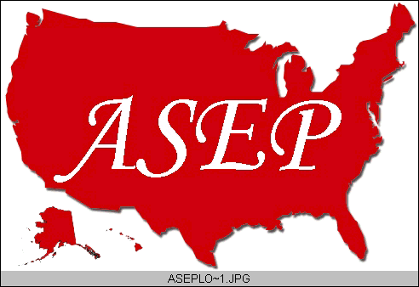ASEPNewsletter
ISSN 1097-9743

September 2015
Vol 19 No 9

Dr. Frank Wyatt, EPC
Editor, ASEPNewsletter
Board Certified Exercise Physiologist
Professor of Exercise Physiology
Department of Athletics and Exercise Physiology
Midwestern State University
Wichita Falls, TX 76308

In The Beginning…
In the beginning there were places of higher education. Actually, the beginning probably began long before institutions of higher education were established but for the sake of this newsletter, placate me. Within these institutions of education, curiosity pertaining to the human body was enhanced. Differences were noticed between gender, age, occupations and eventually, systems within this body. We further investigated the mechanisms of these systems (i.e., muscular, skeletal, myocardial, pulmonary, etc.) until we had the measuring devices to look beyond their mechanistic operations and see how they operated on a cellular and molecular level. And thus was born…human physiology. Noticing that movement (i.e., work/exercise) altered that physiology, we delved deeper into the human physiological reactions to this work. And we named it, “Exercise Physiology”. And it was good. I am sure you will agree that it probably happened exactly like that.
It is a new academic year at these institutions of higher education. We, those of us that work in academia, begin again to work toward educating the masses in our respective fields. In our ASEP accredited program at Midwestern State University (of course this is a sales pitch), we require our students to take two anatomy & physiology classes before entering “Exercise Physiology”. What’s the use of knowing “how something works” if you don’t know “where” it is working? So we have an established hierarchy of classes within our major that eventually lead to other classes that eventually lead to a degree…and then our students know it all. Not quite how it works.
It has occurred to me that this institutional system, while very effective, has room for improvement. I believe this is true of most things. My Dad used to say, “If you can’t improve on the breed, you might as well quit trying”. Funny guy, my Dad, and smart too. In the realm of academia, there is always room for improvement in the classes we offer and the sequence in which we offer them. Not to mention improvement in our (i.e., faculty) knowledge base and in our laboratory experiences offered to the students. It is from accreditation processes that programs, departments, colleges and universities strive to maintain a high level of education. We seek these accreditations from professional organizations within the field to help us improve the program (any program) ultimately for our students.
The American Society of Exercise Physiologists is a professional organization that offers such an accreditation, specifically for Exercise Physiology programs. Through the ASEP accreditation process, Midwestern State University (MSU) was scrutinized by the ASEP Board of Directors. From that review, recommendations were made that would allow the MSU program to be of a high standard for the education of future professionals in Exercise Physiology. It is an interesting process to say the least. And the recommendations are a full array of considerations pertaining to the curriculum, to the sequencing of classes, to the number and expertise of the faculty to laboratory equipment. It is extensive, which is the nature of the accreditation process. It is also a process that hopefully will eventually provide the students of that program the HIGHEST standard of education available to them. We, as educators in academia are not just obligated, but are mandated to seek out this type of education for our students. For this to happen, accreditation is essential to the process.
Now fast-forward with me to a recent observation I made pertaining to…professionalism: I belong to a “network” of professionals on LinkedIn. You have all probably heard of it and perhaps you belong to it. It seems to me it is a version of Facebook…for professionals. So I periodically get people that want to “connect” with me through LinkedIn. I have noticed (herein lies my recent observation) recently that certain individuals use the term “Accredited Exercise Physiologist” in the description of their professional title. Can I assume that these individuals have been through the educational process of obtaining a college degree in Exercise Physiology from an accredited program? Do I know the professional organization from which they (their university) received an accreditation? And more important to me: can all of the graduates from Midwestern State University put “Accredited Exercise Physiologist” after their name to indicate their professional status?
We all want to believe we have received a good education from the institutions we came from. Society recognizes the Ivy League universities as institutions of high quality. How did they reach that status? Having reached that status on some evaluation rubric, how come some really dumb decisions have come from people that graduated from those institutions? Does the work of these institutions facilitate graduates that continue to move their field of study forward and thus enhance the society with which we live?
I do not have the answers to the aforementioned questions. Yet at this time of year when new, young minds enter my classroom, I am overwhelmed with the responsibility of teaching them to the best of my ability. Are my efforts enough? I don’t know, but I hope so. I am aided in that hope by the fact that I have been scrutinized by my peers through the accreditation process, and have been told what I need to improve and what areas I am competent. I am secure in the knowledge that the ASEP Accreditation that was awarded to Midwestern State University facilitates the level and quality of education in Exercise Physiology my students receive. I am convinced that the accreditation process of ASEP for Exercise Physiology Programs enhances the level of professionals entering into the workplace. Most importantly, my students can graduate from our program with confidence in what they have been taught, and what they have experienced. My students will graduate as “Accredited Exercise Physiologists”. What about you, or your program. To discuss and debate this issue, join us in Oklahoma City for the Annual American Society of Exercise Physiologists Conference, October 16 and 17. I hope to see you there.

The Official Newsletter of the
American Society of Exercise Physiologists

