American Society of Exercise Physiologists

ASEPNewsletter
February 2020
ISSN 1097-9743
From the CEO  Dear ASEP Members  I am concerned that exercise physiologists do not understand the vital importance of exercise physiology professionalism and professional development of all exercise physiologists. It is a pleasure to share with you this book by Dr. Tommy Boone.  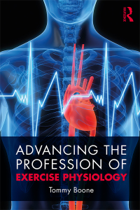 |  |  |  | Recent Inquiry  How is Kinesiology different from  Exercise Physiology?  Lisa  American Kinesiology Association (AKA) says Kinesiology is an academic discipline involving the study of physical activity and its impact on health, society, and quality of life that includes, but is not limited to such areas as exercise science, sports management, athletic training and sports medicine, socio-cultural analyses of sports, sport and exercise psychology, fitness leadership, physical education and teaching, pre-professional training for physical therapy, occupational therapy, medicine, and health related fields.  ASEP says Exercise Physiology is the delivery of treatment services concerned with the analysis, the improvement, and the maintenance of physiological mechanisms underlying physical and mental health and fitness through regular exercise, the prevention and/or treatment of chronic diseases and/or disabilities with exercise medicine, and the professional guidance of athletes and others interested in athletics and sports training.
ASEP is committed to every Exercise Physiologist.  The Exercise Physiologist’s Practice involves four areas:  (1) Promoting health and wellness;  (2) Preventing illness and disability;  (3) Restoring health; and  (4) Helping athletes reach their potential in sports training and performance.  God Isn’t Finished with ASEP  Tommy Boone, PhD, MPH, MAM, MBA, FASEP  (Note: Read the left column all across all pages, and then read the right column from one page to the next.)  I have been asked more than once, “Why do you persist with ASEP?” My answer is simple, “Because God isn’t finished with me.” It is my prayer that as you read this brief piece, you will allow the Holy Spirit to help you work on behalf of all exercise physiologists. Remember, with God’s help, there is always the power to keep going. The only way we can lose is to stop believing in the importance of professional development. So, why not get with ASEP and press on?  God created each of us for a purpose. I believe my purpose is to see that ASEP is recognized as the means to promoting the professional development of exercise physiologist. Or, otherwise everything that exercise physiologists  are presently doing will be taken over by other healthcare professionals. Hence, we cannot quit. Success is just around the corner. We must be committed to accomplishing the ASEP goals and objectives. We cannot give up. We must keep trying. We must continue to dream big and push forward to realize the ASEP vision.  Perseverance is the exercise physiologists’ means to changing the course of “What is exercise physiology?” and “Who are exercise physiologists?” Hence, be strong and do what you can to elevate exercise physiology to the healthcare professional status.  Professionalism and commitment are at the core of thinking about exercise physiology as a profession and not as a discipline. Hence, join ASEP and work on behalf of all exercise physiologists. Show your respect, courage, and expectations to stand on the ASEP shoulders of change.  Yes, among other responsibilities, ASEP exercise physiologists believe in the power of an idea that defines a new 21st century view of all exercise physiologists. In the end, “don’t let the ASEP vision die”. Those who still have hope of something better continue to hang on. They will never give up!  God is not finished with exercise physiologists who are willing to stay the course. Why not take a moment to evaluate your thoughts, gifts, talents, and strengths to understand God’s presence in you in professionalizing the profession of exercise physiology? There is still plenty of time to gain total control of exercise physiology, but we must stop being lazy and take ownership of our mistakes. Yes, there will be times in which we will be put on our knees, but the longer we hold on to the truth of exercise physiology, the more likely we will continue to execute the so-called impossible. So, dream big dreams, and reach for the moon to live your best professional life.  To all ASEP members, God wants each of us to come all the way to realize our dreams. Thus, our ASEP responsibility as agents of change is to stay the course, forgive those who have criticized and/or wronged us, and trust in the Lord to overcome the mess we are in. ASEP exercise physiologists are professionals with a purpose. They are healthcare professionals who make things happen. So, to all exercise physiologists, keep your mind open to the ASEP work to improve career opportunities.  Remember the saying, “As we think, so we are.” If we think we are exercise physiologists because we have an academic degree in exercise physiology or we passed the EPC exam, then we refer to ourselves as Exercise Physiologists. In short, as Benjamin Carson said, “We create our own destiny by the way we do things. We have to take advantage of opportunities and be responsible for our choices.” The important thing to remember is that we have to change our beliefs about what is possible for all exercise physiologists. We are (or should be) leaders in prescribing exercise medicine to prevent or treat chronic diseases. Hence, we must take responsibility for our professional development. ASEP leadership understands that responsibility is the key to success. Our professional footprint cannot be |  |  |  | The ASEP Book  When you are ready to study for the EPC exam (also known as the ASEP Board Certified Exercise Physiologist exam), you will need this book.  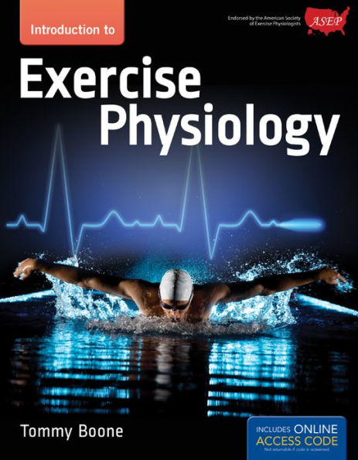  If you have questions regarding metabolism, cardiovascular system, anatomy, how muscles function, biomechanics, ECG, and much more, the answers are in this text. Plan to sit for the EPC and become an ASEP Board Certified Exercise Physiologists and earn also the 21st century title: “Exercise Physiologist Healthcare Professional”.  neutral on the necessity of the ASEP professional organization versus the claim that a generic organization is the appropriate exercise physiology organization to control our destiny.  The bottom line is that exercise physiologists must be decisive in their support of ASEP. It cannot be a matter of, “Well, I like being a member of the most popular organizations.” The choice is ours to share with others that exercise science is not exercise physiology. So, why not say good-bye to yesterday’s status quo? If we continue to avoid doing so, the problem is that we will continue to allow the past views of exercise physiology define us.  If that is the case, each of us will live a sad and discouraging lifestyle in which we are seldom ever recognized for who we actually are. The bottom line is that the more we look forward, the more we will be able to see the future. Therefore, why not be a forward-focused exercise physiology professional invested in the future of exercise physiology as a credible healthcare professional and stop supporting generic organizations?  The past is the past. We must start thinking of our future. But, honestly, if we continue to do nothing about promoting change and moving forward, our lack of initiative will only delay fulfilling our vision. This can’t be the future of exercise physiologists with such a major responsibility in helping adults and others with chronic diseases. We must be committed to effective goal setting, much of which is already defined by ASEP. After all, Winston Churchill said it best, “The price of greatness is responsibility.” We must be accountable for the  impact our work has on the public. By taking responsibility for something (e.g., professional development) more than the size of an organization, exercise physiologists tap into a collective vibrancy that is not only good for their patients and clients but also good for ASEP. In other words, we are the stewards of the ASEP organization, and we are the caretakers of the exercise physiology healthcare profession.  We become what we think, what we talk about, and what we do. If we think our work is for the right reason, if we think that our actions will bring forth positive results, and if we start living as professionals, we will become our vision.  What do you think? You may want to send an email to:  tbooneasep@gmail.com
The best way to predict the future is to create it.
– Peter Drucker

