 | 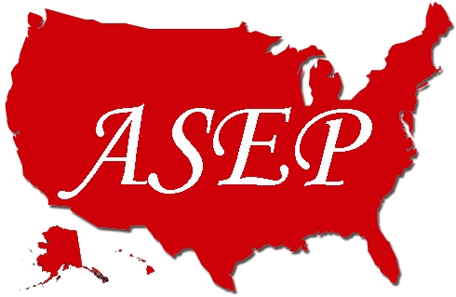 | American Society of Exercise Physiologists  ASEPNewsletter  December 2019  ISSN 1097-9743
National Conference  The 2019 ASEP Conference was hosted by Midwestern State University in Wichita Falls, Texas during October 11-12. The following three are examples of the abstracts presented and published  Streadwick A, Wyatt FB. The Relationship between Aerobic Capacity and Resting Heart Rate. JEPonline 2019;22(6):5. Word  Ayres PJ. Fighting Childhood Obesity in Rural Remote Alaska. JEPonline 2019;22(6):6. Word  Choi SM. How Dancing Can Help Iindividuals with Alzheimer’s Disease? Thinking Behind the Doing of Dance. JEPonline 2019;22(6):7-8. Word |  |  |  |  | Recent Inquiry  Dr. Boone, I heard one of my college teachers say to one of her students, “No, you cannot call yourself an exercise physiologists if you have a degree in exercise science. To be an exercise physiologist, you must have a degree in exercise physiology or have passed the ASEP EPC exam.”  Wait, here is an idea! “Why not mention to your Professors the following book?”  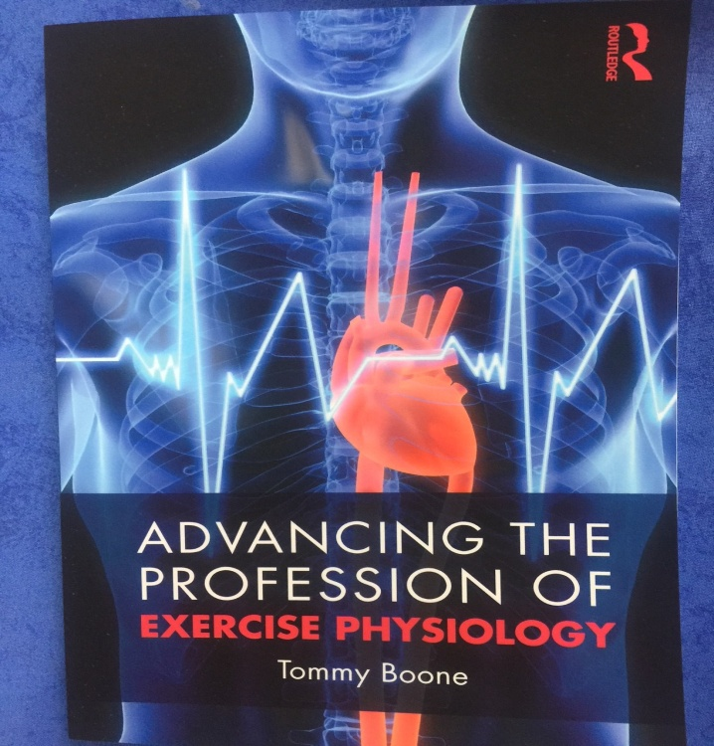
ASEP is working to help the American Students of Exercise Physiology.  Never Give Up On Your Dream  Published in JPEP in the December 2019 issue  The founding of the American Society of Exercise Physiologists is the road to freedom and opportunity. It is largely a reaction to failing for decades to encompass and/or understand the work of enlarging the students’ career opportunities and their capacity to know and to understand the necessity of applying exercise as medicine.  Also, without question, when other healthcare professionals learn this truth, it will free them to support ASEP. They will say that the ASEP Board Certified Exercise Physiologists are critical to helping with the prescription of exercise physiology as a healthcare medicine.  This is a very important point. If society fails to understand the role of a safely prescribed exercise program in redirecting how they live, then society will continue to be at risk of a significant increase in chronic diseases and disabilities.  Always remember that the work required to grow the professional of exercise physiology should not be with anxiety but with hope, expectancy, and conviction. It is simply what it is, and the process begins with the discovery that there are steps to solve a problem. |  |  |  |  |  | Thus, exercise physiologists must stop limiting their view of themselves based on their past experiences. The ASEP leadership can be heard saying more than once at our annual meetings that “It is not a question of ASEP failing or succeeding. It is simply a question of sticking to the ASEP goals and objectives until they become the reality of all exercise physiologists.”  Never give up your beliefs for they have power to change from what is to what should be. So, know what you want and stay the course by thinking what you wish to be.  Ernest Holmes, the author of The Science of Mind, said it this way: “We should also erase the thoughts of yesterday that would rob us of today’s happiness.” Equally important is that exercise physiologists must not fear the future and changes that must come about.  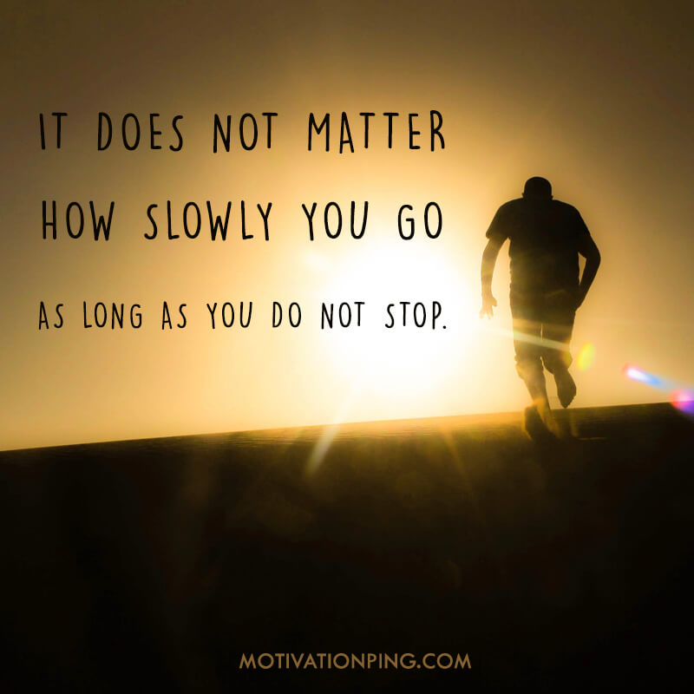
From the CEO  Dear ASEP Members:  Hello, I am concerned that the reader, students in particular, may not understand the importance of professionalism in exercise physiology. Recently, I had the pleasure to meet with several college students where I could share my personal feelings about ASEP. It was a pleasure to share the ASEP goals and to continue to realize and live the importance of the organization for its members and the profession itself.  Mr. Shane Paulson, MA, EPC, FASEP  ASEP Board Certified Exercise Physiologist  Nurturing A Dream  In the 2009 PEPonline (Vol 12 No 12), the following was published:  Exercise physiologists must hang in there. One way of doing so is to regroup, elevate their hopes, and expect opportunities and successes. As Matthew 6:34 says, “Do not worry about tomorrow, for tomorrow will worry about its own things.” That said, exercise physiologists must settle for nothing less than best. To do so, they must choose to follow the ASEP path. That is why exercise physiologists must nurture the ASEP dream by striking a blow that will deepen the instinctive commitment for self-preservation for all the right reasons.  What do you think? You may want to send an email to:  tbooneasep@gmail.com |  |  |  |  |  |  | The ASEP Book  When you are ready to study for the EPC exam (also known as the ASEP Board Certified Exercise Physiologist exam), you will need this book.  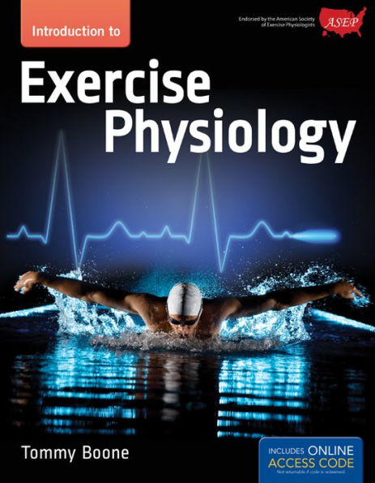  .  If you have questions regarding metabolism, cardiovascular system, anatomy, how muscles function, biomechanics, ECG, and much more, the answers are in this text. Plan to sit for the EPC and become an ASEP Board Certified Exercise Physiologists and earn also the 21st century title: “Exercise Physiologist Healthcare Professional”.

