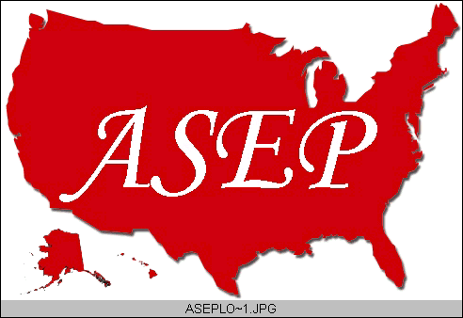ASEPNewsletter
ISSN 1097-9743

August 2015
Vol 19 No 8

Dr. Frank Wyatt, EPC
Editor, ASEPNewsletter
Board Certified Exercise Physiologist
Professor of Exercise Physiology
Department of Athletics and Exercise Physiology
Midwestern State University
Wichita Falls, TX 76308

Fitness Philosophy
Webster’s defines philosophy as: “critical study of fundamental beliefs; sum of personal convictions”. Do you have a “Fitness Philosophy”? As an Exercise Physiologist, I have a fitness philosophy. But what does that mean? Another question on this topic is: When does this philosophy come into play in my daily life?
If you have been in the field of Exercise Physiology, you have been confronted on numerous occasions to give your opinion on some fitness topic. Perhaps it is the latest exercise program (i.e., fad) or the newest diet being used by the stars. Queries of a sports drink or gluten-free diet are continually forthcoming. You are challenged frequently about some case study where a person lived to be 120 and smoked a cigarette a day since he was 10 yrs old. Often, the questions are of a personal nature. These of course range from everyday aches and pains to strategies for heat acclimatization to the mental confrontations of running a marathon to the most often asked topic of “strategies for weight loss”. The list goes on and on. In fact, these relentless inquires are topics I often broach with my students at some point during the semester. Understand, I am not giving them any kind of dire warning, but more like a “heads up” awareness of what to expect when entering the field of Exercise Physiology. When people find out you are an Exercise Physiologist, the aforementioned barrage of questions will occur. Honestly, I view that as a good thing. Any one-on-one discourse on an Exercise Physiology topic can be a moment to move our field forward. To that end, your “Fitness Philosophy”, or better yet, your “critical study of fundamental beliefs” pertaining to exercise, will be on display. The “sum of personal convictions” as it relates to fitness and exercise will be the cornerstone to the foundation of your response.
What is your Fitness Philosophy? Is it a conviction? Do you live this philosophy? The idealistic “me”, wants to believe that my associates in the field of Exercise Physiology and the students I face each semester will answer “yes” to the last two previous questions. I would argue this same point if I were a stock broker or nutritionist or car mechanic. In those instances, I would practice sound fiscal policy, eat nutritiously and my car would always purr like a kitten, respectively. But I am an Exercise Physiologist. I have a Fitness Philosophy. It is my conviction and I live this philosophy. This leads us to the first question: Do you have a Fitness Philosophy?
Without entertaining the idea of me espousing my own philosophy on you, the reader, I believe we first look at what we teach others and ask the question: do you (I) practice what we preach? Learning is a complicated, multifaceted process. It is more than power point slides, lectures, and taking notes. It is modeling the correct behavior and yes, it is “practicing what we preach”. Going back to the original sentence of this newsletter and the definition of philosophy, we must have a “critical study” of our field and then show a true “conviction” to the practice. We must take the scientific evidence of outcomes from exercise and continually recommend the guidelines that allow for greater fitness. We must live a life that not only shows that we exercise on a regular basis, but indicates that we are systematically following a program that we fundamentally believe will facilitate our level of fitness.
What is your Fitness Philosophy? I encourage Exercise Physiologists to establish a fitness philosophy. Critically study our field of Exercise Physiology. Establish a belief system based on scientific evidence. Have personal convictions pertaining to your Exercise Physiology and fitness belief system. Practice what you preach and live your convictions. Then, the next time one of the many individuals approach you with a question or wants your opinion on a related topic, you will speak with authority, accuracy, and conviction. Want to know my Fitness Philosophy? I will share it with you at the National ASEP Conference in Oklahoma City in October. See you there!

The Official Newsletter of the
American Society of Exercise Physiologists

