American Society of Exercise Physiologists

ASEPNewsletter
October 2019
ISSN 1097-9743
National Conference  The 2019 ASEP National Conference will be hosted by Midwestern State University (MSU) in Wichita Falls, Texas. The dates are October 11-12. Presentation slots are filling fast and we have openings for student posters!  All presentation “abstracts” will be published in JEPonline FOR FREE. So, submit your abstracts and poster soon as possible while there is still space available.  Click on the "National Conference" header’s URL to get more information about the meeting. We look forward to seeing you at the meeting in Wichita Falls. https://www.asep.org/organization/national-conference/ |  |  |  |  | Recent Inquiry  Dr. Boone, I heard one of my college teachers say to one of her students, “No, you cannot call yourself an exercise physiologists even if you have a degree in exercise physiology. To be an exercise physiologist, you must have a doctorate degree.”  Wait, here is an idea: “Why not mention to your Professors the following book?”  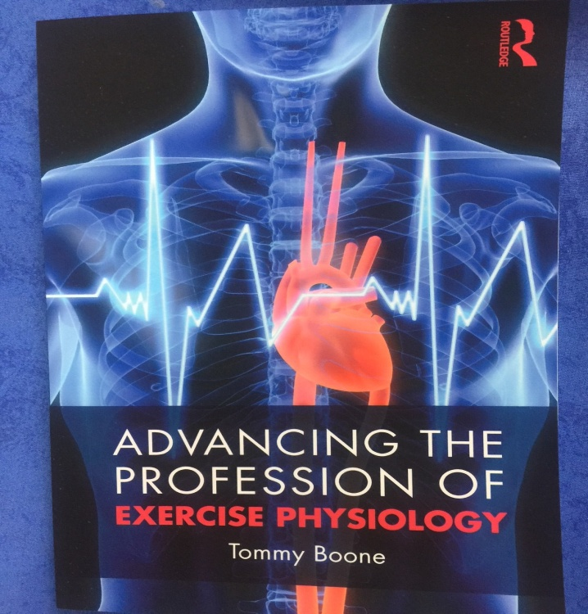
ASEP is working to help the American Students of Exercise Physiology.  We Become What We Think  July 3, 2016  https://exercisephysiologists.wordpress.com/  Years ago I wrote, “We become what we think, what we talk about, and what we do. If we think our work is for the right reason, if we think that our actions will bring forth positive results, and if we start living as professionals, we will become our vision.” The right thinking is everything! Every coach gets this point. Athletic performances, such as executing a series of back handsprings followed by a full twisting back flip, are dependent upon the athlete’s state of mind.  The importance of “what we think” seems so clear, but do we actually believe it. I know it matters with me, just as “what we talk about” drives what we do or will do. Remember, if you think you can or can’t you are right. Hence, even if you could do the gymnastics tumbling sequence mentioned above, if you think you can’t, then, inevitably you will fail. Experience has proven this point over and over that “we become what we think”.  Why not check out the exercise physiologists wordpress.com? |  |  |  |  |  | In This Issue  - From the CEO  - Why is ASEP Important  - The ASEP Book  - Why is ASEP Important?  - What Do You Think?  - Respecting the Dignity of Others  I understand that my thoughts affect my behavior, emotions, and actions. My beliefs about exercise physiology, exercise physiologists, professionalism, ethics, certification, and accreditation help me to understand the need to fight for the evolving profession of exercise physiology or otherwise I would simply begin to shrink into nothingness.  But, the truth is that I don’t shrink and withdraw from the change process. There is hope. The cycle of “what is vs. what should be” can be broken. Exercise physiologists can experience self-control by changing their thinking. Remember, we are not personal trainers. We are healthcare professionals. Don’t accept the “bull” spoken by another exercise physiologist, regardless of his/her credentials, if it doesn’t measure up to empowering the students of exercise physiology. In other words, as Paul in Romans 12:2 said, “Do not be conformed to this world.” Move beyond the trap of the irrational exercise science or kinesiology state of mind. Change your thinking, and you will be what you want to be.
From the CEO  Dear ASEP Members:  At times I too have thoughts about “change” and how long it takes to realize your dreams. It is without question difficult, but also a necessity to correct the mistakes of the past and/or to move forward with new ideas and opportunities. So, just as it is obviously a challenge for most young people to make an athletic team, such as football, basketball, or baseball, most athletes learn to stay the course. That is exactly what we plan to do. We will make the team!  Mr. Shane Paulson, MA, EPC, FASEP  ASEP Board Certified Exercise Physiologist  Why is ASEP Important?  In the October 1999 ASEPNewsletter (Vol 3 No 10), the following was published: So, once again, what is the motivation for someone to get involved in ASEP. The answer comes as no surprise. It is about helping yourself, as an exercise physiologist, and about helping other exercise physiologists and, thus the exercise physiology discipline as it moves toward the ranks of a profession. That is the reason to belong to ASEP. It is not about rocket science. It is not about taking exercise physiologists from sports medicine. It is about respect and dignity. It is about treating the exercise physiologist as an exercise physiologist, not as a physiologist or a physical educator, or even a personal trainer or an exercise specialist, or a health fitness instructor. It is about exercise physiology. It is about listening to the concerns of exercise physiologists. It is about ideas crying for expression. It is about building an organization with members helping each other. It is about creating a shared sense of purpose. It is about preparing students for the future. It is about providing each ASEP member the opportunity and the responsibility for shared-help in the professionalization of exercise physiology.  What do you think?  Honestly, what do you think?  Question?  How many flexibility exercises are required for an athlete (or anyone for that matter) to increase his or her range of motion, regardless of the sport?  How about finding the answer in this book?  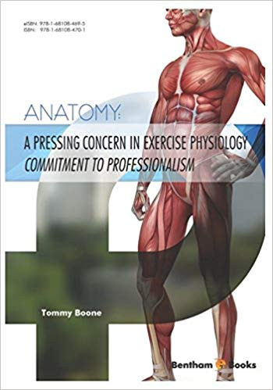  The correct answer is:  - 6  - 12  - 8  - 3 |  |  |  |  |  |  | The ASEP Book  When you are ready to study for the EPC exam (also known as the ASEP Board Certified Exercise Physiologist exam), you will need this book.  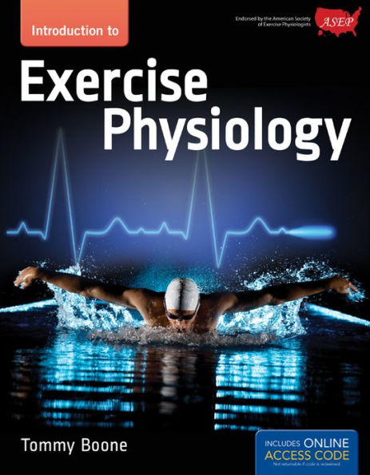  .  Dr. Boone’s textbook is all about the different exercise physiology course content and, yes, professionalism. You will have the content of the EPC test questions right before your eyes. If you have questions about metabolism, cardiovascular system, the anatomy of the body and how muscles function, biomechanics, ECG, and much more, the answers are in this text. Plan to sit for the EPC and become an ASEP Board Certified Exercise Physiologists and earn also the 21st century title: “An Exercise physiologist health care professional”.
ASEPNewsletter
ISSN 1097-0743
October 1999
Vol 3 No 10

Respecting the Dignity of Others
Tommy Boone, PhD, MPH, FASEP
“Never cease to pursue the opportunity to seek something different. Don’t be satisfied with what you’re doing. Always try to seek a way and a method to improve upon what you’re doing, even if it’s considered contrary to the traditions of an industry.”
-- Howard Marguleas

As the 21st Century approaches, exercise physiology is undergoing significant changes. Professionalism is now a topic of concern with significant advances made in several areas: certification, licensure, and accreditation. We in ASEP have been part of the birth of exercise physiology as a profession. What is old and what still exist will remain for some time to come, but businesses is not as usual as it once was.
There is competition now for the exercise physiologist who can choose between sports medicine and exercise physiology. No longer is there just sports medicine. No longer can sports medicine ignore exercise physiologists. Wants and needs, personally and professionally, must be managed, and that is the goal of ASEP. No longer will there be just certification of the exercise physiology types-of-positions by sports medicine. By October 2000, exercise physiologists can be certified by exercise physiologists as an exercise physiologist.
Most important of all, these changes increase the chances of exercise physiologists surviving in the health, fitness, rehabilitative, and sport fields of work. In a relatively short period of time, there will be a new breed of exercise physiology leaders. Their vision will lead exercise physiologists into the future with increased opportunities as professionals. The vision will set the stage for better communication among all exercise physiologists and between them and the public.
The infrastructure is in place. ASEP is dedicated to the involvement of exercise physiologists, professional improvement, and the satisfaction of its members and the public sector. None of this is happening overnight, but it is happening and ASEP is rolling right past the competition. It cannot be ignored, and increasingly, more exercise physiologists as students through the PhD degree have grown to understand ASEP’s importance. It has produced unprecedented opportunities of satisfaction and hope.
Exercise physiologists from around the world can see what’s happening in the United States. It’s a very positive influence in pushing forward with increased communication and teamwork. Coming together as exercise physiologists from around the world is the extra step in educating the public and in designing better work conditions within the public sector. Striking images of new work possibilities are now possible. Bright young college graduates can expect a better future as they come to understand the necessity of weaving things that are important to them with the basic needs and concerns of the public.
Are you prepared to enter the public sector as an exercise physiologist? Are you ready to manage your professional interests with greater ease and success? Would you like to increase your financial value? Are you willing to find the right graduate school to become all that is possible within you? If so, read on. What you read may just change your thinking about exercise physiology.
Management or Leadership?
Without wanting to berate sports medicine, the leaders of the organization have managed exercise physiology. The result is that exercise physiology has just puttered along as if it ever had a chance to grow within the confines of sports medicine. Rarely has it occurred, but once in a while, a leader within sports medicine tried to steer exercise physiology forward with its own niche of possibilities. Predictably along the way, the idea was pushed aside.
The almost “expert” management of exercise physiology by sports medicine leaders has kept exercise physiologists from recognizing the need to stand up and take on the responsibility of professionalism. Sports medicine, after all, is simply doing its job and doing it very well. The sports medicine leaders understand the importance of what exercise physiologists do (research), and they have benefitted tremendously from it. Exercise physiologists have, in other words, helped make sports medicine the valued organization that it is in the United States.
However, what is needed in the United States is “leadership”. Undergraduate students who are majoring in exercise science/physiology need guidance to help them achieve what they are capable of as healthcare professionals. They need college professors with a vision for the future, and who are willing to encourage, mentor, and help establish professionalism.
What exercise physiologists don’t need is irresponsible management of exercise physiology through the sports medicine vision. However, this isn’t going to happen real soon. Sports medicine personalities feel that they have the right to oversee exercise physiology. They don’t, of course. In time the view that they have some natural prerogative of executive position over exercise physiology will disappear. Then, only then, will effective communication take place between the two organizations.
Fortunately, the change towards “leadership” in exercise physiology is taking place. It is taking place with the ASEP committees; members who are working on behalf of the exercise physiologist. Every ASEP member has the potential to move exercise physiology forward. In fact, it will take the skills of all exercise physiologists who, in effect, will thereby become the founders of their vision and shared profession.
Visionary leadership by “exercise physiologists for exercise physiologists” is at the gut level the right thing to do. It is the only thing to do that makes any sense at all. There is no retooling of exercise physiology within the sports medicine context. Visionary leaders are those with a mental image of both the possible and the desirable future of exercise physiology. It is about a vision of what exercise physiology ought to be, what it can be, and what it will be. It is about establishing standards, a trusting relationship, and becoming a first-rate profession with the respect of the public. There isn’t anything new about this. Many other professions started with the same first steps. It’s just that exercise physiologists have far too long avoided taking the risk of acting on shared ideas and concerns.
Building the Organization
Now that the infrastructure is in place, ASEP is building its membership. Organizations get bigger across time, not all at once. You can’t go out and pull members in by their shirt collar. Getting the membership to sustain the vision is, in part, a function of the existing members’ dream and whatever else they believe is important to continual reinforcement of why the organization is important.
What is generally obvious is that once an exercise physiologist becomes a member and gets involved in the ongoing metamorphosis of exercise physiology as an emerging profession, that person begins to see the vision as a way of life. That person then becomes a living example to other exercise physiologists, which encourages them to join and get involved. After all, ASEP is the only professional organization for exercise physiologists. As a team of unified professionals, it seems only reasonable to conclude that all exercise physiologists increase their chances of becoming what they want to be by joining together, by taking risks, and by having the freedom to convey their thoughts and beliefs among peers who understand, trust, respect, and care about them.
So, once again, what is the motivation for someone to get involved in ASEP? The answer comes as no surprise. It’s about helping yourself, as an exercise physiologist, and about helping other exercise physiologists and, thus the exercise physiology discipline as it moves toward the ranks of a profession. That is the reason to want to belong to ASEP. It is not about rocket science. It is not about taking exercise physiologists from sports medicine. It is about respect and dignity. It is about treating the exercise physiologist as an exercise physiologist, not as a physiologist or a physical educator, or even a personal trainer or an exercise specialist, or a health fitness instructor. It is about exercise physiology. It is about listening to the concerns of exercise physiologists. It is about ideas crying for expression. It is about building an organization with members helping each other. It is about creating a shared sense of purpose. It is about preparing students for the future. It is about providing each ASEP member the opportunity and the responsibility for shared-help in the professionalization of exercise physiology.

JUST THINKING...
“You are what you think.” Dale Carnegie

Copyright ©1999
American Society of Exercise Physiologists.
All Rights Reserved.

