American Society of Exercise Physiologists

ASEPNewsletter
August 2019
ISSN 1097-9743

To Think About  “The Transformational Leader” (or the TL) – who is he or she? What is meant by “transformation”? John Maxwell knows and thousands of leaders understand as well. After reading Pierre Bergerson’s article, “A different world cannot be built by indifferent people”, I knew that I needed to share bits of it. The purpose of John’s comments at the opening session of the “Salt & Light Conference” was to explain that TLs are meant to influence people to think, speak, and act in such a way that it makes a positive difference in their lives. ASEP is all about the TLs who see, say, believe, feel, and do things that non-ASEP members do not see, say, believe, feel, or do, respectively. Then, he said the greatest leader ever is Jesus, and I can say that I agree 100%. I too hunger and thirst to be a transformational leader like him on behalf of the students of exercise physiology. |  |  | Recent Inquiry  Dr. Boone, I heard one of my college teachers say to another student, “Exercise physiology is a discipline. It is all about the acute and chronic responses to exercise and sports.” Here is an idea: “Why not tell the Professor about the following book?” 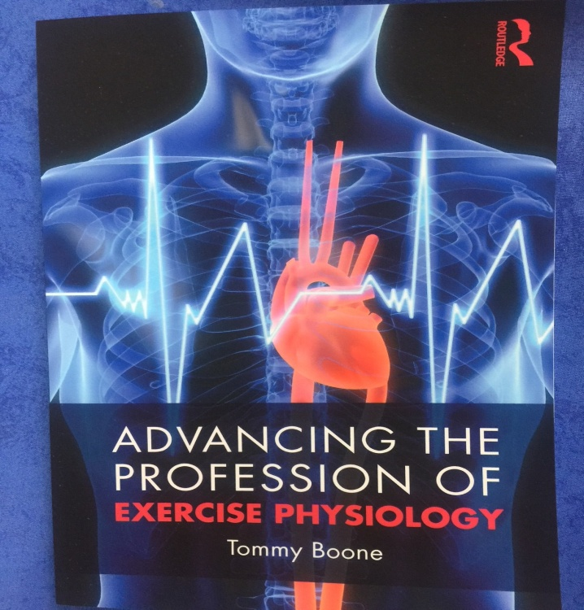
ASEP is working on behalf of the American Students of Exercise Physiology. |  |  |  | In This Issue  - From the CEO  - Why is ASEP Important  - The ASEP Book  - Risk Taking: The ASEP
From the CEO  Dear ASEP Members:  On Friday October 11th and Saturday the 12th, 2019, the ASEP National Conference will be take place at Midwestern State University in Wichita Falls, TX. Please keep a check on this newsletter and the ASEP website for more details about the upcoming meeting.  Mr. Shane Paulson, MA, EPC, FASEP  ASEP Board Certified Exercise Physiologist  Why is ASEP Important?  In the November 1997 ASEPNewsletter (Vol 1 No 3), the following was published. I don't know who wrote it. I found it taped on a wall in one of the academic buildings on the campus where I teach. I was taken by its simplicity yet daring qualities at a time just after the conclusion of the First Annual Meeting of the American Society of Exercise Physiologists at College of St. Scholastica, October 2-3, 1998.  IT CAN BE DONE!  IF YOU CAN DREAM IT...It CAN be done!!!  IF YOU BELIEVE IN YOURSELF...It CAN be done!!!  IF YOU PERSIST WHEN OTHERS QUIT...It CAN be done!!!  IF YOU ARE WILLING TO MAKE SACRIFICES...It CAN be done!!!  IF YOU HAVE FAITH...It CAN be done!!!  IF YOU ACCEPT THE RIDICULE OF THOSE WHO WATCH...It CAN be done!!!  IF YOU BREAK THROUGH YOUR FEARS...It CAN be done!!!  IF YOU HAVE INTEGRITY...It CAN be done!!!  IF YOU TRY WHEN OTHERS SAY IT'S IMPOSSIBLE...It CAN be done!!!  AND IF IT CAN BE DONE, YOU CAN DO IT!!!  What do you think is possible? Do you support ASEP? |  |  |  |  | The ASEP Book  When you are ready to study for the EPC exam (also known as the ASEP Board Certified Exercise Physiologist exam), you will need this book.  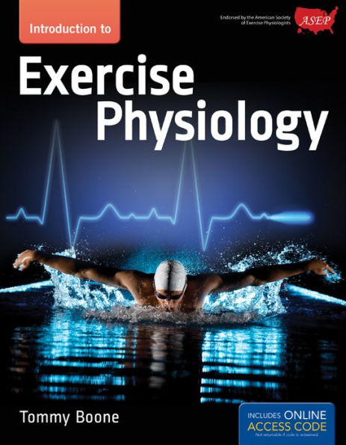  .  Dr. Boone’s textbook is all about exercise physiology professionalism. Students are introduced to the practice of exercise physiology to prevent and/or control mind-body diseases, promote health and well-being, and improve the performance of athletes. The goal of the text is to embrace exercise physiologists as vital members of the 21st century health care profession.
PEPonline
Professionalization
of Exercise Physiologyonline
An international electronic
journal for exercise physiologists
ISSN 1099-5862
Vol 2 No 1 January 1999

Exercise Physiology: Shared Reflections by ASEP Members
Tommy Boone, PhD, MPH, FASEP
Professor and Chair
Department of Exercise Physiology
Director of Exercise Physiology Laboratories
The College of St. Scholastica
1200 Kenwood Office
Duluth, MN 55811
Introduction
Our world is profoundly different from what it was last year, and the changes to come will continue to be breathtaking. The likelihood that exercise physiologists will continue to work toward professionalization is good. Efforts will extend beyond the United States to a more global appreciation of professional needs. The fast changing technology of the internet will create opportunities beyond what could have been imagined with traditional methods of communication.
Exercise physiologists in the United States have taken the lead in professionalization via the nonprofit organization, ASEP. The question now is the expectation and anticipation of changes. Yet, no one believes that ASEP is going to change decades of problems in just a few years. Members of the ASEP Board understand as well as many of the ASEP members believe that the greatest change has occurred with the initiative of ASEP. There are still thousands of exercise physiologists who are yet to voluntarily come forth and joined the Society.
More Than Rhetoric
Yes, ASEP is more than rhetoric. It is an American nonprofit organization that is organized to strengthen the profession by unification of exercise physiologists. The members are important to guiding ASEP and its accommodation of legitimate professional needs to alleviate problems faced by exercise physiologists.
It is an assembly of integrated, responsible professionals who advocate services and assistance with solving professional issues (such as certification, licensure, code of ethics, and accreditation). Obviously, the goals and objectives of ASEP are recognized as proper and important to professional growth and stability.
The collaboration among many serious-minded leaders in the field will be realized with the implementation of new ideas and models for organizational growth. This reminds me that we are clearly at the end of one period of an era and the beginning of a new one. But no one can take the development of exercise physiology for granted. It is a phenomenon of the time.
What ASEP is trying to accomplish is therefore no different than change itself. Objectives, assumptions, and mind-sets some years ago just aren’t the language of the exercise physiologist today. Values are different. People are different. Objectives are different. The profession is different, and hence organizations must be different.
We can no longer work under the older basic assumptions that we have for years in sports medicine. Our very existence is a function of our durability, but even that is subject to exhaustion if business as usual doesn't change. From an ASEP perspective, part of the change is in rethinking the profession and in the anticipation of threats to commanding and managing respect.
The age of one organization that represents many types of professionals including exercise physiologists is over. The age of the organization that fit the needs of the members is beginning. The mission and the work of ASEP (the new organization) are challenging and attractive to exercise physiologists who are looking for respect, financial stability, and credibility.
In February 1999, ASEP will organize a trial-run certification test required for the first national certification based on a series of test questions generated from academic course work at several institutions. This project is shared with exercise physiologists at the University of New Mexico who will also lead the way in national certification during the summer months. Both trail-runs are essential to realizing the best examination, hands-on experiences, and capable staff to ensure the certification process.
The Big Question
The one big question is “will national certification make a difference in the Society's influence on the professionalization of exercise physiology?” The answer is YES of course and why not? What we will see is recognition of the critical difference between an academically certified professional and a technically certified professional!
ASEP members share the belief that academic certification is and should be the conversation of the next century. Students should be encouraged, therefore, to invest in tangible professional benefits with dimensions of professional development, vision, and mission that otherwise have not been underscored in recent decades.
In short, the current strategy is to simply develop and invest in the talent of exercise physiologists. To do so, it is necessary to challenge old assumptions and old structures. Without the willingness to boldly commit to reaffirming professional values and reexamining the mission of exercise physiologists, the future cannot be viewed with much confidence and effectiveness.
Now is the Time to Invest
We are entering not just a new century, but a very different era of professional development. Now is the time to invest in the development of the profession and the message that ASEP is designed to serve its members. We all have experience too often the existence of an organization as though the organization is more important than the members. That just isn't the case with ASEP. It is different. Its reason for being is to provide exercise physiologists a common defense to a lack of a shared absence in professionalism.
It has nothing to do with the "whatever" that may be happening in other organizations; it has everything to do with leadership and management ideas that are important to the intellectual landscape of exercise physiology. It is about a renewed belief in the idea that organizations exist to benefit all members equally.
After so many years building up other organizations, we can now at last capture what we are and build on an integrated understanding of a collective vision of the future. It is this unrealized collaboration among exercise physiologists that is significantly different from the past. It places everything in perspective and connects us with each other.
The Door is Open
This is a miraculous moment in exercise physiology. The door is open for a new way of thinking, and we are learning from one another in ways unrealized before. We are setting the stage for a new kind of exercise physiology that is linked by concepts and beliefs of professionalism.
To make a lasting difference, we must remember that a beginning requires a lot of effort. There are challenges we have to deal with and complexities that must be resolved. Cynical personalities to help. Leadership and partnership transitions to be described, communicated, and managed. We need discussions about the future. Yesterday is in the past. We need help for our students who look to graduate and find a job.
Yet, somehow we have failed to understand that our students are our greatest asset. They are the reason we exist, and it is they who will become our leaders. Their understanding of what we are doing, and our efforts to maintain dignity in our work will influence their personalities, ethics, and personal life.
Our behaviors and our words that speak to being professional are indispensable to building a climate of trust within ASEP and the profession. We can't dismiss our responsibility just as we can't show disrespect and improper consideration for other organizations. We need to be spirited, motivated, and hard working leaders who can be trusted and respected to do the right thing. In a nutshell, that is exactly what ASEP membership is about; the consideration of others and the challenge they are facing to grow professionally.
Sharing Values
A shared commitment to the ASEP mission and purpose is the energy and synergy required to reinvent our profession and the community of exercise physiologists worldwide. ASEP is the organization of the future for exercise physiologists. It is exercise physiology-centered, exercise physiology-focused, and exercise physiology-driven to build and convey the importance of professionalization.
The organization of the future exists because its members know what is important. It is a message to other exercise physiologists that the most important thing we can do at the moment is listen and trust ASEP members. They know where they are going. They are interested in shaping the profession, and providing opportunities and increasing profitability to all exercise physiologists. ASEP is about building trust and encouraging change. It is about treating exercise physiologists with respect and dignity even if it means breaking away from old ways of doing things.
- It is about new initiatives and a high-commitment to professional satisfaction, successful financial measures, retention in the field, new products and new developments including a readiness for new ideas, concepts, and insights.
- It is about commitment and continuous improvement in knowledge and capability as teachers, researchers, rehabilitation specialists, and coaches.
- It is about marketing what exercise physiologists do, the recruitment of new and effective ideas, productivity, and building a shared community of exercise physiologists with greater job opportunities for employability.
There are simply limitless possibilities and benefits of investing in ASEP. With it, we can coach, teach, and cultivate ourselves. Without it, we will continue to debate meaningless strategies for marketing what we think we do. There will be fewer leaders and even less with leadership abilities. Only a few will articulate for the majority and they will have little convincing evidence of their ideas and values. However, we don't have to worry about that happening. Thanks to the ASEP members!

Copyright ©1999 American Society of Exercise Physiologists. All Rights Reserved.

