American Society of Exercise Physiologists
ASEP Newsletter
ISSN 1097-9743

June 2015
Vol 19 No 6
In this issue:
- What Do You Think!
- Ask the EP
•Spotlight & Question
- You Are What You Think
What Do You Think!

Several exercise physiologists have responded to the question “What Do You Think!” with “I like it very much, especially the online opportunity to take the EPC exam.” Others are impressed with the overall simplicity of the website. Well, the credit goes to Mr. Shane Paulson of Minnesota. He supervised the website project, and we are all very appreciative of his time committed to ASEP and the profession of exercise physiology. Thank you Shane!

Click here to visit www.asep.org

Life is about achieving our dreams. It is about living on the outside of “common thinking” and, therefore, it is all about heart.

– William Jennings Bryan
Ask the Exercise Physiologist...

Send your questions to info@asep.org...

Q: Why are you still a member of ASEP?
A: Because I think exercise physiology is a healthcare profession, I want to belong to “the” professional organization of exercise physiologists. That organization is ASEP. Physical therapists belong to APTA, athletic trainers belong to the NATA, and occupational therapists are members of the AOTA. So, as an exercise physiologist, it makes sense to me that I should be a member of ASEP.

Q: Is it Exercise Is Medicine? Or, is it Exercise Medicine? Can you help me understand the differences between the two?
A: Perhaps, you missed the February 2015 ASEPNewsletter, Exercise Medicine (February 2015, Vol 19, No 2), by Dr. Frank Wyatt. He is a professor of exercise physiology at Midwestern State University in Wichita Falls, Texas.

Spotlight:
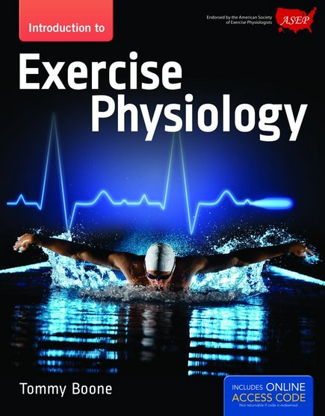
Question: Why?
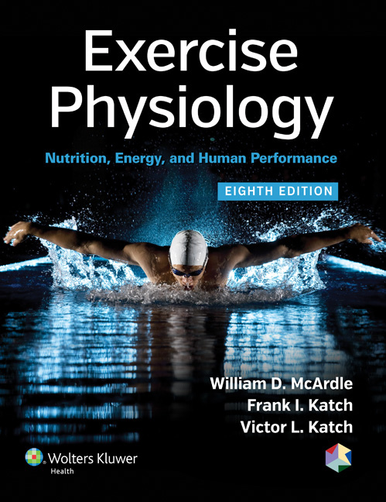

Tommy Boone, PhD, MPH, MAM, MBA
Board Certified Exercise Physiologist

Teaching Professionalism in Exercise Physiology

In 2001, as chair of the Department of Exercise Physiology at The College of St. Scholastica, I publish the book, Professional Development of Exercise Physiology (1), of which I used to teach an undergraduate course with the same title. The reason for the course is very simple. I believed then and still do today that exercise physiologists need a better understanding of professionalism. In fact, the more they know the better they will appreciate the ASEP development of accreditation guidelines for academic programs and board certification.

While I have developed a number of different courses (such as psychophysiology of health and disease, gross anatomy with cadaver dissection, electrocardiography, and cardiorespiratory physiology) at several academic institutions, I had not created a professional development course. However, given the presence of the ASEP organization, it was clear to me that defining professionalism and teaching professional and ethical behaviors cannot be pushed to the side.

Students need an academic course in professionalism just as they need a course in exercise physiology or sports nutrition. In fact, I believe it is essential that exercise physiology students understand the importance of professional characteristics in exercise physiology if they are to graduate as competent and credible exercise physiologists. Also, it is equally important that exercise physiology students (undergraduate and graduate) are taught by college teachers who see exercise physiology as a profession and not just as a job or a discipline.

- Destiny is not a matter of chance, it is a matter of choice; it is not a thing to be waited for, it is a thing to be achieved.
-- William Jennings Bryan

Generally speaking, most professionals agree on the definition and characteristics of professionalism. While some things can be taught in a classroom, it is harder to do so for others. It is important that the teachers are professionals who understand professionalism and how to develop it in their students. In regards to the first point, being a good researcher is not enough.

Moreover, although research is extremely important part of the professional work of exercise physiologists, it cannot become the sole reason why exercise physiology exists. In fact, exercise physiologists who get this point realize the importance of both research and professionalism. As exercise physiologists gain a broader viewpoint, the following short list of components that should be included in the students' education to promote the profession and the professional will become apparent.

First, exercise physiologists must agree on a definition of professionalism, its characteristics, and what it means to the profession. I believe professionalism is a commitment of services that benefit the profession and the public. It is an orientation towards service rather than personal profit. The safety of the public is important, especially the protecting clients from unsafe conditions. That is ASEP developed and promotes the Standards of Professional Practice for Exercise Physiologists. That is why the leadership supports and promotes ASEP as the profession-specific professional organization. They believe the organization is indispensable to the advancement of the profession. It is also the professional means of determining fact from fiction. The organization defines the character of its members (i.e., the professionals and their code of behavior).

Second, there must be identifiable content in the curriculum devoted to teaching professionalism. As co-founder of ASEP I have advocated for more time quality spent talking about professionalism. But, given the exercise physiologist’s history (particularly, at the doctorate level for the majority of the college teachers), most exercise physiologists are not prepared to teach a professionalism course. Also, it is true but sad that many exercise physiologists are so caught up in the status quo of exercise physiology that they are not interested in sharing their thoughts (if any) about professionalism. I keep expecting things to change. In fact, it has to change if exercise physiology is going to become more than just a course or a discipline subservient to the well-established professions. It has to change if exercise physiologists are going to be recognized as credible members of a healthcare profession.

Third, the foundational content in a Code of Ethics that governs a profession must be communicated, discussed, and researched. Yet, having said that, I wonder how many exercise physiologists have read the ASEP Code of Ethics. If you have, what do you think? Are you willing to write an article and submit it to the editor of the PEPonline journal? It seems obvious to me that it is important if not imperative that expectations for professional behavior must be clearly stated and communicated. Why isn’t it obvious to all exercise physiologists?

The exercise physiology educators have an obligation to educate their students about the ASEP Code of Ethics, Accreditation Guidelines and why they exist, Board Certification, and the Standards of Professional Practice. They are equally obligated to help their students become ASEP Board Certified (2).

- It is not a question of failing or succeeding. It is simply a question of sticking to an idea until it becomes a tangible reality.
  - Ernest Holmes

Fourth, members of a profession are bound together by a shared commitment. Think about it. As early as 1964, professionalism was at the forefront of the Physical Therapy profession. Dr. Jacquelin Perry published in the Physical Therapy Journal a manuscript entitled “Professionalism in Physical Therapy.” In fact, one of the 6 key elements forming the strategic plan of Vision 2020 was professionalism. If I am not mistaken, that places physical therapy light years ahead of exercise physiology. But, of course, to be fair, physical therapists formed in 1921 their professional organization.

While exercise physiologists are infants compared to the aging status of physical therapists, they are giants when it comes to their research and analytical skills. Now, they must do the same in building the profession of exercise physiology as “the” health care profession responsible for prescribing exercise medicine. I believe they will, but understandably it will take decades to see it through and even longer to experience it as our reality.

Each day is an opportunity to learn, to grow, and acknowledge life’s gifts of new thinking and new possibilities. Each day provides new opportunities.
- -- Marcus Aurelius

Reference

- Boone T. (2001). Professional Development of Exercise Physiology. Lewiston, NY: The Edwin Mellen Press.

- Boone, T. (2014). Introduction to Exercise Physiology. Jones & Bartlett Learning.

Copyright 1997-2015. All Rights Reserved. American Society of Exercise Physiologists

