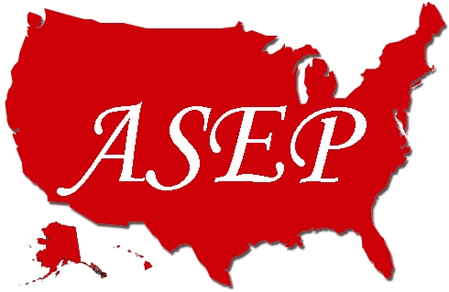 | American Society of Exercise Physiologists  ASEPNewsletter  August 2018  ISSN 1097-9743

To Think About  Take a moment and the following may hit you as hard as it has me. The ASEPNewsletter is 21 years old. In the October 1997 issue, I wrote the following about The Power of Change. “It is an interesting idea. It is very much like a vision or a dream that says, "Let's move forward. We can do it. We can make a difference." If only we would take that step forward, the change (and commitment) would release the power to make it happen. So, from the publisher, let's get on with directing our energies toward the professionalization of exercise physiology. Let's set a course toward a destination that others will recognize as representing real progress for all exercise physiologists. That destination is the American Society of Exercise Physiologists. It is the opportunity to realize a clear step ahead in effectiveness and efficiency. It is a compelling reason for everyone to stand together to catalyze change and achieve excellence. |  |  |  |  | Recent Inquiry  Question:  I currently have a MS in Exercise Science and am interested in obtaining additional certification as BCEP or CEP. Could you please provide me with more detail regarding BCEP? Thank you  Answer:  The certifications you identified are not provided by ASEP. Please refer to this URL: https://www.asep.org/epc-online/ After you have had a chance to read the content, feel free to email me again.  Dr. Tommy Boone, EPC
ASEP...  has worked on behalf of Exercise Physiologists for 21 years. |  |  |  |  |  | In This Issue  - From the CEO  - ASEP Books  - The ASEP Vision  - JEPonline Abstracts  - EPC Registry  - PEPonline  - Exercise Medicine/Business Books  - JPEPonline
From the CEO  Dear ASEP Members:  The American Society of Exercise Physiologists (ASEP) is 21 years old. Yes, it is committed to the advancement of exercise physiologists, not as personal trainers but as healthcare professionals. Founded in 1997 as a national non-profit professional organization in the state of Minnesota, ASEP provides a forum for leadership and exchange of information to stimulate discussion and collaboration among exercise physiologists active in all aspects of the profession. The Society has set standards for ASEP Board Certified Exercise Physiologists through ASEP-approved curricula in universities and colleges in the United States.  Mr. Shane Paulson, MA, EPC, FASEP  The ASEP Vision  In the December 1997 ASEPNewsletter, the following was published under the title, Commitment and Dedication!  What does it mean to be committed and dedicated to a dream? The short answer is "If you care long and hard enough, you can teach old dogs new tricks." That is, even those among us who have been associated with and have embraced the inertia of certain beliefs can change and they, too, can dream.  It all depends on us! We can become a profession of exercise physiologists. Do you have the courage and conviction to think with your heart as well as your mind? The power to change is within you. We can do what we want to do and accomplish what we want to accomplish. All we have to do is do it day by day. Remember the old Latin proverb: "Believe that you have, and you have it." Make things happen and forget about the fear of failure. Join the American Society of Exercise Physiologists.  What do you think? |  |  |  |  |  |  | ASEP Books  When you are ready to study for the EPC exam, you need thi book.  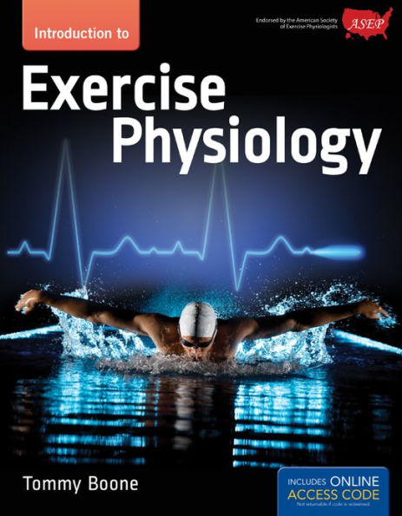  Without question, all Board Certified Exercise Physiologists must know anatomy when working with clients and/or patients.  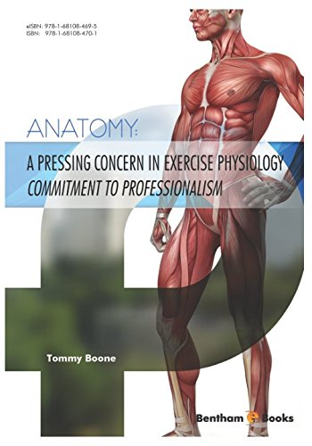
Impact of Daily Exercise Compared to Exercise on Alternating Days on Excess Post-Exercise Oxygen Consumption

Zachary Zeigler, Malachi Votaw, Connor Dreos, Lydia Durnil, Jamie Terran, Ezekiel Palmani, Danielle Akin, Trevor Nordin

College of Science, Engineering, and Technology, Grand Canyon University, Pheonix, AZ

Zeigler Z, Votaw M, Dreos C, Durnil L, Terran J, Palmani E, Akin D, Nordin T. Impact of Daily Exercise Compared to Exercise on Alternating Days on Excess Post-Exercise Oxygen Consumption. JEPonline 2018;21(4):66-78. The purpose of this study was to compare daily exercise (DE) to exercise performed on alternating days (AE) and a control (CON) on excess post-exercise oxygen consumption (EPOC). Sedentary men aged 18 to 30 yrs were the subjects in this three-arm randomized cross-over trial. The primary comparison was the magnitude of EPOC between the three groups (DE, AE, and CON) and within each group over time (day 1, 2, 3, and 4). Both exercise groups were prescribed the same exercise intensity (70 to 75% HR max), and total duration of exercise (90 min) on a cycle ergometer. The DE group performed exercise on three consecutive days (3 bouts of 30 min). AE performed exercise on two alternating days (2 bouts of 45 min). After exercise the subjects remained in the laboratory for 1 hr while VO₂ was measured continuously. Nine young (21 ± 2) overweight (28 ± 4 kg·m⁻²) male subjects completed the study. There was no significant difference on VO₂ or RER over 4 d for CON (P=0.561, P=0.179). EPOC did not accumulate over time during DE (P=0.561). However, DE did produce an overall greater EPOC than CON (P=0.009) while AE did not (P=0.106) (CON: 17 ± 3 L·min⁻¹, AE: 19 ± 2 L·min⁻¹, DE: 20 ± 3 L·min⁻¹). RER did not accumulate over time (P>0.05). In conclusion, EPOC was not impacted by back to back exercise sessions. However, when combing all exercise sessions, DE produced more overall EPOC than AE, thus DE could be superior to AE on total energy expenditure.

Key Words: Acute Exercise, Daily Exercise, EPOC, Weight Loss

A Brief Reflection
Tommy Boone, PhD, MPH, MAM, MBA, FASEP
Board Certified Exercise Physiologists

Published in PEPonline August 2018 issue:

In the July 1998 Volume 1 Number 1 PEPonline issue, the first of three articles was published of which the first sentence of the first article says: “Ever notice how well-meaning people resist change.” Most people are not willing to risk losing what is comfortable. Have you ever been in a situation where you and/or your colleagues resisted change because of what others might think? Just asking, is that a good reason to avoid engaging a new reality if it is obvious that is what should be done? The second paragraph of the same article contained the following: “At first glance, it appears that exercise physiologists are in control of the lay of the land. But, in reality, there are questions that are having a negative impact on students who are thinking about majoring in exercise physiology. As an example, how would you have answered the following questions in 1998 and now? What is exercise physiology? What is exercise science? Are they the same? What kind of certification is required? Is their salary comparable to other college graduates?

Professionalization of Exercise Physiologyonline  ISSN 1099-5862  July 1998  Volume 1 Number 1 |  |  |  | EPC Registry  The American Society of Exercise Physiologists endorses those individuals who have successfully challenged the EPC Board Certification Exam and maintained their professional member status. ASEP now requires individuals to sustain their membership with ASEP to be listed on the EPC Registry and be endorsed by ASEP. Check out the URL: https://www.asep.org/people/epc-registry1/
ACSM and Exercise Physiology: Past, Present, and Future  Roberts A. Robergs, PhD  It is no surprise that because of the important involvement of exercise physiologists in ACSM functions, there has been a trend for exercise scientists, especially exercise physiologists, to view ACSM as their professional organization. No matter how extensive this belief is among exercise physiologists, the facts that will be presented in this article indicate that the belief is incorrect. Furthermore, the inability for many exercise physiologists to reconcile the differences between their professional needs and the functions of ACSM has and continues to be damaging to their very own discipline and future profession (exercise physiology is still not a true profession).  ACSM has and never will be a governing body to the field of exercise physiology. Exercise physiologists need to become responsible for their own academic and laboratory standards and certification, and receive recognition for their knowledge and contributions to society. They also need to strive to work with clinicians, ACSM, and the medical insurance industry to secure employment for exercise physiologists, as exercise physiologists, in the growing allied health and clinical medical fields. The best way for this to happen is if exercise physiologists pursue self autonomy so that they control their own certification standards, employment conditions, and future status in the allied health and medical communities. The presence and contributions of exercise physiologists in the ACSM should continue, as ACSM is unique it its abilities to combine exercise science, health, and medical fields into a collective body to further our understandings of the effects of exercise on the human body. It is for this reason that ACSM was founded, and should continue to exist.  Well, what do you think? |  |  |  | Contact Us  The American Society of Exercise Physiologists provides academic EP program accreditation and individual EP Board Certification as the only exclusive professional organization for Exercise Physiologists in the United States. Our National Office is in Minnesota. You may contact the ASEP office at the following address:  ASEP  P.O. Box 515  Osakis, MN 56360-0515  (320) 491-9662  Email: info@asep.org  Visit us on the web at www.asep.org/
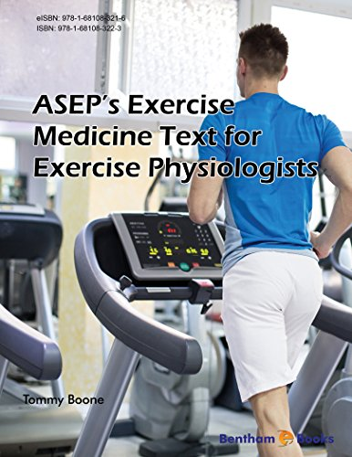 |  | 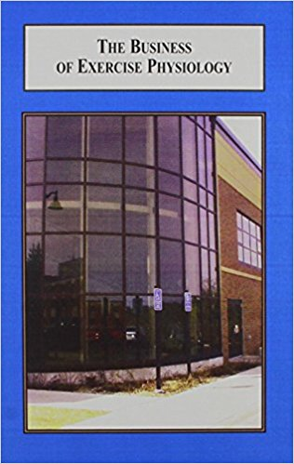
Here is the question: Which of the two books above should be read first? The book that indicates how to prescribe exercise medicine or the book that lays out the specifics of how to start an exercise medicine clinic? What do you think? Perhaps, it is the wrong question to ask. A Board Certified Exercise Physiologist could very well come to understand what it takes to start his or her own business and, then the product to be sole is his or her knowledge and hands-on laboratory experiences in prescribing an individualized exercise program to individuals of all ages and sex to prevent and/or treat chronic diseases and disabilities. Would this approach to using the academic degree in exercise physiology be better than having to transition to a different field of study (such as a personal trainer or a fitness instructor) or, perhaps, spend more tuition dollars, and end up outside your dream looking in? You have the right to your dream. You can be a Board Certified Exercise Physiologist with your own Exercise Medicine Clinic from which you can earn a living to put icing on your dream. Don’t give in to the thinking of status quo. Don’t give up your dream. These books and others like them can help you. They were written to help you as a credible healthcare professional.
Journal of Professional Exercise Physiology

ISSN 1550-963X

August 2018
Volume 15 Number 4

American Society of Exercise Physiologists
The Professional Organization of Exercise Physiologists

Making a Difference by Doing Something
Tommy Boone, PhD, MPH, MAM, MBA, FASEP
Board Certified Exercise Physiologist

In closing, I want to say a little about the forces in opposition to ASEP. Yes, they exist and they have the power to affect things. But, please keep in mind that ASEP is not about asserting a more powerful will to resist the influence. Instead, there is no reason to get all stressed out or always taking the time to think about what things could be if they didn’t exist. The smart way out is to simply not give the thinkers of yesterday a passing thought. After all, it is just a waste our energy regardless of what continues to happen. This doesn’t mean ASEP should not deal with events that are ethically and/or legally wrong. The key is to keep working on completing the tremendously important work of ASEP while doing so with the contentment and peace of mind. Remember daily that ASEP is a gift, and that gift is the challenging and exciting work that helps to promote the professionalization of exercise physiology.
Note: This is the final paragraph of a 5 page paper.

The article can be located at: https://www.asep.org/resources/journal-professional-exercise-physiology/
Why not take a look at it?

