Journal of Exercise Physiologyonline
(JEPonline)

Volume 8 Number 5 October 2005



Fitness and Training

Managing Editor
Robert Robergs, Ph.D.

Editor-in-Chief
Robert Robergs, Ph.D.

Review Board
Todd Astorino, Ph.D.
Julien Baker, Ph.D.
Tommy Boone, Ph.D.
Lance Dalleck, Ph.D.
Dan Drury, DPE.
Hermann Engals, Ph.D.
Eric Goulet, M.Sc.
Robert Gotshall, Ph.D.
Len Kravitz, Ph.D.
James Laskin, Ph.D.
Jon Linderman, Ph.D.
Derek Marks, Ph.D.
Cristine Mermier, Ph.D.
Daryl Parker, Ph.D.
Robert Robergs, Ph.D.
Brent Ruby, Ph.D.
Jason Siegler, Ph.D.
Greg Tardie, Ph.D.
Ben Zhou, Ph.D.

Official Research Journal of The American Society of Exercise Physiologists (ASEP)

ISSN 1097-9751

THE EFFECTS OF FATIGUE FROM LIMITED RANGE EXERCISE ON FULL RANGE FUNCTION

BRIAN D. JOHNSTON

Fitness Logistics, Exercise and Performance Testing Center, Sudbury, ON Canada P3A 6C1.

ABSTRACT

Johnston BD. The Effects Of Fatigue From Limited Range Exercise On Full Range Function. JEPonline. 2004;8(5):15-21. There is debate as to whether a person can achieve full range strength from limited range exercise. The purpose of the experiment was to determine the immediate effect exercise at one joint angle would have on the force output at a distant and non-worked joint angle. It was hypothesized that if there was a large carryover of fatigue (loss of force output) to a distant and non-worked angle because of the work incurred at a different joint angle, then an ‘exercise effect’ presumably did occur throughout the full range. Five experienced and highly motivated subjects (three male and two female) were selected, with ages ranging from 17 to 39, and with exercise experience ranging from two years to 25 years. All subjects were used to training to muscular fatigue and exhibiting high levels of exertion in exercise. Fresh quadriceps strength was tested toward full extension. The thigh then was placed an additional 42° toward flexion, and a series of isometric exercise attempts (2 s to ease into tension, followed by 5 s of maximum effort, followed by 2 s to ease out of tension, and followed by 5 s rest) repeated, to create a deep fatigue in the muscles. Immediately (~ 5 s) after the exercise bout, the leg was re-positioned at the initial joint angle, and force output again was measured to determine to what extent the fatigue that resulted toward the point of flexion, because of exercise, affected this distant and non-worked joint angle. Results revealed 4 subjects experienced decreased muscular strength (-17 to 20%) and 1 experienced improvement (43%). Force declines were small compared to the decrements experienced at the exercise joint angle. Muscular strength is detrimentally affected from exercise to fatigue at a different joint angle, but only to a small degree.
Key Words: Isometric, Strength, Contraction, Fatigue, Force.

INTRODUCTION

Since 1995, with the release of the book Power Factor Training (1), and many body-part specialty books on the same subject, the popularity of limited range exercise has increased significantly. Popularity continued to rise with similar books (by the same authors), including Static Contraction Training (2) to suggest that significant increases in hypertrophy and strength are possible by moving very heavy weights a short distance (toward a muscles strongest range of motion – where leverage is greatest), and for only a few min/week. Although the issue of hypertrophy is not in contention, since no evidence exists to the effect that muscle development is contingent on full range exercise, there is evidence that demonstrates full range exercise is equal to or superior to limited range exercise for producing full range strength results, as explained below.
Arthur Jones (3), and the work MedX Inc. did with the University of Florida, has concluded that muscles fall in one of two categories: Type S (specific) and Type G (general). In essence, a muscle that is Type S will produce a specific response to exercise relative to its trained range of motion, in that a lack of stimulus at a particular range of motion will not produce strength increases at that range. Conversely, a Type G response means that an overall benefit can be achieved with limited-range work (although best results are achieved by providing specific work to a specific range). Jones made this conclusion relative to investigating each subject independently, rather than considering the average effects of a group of subjects. He further concluded that 80 % of individual’s (muscles) tend to be Type S, whereas 20 % are Type G. He had no idea why this anomaly existed or what caused it, but that the response was observable and measurable among thousands of individuals.
In regard to group studies, Graves et al. (4) determined that trainees produce the best strength results at a particular joint angle when that particular joint angle was exercised, although full range benefits were produced to some extent even with limited range exercise. Another study (5), which implemented isometric exercise at two different and distant joint angles, has suggested that strength increases were mainly specific to the angle at which a muscle was exercised (in this instance, the quadriceps).

METHODS

Based on random experiences, our facility has come to the same conclusions as Jones, in that some muscles tend to respond favourably as a whole from limited-range exercise, whereas other muscles do not. To demonstrate these individual differences we then proceeded to test a small group, beginning in December 2004 to determine their responses, and in a highly specific manner, as described in the Procedures.
In January 2005 we also established two polls on Internet exercise discussion boards (6), having asked those with limited-range exercise experience to conclude their responses to such exercise, and upon returning to full-range exercise. Respondents were asked when returning to full ROM exercise, after experimenting with limited-ROM exercise, if they experienced 1) an increase in full ROM strength; 2) a loss of full ROM strength; 3) no perceivable change; or 4) the ‘effect’ varied among the muscles. The results, although not scientifically monitored or controlled, do provide some empirical insight from dedicated exercise enthusiasts, as presented in Table 2 of the Results.
Subjects
Five experienced and highly motivated subjects (three male and two female) were selected, with ages ranging from 17 to 39, and with exercise experience ranging from two years to 25 years. All subjects were used to training to muscular fatigue and exhibiting high levels of exertion in exercise.
Procedures
Each subject was seated in a MedX leg extension machine and restrained with a seatbelt. The non-tested leg was elevated and hands were placed behind the subject’s head (Figure 1a and b), and then instructed to remain as relaxed as possible with all muscle groups except for the tested left leg (all subjects are right-hand dominant).
Two joint angles within the quadriceps ROM were included in the experiment. Leg length and body structure altered the exact positioning slightly from one subject to another, but the differences were relatively the same. For example, subject one was tested at 38° and 84°, whereas subject two was tested at 26° and 72°, with a difference between the two testing positions being 46° in either case.
Two well-separated joint angles for the experiment were selected for an important reason. Fundamentally, the differences had to be greater than 15° since it has been suggested that strength improvements “carry over” by 12-15° at either end of a trained (isometric) point. For example, if a person were to exercise a muscle isometrically at 45°, then some “benefit” would be experienced at either extremes between 30° and 60°, with little or no benefit thereafter (and if true, then the extent of strength improvement would be progressively less as the distance increases from the limited range of motion exercised). This belief may be why MedX testing machines are designed to test isometrically every 15° of movement.
The method behind this experiment was as follows:
- Fresh quadriceps strength was tested toward full extension (but not at full extension since it is difficult to produce maximum isometric force at near-zero degrees; see Photo A).
- The thigh then was placed toward flexion, and a series of isometric exercise attempts repeated, to create a deep fatigue in the muscles (see Photo B). Each subject performed continuous isometric exercise until leg fatigue was noticeable and considerable (± 40 % reduction in force as indicated by the strain gauge). Each isometric, all-out attempt of exercise consisted of the following protocol: 2 s to ease into tension, followed by 5 s of maximum effort, followed by 2 s to ease out of tension, and followed by 5 s rest.
- Immediately after the exercise bout, the leg was re-positioned at the initial joint angle (Photo A), and force output again was measured to determine to what extent the fatigue that resulted toward the point of flexion, because of exercise, affected this distant and non-worked joint angle. This step occurred within 5 s of step 2, which would not have allowed for much recovery.

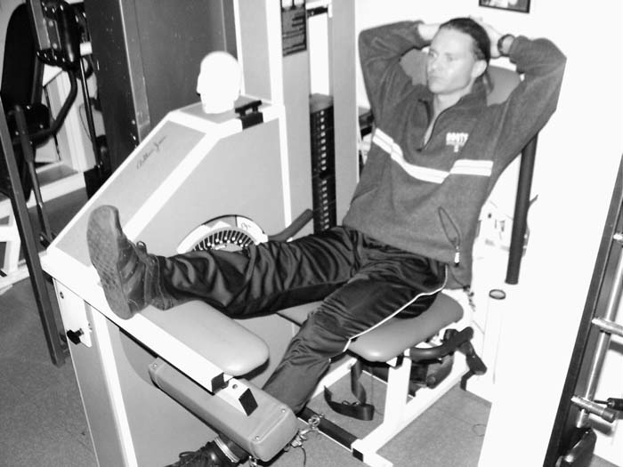  Photo A  PHOTO A: The left leg was tested twice toward extension; once, at the beginning of the test, then again after an exercise bout that resulted in significant fatigue (see Photo B) | 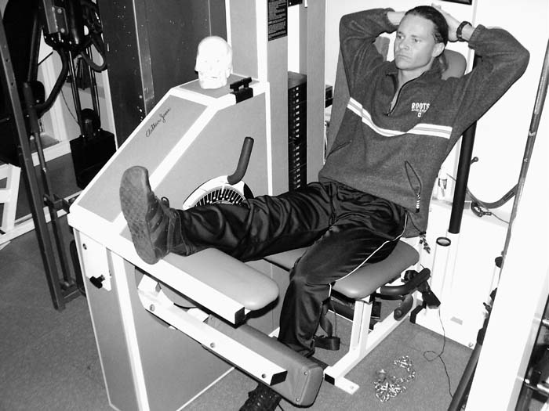  Photo B  PHOTO B: After an initial strength test (Photo A), the leg was positioned toward flexion and exercised isometrically at that position until significant fatigue was experienced.
Figure 1. Photos of a subject with the left leg positioned at A) 26° and B) 72°.

RESULTS

Table 1 presents a comparison of the five subjects. Four of the five subjects noticed some degree of fatigue (reduction in force output) at the non-worked angle as a result of exercise at a distant angle, although three of those four produced far greater functional loss at the worked angle. The first subject increased function at the non-worked angle as a result of the exercise.
Subject one (male, age 39) required a total of 11 maximum effort isometric exercise attempts to reduce his strength significantly during the bout of exercise. He was the most experienced in the group. Subject two (male, age 37) required a total of 25 all-out attempts to reduce his strength significantly, primarily because he continually contracted outside muscles (abdominals, opposite thigh, etc.) as he fatigued. It was not until his final five attempts, when coached, did he mentally focus to fully (adequately) relax all muscle groups except the tested quadriceps. This tells us much about the participatory role of outside muscles when attempting to isolate a particular muscle, and especially when approaching muscular fatigue. It stands to reason that the so-called “indirect effect” that muscles receive when other muscles are exercised may be, in fact, far more of a direct effect than realized; a stimulatory effect achieved by way of very intense isometric contractions that go unnoticed as a result of mental focus (and discomfort) on the targeted muscles being exercised primarily. Arthur Jones (7), on the other hand, has suggested that the indirect effect is more systemic (hormonal?) in nature and has nothing to do with the modest (isometric) tension performed by one muscle while another muscle exercises specifically.
A third subject (male, age 20) required 29 all-out attempts to reduce his quadriceps’ strength significantly, and also had difficulty to relax all muscles except the working muscle. A fourth subject (female, age 37) required 20 attempts to reduce her strength significantly. A fifth subject (female, age 37) required 20 attempts to reduce her strength significantly.

Table 1. Force application data for the five subjects.
Data | Subject 1 | Subject 2 | Subject 3 | Subject 4 | Subject 5
Test 1: Fresh Strength at extended joint angle | 45.6 kg (38°) | 29.44 kg (26°) | 60.3 kg (42°) | 35.8 kg (30°) | 21.3 kg (34°)
Exercise Bout: Amount of fatigue generated at flexed joint angle | 76.7 to 36.9 kg (84°; 51.83% functional loss) | 44.1 to 36.9 kg  (72°; 40.33% functional loss) | 56.2 to 26.2 kg (85°; 53.4% functional loss) | 53.1 to 29.7 kg  (78°; 44% functional loss) | 38.5 to 24.5 kg  (80°; 36.4% functional loss)
Number of attempts to induce fatigue | 11 | 25 | 29 | 17 | 20
Test 2: Force output/strength when extended joint angle was re-tested | 65.14 kg (38°) | 23.5 kg (26°) | 39.74 kg (42°) | 29.7 kg (30°) | 17.4 kg (34°)
Difference between pre- and post-exercise tests | +42.74% | -20.34% | -34.1% | -16.98% | -18.5%
Difference between fatigue-induced exercised joint angle and non-worked joint angle | 94.57% difference based on the gain vs. loss | 49.57% greater functional loss at exercised joint angle | 19.3% greater functional loss at exercised joint angle | 61.48% greater functional loss at exercised joint angle | 49.18% greater functional loss at exercised joint angle

Table 2 presents a poll that was conducted on two Internet exercise bulletin boards, with 20 respondents.
Table 2. Results from two internet polls on partial range
exercise training.
As a Result of Implementing Partial Range Exercise…
I gained full ROM strength – 11.6%
I lost full ROM strength – 53.5%
I maintained full ROM strength – 11.6%
The response/effect varied among my muscles – 11.6%

DISCUSSION

Subjects 2-5 produced a loss of function at one joint angle as a result of limited-range exercise at a different and distant joint angle, but certainly not to the same or equal extent, ranging from 19.3 % to 61.48 % greater functional loss at the exercised joint angle. Subject 1 did not experience a negative effect from exercise at a different joint angle, although he induced the greatest extent of fatigue (a 51.83 % loss of functional ability) during exercise. In fact, he was 42.74 % stronger or more functional at that different joint angle after exercise. Although speculative, the reason for such an increase may be because the exercise at a different joint angle had a generalized “warming-up” effect, and this subject has claimed unusual endurance in his thighs. Although the results with this subject may be suspect, it should be known that the author was that subject. I was highly motivated to be tested for this experiment, and I am well aware of how my quadriceps’ do respond to exercise, with the experiments results being no surprise. Nonetheless, if I were eliminated from the overall results, it still is obvious that deep fatigue at one joint angle does not induce a similar degree of fatigue at another joint angle and, consequently, it may be hypothesized that there would be less of a stimulatory training effect at the non-worked joint angle.
A Comparison Study
Certainly the above “experiment” cannot be considered a ‘study,’ but let us compare our procedure and findings to that of a published 10-week study by Massy et al. (8), whereby the researchers had one group (11 participants) perform the bench press with three full ROM sets. A second group (30) did three limited range sets of the bench press. Limited range in this study meant beginning just past the sticking point to full extension of the arms. A third group performed both limited and full range repetition sets; two limited and one full range set in the first five weeks, and one limited and two full range sets in the second five weeks. It is uncertain why group one had fewer than half the participants.

Now, if it is true that there is some measure of “carryover” in strength development as a result of exercise, presumably by 12-15° at any joint angle, then group two would develop strength at the sticking point of the exercise since the limited ROM group did lower the weight just shy of that point. This is important to realize since the ‘sticking point’ of an exercise is the limiting factor as to how much weight can be lifted. So long as that particular area is strengthened, even if stimulated by way of the carryover effect, then the ability to lift progressively heavier resistance will increase in the bench press.
Second, the choice of exercise was not a good one. The bench press involves the pectorals, anterior deltoids and triceps, besides any outside forces from other muscles that may assist in the lifting of the weight. In this regard, it is unclear what muscle is a limiting factor or a benefit (at different joint angles) so that the participants can become more proficient in the bench press exercise, and whether performing full ROM or limited ROM exercise. A person with very powerful triceps, for example, may be able to eke out repetitions beyond the sticking point although the deltoids and pectorals do not produce additional force because of the training protocol’s limitations. And what of a person’s overall mechanics (genetics) to lift a barbell in this particular exercise? The questions are numerous.
Massey et al. concluded that although each group improved throughout the study, there were no differences in the amount of increase among the groups. A problem in this regard is that individual differences were not considered, as our experiment demonstrated, and the participants were ‘averaged out’ in the conclusion. If the reader were to reflect back to the results produced by our different subjects, we focused on each person (and muscle) individually with as much isolation as possible, with exact positioning, and tested in an isometric fashion; and with the time investment of about five min per subject, as opposed to ten weeks of questionable methodology that discloses nothing in particular about any person, muscle or training protocol’s effectiveness.

CONCLUSIONS
With the above noted data it can be concluded that if limited-range exercise had a positive influence on strength gains at different joint angles, then the degree of fatigue would be similar at those other joint angles. This is reasoned since exercise stimulus (to stimulate gains) results in some measure of fatigue or muscular inroad, and the measure of fatigue, or lack of such fatigue will have a bearing on the potential exercise effect.
From these five subjects (and the above noted conclusions and empirical evidence polls) it can be concluded further that:
- Some people/muscles respond well to limited range exercise, by producing full range results, although best results still are at the joint angle trained;
- Some people/muscles produce a modest full range effect from limited range exercise; and
- Some people/muscles necessitate full range exercise in order to produce full range results.
In many instances, i.e., with the general public, this may not be an important concern. For athletes and those with physical jobs that challenge and fatigue tissue integrity at specific angles or involve unique mechanics, such information should not be ignored. For these reason, exercise should be carried throughout the fullest range possible, and preferably with variable resistance machines that accommodate muscle force output (since changes in force production do occur from one joint angle to the next). And, maintaining a particular position for too long during work-related tasks could result in excess fatigue and tissue injury; hence, improving strength and muscular endurance at such joint angles would prove beneficial.
Although full range of motion was not tested in this experiment (e.g., approximately every 15° with data interpolated to create a force curve), comparison of broad joint range differences do indicate that exercise fatigue does have a localized effect, in that the greatest response to fatigue is relative to the angle or range of exercise. Thus, this short-term ‘fatigue’ study may support the conclusions made by longer-term research conducted that indicates differences in strength improvement among joint angles appear to be localized as well, i.e., most significant where applied/stimulated.

ACKNOWLEDGEMENTS
Thanks to CSC Force Measurements Inc. (www.cscforce.com) for supplying the necessary hardware for this experiment.

Address for correspondence: Brian D. Johnston, Fitness Logistics I.A.R.T., 5 Abigail Court, Sudbury, ON P3A 6C1 Canada. info@ExerciseCertification.com

REFERENCES

- Sisco and Little. Power Factor Training: A Scientific Approach to Building Lean Muscle Mass. McGraw-Hill 1997.
- Sisco and Little. Static Contraction Training. Mc-Graw Hill 1998.
- Jones, Arthur. The Lumbar Spine, the Cervical Spine and the Knee: Testing and Rehabilitation. 1993. pp. 82-85.
- Graves, J.E., Pollock, M.L., Leggett, S.H., Carpenter, D.M., Fix, C.K., & Fulton, M.N. (1992). Med Sci Sports Exer 1992;24:128-133.
- Lindh M. Increase of muscle strength from isometric quadriceps exercises at different knee angles. Scand J Rehabil Med. 1979;11(1):33-36.
- www.ExerciseCertification.com and www.DrDarden.com
- Jones, Arthur. Nautilus Bulletin #1, 1973.
- Massey CD, Vincent J, Maneval M, Moore M, Johnson JT. An analysis of full range of motion vs. limited range of motion training in the development of strength in untrained men. J Strength Cond Res 2004;18:518-521.

