Journal of Exercise Physiologyonline

Volume 15 Number 3 June 2012



JEPonline
Editor-in-Chief
Tommy Boone, PhD, MBA
Review Board
Todd Astorino, PhD
Julien Baker, PhD
Steve Brock, PhD
Lance Dalleck, PhD
Eric Goulet, PhD
Robert Gotshall, PhD
Alexander Hutchison, PhD
M. Knight-Maloney, PhD
Len Kravitz, PhD
James Laskin, PhD
Yit Aun Lim, PhD
Lonnie Lowery, PhD
Derek Marks, PhD
Cristine Mermier, PhD
Robert Robergs, PhD
Chantal Vella, PhD
Dale Wagner, PhD
Frank Wyatt, PhD
Ben Zhou, PhD

Official Research Journal of the American Society of Exercise Physiologists

ISSN 1097-9751

Editor-in-Chief
Tommy Boone, PhD, MBA
Review Board
Todd Astorino, PhD
Julien Baker, PhD
Steve Brock, PhD
Lance Dalleck, PhD
Eric Goulet, PhD
Robert Gotshall, PhD
Alexander Hutchison, PhD
M. Knight-Maloney, PhD
Len Kravitz, PhD
James Laskin, PhD
Yit Aun Lim, PhD
Lonnie Lowery, PhD
Derek Marks, PhD
Cristine Mermier, PhD
Robert Robergs, PhD
Chantal Vella, PhD
Dale Wagner, PhD
Frank Wyatt, PhD
Ben Zhou, PhD

Official Research Journal of the American Society of Exercise Physiologists

ISSN 1097-9751

Prescription of Aerobic Exercise Training Based
on the Incremental Load Test: A Model of Anaerobic
Threshold for Rats

Phablo Sávio Abreu Teixeira², Igor Cabral Coutinho do Rego Monteiro¹, Tanes Imamura Lima¹, Aline Colares Camurça dos Santos¹, Vânia Marilande Ceccatto¹

¹Superior Institute of Biomedical Sciences – State University of Ceará, Fortaleza, Ceará, Brazil, ²Institute of Biomedical Sciences - University of São Paulo, São Paulo, São Paulo - Brazil

ABSTRACT

Abreu PST, Rêgo-Monteiro ICC, Lima TI, Santos ACC, Ceccatto VM. Prescription of Aerobic Exercise Training Based on the Incremental Load Test: A Model of Anaerobic Threshold for Rats. JEPonline 2012;15(3):45-52. This study determined the efficiency of a training program based on the Incremental Load Test (ILT) to prescribe and evaluate aerobic exercise training. The maximum lactate steady-state (MLSS) was determined at 1.2 km·h⁻¹ and the lactate concentration achieved at this intensity was 2.32 ± 0.33 mmol·L⁻¹ (P<0.05). In addition, the MLSS corresponded to 60% of maximal speed achieved during the ILT. The time (78.62%), speed (74.98%), and total distance run (190.28%) during exercise training increased significantly after 6 wks when compared to the control group. Data from the ILT demonstrated a significant difference in exhaustion when compared to rest. The lactate concentrations in the control group at 27 min rose over 90.15% and in the trained group at 51 min, 6.66%. The lactate concentration at exhaustion in the trained group was significantly higher (an increase of 41.90%; P<0.05) than the control group. Both the detection of the lactate threshold in the ILT (the percentage of 60%) and the MLSS (showing that 1.2 km·h⁻¹ as the target speed) as a valid parameter with an important metabolic meaning.

Key Words: Experimental Animal Model

INTRODUCTION

The exercise prescription for training and fitness assessment proposed for animal models differ extensively. For example, with regard to the exercise prescription and evaluation, VO₂ max (23), lactate threshold (9), maximum lactate at steady-state (20), maximum intensity testing (12), and critical speed (7) are all measurable parameters that have been adopted in order to determine the ideal training intensity. Yet, to circumvent the difficulty required of specific equipments for the determination of VO₂ max, some researchers have applied arbitrary velocities (1,14,17,18,21) while others have used blood lactate threshold (LT) (8,10,26,28). Thus, the accumulation of lactate observed during a graduated exercise test is usually interpreted as indicative of augmented contribution of the anaerobic metabolism as the main energy source (25,27).

The use of VO₂ max test is often impractical due to the high costs of the equipment in rat research. Also, given that one of the strategies used in similar studies is the evaluation of the concentration of blood lactate, the invasive technique itself often acts as a confounding variable due to the stress, waste, and trauma that leads to rejecting the exercise. Instead, researchers can use the correlations of the metabolic parameters with the use of incremental and constant tests (which are easily applied).

Some interesting correlations have already been made that correspond to a maximum lactate steady-state (MLSS) (13,20) and the value of 60% in the incremental load test (ILT) without collecting blood (12). This approach makes the application of the ILT as an important means to deriving a training prescription. The characteristics of these tests are distinct; one is a constant test and the other is an incremental test. Thus, the purpose of this study is to apply the ILT with the evaluation of blood concentrations of lactate to determine its relation with MLSS and 60% in the ILT with the expectation to applying the findings to the prescription of an endurance training program for rats.

METHODS
Animals
Twelve male Wistar rats were kept in a light/dark cycle (12 hrs/12 hrs) with water and a commercial diet ad libitum. At 60 days of age, the rats began a phase of adaptation in the treadmill for 2 wk, 5 times per wk at 0.4 km·h⁻¹ during 10 min. After this stage, the animals were separated into 2 randomized groups: a control group (n = 6) and a trained group (n = 6).

Blood Lactate Concentration
Capillary blood samples (25 µL) were taken from the caudal vein. The rats was kept running while blood was being harvested gently. Blood was transferred to 1.5 mL tubes containing 50 µL of sodium ﬂuoride (1%). The lactate concentration was analyzed via an electro enzymatic method with a lactate analyzer (YSI 2300 Stat Analyzer; Yellow Springs Instruments, Yellow Springs, OH, USA).

Constant Load Test
Before the constant-load test was applied, the ILT was performed without taking blood samples. Then, 12 rats were submitted to a subsequent constant-load tests performed with intensities varying from 0.9 to 1.5 km·h⁻¹. Blood samples (25 µL) were taken from the caudal vein each 7 min for further measurements. The highest workload that could be sustained over 28 min of running without lactate accumulation (blood lactate varying by less than 1 mmol·L⁻¹ from 7 to 28 min) was considered the MLSS (2,15). The MLSS was calculated as the average lactate concentration measured at 7, 14, 21, and 28 min of the test. The interval between each test was 48 hrs.

Incremental Load Test
After aerobic exercise training, 12 rats were subjected to a maximum intensity test, which consisted of adding 0.2 km·h⁻¹ at 3-min intervals with 0% incline until exhaustion (i.e., when the rat could no longer respond to mechanical stimuli applied by the researcher to maintain the physical activity). Blood samples (25 µL) were taken from the caudal vein every 3 min of running for further measurements. This test provided the total distance run and the peak workload.

Physical Training Protocol
The prescription of aerobic exercise training was designed from the ILT (60%), legitimized by the constant load test or MLSS (1.2 km·h⁻¹). The animals trained on a treadmill (Atletic Speed 2, Atletic, Brazil), 5 days a wk for 6 wks. The training session was assembled: (a) warm-up period (5 min); (b) buffer zone (0-10 min); (c) the target zone (40 to 50 min); and (d) cool-down period (5 min).

Statistical Analysis
The data were analyzed by using the Graph Pad Prism software and graph package (V 4.0, Graph Pad Inc., San Diego, CA, USA). The findings are presented as mean ± standard error of the mean (SEM). Results were analyzed by a one-way analysis of variance (ANOVA) followed by a Tukey’s post hoc test for comparison between three or more groups, and the Student’s t-test for comparison between the two groups. A signiﬁcance level of P≤0.05 was chosen for all comparisons.

RESULTS
Method for Determination of MLSS
The response of blood lactate concentrations over time in running rats (constant workload intensities ranged from 0.9 to 1.5 km·h⁻¹). An apparent stabilization of lactate concentration was observed in running rats at 0.9 and 1.2 km·h⁻¹, which corresponded to lactate changes by less than 1 mmol·L⁻¹ after the 7 min of testing (Figure 1). At 1.5 km·h⁻¹, lactate accumulation was observed over time and changes in lactate concentration exceeded 1 mmol·L⁻¹ within 7 to 28 min of testing. Therefore, MLSS was determined at 1.2 km·h⁻¹ and the lactate concentration achieved at this intensity was 2.32 ± 0.33 mmol·L⁻¹ (P<0.05). In addition, the MLSS matched 60% of maximal speed achieved in the incremental exercise testing (Table 1).

Table 1. Parameters Evaluated Before and After Six Weeks of Aerobic Exercise Training: Time (min), Speed (km·h⁻¹), and Distance (m).
Groups | All Groups  Before Training (n=12) | Control  After Training (n=6) | Trained  After Training (n=6)
Time (min) | 26.9 ± 1.04 min | 26.2 ± 1.01 min | 51.0 ± 2.0 min ***
Speed (km·h⁻¹) | 2.0 ± 0.08 km·h⁻¹ | 1.9 ± 1.08 km·h⁻¹ | 3.5 ± 0.10 km·h⁻¹ ***
Distance (m) | 416 ± 0.35 min | 385 ± 0.12 min | 1388 ± 0.76 min ***
***Significant difference between groups. Values ​​are expressed as mean ± SEM and analyzed by the
Student t-test with significance level (P<0.0001).

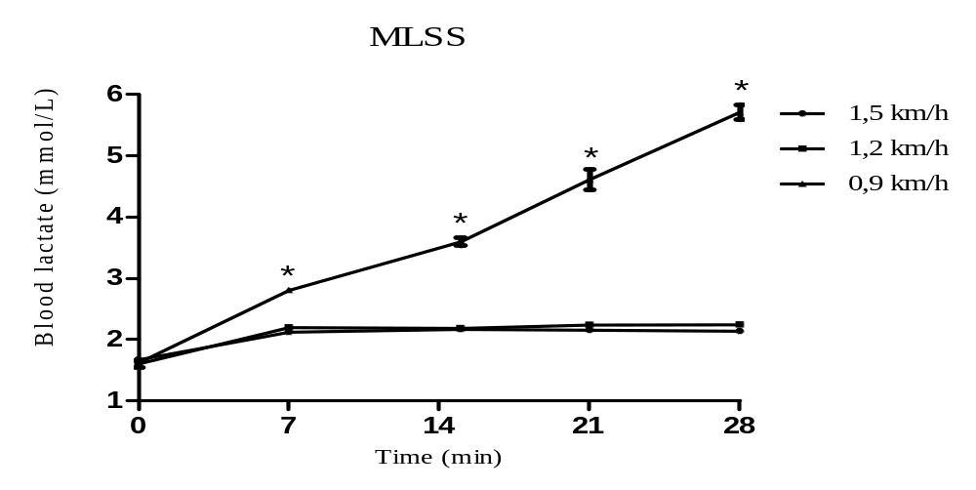
Figure 1. Time-course of alterations on blood lactate concentration assessed during submaximal constant load tests. The workload of the ﬁrst constant load test corresponded to 60% of maximal speed achieved during an incremental load test. Changes in blood lactate concentration between 7 and 28 min of constant load tests performed at different exercise intensities. Note that maximal lactate steady-state (MLSS) was attained at 1.2 km·h⁻¹, which was the highest workload at which blood lactate changed by less than 1 mmol·L⁻¹ after 7 min of testing. Values are expressed as mean ± SEM and analyzed by one-way ANOVA (repeated measures) and a Tukey’s post hoc test (*) (P<0.05) compared with 0.9, 1.2 and 1.5 km·h⁻¹.

Incremental load test
The time, speed, and total distance run during exercise training increased significantly after 6 wks when compared with the control group (Table 1), respectively, 78.62% (Figure 2A), 74.98% (Figure 2B), and 190.28% (Figure 2C) (P<0.0001). Data of the incremental load test demonstrated a significant difference in exhaustion when compared to rest (Figure 3A). The lactate concentrations in the control group at 27 min increased over 90.15% and in the trained group at 51 min to 206.66%. The lactate concentration at exhaustion in the trained group was significantly higher than the control group, which demonstrated an increase of 41.90% (Figure 3B) (P<0.05).

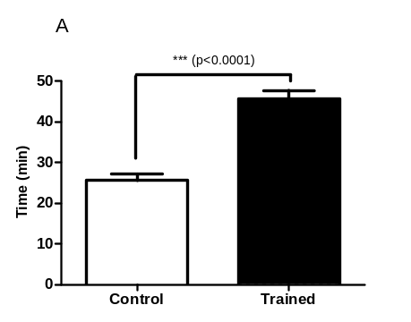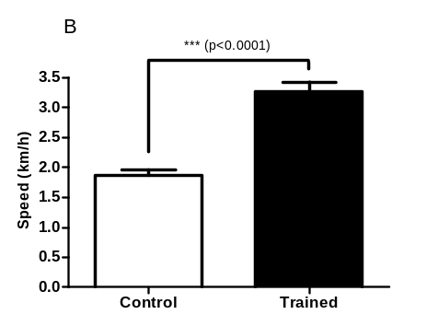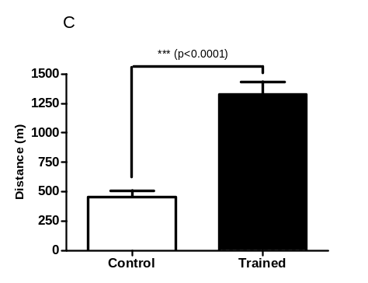

Figure 2. Effects of exercise training on (A) time, (B) speed, and (C) distance from the incremental load test (ILT) executed 48 hrs after the last training session. Control group (n=6) and trained group (n=6). ***Significant difference between groups. Values ​​are expressed as mean ± SEM and analyzed by student t-test with a significance level at P<0.0001.

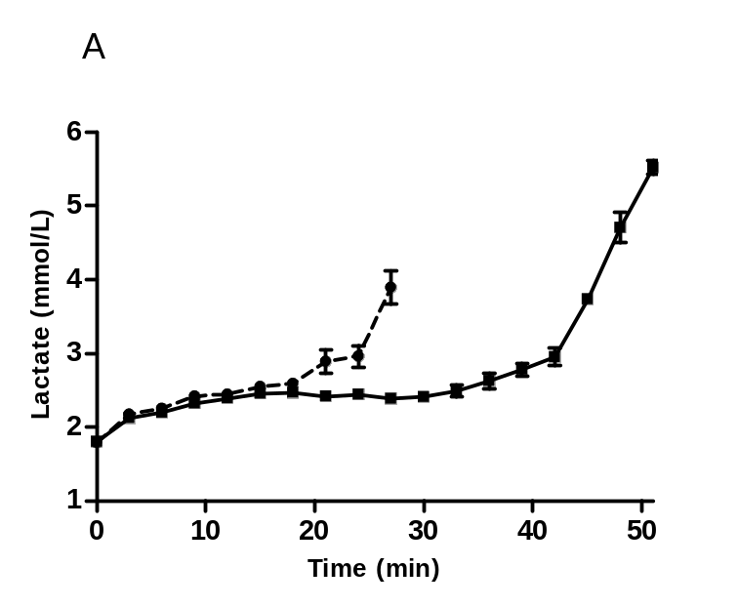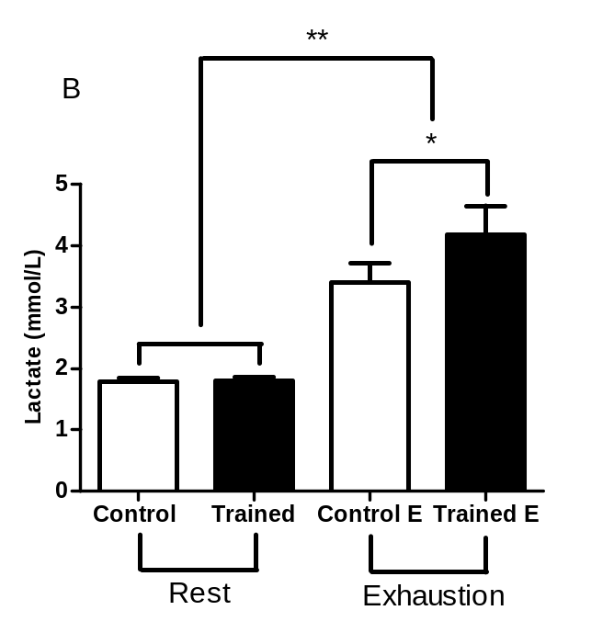
Figure 3. Effect of exercise training on blood lactate concentration (A) in the control (n=6) and the trained (n=6) groups, found in incremental load test. *Significant difference between groups. Values are expressed as mean ± SEM analyzed by a One-Way ANOVA (repeated measures) followed by Bonferroni post test with significance level set at P≤0.05. Lactate (B) concentration values in rest and after exhaustion. *Significant difference between groups and **between times. Values are expressed as mean ± SEM and analyzed by a One-Way ANOVA followed by Tukey’s post hoc test with significance level set at P≤0.05.

DISCUSSION

This study provides a method for measuring endurance capacity based on the determination of lactate threshold by an incremental “aerobic exercise” load test (ILT) in rats. It is well established that MLSS is a good marker of endurance exercise capacity, and its determination is used to propose training programs for athletes (5). The results showed that MLSS obtained from consecutive constant-load tests was 1.2 km·h⁻¹, which occurred at 60% of maximal speed achieved in the ILT. Furthermore, exercise training increased running performance and lactate threshold.

The MLSS represents a balance between lactate transport to the blood and its removal from it (15). Billat and colleagues (7) used critical speed to assess endurance capacity in 2-month-old mice of different strains. Critical speed was determined by a regression line of a plot of the distance run and time to exhaustion in four constant-load runs (in a range of 18 to 51 m·min⁻¹). They reported that the critical speed of C57BL/6J mice was achieved at 18 m·min⁻¹.

The MLSS occurs at 60% of maximal speed achieved in an incremental exercise test, which enables its application in the prescription of aerobic exercise training and evaluation of endurance performance. Exercise training based on MLSS is known to reduce glycolytic rate, and it is associated with a minor reduction in muscle glycogen (along with an increase in the rate of fat oxidation and improved mitochondrial oxidation of pyruvate) at a given workload (3,4,6,11,24).

Carvalho and co-workers (20) showed that the kinetics of blood lactate concentration during exercise is modified by endurance training. According to Billat and co-workers (6), endurance training increases the oxidation of fatty acids while decreasing glycogen breakdown in skeletal muscle during exercise. Metabolic plasticity of skeletal muscle tissue involves faster changes in enzyme activity via allosteric control as well as post-translational modifications that increase the control of mitochondrial content and substrate preference (16,19). In 1963, Randle and co-workers (22) demonstrated that glucose oxidation is decreased when plasma fatty acid (FA) availability is increased. According to Wende et al., (29) in order to match energy requirements with activity demands, muscle substrate utilization pathways must be tightly controlled. During intense bouts of exercise, the majority of the energy demand for muscle function is supplied by glucose. Following exercise, muscle glucose is spared via a shift towards mitochondrial fatty acid oxidation so that glycogen levels may be quickly replenished.

CONCLUSION

We found a consistent interrelation of the parameters used for the endurance training prescription for rats. The MLSS obtained from consecutive constant-load tests was 1.2 km·h⁻¹ (as the target speed), which occurred at 60% of maximal speed achieved in the ILT. This shows that the ILT is a valid test with important metabolic significance for purposes.

ACKNOWLEDGMENTS
This work was supported by Brazilian Federal Agency for Support and Evaluation of Graduate Education (CAPES), The National Council for Scientific and Technological Development (CNPq), Ceará Foundation for the Support of Scientific and Technological Development (FUNCAP).

Address for correspondence: Phablo Sávio Abreu Teixeira (Msc), Institute of Biomedical Sciences, State University of São Paulo, São Paulo-SP, Brazil, Phone: +55 11 3091 7245; Email. phablofisio@gmail.com

REFERENCES

- Arida RM, Vieira AJ, Cavalheiro EA. Effect of physical exercise on kindling development. Epilepsy Res. 1998;30:127-132.

- Beneke R. Anaerobic threshold, individual anaerobic threshold, and maximal lactate steady- state in rowing. Med Sci Sports Exerc. 1995;27:863-867.

- Beneke R, Hutler M, Leithauser RM. Maximal lactate-steady-state independent of performance. Med Sci Sports Exerc. 2000;32:1135-1139.

- Beneke R, von Duvillard SP. Determination of maximal lactate steady state response in selected sports events. Med Sci Sports Exerc. 1996;28:241-246.

- Billat V. Use of blood lactate measurements for prediction of exercise performance and for control of training. Recommendations for long distance running. Sports Med. 1996;22:157-175.

- Billat V, Demarle A, Paiva M, Koralsztein JP. Effect of training on the physiological factors of performance in elite marathon runners (males and females). Int J Sports Med. 2002;23:336-341.

- Billat VL, Mouisel E, Roblot N. Inter- and intrastrain variation in mouse critical running speed. J Appl Physiol. 2005;98:1258-1263.

- Bosquet L, Leger L, Legros P. Methods to determine aerobic endurance. Sports Med. 2002; 32:675-700.

- Carvalho JF, Masuda MO, Pompeu FA. Method for diagnosis and control of aerobic training in rats based on lactate threshold. Comp Biochem Physiol A Mol Integr Physiol. 2005;140:409-413.

- Denadai BS. Limiar anaero´bio: consideracões fisiológicas e metodológicas. Rev Bras Ativ Fis Saude. 1995;1:74-88.

- Denadai BS, Gomide EB, Greco CC. The relationship between onset of blood lactate accumulation, critical velocity, and maximal lactate steady state in soccer players. J Strength Cond Res. 2005;19:364-368.

- Ferreira JC, Rolim NP, Bartholomeu JB, et al. Maximal lactate steady state in running mice: Effect of exercise training. Clin Exp Pharmacol Physiol. 2007;34:760-765

- Gobatto CA, de Mello MA, Sibuya CY, de Azevedo JR, dos Santos LA, Kokubun E. Maximal lactate steady state in rats, submitted to swimming exercise. Comp Biochem Physiol A Mol Integr Physiol. 2001;130:21-27.

- Hall JL, Sexton WL, Stanley WC. Exercise training attenuates the reduction in myocardial GLUT-4 in diabetic rats. J Appl Physiol. 1995;78:76-81.

- Heck H, Mader A, Hess G, Mucke S, Muller R, Hollmann W. Justification of the 4-mmol/1 lactate threshold. Int J Sports Med. 1985;6:117-130.

- Hildebrandt AL, Pilegaard H, Neufer PD. Differential transcriptional activation of select metabolic genes in response to variations in exercise intensity and duration. Am J Physiol Endocrinol Metab. 2003;285:1021-1027.

- Ji LL, Lennon DLF, Kochan RG, Nagle FJ, Lardy HA. Enzymatic adaptation to physical training under h-blockade in the rat. J Clin Invest. 1986;78:771-778.

- Kainulainen H, Komulainen J. Effects of training on regional substrate oxidation in the hearts of ageing rats. Gerontology. 1989;35:289-296.

- Leandro CG, Levada AC, Hirabara SM, Castro RM, Castro CB, Curi R, Pithon-Curi TC. A program of moderate physical training for wistar rats based on maximal oxygen consumption. Journal of Strength and Conditioning Research. 2007;21:751-756.

- Manchado FB, Gobatto CA, Contarteze RVL, et al. Maximal lactate steady state in running rats. J Exerc Physiol. 2005;8:29-35.

- Paulson DJ, Mathews R, Bowman J, Zhao J. Metabolic effects of treadmill exercise on the diabetic heart. J Appl Physiol. 1992;73:265-271.

- Randle PJ, Garland PB, Hales CN, Newsholme EA. The glucose fatty-acid cycle. Its role in insulin sensitivity and the metabolic disturbances of diabetes mellitus. Lancet. 1963;1:785-789.

- Rodrigues B, Figueroa DM, Mostarda CT, et al. Maximal exercise test is a useful method for physical capacity and oxygen consumption determination in streptozotocin-diabetic rats. Cardiovasc Diabetol. 2007;6:38.

- Rondon E, Brasileiro-Santos MS, Moreira ED et al. Exercise training improves aortic depressor nerve sensitivity in rats with ischemia-induced heart failure. Am J Physiol Heart Circ Physiol. 2006;291:2801-2806.

- Simões HG, Grubert Campbell CS, Kokubun E, Denadai BS, Baldissera V. Blood glucose responses in humans mirror lactate responses for individual anaerobic threshold and for lactate minimum in track tests. Eur J Appl Physiol. 1999;80:34-40.

- Smekal HG, Von Duvillard SP, Pokan R, Tschan H, Baron R, Hofmann P, Wonisch M, Bachl N. Changes in blood lactate and respiratory gas exchange measures in sports with discontinuous load profiles. Eur J Appl Physiol. 2003; 89:489-495.

- Spirduso WW. Physical dimensions of aging. Human Kinetics. 1995;39:429-435

- Wasserman K, Beaver WL, Whipp BJ. Gas exchange theory and the lactic acidosis (anaerobic) threshold. Circulation. 1990;81:II-30.

- Wende AR, Huss JM, Paul J, Giguère SV, Kelly DP. PGC-1α coactivates PDK4gene expression via the orphan nuclear receptor ERR: a mechanism for transcriptional control of muscle glucose metabolism. Molecular and Cellular Biology. 2005;10684-10694.

Disclaimer
The opinions expressed in JEPonline are those of the authors and are not attributable to JEPonline, the editorial staff or the ASEP organization.

