Journal of Exercise Physiologyonline

June 2013
Volume 16 Number 3



JEPonline
Editor-in-Chief
Tommy Boone, PhD, MBA
Review Board
Todd Astorino, PhD
Julien Baker, PhD
Steve Brock, PhD
Lance Dalleck, PhD
Eric Goulet, PhD
Robert Gotshall, PhD
Alexander Hutchison, PhD
M. Knight-Maloney, PhD
Len Kravitz, PhD
James Laskin, PhD
Yit Aun Lim, PhD
Lonnie Lowery, PhD
Derek Marks, PhD
Cristine Mermier, PhD
Robert Robergs, PhD
Chantal Vella, PhD
Dale Wagner, PhD
Frank Wyatt, PhD
Ben Zhou, PhD

Official Research Journal of the American Society of Exercise Physiologists

ISSN 1097-9751

Official Research Journal of the American Society of Exercise Physiologists

ISSN 1097-9751

Heart Rate Variability (HRV) as a Tool for Diagnostic and Monitoring Performance in Sport and Physical Activities

Bojan Makivić¹, Marina Djordjević Nikić², Monte S. Willis³

¹Center for Sport Science and University Sport, University of Vienna, Auf der Schmelz 6, 1150 Vienna, Austria, ²Faculty of Sport and Physical Education, University of Belgrade, Blagoja Parovića 156, 11000 Belgrade, Serbia, ³McAllister Heart Institute, University of North Carolina, 2336 Medical Biomolecular Research Building, Campus Box # 7525, NC 27599 Chapel Hill, USA

ABSTRACT
Makivić B, Djordjević Nikić M, Willis MS. Heart Rate Variability (HRV) as a Tool for Diagnostic and Monitoring Performance in Sport and Physical Activities. JEPonline 2013;16(3):103-131. The dynamic autonomic responses during exercise can be measured to give actionable information for training by analysis of the ECG to determine heart rate variability (HRV). While application of HRV has been applied to predict sudden cardiac death and diabetic neuropathy in assessing disease progression, recent studies have suggested that it may be applied to exercise training. In this review, we present the rationale for measuring HRV. We describe the different variables used and what they can tell us about the autonomic nervous system. The use of HRV in detecting changes in exercise intensity is presented, along with evidence that gender and age changes may affect autonomic HRV. Lastly, we illustrate how HRV measurements taken immediately post-exercise have proven to be useful in measuring and monitoring training load to proscribe workouts and/or prevent over-training. Despite the studies that vary widely in their application to different training levels of athletes being tested and HRV measures used, the standardization of methodologies and results should help accelerate the use of HRV in sports training.

Key Words: Autonomic Nervous System; Overtraining; HRV

TABLE OF CONTENTS

ABSTRACT------------------------------------------------------------------------------------------------------------ 103
1. INTRODUCTION ------------------------------------------------------------------------------------------------- 105
1.1 ORIGINS OF HEART RATE VARIABILITY (HRV) MEASUREMENTS------------------ 105
1.2 BASICS OF THE AUTONOMIC NERVOUS SYSTEM AND ITS REGULATION
OF HRV ------------------------------------------------------------------------------------------------- 105
1.3 COMMONLY USED HRV PARAMETERS/DESCRIPTORS ------------------------------ 107
1.4 APPLICATION OF HRV ON EXERCISE ------------------------------------------------------- 108
1.5 EXPERIMENTAL APPROACH TO THE PROBLEM ---------------------------------------- 109
2. RESULTS ---------------------------------------------------------------------------------------------------------- 109
2.1 BASICS OF HEART RATE VARIABILITY (HRV)----------------------------------------------- 110
2.2 MEASUREMENT OF HRV DURING DIFFERENT EXERCISE INTENSITIES -------- 110
3. ASSOCIATION OF EXERCISE, GENDER, AND AGE WITH AUTONOMIC TONE ------------ 113
4. HRV MEASUREMENT TAKEN POST-EXERCISE: WHAT THEY CAN TELL US ABOUT
EXERCISE JUST COMPLETED ----------------------------------------------------------------------------- 114
4.1 HRV TAKEN IMMEDIATELY POST-EXERCISE DURING RECOVERY REFLECTS
THE EFFECTS OF THE EXERCISE ON THE BODY --------------------------------------- 114
4.2 EXERCISE LOAD DISTRIBUTIONS ARE REFLECTED BY HRV POST-EXERCISE 114
4.3 TRAINED ATHLETES HAVE DIFFERENT HRV POST-EXERCISE THAN LESS
TRAINED ATHLETES ------------------------------------------------------------------------------- 114
4.4 HIGH FREQUENCY POWER (HFP) (VAGAL REACTIVATION) AFTER EXERCISE
IS BLUNTED WITH EXERCISE INCREASED EXERCISE INTENSITY IN
SEDENTARY WOMEN ------------------------------------------------------------------------------115
4.5 POST-EXERCISE, LFP, AND TP ARE INCREASED WITH INCREASE WORKLOAD
IN MALE ENDURANCE ATHLETES -------------------------------------------------------------115
5. HRV AS A MONITORING TOOL IN ATHLETIC TRAINING PROGRAMS------------------------- 118
6. HRV, OVERTRAINING, AND OVER-REACHING STATES ------------------------------------------- 121
7. DISCUSSION ------------------------------------------------------------------------------------------------------ 125
8. SUMMARY---------------------------------------------------------------------------------------------------------- 126
9. REFERENCES------------------------------------------------------------------------------------------------ 127

1. INTRODUCTION

The way in which the cardiovascular system responds to the stress of exercise has captured the imagination of sports physiologists for the past century . Critical adjustments are continually made to the cardiovascular system to meet the diverse demands of the musculature and heart . These dynamic adjustments in cardiac and peripheral vascular control, including their regulation by the autonomic nervous system (ANS), occur in response to rapid changes in heart rate and blood pressure. Analysis of electrocardiographic (ECG) tracings allows for the measurement of the autonomic nervous system. The application of heart rate variability (HRV) to assess risk for sudden cardiac death and diabetic neuropathy is well known . However, the use of HRV in monitoring sports training is in its infancy, despite technological advances in heart rate monitors that allow the collection of ECG tracings fairly conveniently. In this review, we present the underlying rationale for HRV measurement as a surrogate marker of autonomic nervous system function, the commonly used analytics applied to HRV, and present how HRV has been applied to exercise in athletes and non-athletes alike. We then review the literature to illustrate how HRV measures change with different exercise intensities, and describe how exercise, gender, and age changes may affect the autonomic tone determined by HRV. Lastly, we describe the utility of taking HRV measurements immediately post-exercise to determine training load and present how HRV may be used as a monitoring tool in athletic training programs to avoid over-training. Despite studies that vary widely in their application to different training levels of the athletes being tested and HRV measures used, standardization of methodologies and the publishing of results are still needed and will help accelerate the potential use of HRV monitoring in sports training in the future.

  - Origins of Heart Rate Variability (HRV) Measurements
In 1733, Stephen Hales first observed variation in arterial pressure and beat-to-beat time length during the respiratory cycle in horses . The first documented report of variability of and cardiac rhythms is credited to Carl Ludwig in 1847, when he documented respiratory sinus arrhythmia (RSA) using a smoked drum kymograph, a device he invented that allowed for the measurement of mechanical activity . Using galvanometers in the early 20th century, William Einthoven produced the first continuous recordings of the electrical activity of the heart . In early 1960s, Norman Jeff Holter developed a small portable device capable of obtaining long-term ambulatory ECGs (>24 hr) . The device resulted in exponential growth in information regarding the relationship between HRV and disease. Time domain analysis was performed on these early ECG measurements, whereas frequency domain analysis did not exist until the early 1970s . The detection of heart rate variability in relation to monitoring performance in physical activities is a relatively new field that detects changes in the autonomic system in response to exercise.

1.2 Basics of the Autonomic Nervous System and Its Regulation of HRV
The sympathetic and parasympathetic (autonomic) nervous systems innervate the heart and regulate heart rate (HR). The balance between these systems affects the consistency in the time between heart beats; a measure determined by calculated the heart rate variability (HRV). As illustrated in Figure 1 the HRV represents a physiological phenomenon that may be monitored and analyzed to determine the state of the nervous system that controls the heart. A simple method of detecting the autonomic response involves determining variations in consecutive time intervals between peaks of the QRS complex called the R-R interval, which can be collected in relatively simple devices such as modern wrist computers .

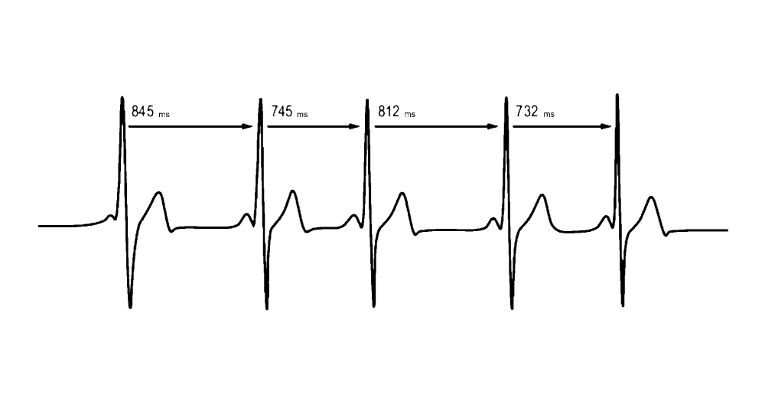
Figure 1. Model of HRV Control. This illustrates independent actions of the vagal, α- and β- sympathetic system. Their action can be assessed by measuring heart rate variability, blood pressure variability, and the baroreflex mechanism. The parasympathetic nervous system is responsible for the bradycardia accompanying baroreceptor stimulation, and for the tachycardia accompanying baroreceptor deactivation, with the sympathetic nervous system also playing a minor role .

The effects of the ANS on the heart’s R-R intervals are complex, resulting from both innervation of the heart and the vasculature. The heart and circulatory system are controlled primarily by higher brain centers (central command) and cardiovascular control areas in the brain stem through the activity of the ANS, which is composed of sympathetic and parasympathetic nerves. The medulla is the primary site to regulate sympathetic and parasympathetic (vagal) outflow to the heart and blood vessels. Specifically, the nucleus tractus solitarius in the medulla receives sensory input and stimulates cardiovascular responses to emotion and stress, including physical stress (e.g., exercise). From the medulla, the parasympathetic vagus nerve innervates the heart, as do sympathetic nerve fibers. The right and left vagus nerves innervate the sinoatrial (SA) and atrioventricular (AV) nodes, respectively. The atria are also innervated by vagal efferents, whereas the ventricular myocardium is sparsely innervated by vagal efferents. Sympathetic efferent nerves are present throughout the atria (including the conduction system), particularly in the SA node and ventricles.

Sympathetic stimulation increases the heart rate, contractility, and conduction velocity, whereas parasympathetic stimulation has the opposite effect. Sympathetic effects are mediated through adrenoreceptors (alpha and beta). Parasympathetic effects are relayed through muscarinic receptors. Autonomic control of the cardiovascular system is also affected by baroreceptors, chemoreceptors, muscle afferents, local tissue metabolism, and circulating hormones (Figure 2). Although both the sympathetic and parasympathetic systems are active at rest, the parasympathetic fibers release acetylcholine, which acts to slow the pacemaker potential of the SA node and thus reduce heart rate.

Figure 2. R-R Variations of R-R Distance, Measured Above, Make Up the Data Used to Calculate the Heart Rate Variability (HRV). Adapted from Aubert et al. (5).

  - Commonly Used HRV Parameters/Descriptors
The most commonly used HRV parameters in ANS evaluation are the frequency-domain, time-domain, and Poincaré plot parameters. While the nomenclature of the different measurements is complex, they represent different ways to look at the variability and distribution of the heart rate over time and parallel the similar, and unique, uses of mean, median, and mode as descriptors of population measurements. Frequency-domain analysis describes high and low frequency rates of the variability changes, which correspond to the activity of different branches of the ANS. By applying these frequency range differences in HRV analysis, researchers are able to distinguish the individual contributions of the sympathetic and parasympathetic systems . Low-frequency (LF) modulation (0.04-0.15 Hz) of R-R interval changes corresponds to the sympathetic and parasympathetic activities together. High-frequency (HF) modulation (0.15-0.4 Hz) of R-R interval changes is primarily regulated through innervation of the heart through the parasympathetic (vagal) nerve. In the second HRV parameter described here, common time-domain parameters reflect the standard deviation (SD) of all N-N intervals (SDNN) that reflect the total variability and the root mean square of SDs between adjacent N-N intervals (RMSSD), which reflects parasympathetic activity . The N-N interval here corresponds to the R-R interval of normal (sinus) beats. In the third HRV parameter represented by the Poincaré plot, a person’s R-R intervals are plotted over time and standard deviation is used to interpret changes seen in the plot. The standard descriptor 1 (SD1) represents the fast beat-to-beat variability in the R-R intervals, while the standard descriptor 2 (SD2) describes the longer-term variability . The SD1 reflects mainly the parasympathetic input to the heart, while SD2 reflects both sympathetic and parasympathetic contributions to the heart.

The HRV increases when respiratory frequency decreases. Although respiration greatly affects the HRV, the absence of standardized models of respiratory frequency makes it difficult to interpret HRV data from that perspective. According to the previous studies, researchers have accepted various respiratory frequency ranges (e.g., from 6 to 15 breaths·min⁻¹). However, it is clear that a self-organized respiratory pattern should be maintained during the recording period . Also, it is important that standard protocols and methods for research with athletes should be established with regard to exercise intensity and duration, respiration rate, position of the body during recording, and duration of recording .

  - Application of HRV on Exercise
Based on data from major indexing sources, the number of studies that have examined heart rate variability (HRV) in general has steadily increased at least 5-fold since 1990 (through 2012), and the number investigating the influences of different physical activities on HRV has risen dramatically since 1999 (Figure 3). The HRV has long been investigated for its role in cardiac health during disease processes. However, recent studies have shown that HRV parameters change during and after exercise. These findings suggest that the HRV parameters could be used to analyze the stress the body experiences during training and to gain insight into physiological recovery after training. In fact, it is reasonable that changes in the autonomic nervous system (ANS) patterns reflected by changes in the HRV may serve as useful parameters for managing physical fatigue and exercise intensity . Moreover, information regarding the extent to which the body recovers after training may provide useful data for the personalization of sports training, training loads, and recovery times.

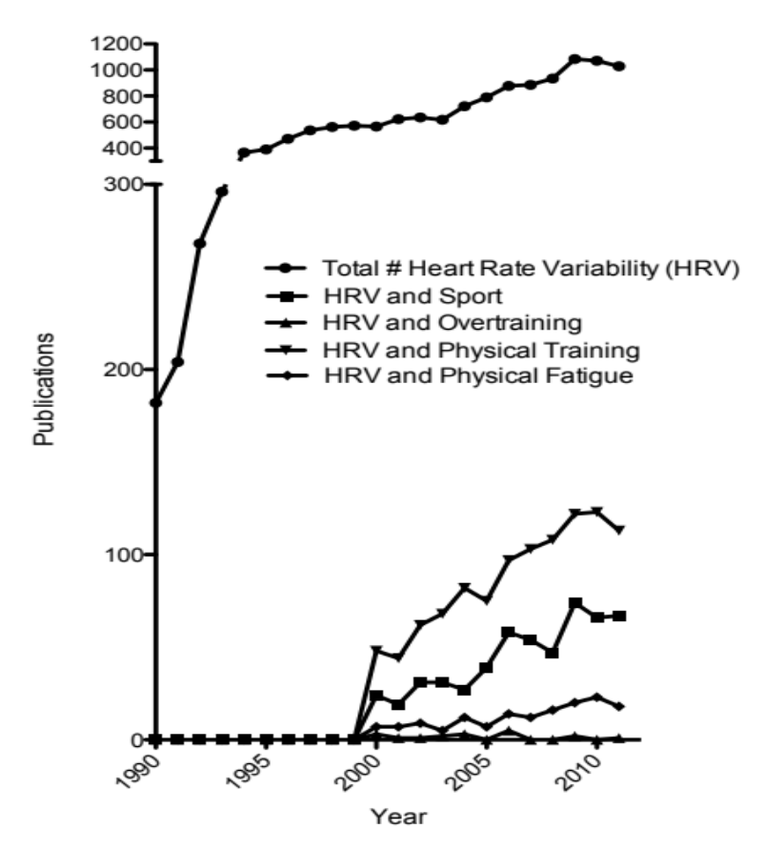

Figure 3. The Number of Publications Having the Key Words “Heart Rate Variability” (HRV), HRV and Sport, Overtraining, and Physical Training has Continued to Increase Since 1990. Based on searches made on four major biomedical and sports medicine databases (detailed in 1.5 Experimental Approach to the Problem Section).
In this review, we summarize how HRV analysis has been reported in sport science. We also discuss the advantages and limitations of the applications of these studies to the training and monitoring of the physiological performance of athletes.

1.5 Experimental Approach to the Problem

Four major biomedical and sports medicine databases (PubMed, MEDLINE, NSCA, and ACSM) were reviewed for studies on heart rate variability and it relationship to exercise training from 1990-2011. The 2001-2010 Proceedings of the German Union for Sport Science were also reviewed. The Union holds annual conferences to discuss the application of HRV in sports. The key search terms were: heart rate variability, HRV and sport, HRV and overtraining, HRV and physical activity, and HRV and physical fatigue. Given the diversity of athlete populations studied, the methodologies and training regimens used, and the mathematical analyses applied in these studies, meta-analysis was not possible.

Subjects and Procedures. To be included in this review, studies had to incorporate research and athletes, individuals who exercised regularly, or sedentary individuals challenged with exercise. Also, the studies had to include the Institutional Review Board or Ethics Committee approval of their projects including the appropriate informed consent.

2. RESULTS
Most athletes understand the importance of recovery after exercise, which is defined as the return of body homeostasis after training to pre-training or near pre-training levels. Recovery involves getting adequate rest before training continues to allow the body to repair and strengthen itself between workouts. By allowing recovery to pre-training or near pre-training levels, recovery supports optimizing future performance. However, according to Zatsiorsky and Karaemer (52) this near-training level is based on the constantly changing dynamic of the athlete and the amount of further training that is encountered. Recovery seeks to minimize the negative effects of training, such as fatigue, of the previous workout while retaining the positive effect (i.e., physical fitness and improved performance). To optimize recovery, monitoring after workouts is very important to avoid excessive accumulation of physical fatigue during preparation or competition. If recovery is not achieved, performance begins to decline, as is seen in the overtraining syndrome in which training for an event or the event itself pushes beyond the body’s ability to recover.

Researchers in the field of sport science are intensely engaged in identifying tools to estimate the quantity of physical stress in the training process needed to optimize competitive performance. The goal of training is to put a sufficient training load on the body to disturb homeostasis and the whole autonomic balance. Athletes may expect a better response in terms of physiological adaptation only if the recovery of the body is sufficient . The question then becomes how to measure the recovery level in an objective manner to maximize the benefits of training.

Traditionally, researchers studying recovery and performance level in the experimental laboratory have assessed aerobic fitness by measuring various parameters, including the maximum oxygen uptake (VO₂ max), minimum velocity needed to reach VO₂ max (vVO₂ max), velocity at the onset of blood lactate accumulation (VOBLA), and repeated sprint abilities. Other factors in the blood have also been described, including creatine kinase, cortisol, white blood cell counts, C-reactive protein (CRP), myeloperoxidase protein levels (MPO), and glutathione status . Although these measures are periodically used to determine performance and recovery , they are either too expensive or complicated for everyday use, even for professional athletes. In addition to requiring large, expensive equipment that is found primarily in performance laboratories, exercise physiologists must be available to conduct the tests and analyze the results. Accordingly, scientists and coaches are looking for useful, noninvasive methods to obtain valuable data about physiological changes that occur in response to physical activity.

Optimal training depends on matching the specific abilities of the individual, such as muscle strength, endurance, explosiveness, and flexibility to the individual’s aerobic capacity, training load, and recovery. Since improvements and adjustments in each of these abilities are constantly changing with continued training, balancing these multiple components to prevent overtraining can be challenging. To this end, the use of heart rate variability (HRV) may be one logical solution because it reflects the major regulatory processes after exercise. While multiple recent studies have used HRV to detect which measures change in relationship to exercise type and intensity, its use also illustrates how monitoring physical fitness during exercise and the post-exercise periods may be applied to athletic training more broadly in the future .

2.1 Basics of Heart Rate Variability (HRV)
The lengths of successive R peaks (RR) in the QRS complex can be described mathematically; the R-R parameter is not consistent between successive R peaks. How this measure varies can be described mathematically in a number of different ways. During the onset of physical activity, R-R intervals become shorter and more uniform (less varied), resulting from increased sympathetic activity and parasympathetic withdraw. It is becoming increasingly appreciated that the variation in R-R intervals can provide actionable information regarding the physiological stress and fatigue levels during and after training. A variety of mathematical and algorithmic models that represent R-R intervals can be used to present the data in time or frequency domains or even in non-linear methods. Despite the complexity of the mathematics involved in these methods, wrist watch monitors such as those made by Polar or Suunto or portable devices made by Omegawave Sport Technology Systems can collect the data for additional analysis using widely available software. As an example, autonomic activation may be evaluated by analyzing the HRV to estimate the sympathetic-vagal balance . The frequency-domain analysis of HRV provides different parameters related to sympathetic activity (low frequency/LF) or parasympathetic (vagal) activity (high frequency/HF). Both LF and HF may be given as absolute values or ratios (LF/HF). Additionally, low frequency and high frequency parameters of HRV may be provided as normalized values (LFn and HFn) by calculating the fraction of LF or HF relative to the total minus very low frequency (VLF) . The standard deviation of the N-N intervals (SDNN) has also been associated with changes in vagal activity .

2.2. Measurement of HRV during Different Exercise Intensities
The sympathovagal balance changes in response to different intensities and durations of aerobic training, as evidenced by changes in HRV measures, including significant changes LF, HF, and total power of the frequency domain. In studies of a recreational cyclist, changes in the HRV power spectra were detected in an intensity-dependent manner (Figure 4). Challenged with a workload of 60 W that was increased by 20 W every 3 min, the HRV power spectra of a cyclist differed quantitatively before and after a series of 20-min exercise pulses at various workloads. At baseline, the normalized LF (LFn) was slightly greater than the normalized HF (HFn). As exercise intensity increased over time, the LF/HF ratio increased with exercise intensity, reflecting an increase in the sympathetic tone (increased LFnu) and a decrease in the parasympathetic tone (decreased HFnu).

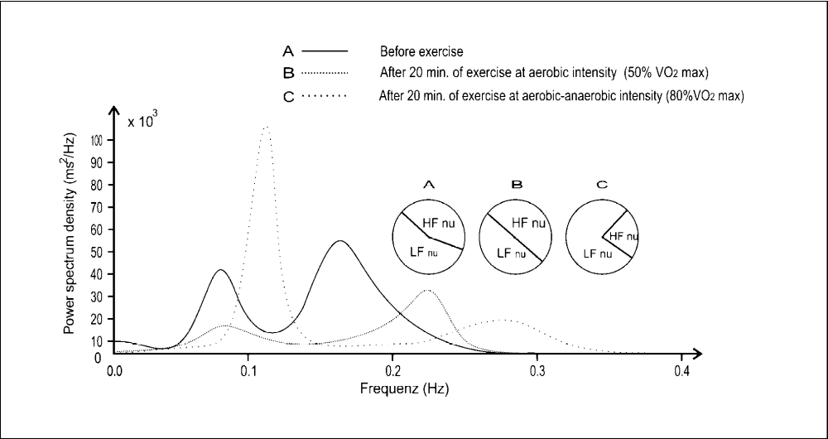
Figure 4. HRV Power Spectra of Recreational Athlete Before and After a Series of 20-min Exercise Impulses at Various Workloads. Vertical axis represents power spectrum density while horizontal axis depicts frequency of each frequency band. Circles describe relationship between Low Frequency (LFn) and High Frequency (HFn) bands in normalized units during rest and different intensity of exercise. The area under three different lines represent area of Total Power (TP) during rest (solid line) and different exercise intensity (dotted lines). A: before exercise; B: at 50% dVO₂/dt max, HR 125 beats·min⁻¹, lactate 1.7 mmol·L⁻¹; C: at 80% dVO₂/dt max, HR 155 beats·min⁻¹, lactate 3.0 mmol·L⁻¹). Used with permission and translated from Hottenrott et al. .

The results of HRV spectra indicated by LFn and HFn in exercise vary between different reports. For example, a study of the differences in HRV at different ventilatory thresholds (VTs) identified a sympathetic predominance (indicated by an increased LF/HF ratio) during relatively less intense exercise and parasympathetic predominance (indicated by a decreased LF/HF ratio) during relatively more intense exercise. Cottin et al. (14) investigated 11 regional elite triathletes (age, 14.6 ± 1.1 yrs) who were challenged with a moderate-intensity test (below VT power) or high-intensity test (above VT power) until exhaustion. Under each circumstance, the R-R interval, VO₂, VCO₂, and blood lactate levels were measure. They identified higher absolute LF, HF, and TP values at moderate-intensity compared to high-intensity cycling. The normalized results indicated that the LFn was significantly higher in cycling below VT (LF 80% ± 10% vs. HF 20% ± 10%, P<0.001), indicating predominance of the sympathetic input . The opposite was seen during heavy exercise (LF 11% ± 8% vs. HF 89% ± 8%, P<0.001), which indicated predominance of the parasympathetic input . These results may be explained by changes in the breathing rate combined with disappearance of the cardiac autonomic control that occurs with heavy exercise conditions. Furthermore, the LF/HF ratio was always >1 for cycling below VT and <1 for cycling above VT (4.92 ± 2.4 and 0.14 ± 0.12, respectively; P<0.001) . This gradual switch of the LF/HF ratio implies the overstepping of the VT and could be a reliable index of VT detection from the HRV.

Although Cottin and colleagues (14) found an HFn predominance only under conditions of high-intensity exercise, Pichon et al. (34) reported different patterns in the HFn and LFn distribution as physical effort increased. Fourteen healthy-trained subjects exercised for 3, 6, and 9 min at 60% and 70% of the power achieved at PVO₂ max and for 3 and 6 min (or 3 min twice) at 80% PVO₂ max (power achieved at maximal oxygen consumption). With increasing exercise intensity, the HFn component reflecting parasympathetic modulation increased, whereas the LFn component reflecting sympathetic modulation decreased. The authors concluded that parasympathetic respiratory control and nonautonomic mechanisms may influence the HF-peak shift with strenuous exercise, whereas the indices of sympathetic activity do not reflect changes in autonomic modulation with exhaustive exercise .

The HRV indices change with exercise, reflecting the changes in the autonomic system that occurs (summarized in Table 1). Recent studies illustrate that exercise and increasing exercise intensities results in detectable changes in HRV measures, reflecting the relative input of the autonomic system the body makes in response.

Table 1. Measurement of HRV during Different Exercise Intensities.

Publication | Subjects Test  (n) Protocol | HRV  Variables | Other  Variables | Results
Hottenrott et al., 2006 | 1 Bicycle ergometer  recreational  cyclist  (male) | HFnu, LFnu | VO₂ max,  lactate,  HR | Changes in the power spectra of HRV were identified with Increased cycling intensity (50% VO₂ max and 80% VO₂ max). Increased LFnu was identified with increased cycling intensity.
Cottin et al., 2004 | 11 Bicycle ergometer  regional  (Enry,  Cedex,  France)  elite  triathletes  (9 males,  2 females) | TP, LF, HF, LFnu, HFnu, LF/HF, RR | VO₂,VCO2,VE, VT, lactate | At moderate intensity, cycling (30% below PVT) compared to high intensity cycling (10% above PVT) higher values of HF, LF and TP was identified. Higher LFnu was seen with moderate intensity cycling, whereas higher HFnu was found at high intensity cycling. LF/HF was always >1 during moderate intensity cycling, whereas during high intensity cycling LF/HF was <1.
Pichon et al. 2004 | 14 Bicycle ergometer  healthy  trained  subjects  (male) | LF, HF, LFnu, HFnu, LF/HF | %PVO₂ max | With increased exercise intensity, increased HFnu and lower LFnu was identified. Increasing exercise intensity was associated with shift HF peak frequency related to an increase in respiratory rate.
LF Low frequency power spectra; HF High frequency power spectra; LFnu Normalized units of low frequency power; HFnu Normalized units of high frequency power; TP Total power of HRV power spectra; LF/HF low frequency power spectra to high frequency power spectra ratio; HR Heart rate; VO₂ max Maximal oxygen consumption; VO₂ Oxygen consumption (absolute in L·min⁻¹); VCO₂ Carbon dioxide release (absolute in L·min⁻¹); VT Ventilatory threshold; %PVO₂ max Percentage of cycling power output achieved at maximal oxygen consumption.

3. Association of Exercise, Gender, and Age with Autonomic Tone
Numerous studies have identified the effects of exercise on enhancing vagal tone. Recently, Tulppo et al. (46) assessed the effects of age and physical activity on vagal modulation by HRV. They compared 3 age groups: young (24-34 yrs), middle-aged (35-46 yrs), and old (47-64 yrs) with 3 different levels of conditioning (based on VO₂ max): poor (28-37 mL·kg⁻¹·min⁻¹); average (38-45 mL·kg⁻¹·min⁻¹); and good (46-60 mL·kg⁻¹·min⁻¹). Using the standard descriptor 1 (SD1) normalized for the average R-R interval (SD1n), subjects from different age groups and conditioning were analyzed for the parasympathetic (vagal) activity at rest and after exercise. SD1n was higher at rest in the young subjects compared to the middle-aged or old (P<0.001). These age-related differences in cardiac vagal activity were not significant after exercise (at 100 W). The age-matched subjects with good, average, and poor VO₂ peaks showed no differences in SD1n at rest, but were significantly different in the low to moderate intensity levels (P<0.001 at 100 W). These findings indicate that poor physical fitness is associated with impairment in cardiac vagal function during exercise, while enhanced vagal activity at younger ages is more evident at rest .

While endurance athletes have an elevated parasympathetic tone compared to more sedentary ones, the effects of resistance training on athletes illustrate gender differences that result from training . In endurance-trained and power-trained track and field athletes tested prior to the 2004 USA Olympic trials, analysis of R-R intervals and HRV indices were collected based on training emphasis and gender (average 24.8 yrs, range 18-33) in 58 women and 87 men (mean 24.81 and 24.56 yrs of age, respectively). Significant differences in selected domain variables (NFnm, LFnm, LH, LHnu, and PNN50) were seen between genders, which illustrated that autonomic control of the heart is not controlled just by conditioning . While previous studies illustrate that elite athletes have a higher parasympathetic tone than recreational athletes and non-athletes, differences between gender, but not aerobic vs. power-based training is seen .

Section Summary: Age, Gender, and Athletic Conditioning Affect the Autonomic Control of the Heart. As summarized in Table 2, Tulppo et al. (46) and Berkoff et al. (7) point out that age, gender, and athletic conditioning are important variables that influence the autonomic control of the heart. Understanding these differences is an important point to consider when HRV is used to prescribe training and/or oversee recovery for specific individuals or groups. Experimentally, researchers should avoid comparing HRV data between older and younger subjects, males and females, and differently conditioned athletes as these variables can confound the findings.

Table 2. Association of Exercise and Age with Autonomic Tone.
Publication | Subjects  (n) | Test  Protocol | HRV  Variables | Other  Variables | Results
Tulppo et al.,  1998 | 110 | Bicycle ergometer | Poincare plot  scattergram, SD1, SD2, SD1n, SD2n, HF | VO₂ max,  age | Younger subjects have higher values of HRV variables at rest and during exercise (until moderate intensity) compared to older subjects. HRV values did not differ in rest between subjects of different fitness level but subjects with better fitness level had a higher value of HRV variables during exercise from low to moderate intensity.
Berkoff et al.,  2007 | 87 men,  58 women | Resting HRV measurement | HFnu, LFnu, LH, LHnu,  pNN50  RMSSD, TP, SDNN | Gender, endurance-trained athletes, power-trained athletes | Significant differences in selected domain variables (NFnm, LFnm, LH, LHnu, PNN50) were seen between genders, illustrating that autonomic control of the heart is not only controlled by the amount of conditioning a person has.
SD1 The standard deviation of the points perpendicular to the line of the identity (Short-term variability); SD2 The standard deviation of the points along the line of the identity (Long-term variability); SD1n Normalized units of the SD1; SD2n Normalized units of the SD2; HF High frequency power spectra; VO₂ max Maximal oxygen consumption.

4. HRV Measurements Taken Post-Exercise: What They Can Tell Us about the Exercise Just Completed

4.1 HRV Taken Immediately Post-Exercise During Recovery Reflects the Effects of the Exercise on the Body
The HRV found immediately after the cessation of exercise reflects characteristic responses the body has to exercise, which is correlates to athletic fitness. Hautala et al. (18) demonstrated this in 10 healthy male cross-country skiers (mean age: 36 ± 11 yrs) during a 75-km race. Analysis of HRV identified that HFn, SD1, SD2, and SDNN were lower on the first day after maximal exercise compared to the pre-exercise values; by day 2, HFn returned to baseline levels. Conversely LFn values were higher on the first day after exercise, dropping to near or below pre-exercise levels on the second day after the race. These studies reveal a reduction in the parasympathetic tone after a cross-country skiing performance and demonstrated that recovery time correlated inversely with the VO₂ max measured during a bicycle exercise test before the race. The reduced vagal outflow appeared to be blunted after prolonged exercise of which it was dependent on the cardiorespiratory fitness of the athlete. An accentuated rebound of altered regulation was found on the second day after prolonged exercise. By linking HRV measurements of VO₂ max, the intensity of the exercise (VO₂ max) was correlated to the HRV measurements.

4.2 Exercise Load Distributions are Reflected by HRV Post-Exercise
Recent studies have found that the determination of HRV immediately after exercise allows analysis of the intensity and type of exercise performed. These studies illustrate a proof of concept that HRV changes occur with increased exercise intensity in several different exercise regimens. Mourot et al. (33) reported that the HRV immediately post-exercise in different training regimens (interval method vs. constant intensity of exercise) resulted in different changes in HRV. HF values during the first hour post-exercise were higher after constant intensity training compared to interval training. The early recovery of autonomic modulation from a bout of exercise (from 5 min to 1 hr after termination of exercise) greatly depended on the distribution of training or exercise load. In particular, athletes showed slower return of parasympathetic activity during short-term recovery after an interval (intensive) method of training compared to constant intensity of exercise . Mourot et al. (33) suggested that this slower return could be due to withdrawal of the parasympathetic activity or more pronounced sympathetic involvement during the interval method compared to the constant method. In contrast to early recovery of autonomic function, late recovery (24 and 48 hrs after termination of exercise) did not depend on the type of exercise (interval training or constant intensity of exercise). The authors concluded that the total exercise load (volume) determined long-term HRV recovery.

4.3 Trained Athletes have Different HRV Post-Exercise than Less Trained Athletes
In a subsequent study, Seiler and colleagues (40) studied highly trained male athletes and found that they had a faster trend in HRV recovery compared to the less-trained athletes after implementation of exercise intensities above the VT during running (>95% VO₂ max). Seiler et al. studied 9 highly trained male runners (VO₂ max 72 ± 5 mL·kg⁻¹·min⁻¹, 14 ± 3 training hr·wk⁻¹) and 8 trained male runners (VO₂ max 60 ± 5 mL·kg⁻¹·min⁻¹, 7 ± 1 training hr·wk⁻¹). They were challenged to 4 intensity-controlled training sessions, and HRV was quantified through 4 hr of recovery. When the highly trained athletes ran 60 or 120 min below their ventilatory threshold 1 (VT1-the point of transition between aerobic energy production to mixed aerobic/anaerobic energy production), the HRV returned to pre-training levels in 5-10 min. Training at their VT2 threshold or higher (defined as the transition to pure anaerobic threshold), however, induced a significant delay in HRV, which returned to baseline by 30 min. In the less-trained athletes, recovery was significantly slower, returning to baseline at >90 min. These studies demonstrate that the HRV recovery depends on the physiological ability of the athlete as well as on the specific performance demands .

4.4 High Frequency Power (HFP) (Vagal Reactivation) after Exercise is Blunted with Increased Exercise Intensity in Sedentary Women
Kaikkonen et al. (25) studied HRV during the first minutes of recovery after exercise immediately after five different constant-speed exercises on 13 sedentary women performed at two low-intensity treadmill exercises at 50% vVO₂ max (short and longer distance), two moderate-intensity exercises at 63% vVO₂ max (short and longer distance), and one high-intensity exercise at 74% vVO₂ max. Upon analysis of HRV during the 30-min post-recovery time, high frequency power (HFP) was found to be higher at the end of exercise after the 1st min (low intensity regimens), after the 4th and 5th min (moderate-intensity regimens), and 30 min (high intensity regimens). Increased HFP and TP were higher during the whole recovery after the shorter distance at low, moderate, and high. Increased HFP, due to vagal reactivation, during the first 5 min of recovery was seen after the low and moderate exercise, but not the high intensity. The high intensity exercise resulted in a slower HFP recovery, and lower HFP and TP compared to low-intensity exercise. This slower vagal activity (slower HFP recovery) after high intensity exercise indicates one parameter that is affected by exercise intensity.

4.5 Post-Exercise, LFP, and TP are Increased with Increased Workload in Male Endurance Athletes
When 8 national-level, endurance-trained males (mean age 26 ± 4) were challenged by Kaikkonen et al. (26) to 2 interval exercise challenges (IV) at increasing intensity (at 85% and 93% vVO₂ max) or 2 continuous exercise challenges (CO) at increasing intensity (at 80 and 85% vVO₂ max), an increased HFP was not identified in the recovery period. This finding is in contrast to prior studies in sedentary women. Both low frequency power (LFP) and total power (TP) were increased during the first 5 min post-exercise in each intervention . During the 30-min recovery period, HFP, LFP, and TP increased slowly to resting values, but HFP remained lower than at rest. In the higher intensity IV and CON training, the increases in HFP, LFP, and TP were attenuated compared to parallel lower intensity training . Understanding these changes that occur with increasing exercise intensity may make them useful to monitor HRV post-exercise to determine training load exerted in these athletes.

In subsequent studies, Kaikkonen et al. (23) investigated 13 male distance runners from marathon clubs (mean age, 35 ± 5 yrs) to determine if post-exercise HRV could detect training load in athletes who were not previously investigated (e.g., endurance trained national athletes). Marathon runners were challenged with moderate-intensity (3 km at 60% VO₂ max), high-intensity (3 km at 85% VO₂ max), and prolonged-intensity (14 km at 60% VO₂ max) exercise on a treadmill. Their HRV values were analyzed at rest, during exercise, and during a 15-min recovery phase. The runners’ rating of perceived exertion (RPE), blood lactate, and HFP were significantly different between the high intensity and moderate intensity runners compared to those challenged with prolonged intensity exercise. With increasing RPE and lactate (measures of training intensity), increased HFP, LFP, and TP were identified at 2 min , which agree with the elevations in these parameters seen in endurance-trained volunteers from athletic clubs and university students described in the paragraph above . The authors also observed a significant delay in HRV recovery after high intensity and prolonged duration of exercise and a significant relationship between post-exercise HRV, the rating of perceived exertion, and lactate (an objective measure of exercise intensity) . These studies confirmed the increases in LFP, and TP post-exercise that are attenuated with increased exercise intensity . Uniquely, they found these changes could be identified at 2 min post-exercise recovery making it pragmatic that HRV could be used in practical settings to evaluate training load using data taken within such a short period after exercise .

Kaikkonen et al. (24) challenged 13 recreational level distance male runners whose goal was to run a marathon in 6 mth (mean age, 35 ± 5 yrs) to even higher (ultra-high) treadmill exercise intensities that included moderate-intensity (85% VO₂ max) and high-intensity (105% VO₂ max). Like their findings in the previous studies (23,26), Kaikkonen and colleagues found that elevations in LFP, HFP, and TP decreased during the first 2 min post-exercise. Interestingly, HRV was able to differentiate between interval exercises of equal work, varying only in intensity or distance of running. This study indicated that not only can immediate post-exercise elevation of HRV values (HFP, LFP, and TP) could be used to differentiate exercise intensity, but that HRV values could differentiate intensity and distance as well. This finding further refines a trainer’s ability to objectively quantify the training load the trained athletes were undergoing. Based on these last 2 studies, a 2-5 min post-HRV recording post-exercise may provide enough information to differentiate exercises with different training load, which may be used to guide training in the future.

Section Summary: Changes in Post-Exercise HRV Can Be Detected in Different Types and Intensities of Exercise. Changes in HRV determined from post-exercise recordings can differentiate between different types and intensities of exercise (summarized in Table 3). While this series of studies provides valuable information on what parameters of HRV may be useful to follow, there are clear differences in the HRV changes seen depending on gender, prior training or lack thereof, or the type (interval vs. continuous) and intensity (VO₂ max) of the exercise performed. Due to the variety of differences in exercises (skiing, running), genders, prior training, it is not clear which HRV variables would be best to use to target optimal training. Future studies will need to determine if common HRV measurements using standardized testing protocols may be applied to athletes of variable conditioning, gender, sport, or type of exercise. These are important points, which have not been answered to date.

Table 3. HRV Measurements Taken Post-Exercise: What They Can Tell Us About the Exercise Just Completed.
Publication | Subjects  (n) |  | HRV  Variables | Other  Variables | Results
Hautala et al., 2001 | 10  healthy male cross-country skiers | 75 km cross country skiing race | LF, HF, LFnu, HFnu, LF/HF, SD1, SD2, SDNN | VO₂ max, HR, Maximal work load in bicycle exercise test, skiing time | HFnu, SD1, SD2, SDNN were lower first day after a race compared to pre-exercise value and returned to or even exceeded the prerace level on the second day. LFnu was higher on the first day after race compared to the prerace level and returned to or even dropped below pre-exercise level on the second day. VO₂ max of subjects showed strong inversely correlation with HRV recovery time, illustrating that HRV changed with increased exercise intensity.
Mourot et al., 2004 | 10 healthy, moderately trained males | Bicycle ergometer | TP, LF, HF, LF/TP, HF/TP, LF/HF | VT, VO₂VT, RRVT, WVT, f, SAP, DAP | HF values during first hour of recovery were higher after constant intensity training (WVT) compared to interval training (Nine consecutive periods of 4 min. base work rate followed with 1 min of WVT or maximum power output). Short term HRV recovery was dependent on type of exercise (constant or interval exercise), contrary to long term HRV recovery. Short term HRV recovery was slower at interval type of training compared to constant.
Selier et al., 2007 | (17 total)  9 Highly trained and 8 trained male runners | Treadmill  running, Outdoor running | HFnu, LFnu, mean RR interval, RMSSD, pNN50 | VO₂ max, lactate, RPE, HR, VT1, VT2, VE/VO₂, VE/VCO₂ | Recovery of HRV indices returned to baseline faster in highly trained subjects than in trained subjects after high intensity exercise. Delays in recovery time of HRV indices were seen after high intensity exercise compared to low intensity exercise.
Kaikkonen et al., 2007 | 13 sedentary females | Treadmill running | HFP, TP | VO₂ max, vVO₂ max, lactate, rating of perceived exertion at end of exercise, | Five different constant speed challenges were given: 2 low intensity challenges (50% vVO₂ max – for either 3500 m or 7000 m), 2 medium intensity challenges (63% vVO₂ max – for either 3500 m or 7000 m), and 1 high-intensity challenge (74% vVO₂ max – at for 7000 m). High frequency power (HFP) was higher at the end of exercise after the 1st min (low intensity regimens), after the 4th and 5th min (moderate-intensity regimens), and 30 min (high intensity regimens). Increased HFP, due to vagal reactivation, during the first 5 min of recovery was seen after the low and moderate exercise, but not the high intensity.
Kaikkonen et al., 2008 | 8 national level endurance trained males | Treadmill running | HFP, LFP, and TP | VO₂ peak, RPE, Lactate | Low frequency (LFP) and total power (TP) were increased during the first 5 min post-exercise in each intervention (2 interval interventions (IV) at 85 and 93% vVO₂ max or 2 continuous (CON) interventions at 80 and 85% vVO₂ max. Further, they found that during the 30-min recovery period, HFP, LFP, and TP increased slowly to resting values, but HFP remained lower than at rest. In the higher intensity IV and CON training, increased HFP, LFP, and TP was attenuated compared to parallel lower intensity training.
Kaikkonen et al., 2010 | 13 distance runners from marathon clubs (males) | Treadmill  running | HFP, TP | VO₂ max, lactate, VO₂,  Speed, RPE | Significantly delayed HRV recovery was identified with a high intensity (3 km at 85% VO₂ max) and prolonged moderate intensity (14 km at 60% VO₂ max) of constant load exercise compared to moderate intensity exercise (3 km at 60% VO₂ max).
Kaikkonen et al., 2012 | 13 recreational level distance runners whose goal was to run a marathon in 6 mth | Treadmill  running | LFP, HFP, TP | VO₂ max, lactate, EPOC, RPE, TRIMP | Elevations in LFP, HFP, and TP were decreased during the first 2 min post-exercise. HRV could differentiate between intensities of exercise. High intensity interval exercise provoked slower short-term recovery of HRV. Interval exercise of same intensity, but different durations, have minor differences in HRV recovery dynamics during the first 5 min of recovery. Exercise challenges with longer duration have slightly slower HRV recovery.
LFP Low frequency power spectra; HFP High frequency power spectra; LFnu Normalized units of low frequency power; HFnu Normalized units of high frequency power; VO₂ max Maximal oxygen consumption; EPOC Excess post-exercise oxygen consumption; TRIMP Training impulse; RPE Rating of perceived exertion; LF/TP low frequency power spectra to total power spectra ratio; HF/TP High frequency power spectra to total power spectra ratio; LF/HF low frequency power spectra to high frequency power spectra ratio; VO₂ max Maximal oxygen consumption; VT Ventilatory threshold; VT1 First ventilatory threshold; VT2 Second ventilatory threshold; V_{E}/VO₂ Ventilatory equivalent for oxygen; V_{E}/VCO₂ Ventilatory equivalent for carbon dioxide; VO₂VT Oxygen consumption at ventilatory threshold; RRVT R-R intervals at ventilator threshold; WVT Cycling power output at ventilator threshold; f Breathing frequency; SAP Systolic arterial pressure; DAP Diastolic arterial pressure; HR Heart rate; SDNN Standard deviation of the NN (normal to normal intervals that do not differ more than 50ms) intervals; SD1 The standard deviation of the points perpendicular to the line of the identity (Short-term variability); SD2 The standard deviation of the points along the line of the identity (Long-term variability); RMSSD Root mean square of sequential deviation; pNN50 Percentage of all sequential RR deviations exceeding 50 ms.

5. HRV as a Monitoring Tool in Athletic Training Programs
Long-term HRV changes during a prolonged period of exercise (>4 wks) appear to be a potentially good indicator of physiological adaptation in athletes, which could help in the planning of training programs. Based on these observations, several researchers (35,36) have investigated the utility of prescribing daily exercise intensity based on the HRV of the athlete, lowering the intensity if the athlete’s HRV decreases. These groups found that modulating the exercise intensity based on HRV maintained fitness levels compared to control groups, indicating the utility of HRV use in athletes.

Kiviniemi et al. (29) identified the usefulness of HRV measurements in prescribing exercise training in moderately active men and women. They reported that 21 men and 32 women were prescribed standard training or HRV-guided training, which included 8 wks of moderate training (70% max HR) or vigorous training (85% max HR). The standard training group performed ≥2 sessions at moderate- intensity and ≥3 sessions at vigorous-intensity weekly. The HRV-1 and HRV-2 groups trained based on changes in HRV. The HRV-1 group, defined as an increase or no change in HRV, performed vigorous-intensity training. The HRV-2 group, defined as a decrease in HRV, performed moderate-intensity exercise. The peak VO₂ max and maximal workload (Loadmax) were measured on a bicycle ergometer before and after the training.

No differences in VO₂ max were found between the standard and HRV-guided training groups. However, in men, the workload (Loadmax) was higher in the HRV-1 group than in the standard training group. In the women, no differences in workload were seen between the groups. These are significant findings because improvements in performance were seen in both the HRV-guided and standard training groups. These results parallel the researchers’ previous work (30) that investigated the utility of HRV in daily endurance exercise prescriptions in 26 moderately fit males during a 4-wk training period. They identified similarly beneficial outcomes in individuals who were prescribed lower-intensity exercise with decreased HRV. Although these studies are promising, their applicability to less-active people has not been tested. Therefore, the results should be interpreted with caution when applied to non-trained athletes or subjects with lower levels of physical ability .

Aimet et al. demonstrated that specific HRV dynamics correlate with the levels of anaerobic thresholds (i.e., lactate turn point 2, also known as VT2; a useful parameter to guide future training). Identifying this threshold rather having to determine blood lactate levels and VO₂ max values allows for the non-invasive evaluation of the anaerobic thresholds that can be used to guide future exercise to optimize performance. They investigated 53 subjects (27 males with a mean age, 21-79 yrs) with poor to trained fitness levels. Several HRV parameters were measured during both the 1st min of exercise (incremental ergometer cycling until exhaustion) and the 3rd min of the recovery period. These researchers reported that HRV parameters decreased with increasing exercise challenge, and that the decrease had its own minimum value, designated as the lactate turn point 2 (LTP2), which corresponded to the anaerobic threshold (refer to Figure 5).

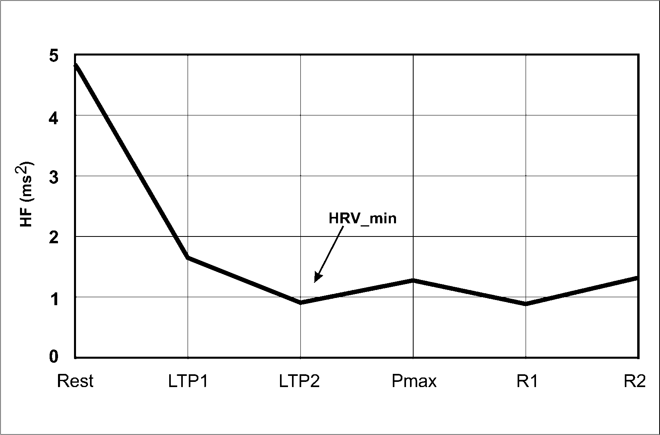
Figure 5. Mean High Frequency (HF) Curve of All Subjects at Rest, During the Cycle Ergometer Test and In Recovery (abscissa-steps; ordinate-HF parameter). LTP1: lactate turn point 1; LTP2: lactate turn point 2; P_{max}: maximal power output; R1: recovery after first minute; R3: recovery after third minute. In this figure is presented High Frequency Power (HF) trend but all other frequency bands (TP, VLF and LF) had similar shape and trend. Adapted from M. Aimet et al. (OpenAccess) .

When male soccer players (n = 31, age: 14-16 yrs) were challenged with a standardized cycling challenge (30 W, increasing in increments of 40 W every 3 min until subjective exhaustion), significant correlations among maximal performance, lactate levels (increased muscle damage), and ventilatory equivalents to HRV variables were identified by Röttger and colleagues. Both SD1 and RMSSD decreased during progressive increases in intensity, and the decrease had its own minimum (designated as the HRV-minimum). After SD1 and RMSSD reached their minimums, they increased if the exercise intensity increased simultaneously. Three lactate values (2, 3, and 4 mM) were reported to correlate with cycling powers (P_L2, P_L3, and P_L4, respectively) and with the cycling power at HRV-minimum (P_HRVmin) (L2 r = 0.69, P<0.001, L3 and L4 r = 0.73, P<0.001). Subjects with higher values of SD1 and RMSSD at HRVmin have higher vagal activity during higher intensity of exercise and, thus better physiological performance. These findings suggest that employing HRV analysis to evaluate anaerobic thresholds to drive future training may have some utility, although this was not determined directly.

Section Summary: HRV as a Monitoring Tool in Athletic Training Programs. Using HRV to prescribe daily exercise intensity or identify anaerobic threshold by HRVmin has been used to monitor athletic training programs (summarized in Table 4). The monitoring of the body’s reaction to exercise without invasive studies of lactate or ventilatory thresholds using HRV parameters represents a potential alternative that could be applied more broadly to athletic training to optimize fitness levels in athletes. These findings lead to the application of HRV in monitoring training in subsequent studies that are discussed in the next section.

Table 4. HRV as a Monitoring Tool in Athletic Training Programs.
Publication | Subjects  (n) | Test  Protocol |  | HRV  Variables |  | Other  Variables |  |  | Results
Kiviniemi et al., 2010 | 53 moderately fit subjects (21 men,  32 women) |  | Bicycle ergometer, different aerobic training  sessions |  | SD1, RR |  | VO₂ max, Loadmax, HR | No differences in VO₂ max were observed between groups that used standard trainings (ST) and trainings based on HRV values in recovery (HRV group). In men, maximal workload (Loadmax) was higher in HRV group then in ST group, whereas in women, no differences were observed in Loadmax between the groups.
Kiviniemi et al., 2007 | 26  moderately  fit  males |  | Treadmill  running, Outdoor running |  | HF, RR |  | VO₂ peak, Loadmax, HR | In the group with predefined training program (TRA), maximal running velocity (Loadmax) increased whereas no significant changes were observed in VO₂ peak. In the group that training intensity was defined by HRV values in rest (HRV group), significant increases in VO₂ peak and Loadmax, respectively were identified.
Aimet et al., 2001 | 53 subjects with different fitness levels from poor to trained athletes (Age, 21-79, 27 males, 26 females) |  | Bicycle ergometer |  | SD1, ULF, VLF, LF, HF, TP |  | VO₂ max, lactate, HR, HRVmin, Loadmax, LTP1, LTP 2 | TP, VLF, LF and HF showed minimum values (HRVmin) during exercise test until exhaustion, which then they were starting to increase toward Loadmax. HRVmin from TP, VLF, LF and HF was occurred at LTP2. SD1 showed decreasing trend until LTP1 point where then leveling off occurred. ULF demonstrated continuously decreasing trend toward Loadmax after which it started to increase in recovery period.
Röttger et al., 2005 | 31 trained male adolescents (Ages, 14-16) |  | Bicycle ergometer |  | SD1, RMSSD |  | VO₂ max, lactate, HR, P_max, P_HRV_{min}, P_L2, P_L3, P_L4, P_RE | 20 of 31 subjects presented HRV-minimum at the lactate level of 3.6. mmol·L⁻¹, 90% of HR max, 78% of VO₂ max, 76% of P_max, 95% of P_L4 and 90% of P_RE. It was observed significant correlation between P_HRVmin and P_RE, P_max, P_L3 and P_L4.
RR R wave to wave R interval; VO₂ peak Peak oxygen consumption; HR Heart rate; Loadmax Maximal workload; HF High frequency power spectra; SD1 The standard deviation of the points perpendicular to the line of the identity (Short-term variability); RMSSD Root mean square of sequential deviation; P_max Maximal workload at bicycle ergometer; P_HRVmin Cycling workload at minimum of SD1 and RMSSD with a subsequent rise to the end of the test; P_L2, P_L3, P_L4 Workload of cycling at lactate level of 2, 3 and 4 mmol/L; P_RE Workload of cycling at the respiratory equivalent; TP Total power of HRV power spectra; LF Low frequency power spectra; HF High frequency power spectra; VLF Very low frequency power spectra; ULF Ultra low frequency power spectra; HR Heart rate; LTP1 Lactate turn point 1 (aerobic threshold); LTP2 Lactate turn point 2 (anaerobic threshold); HRVmin Minimal reached values of HRV parameters during exercise, after they started to increase; VO₂ max Maximal oxygen consumption.

6. HRV, Overtraining, and Over-Reaching States
In athletes, HRV monitoring is frequently applied to the prevention and diagnosis of overtraining (OT) syndrome, which is associated with numerous symptoms including ANS dysfunction and imbalance . Researchers (21,22) have developed a test to diagnose fluctuations in the ANS and the OT state by measuring the orthostatic HR that occurs between sitting and standing. Athletes in an OT state may show a significant drop in frequency domain (TP, LF, and HF) and time domain (RMSSD and SDNN) variables, whereas Tian and colleagues (45) observed additionally hyper-responsiveness in frequency and time domain variables in OT athletes.

There have been reports that changes in HRV do not occur in over-trained athletes with short-term training (i.e., 6 d) or long-term (6 mth) over-training . In contrast, others have reported predominance of either LF (sympathetic) or HF (vagal) parameters. For example, studies by Hottenrott et al. (21) have shown changes in the HRV HF and LF parameters (Figure 6) with significant decreases in HF (decreased vagal activity) and increases in LF (sympathetic activity) during the 1st 6 d of intensive boot camp training in one subject. This shift from vagal to sympathetic predominance has also been reported in female athletes assayed for HRV in the supine rest position after 6 to 9 wks of high-intensity training .

Bosquet et al. (10) examined 9 experienced endurance athletes who increased their usual amount of training by 100% within 4 wks. HRV analysis of ECG was recorded during sleep at baseline, after overtraining, and 2 wks after recovery. Overtraining was diagnosed in 6 subjects by physiological and psychological criteria; however, no differences in HRV determined from sleep recordings were noted. There were no changes in ANS activity in general (LF + HF), no changes on the sympathetic (LF/HF) and parasympathetic activity (HFnu) in baseline, after overtraining, or after recovery . While it is possible that these HRV parameters did not differ between groups, various respiratory issues have been suggested to possibly interfere with the HRV recordings. Hence, more sophisticated measures are needed to rule out this method of assessing over-training.

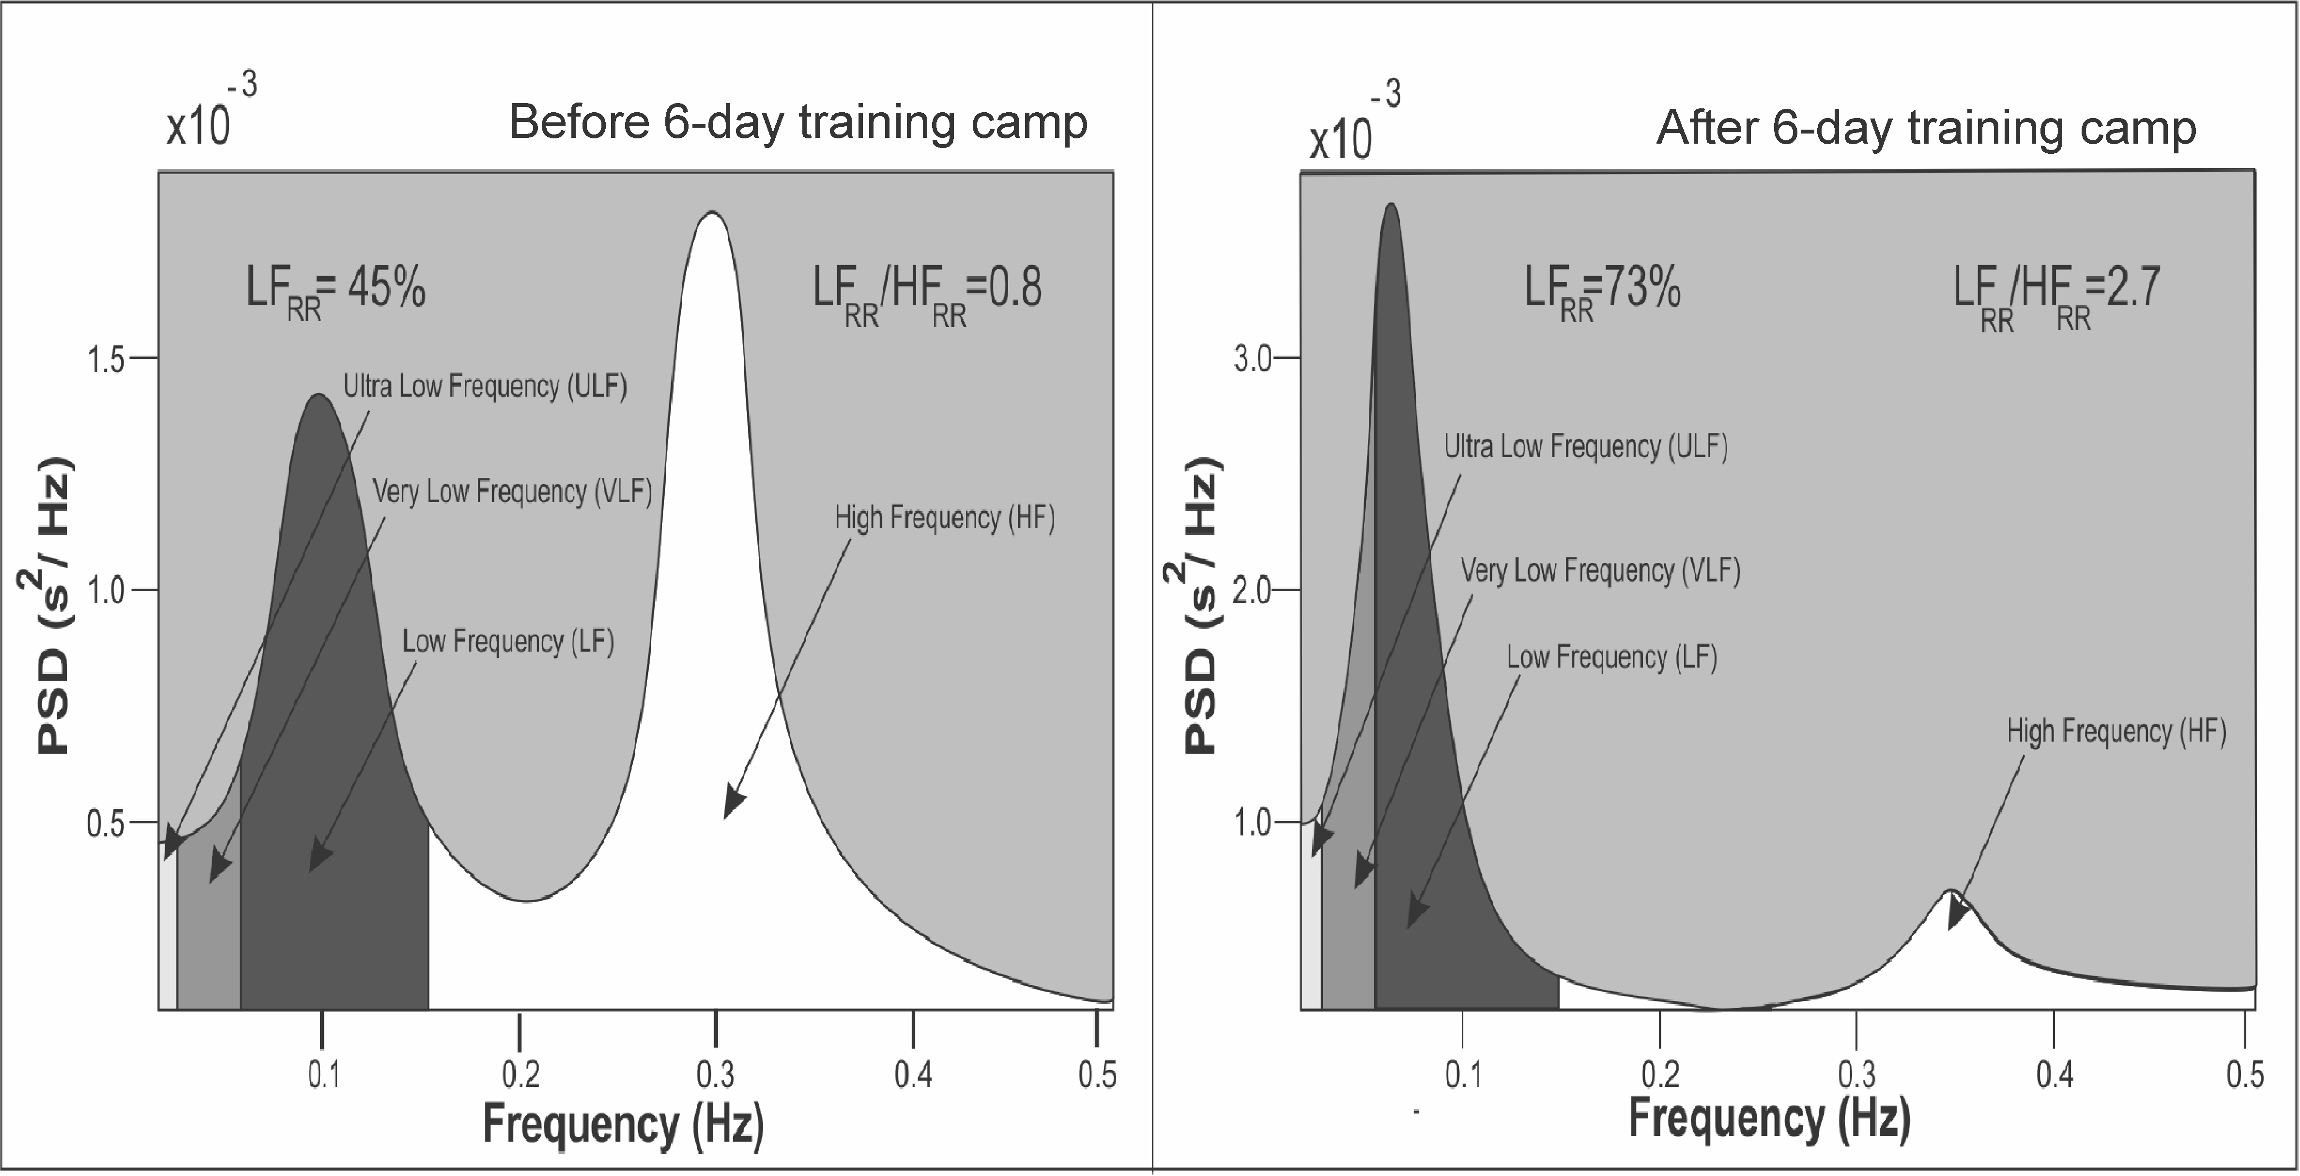
Figure 6. Temporal Changes of the HRV Power Spectrum of a 57-yr-old Male Endurance Athlete Before (left) and After (right) Completing a 6-d Training Camp, During Which Each Participant Accomplished an Overall Distance of 1,100 km (on average 183 km·d⁻¹) on a bicycle. Interestingly, the values of the HRV time domains indices, which were already reduced before the very beginning of the tour, exhibited a further marked reduction while LF/HF ratio increased with completion of the camp: Heart Rate (HR): 55 beats·min⁻¹ (63 beats·min⁻¹), SDNN: 33 ms (22 ms); RMMSD: 27 ms (7.7 ms); pNN50: 7.9 (0); LF/HF: 0.8 (2.7). Used with permission and adapted from Hottenrott et al. .

Mourot and colleagues (32) investigated the OT state in 7 athletes (5 women and 2 men; 2 were endurance runners, 4 were cross-country skiers, and 1 was a motorcyclist). All 7 subjects suffered from OT syndrome compared to 8 endurance-trained athletes who had performed physical training for at least 3 yrs and 8 sedentary controls. A special tilt test from supine to the 60° upright position was performed to allow the investigators to exclude blurring of sympathetic activity that occurs in the supine position. The findings indicated a marked predominance of sympathetic modulation in the overtrained athletes (OA) in both positions compared to the athletes categorized as non-overtrained (NOA) who had predominance of parasympathetic modulation only in the supine position. During the tilt test, the reactivity of the ANS was higher in the NOA group compared to the OA group (P<0.05). This indicated a low responsiveness of baroreflex sensitivity in OA due to the OT state . The TP, LF, HF, SD1, and SD2 (standard descriptor 2) values were higher in the NOA compared to the OA athletes in the supine and upright positions. This study also demonstrated that the shape of the Poincaré scatter plot might be used to distinguish OT from the non-OT state, with narrower patterns being associated with increased sympathetic activity. An elliptic disperse shape of the scatter plot was associated with relaxation and good balance of the ANS, whereas a more narrow shape was associated with ANS imbalance (Figure 7).

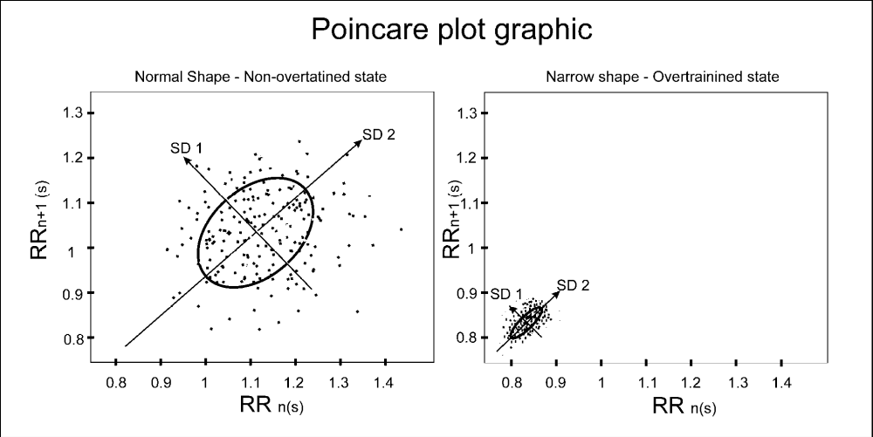
Figure 7. Non-Overtrained State (left) and Overtrained State (right) Presented through Poincaré Plot Graphic. Each of the dots are composed of two R-R intervals: RRn (horizontal axis) and RRn+1 (vertical axis). Place where SD1 and SD2 lines cross each other represent mean value of all R-R intervals. Line-of-identity is presented by SD2 line and all dots along the line-of-identity corresponding to long-term variability (i.e., sympathetic and parasympathetic modulation) while all perpendicular to line-of-identity (SD1) corresponding to short-term variability (i.e., parasympathetic modulation).

Hedelin et al. (20) reported on the effects of OT in a junior cross-country skier, who presented with reduced performance in competitions, early breathlessness in training, and central fatigue. When a power spectral analysis of the HRV was performed at rest, during OT, and after recovery, it was found that HF and TP were higher in the lying position compared before and after OT. This shift towards increased HRV in the HF range along with a reduced HR suggests an extensive parasympathetic modulation during OT. This finding is in contrast to the sympathetic predominance identified during the 6 d of intensive boot camp and athletes in the OT state described in the 3 studies above .

To illustrate the utility of HRV monitoring to prevent the “pre-overtraining” state, Tian et al. (45) recently used HRV to detect changes in 34 elite women wrestlers (age, 23 ± 3 yrs) – some of which exhibited over-reaching states. HRV was used to detect non-functional (NFOR) over-reaching states that are periods when athletic performance is substantially decreased due to prolonged intensive training. Supine HRV was analyzed weekly at the same time of day using time and frequency domain before 11 competitions. In the course of the study, 7 athletes were found to be in NFOR state and 2 athletes in a functional (FOR) state (i.e., the brief reduction in performance, followed by performance super-compensation) . Some of athletes in both overreaching states demonstrated decreased HRV variables while some hyper-reactiveness was found in the same variables. These findings indicate that it is possible to identify overreaching states in professional athletes by the means of HRV measurements. Since athletes in overreaching states demonstrated decreased or increased HRV values during FOR or NFOR when compared to normal values, it is likely that with more research they may be useful for monitoring overtraining states more broadly.

Section Summary: HRV Changes are Detectable in Overtraining and the Over-Reaching (Pre-OverTrained) State. Multiple studies illustrate that HRV variables change in the context of overtraining (summarized in Table 5). Several studies reported changes in HRV variables that reflect enhanced sympathetic activity at rest in the overtrained state while others identified a predominance of parasympathetic activity at rest in the overtrained states. The different forms of overtraining that have been described may explain the changes. Specifically, overtraining associated with increased exercise volume (sets x repetitions) and intensity (percent repetition maximum) has been associated with a sympathetic or parasympathetic predominance, respectively . Recent studies also provide evidence that in the early stages of overtraining, designated as overreaching phases, HRV may be characterized by a sympathetic dominance. When this over-reaching phase occurs over a longer period of time, then, the development to that of the overtrained stated, as characterized by parasympathetic predominance, may ensue .

Table 5. HRV, Overtraining, and Over-Reaching States.
Publication | Subjects  (n) | Test  Protocol | HRV  Variables | Other  Variables | Results
Hedelin et al.,  2000 | 9 International Class Canoeists (6 men, 3 women) | Treadmill running, cross-country skiing, strength training | LF, HF, TP | VO₂ max, lactate, HR, RPE, plasma volume, resting cortisol, resting level of adrenalin and noradrenalin | There were no changes in LF, HF and TP in subjects, which could indicate overtrained state.
Hynynen et al.,  2006 | 24 endurance athletes. 12 over-trained athletes (6 women, 6 men) and 12 control athletes (6 women, 6 men) | Two groups: Overtrained and control group. Treadmill running, bicycle ergometer, Nordic walking | RR, SDRR, RMSSD, LF, HF, TP, LF/HF | VO₂ max , resting cortisol, resting level of adrenalin and noradrenalin | Overtrained athletes demonstrated imbalance of cardiac autonomic modulation after awakening but not during night sleep.
Uusitalo et al.,  2000 | 15 endurance athletes (female) | Treadmill running, cross-country skiing, cycling, swimming | RR, SDRR, RMSSD, VLF, LF, HF, TP, 30/15 index, LF/HF, | VO₂ max, lactate, HR, SAP, DAP, V_{E}/VO₂ | Athletes who are diagnosed as overtrained athletes demonstrated different sympathetic excitability during prolonged standing after head-up tilt. LF in overtrained athletes was elevated in rest supine position, which was induced by heavy endurance training.
Bosquet et al.,  2003 | 9 moderately to well-trained male endurance athletes (6 runners, 3 triathletes) | Distance running | LF, HF, TP (LF+HF)*, HFnu, LFnu, LF/HF | Lactate, HR | There were no significant differences in HR, LF+HF, LF/HF and HFnu in overtrained subjects during overtraining and recovery period.
Mourot et al.,  2004 | 7 professional athletes (5 women, 2 men); 8 endurance trained subjects (4 women, 4 men); 8 sedentary control subjects (4 women, 4 men) | Three groups: Overtrained (OA), endurance trained (T) and sedentary control group (C). Tilt test 60° | LF, HF, TP, LF/HF, LF/TP, HF/TP, RR, SDRR, pNN50, RMSSD, SD1, SD2, SD1n, SD2n, | Hemoglobin, red blood cells, white blood cells, ferritin, urea, cortisol | RR, SDNN, RMSSD, pNN50, TP, HF, SD1 and SD1n were significantly higher in T than in OA and C. HF/TP was higher in C than in T and OA. LF/HF was higher in OA compared to other two groups, whereas LF/TP, SD2 and SD2n were higher in T group. Overtrained subjects exhibited during tilt test lowest reactiveness of autonomic nervous system.
Hedelin et al.,  2000 | 1 cross-country male skier (16 years old) | Case study. Tilt test 70° | LF, HF, TP, HFnu, LFnu | HR, hemoglobin, white blood cells, ferritin, cortisol, luteinizing hormone (LH) | HF and TP were higher in lying position during overtrained state compared before overtraining and during recovery period, indicating a predominance of parasympathetic activity during overtrained state.
Tian et al.,  2012 | 34 female wrestlers | HRV measured 6 wks prior to each tournament | TP, LF, HF, LF/HF, VLF, SDNN, rMMSD | VO₂ max, FOR/NFOR/OTS | The pre-overtraining state (i.e., over-reached states) in athletes demonstrate a significant decrease or increase in time domain HRV indices (rMSSD and SDNN).
LF Low frequency power spectra; HF High frequency power spectra; TP Total power of HRV power spectra; VLF Very low frequency power spectra; LF/HF low frequency power spectra to high frequency power spectra ratio; LF/TP low frequency power spectra to total power spectra ratio; HF/TP High frequency power spectra to total power spectra ratio; RPE Rating of perceived exertion; VO₂ max Maximal oxygen consumption; HR Heart rate; SDRR Standard deviation of all RR intervals; RMSSD Root mean square of sequential deviation; RR (RRI) R wave to wave R interval; SAP Systolic arterial pressure; DAP Diastolic arterial pressure; 30/15 index RRlmax30 /RRImin15 where RRlmax30 denotes the longest RRI closet to the 30th RRI and RRImin15 denotes the shortest RRI close to the 15th RRI; V_{E}/VO₂ Ventilatory equivalent for oxygen; LFnu Normalized units of low frequency power; HFnu Normalized units of high frequency power; SD1 The standard deviation of the points perpendicular to the line of the identity (Short-term variability); SD2 The standard deviation of the points along the line of the identity (Long-term variability); SD1n Normalized units of the SD1; SD2n Normalized units of the SD2; pNN50 Percentage of all sequential RR deviations exceeding 50 ms. *Some authors use for total power spectra LF+HF instead of TP

7. DISCUSSION

The use of HRV to identify ANS changes in athletic performance has been increasingly researched and analyzed in recent years, it has been used primarily with trained athletes. The prospective use and application in sports training have been minimally studied. In contrast to the standard laboratory measures of athletic performance (such as VO₂ max), the use of the noninvasive HRV represents an inexpensive alternative to evaluate and promote training to enhance performance in both the highly trained and the less-trained athletes. In this review, we present evidence that HRV measurements change with different exercise intensities and during recovery. The changes in HRV demonstrated by monitoring ECG immediately post-exercise, for example, illustrate the potential application that could give athletes and trainers immediate feedback on the body’s response to a workout. This may then guide the next steps in training to optimize fitness and recovery and minimize over-training and over-reaching.

The studies presented here demonstrate that HRV measurements change with exercise intensity. For example, Hottenrott et al. (21) demonstrated that increased exercise intensity was associated with an increased LF/HF ratio, reflecting increased sympathetic tone in recreational cyclists. Elite triathletes challenged with moderate-intensity and high-intensity exercise tests showed increased sympathetic and parasympathetic tone, respectively . Similarly, during exhaustive exercise, Pichon et al. (34) reported increases in parasympathetic input. These studies indicate that, depending on the length and intensity of exercise, the autonomic input may be sympathetic up to a point with parasympathetic predominance at exhaustion.

The HRV during the exercise recovery period may offer some insight into training in athletes. In marathon distance runners, the HRV during the recovery period of high-intensity training was more sympathetic, whereas lower-intensity training was associated with more vagal tone . Recovery of HRV changes due to exercise appears to depend on the training load. Athletes showed a slower return of parasympathetic activity during short-term recovery after interval training compared to constant exercise . However, late recovery at 24 hrs and 48 hrs after exercise did not appear to show these changes. The fitness of an athlete also affects the HRV during recovery. Hautala et al. (18) identified a reduced parasympathetic tone after cross-country skiing performance. This blunted vagal outflow after exercise was dependent on the fitness of the athlete. As expected, HRV recovery time is reduced in highly trained athletes compared to less trained athletes. Given this relationship between HRV recovery time and fitness, the HRV recovery time might be a good indicator of fitness that could be regularly monitored.

Multiple studies have shown that using HRV as a monitoring tool in athletic training programs may be beneficial. In recent studies, the use of HRV as a training guide resulted in improvements in men when compared to standard training . These studies demonstrated that backing off on the strenuousness of exercise when HRV was decreased did not hamper overall performance and, in some groups (men), the performance was better than with standard training regimens. Other studies (4,29,39) have shown that HRV parallels changes in VO₂ max, lactic acid levels, and vagal modulation. Guiding exercise by HRV may be an efficient way to measure these several critical indicators that are not generally easy to monitor in a routine setting. Because HRV monitoring can accurately detect these key indicators of OT, it is not surprising that HRV is a good monitor of OT as well. Multiple studies (21,32,48) have indicated that shifts of HRV from vagal to sympathetic dominance result when OT occurs. Researchers (10,19,20,22,32,45,48) have monitored the imbalance in autonomic activity that occurs with OT by HRV in both non-athletes (boot-camp participants) and athletes. These findings may offer another application of HRV monitoring to guide OT in amateur and professional athletes alike.

8. SUMMARY

Determination of HRV has been used to guide therapy in patients at risk for sudden cardiac death and diabetic autonomic neuropathy . Despite the increasing availability of heart rate monitoring systems using watches, HRV is not routinely applied to sports and training sciences and only has research application at this time. As illustrated in Tables 1-5, standardization of reliable measures for prospective training feedback is not presently available. Although more work is needed to determine how HRV can be applied more broadly, particularly to non-athletes, the technology to perform HRV studies is largely available to almost anyone, making its application increasingly attractive. For example, small wristwatch computers capable of collecting accurate HRs and R-R interval data and free software to calculate HRV measurements are readily available, such that implementing HRV analyses into routine exercise is possible. There are even HR monitors that integrate some HRV analyses directly, thus allow for the monitoring of real-time changes in HRV and, consequently, disturbances in the ANS. However, until dependable models of HRV are available that are applicable to specific populations, it is not currently used beyond specific research settings as described in this review. Analysis of the HRV may allow an inexpensive, fast, and noninvasive method to establish relevant parameters that can be followed throughout a training season.

ACKNOWLEDGMENTS
The authors wish to thank Dr. Aimen Farraj of the US Environmental Protection Agency for his insightful comments and suggestions on working drafts of this manuscript.

Address for correspondence: Monte S. Willis, MD, PhD, McAllister Heart Institute, University of North Carolina, 2340B Medical Biomolecular Research Building, 111 Mason Farm Road, Chapel Hill, NC 27599-7525. Phone: (919) 843-1938; Fax: (919) 843-4585; Email: monte_willis@med.unc.edu

REFERENCES

- Heart rate variability. Standards of measurement, physiological interpretation, and clinical use. Task Force of the European Society of Cardiology and the North American Society of Pacing and Electrophysiology. Eur Heart J. 1996;17(3):354-381.

- Acharya UR, Suri JS, Spaan JAE, Krishnan SM. Advances in Cardiac Signal Processing. Berlin, New York: Springer, 2007.

- Achten J, Jeukendrup AE. Heart rate monitoring: Applications and limitations. Sports Med. 2003;33(7):517-538.

- Aimet M, Pokan R, Schwieger K, Smekal G, Tschan H, von Duvillard SP, Hofmann P, Baron R, Bachl N. Heart Rate Variability During Exercise and Recovery. Tokai J Sport Med Sci. 2001;x(x):7-14.

- Aubert AE, Seps B, Beckers F. Heart rate variability in athletes. Sports medicine. 2003; 33(12):889-919.

- Beck LS, Ammann AJ, Aufdemorte TB, Deguzman L, Xu Y, Lee WP, McFatridge LA, Chen TL. In vivo induction of bone by recombinant human transforming growth factor beta 1. J Bone Miner Res. 1991;6(9):961-968.

- Berkoff DJ, Cairns CB, Sanchez LD, Moorman CT. Heart rate variability in elite American track-and-field athletes. J Strength Cond Res. 2007;21(1):227-231.

- Berntson GG, Bigger JT, Jr., Eckberg DL, Grossman P, Kaufmann PG, Malik M, Nagaraja HN, Porges SW, Saul JP, Stone PH, et al. Heart rate variability: origins, methods, and interpretive caveats. Psychophysiology. 1997;34(6):623-648.

- Billman GE: Heart rate variability - A historical perspective. Front Physiol. 2011;2:86.

- Bosquet L, Papelier Y, Leger L, Legros P. Night heart rate variability during overtraining in male endurance athletes. J Sports Med Phys Fitness. 2003;43(4):506-512.

- Buchheit M, Millet GP, Parisy A, Pourchez S, Laursen PB, Ahmaidi S. Supramaximal training and postexercise parasympathetic reactivation in adolescents. Med Sci Sports Exerc. 2008;40(2):362-371.

- Campos EZ, Bastos FN, Papoti M, Freitas Junior IF, Gobatto CA, Balikian Junior P. The effects of physical fitness and body composition on oxygen consumption and heart rate recovery after high-intensity exercise. Int J Sports Med. 2012.

- Cerutti S, Bianchi AM, Mainardi LT. Spectral analysis of the heart rate variability signal. In: Heart Rate Variability. Edited by Malik M, Camm AJ. Armonk, New York: Futura Publishing Company, Inc.; 1995: 63-74.

- Cottin F, Medigue C, Lepretre PM, Papelier Y, Koralsztein JP, Billat V. Heart rate variability during exercise performed below and above ventilatory threshold. Med Sci Sports Exerc. 2004;36(4):594-600.

- Dagmar S. Kurvenverlauf der Herzfrequenzvariabilität bei einer stufenförmig ansteigenden Belastung. Graz, Austria: Graz University, 2004.

- Fagard RH. Impact of different sports and training on cardiac structure and function. Cardiol Clin. 1992;10(2):241-256.

- Garatachea N, Garcia-Lopez D, Jose Cuevas M, Almar M, Molinero O, Marquez S, Gonzalez-Gallego J. Biological and psychological monitoring of training status during an entire season in top kayakers. J Sports Med Phys Fitness. 2011;51(2):339-346.

- Hautala A, Tulppo MP, Makikallio TH, Laukkanen R, Nissila S, Huikuri HV. Changes in cardiac autonomic regulation after prolonged maximal exercise. Clin Physiol. 2001;21(2):238-245.

- Hedelin R, Kentta G, Wiklund U, Bjerle P, Henriksson-Larsen K. Short-term overtraining: effects on performance, circulatory responses, and heart rate variability. Med Sci Sports Exerc. 2000;32(8):1480-1484.

- Hedelin R, Wiklund U, Bjerle P, Henriksson-Larsen K. Cardiac autonomic imbalance in an overtrained athlete. Med Sci Sports Exerc. 2000;32(9):1531-1533.

- Hottenrott K, Hoos O, Esperer HD. Heart rate variability and physical exercise. Current status. Herz. 2006;31(6):544-552.

- Hynynen E, Uusitalo A, Konttinen N, Rusko H. Heart rate variability during night sleep and after awakening in overtrained athletes. Med Sci Sports Exerc. 2006; 38(2):313-317.

- Kaikkonen P, Hynynen E, Mann T, Rusko H, Nummela A. Can HRV be used to evaluate training load in constant load exercises? Eur J Appl Physiol. 2010;108(3):435-442.

- Kaikkonen P, Hynynen E, Mann T, Rusko H, Nummela A. Heart rate variability is related to training load variables in interval running exercises. Eur J Appl Physiol. 2012;112(3):829-838.

- Kaikkonen P, Nummela A, Rusko H. Heart rate variability dynamics during early recovery after different endurance exercises. Eur J Appl Physiol. 2007;102(1):79-86.

- Kaikkonen P, Rusko H, Martinmaki K. Post-exercise heart rate variability of endurance athletes after different high-intensity exercise interventions. Scand J Med Sci Spor. 2008;18(4):511-519.

- Kellmann M. Preventing overtraining in athletes in high-intensity sports and stress/recovery monitoring. Scand J Med Sci Spor. 2010;20(Suppl 2):95-102.

- Khandoker AH, Jelinek HF, Palaniswami M. Identifying diabetic patients with cardiac autonomic neuropathy by heart rate complexity analysis. Biomed Eng Online. 2009;8(3).

- Kiviniemi AM, Hautala AJ, Kinnunen H, Nissila J, Virtanen P, Karjalainen J, Tulppo MP. Daily exercise prescription on the basis of HR variability among men and women. Med Sci Sports Exerc. 2010;42(7):1355-1363.

- Kiviniemi AM, Hautala AJ, Kinnunen H, Tulppo MP. Endurance training guided individually by daily heart rate variability measurements. Eur J Appl Physiol. 2007;101(6):743-751.

- Malpas SC, Purdie GL. Circadian variation of heart rate variability. Cardiovasc Res. 1990;24(3):210-213.

- Mourot L, Bouhaddi M, Perrey S, Cappelle S, Henriet MT, Wolf JP, Rouillon JD, Regnard J. Decrease in heart rate variability with overtraining: Assessment by the Poincare plot analysis. Clin Physiol Funct I. 2004;24(1):10-18.

- Mourot L, Bouhaddi M, Tordi N, Rouillon JD, Regnard J. Short- and long-term effects of a single bout of exercise on heart rate variability: Comparison between constant and interval training exercises. Eur J Appl Physiol. 2004;92(4-5):508-517.

- Pichon AP, de Bisschop C, Roulaud M, Denjean A, Papelier Y. Spectral analysis of heart rate variability during exercise in trained subjects. Med Sci Sports Exerc. 2004;36(10):1702-1708.

- Pichot V, Busso T, Roche F, Garet M, Costes F, Duverney D, Lacour JR, Barthelemy JC. Autonomic adaptations to intensive and overload training periods: A laboratory study. Med Sci Sports Exerc. 2002;34(10):1660-1666.

- Pichot V, Roche F, Gaspoz JM, Enjolras F, Antoniadis A, Minini P, Costes F, Busso T, Lacour JR, Barthelemy JC. Relation between heart rate variability and training load in middle-distance runners. Med Sci Sports Exerc. 2000;32(10):1729-1736.

- Quintana DS, Heathers JA, Kemp AH. On the validity of using the Polar RS800 heart rate monitor for heart rate variability research. Eur J Appl Physiol. 2012.

- Roberts JD, Tarpey MD, Kass LS, Roberts MG. An investigative study into the influence of a commercially available carbohydrate-protein-electrolyte beverage on short term repeated exercise performance. J Int Soc Sports Nutr. 2012;9(1):5.

- Röttger H, Kuhn K, Platen P. Verhalten der Herzfrequenzvariabilität während stufenförmiger fahrradergometrischer Belastung bei trainierten männlichen Jugendlichen im Alter von 14-16 Jahren. In: Herzfrequenzvariabilität: Methoden und Anwendungen in Sport und Medizin: 2005: Halle: Deutsche Vereinigung für Sportwissenschaft, 2005.

- Seiler S, Haugen O, Kuffel E. Autonomic recovery after exercise in trained athletes: Intensity and duration effects. Med Sci Sports Exerc. 2007;39(8):1366-1373.

- Stein PK, Bosner MS, Kleiger RE, Conger BM. Heart rate variability: A measure of cardiac autonomic tone. Am Heart J. 1994;127(5):1376-1381.

- Strano S, Lino S, Calcagnini G, Di Virgilio V, Ciardo R, Cerutti S, Calcagnini G, Caselli G. Respiratory sinus arrhythmia and cardiovascular neural regulation in athletes. Med Sci Sports Exerc. 1998;30(2):215-219.

- Suetake N, Morita Y, Suzuki D, Lee K, Kobayashi H. Evaluation of autonomic nervous system by heart rate variability and differential count of leukocytes in athletes. Health. 2010;2:1191-1198.

- Tereshchenko LG, Cygankiewicz I, McNitt S, Vazquez R, Bayes-Genis A, Han L, Sur S, Couderc JP, Berger RD, Bayes de Luna A, et al. Predictive value of beat-to-beat QT variability index across the continuum of left ventricular dysfunction: Competing risks of non-cardiac or cardiovascular death, and sudden or non-sudden cardiac death. Circ Arrhythm Electrophysiol. 2012.

- Tian Y, He ZH, Zhao JX, Tao DL, Xu KY, Earnest CP, Mc Naughton LR. Heart rate variability threshold values for early-warning non-functional overreaching in elite women wrestlers. J Strength Cond Res. 2012.

- Tulppo MP, Makikallio TH, Seppanen T, Laukkanen RT, Huikuri HV. Vagal modulation of heart rate during exercise: Effects of age and physical fitness. Am J Physiol. 1998;274(2): Pt 2:H424-429.

- Tulppo MP, Makikallio TH, Takala TE, Seppanen T, Huikuri HV. Quantitative beat-to-beat analysis of heart rate dynamics during exercise. Am J Physiol. 1996;271(1):Pt 2:H244-252.

- Uusitalo AL, Uusitalo AJ, Rusko HK. Heart rate and blood pressure variability during heavy training and overtraining in the female athlete. Inter J Sports Med. 2000;21(1):45-53.

- van Ravenswaaij-Arts CM, Kollee LA, Hopman JC, Stoelinga GB, van Geijn HP. Heart rate variability. Ann Intern Med. 1993;118(6):436-447.

- Vanderlei LC, Silva RA, Pastre CM, Azevedo FM, Godoy MF. Comparison of the Polar S810i monitor and the ECG for the analysis of heart rate variability in the time and frequency domains. Brazilian journal of medical and biological research = Revista brasileira de pesquisas medicas e biologicas / Sociedade Brasileira de Biofisica [et al]. 2008, 41;10:854-859.

- Vatner SF, Pagani M. Cardiovascular adjustments to exercise: Hemodynamics and mechanisms. Prog Cardiovasc Dis. 1976;19(2):91-108.

- Zatsiorsky VM, Karaemer WJ. Science and Practice of Strength Training. Champaign, IL: Human Kinetics, 2006.

Disclaimer
The opinions expressed in JEPonline are those of the authors and are not attributable to JEPonline, the editorial staff or the ASEP organization.

