Journal of Exercise Physiologyonline

February 2018
Volume 21 Number 1



JEMonline
Editor-in-Chief
Tommy Boone, PhD, MBA
Review Board
Todd Astorino, PhD
Julien Baker, PhD
Steve Brock, PhD
Lance Dalleck, PhD
Eric Goulet, PhD
Robert Gotshall, PhD
Alexander Hutchison, PhD
M. Knight-Maloney, PhD
Len Kravitz, PhD
James Laskin, PhD
Yit Aun Lim, PhD
Lonnie Lowery, PhD
Derek Marks, PhD
Cristine Mermier, PhD
Robert Robergs, PhD
Chantal Vella, PhD
Dale Wagner, PhD
Frank Wyatt, PhD
Ben Zhou, PhD

Official Research Journal of the American Society of Exercise Physiologists

ISSN 1097-9751

Published by the American Society of Exercise Physiologists

ISSN 2378-4083

Myostatin and Follistatin mRNA Expression in Castrated Rats Submitted to Resistance Training

Diego Adorna Marine¹, Fernando Fabrizzi¹, Keico Okino Nonaka¹, Ana Claudia Garcia de Oliveira Duarte², Angela Merice de Oliveira Leal³

Departamento de Ciências Fisiológicas¹, Departamento de Educação Física e Motricidade Humana² e Departamento de Medicina³. Universidade Federal de São Carlos. São Carlos/SP, Brasil

ABSTRACT
Marine DA, Fabrizzi F, Nonaka KO, Duarte ACGO, Leal AMO. Myostatin and Follistatin mRNA Expression in Castrated Rats Submitted to Resistance Training. JEPonline 2018;21(1):162-171. The purpose this study was to evaluate the influence of resistance training on the expression of myostatin and follistatin in castrated rats. Wistar rats were placed under controlled conditions divided into four groups: (a) castrated trained; (b) intact trained; (c) castrated sedentary; and (d) intact sedentary. The animals trained for 8 wks, climbing a ladder with weights tied to their tail. Myostatin (MSTN) and follistatin (FS) mRNA were quantified by qRT-PCR of the white gastrocnemius and P≤0.05 were considered statistically significant. MSTN mRNA expression was higher in the castrated sedentary than the intact sedentary, the intact trained, and the castrated trained. The expression of FS mRNA decreased in the castrated trained compared to the intact sedentary and the intact trained. MSTN expression increased in the skeletal muscle of castrated rats due to the absence of testosterone and the influence of training that promoted regulation in relation to the castrated sedentary. The FS decreased with castration and training with difference of trained castrated and intact trained, and sedentary intact, and there may be influence of other hormones in the absence of testosterone. Resistance training was able to regulate the expression of MSTN in the castrated group, and reduced the FS gene expression in the same group. The castration increased the expression of MSTN in castrated sedentary rats.

Key Words: Follistatin and Resistance Training, Myostatin
INTRODUCTION

Myostatin (MSTN) is a negative regulator of skeletal muscle mass. It is a member of the transforming growth factor-β (TGF-β) and a growth-differentiating factor-8 (GDF-8). Knock-out rats for the MSTN gene have increased muscle mass from 100 to 200% in adult animals engaged in muscle hypertrophy protocols (11,18). MSTN is the target of therapies in patients with diabetes, cancer, and AIDS. MSTN has been the target of commercial supplements that promise to inhibit MSTN that allows for muscle hypertrophy (21). The increase in skeletal muscle from knock-out animals to MSTN is attributed not only to the proliferation of satellites of the muscle fiber, but also according to Amthor et al. (2) have shown that the absence of MSTN involves hypertrophy and little or no satellite cell.

MSTN acts on hypertrophy in two ways. It does so by the inhibition of PDK1 (phosphoinositide-1-dependent protein kinase) and PI3K (phosphatidylinositol-3 kinase), which stimulates Akt in which it stimulates mTOR (rapamycin target protein) and promotes protein synthesis, and also by stimulating Smads 2 and 3 that bind to Smad 4 to form a complex that translocates to the nucleus and increases the transcriptional activity of the apoptosis enzymes (3,14,18).

There are several ways to inhibit MSTN, such as Folistatin (FS) that is responsible for inhibition by extracellular binding (8,14,18), or by other inhibitors such as follistatin-related gene (FLRG), differentiation and growth factor associated with serum protein 1 (GASP-1) and associated adeno virus (AAV) (3,8,24). Little is known about FS and its action or relationship with other inhibitors of MSTN action. Lee and McPherron (18), working with MSTN knock-out animals and with FS superexpression, had a four-fold increase in muscle mass compared to the control animals.

Kovacheva et al. (15) demonstrated that testosterone stimulates cell growth by inhibiting apoptosis and atrophy. It also stimulates proliferation and differentiation of satellite cells. Testosterone is an anabolic hormone. It causes hypertrophy when it is administered exogenously, and its action is a dependent dose (4,28).

The effect of MSTN, FS, and testosterone is not fully known. However, MSTN is a mediator of sarcopenia, and FS and testosterone among other hormones that are mediators of muscle hypertrophy. Morisette et al. (23) demonstrated that aged animals have lower mass muscle than adults and that knock-out animals for MSTN have greater muscle mass only in adult animals.

In adult skeletal muscle, chronic overload attenuates sarcopenia by inducing hypertrophy and increasing strength (12). Jones et al. (11) related to sarcopenia with two factors: decreased protein synthesis due to a decrease in production and secretion of hormones such as GH and testosterone in aging, as well as an increase in protein degradation through sedentarism and increased MSTN. Goto et al. (7), on the other hand, demonstrated that resistance training increases muscle mass.

Therefore, the castration performed in the present study and the resistance training was to relate the effects of the absence of testosterone and training in Wistar rats on the gene expression of MSTN and FS. Thus, we hypothesized that the absence of testosterone will increase MSTN and that the training will reduce the deleterious effects of this increase even with castration. We also hypothesized that FS will help the MSTN regulation process in the absence of testosterone.

METHODS

Subjects
Wistar rats (N = 32) from the University of São Paulo (USP), Ribeirão Preto-SP, Brazil, with the initial weight of 180 ± 1.2 g were used in this study. The animals had free access to water and feed plus a controlled environment with a temperature of 22 ± 20°C, humidity, and a 12 hr light/dark cycle.

The research was approved by the ethics committee of animal experiments of the Universidade Federal de São Carlos (protocol n° 034/2010), and consistent with the rules of the National Council of Control of Animal Experimentation (CONCEA).

The trained groups underwent 8 wks of resistance training. They were divided into four groups (8 animals per group): intact sedentary (IS), castrated sedentary (CS), intact trained (IT) and castrated trained (CT). All animals had 1 wk of adaptation before castration surgery.

Procedures

Experimental Design
Castration was performed when the animals were at a body mass of 229.3 ± 4.1 g (pre-castration) in accordance with the work of Leal and Moreira (17) with 10 d of recovery after surgery. The training protocol performed after the 3-d adaptation (pre-training) started with a test and retest of maximum load with 75% of the animals’ mass of which 30 g were added for subsequent climbs until the animals could not voluntarily climb. Fatigue of the animals was determined with three successive stimuli in the unresponsive syringe. The training sessions consisted of 4 climbs, 65%, 85%, 95%, and 100% of the previous loading capacity, which was determined in the previous session, plus the subsequent climbs with an additional 30 g with a maximum of 9 climbs per session and then the determination of a new maximum load (6).

Euthanasia occurred 48 hrs after the last training session (post-training). All samples were weighed, immediately frozen in liquid nitrogen, and then stored in a -80ºC freezer for further analysis.

Isolation of RNA and Real-Time Quantitative (RT) Polymerase Chain Reaction (PCR)
Total RNA was extracted from the white gastrocnemius with Trizol (Invitrogen Corporation®, California, USA) according to the manufacturer's specifications. The integrity and quality of the purified RNA were determined by agarose electrophoresis gel and measured at A₂₆₀/A₂₈₀ frequency with Nanodrop®. For the removal of the genomic DNA, 1 μg of total RNA from each sample was treated with Deoxyribonuclease I (DNase I, Invitrogen Corporation, California, USA) following manufacturer's specifications. The treated RNA was transcribed with cDNA using reverse M-MLV transcriptase (Promega Corporation®, Madison, WI, USA). For the qRT-PCR procedure, 20 ng of cDNA and 0.5 μM of each primer was used in 25 μL containing SYBR Green PCR Master Mix (Applied Biosystems®, Fosters City, CA). Samples were analyzed in duplicates. The temperature cycles were 95ºC for 10 min, followed by 40 cycles of 94ºC for 15 sec, 57 to 61ºC for 30 sec, and 72ºC for 60 sec. The melting curve demonstrated that only one PCR product was amplified. β-Actin was used as endogenous control. The relative expression of the qRT-PCR products was determined by the ΔΔCt method.

Statistical Analyses

The data are presented as mean ± standard error of the mean (SEM). A homoscedasticity and normality test by Kolmogorov-Smirnov was performed, and analysis of one-way variance (ANOVA) used to compare resistance training and castration variables. Tukey's post hoc test was used in the event of statistical significance, which was considered at an alpha level of P≤0.05. All the analysis was performed using SPSS® version 22 (IBM® corporation). Sample power of 0.80 was determined and sample size was calculated by GPower® software after pilot study.

RESULTS

No statistical difference was found between the body mass of the animals between groups (data not shown). Only difference between the time of the experiment (expected data) was found. There was no statistical difference between the TC and TI groups in the first or last training session. There was a difference between the first and last training session within their respective CT or IT group, as expected (P<0.0001) and shown in Figure 1.
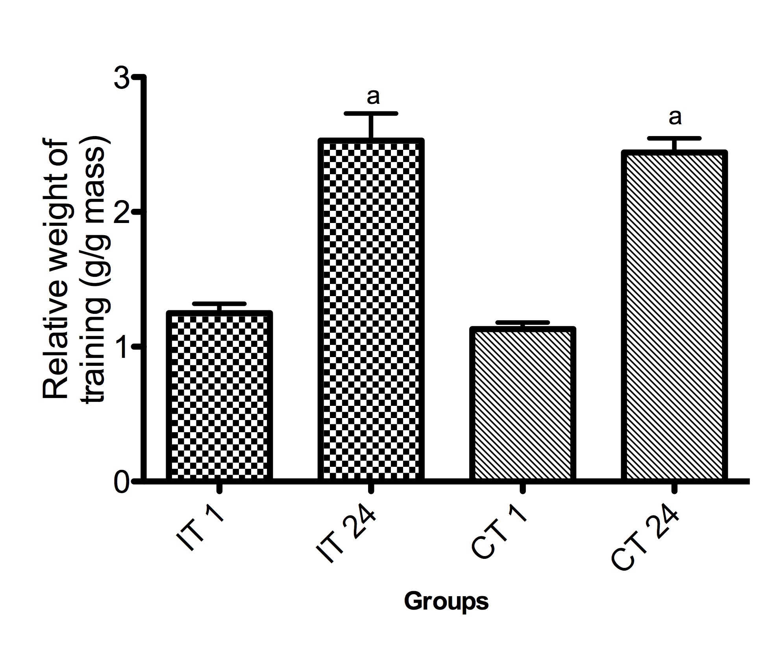
Figure 1. Relative Training Load (Grams of Load / Body Weight). IT = Intact Training; CT = Castrated Training; IT 1 and CT 1 = Relative Loading Load of the First Training Session; IT 24 and CT 24 = Relative Loading Load of the Last Training Session. ªDifference between Training Periods: Between First and Last Session. P<0.0001.
There was a statistical difference in the expression of MSTN (P<0.05) between the IS, IT, and CT groups in relation to the CS group. However, no difference was found between the trained groups or between the trained groups and the IS group as shown in Figure 2. We found a statistical difference in FS expression (P<0.05) between the CT and IS groups, and also between the CT and IT groups shown in Figure 3, and there was no difference between the sedentary groups.
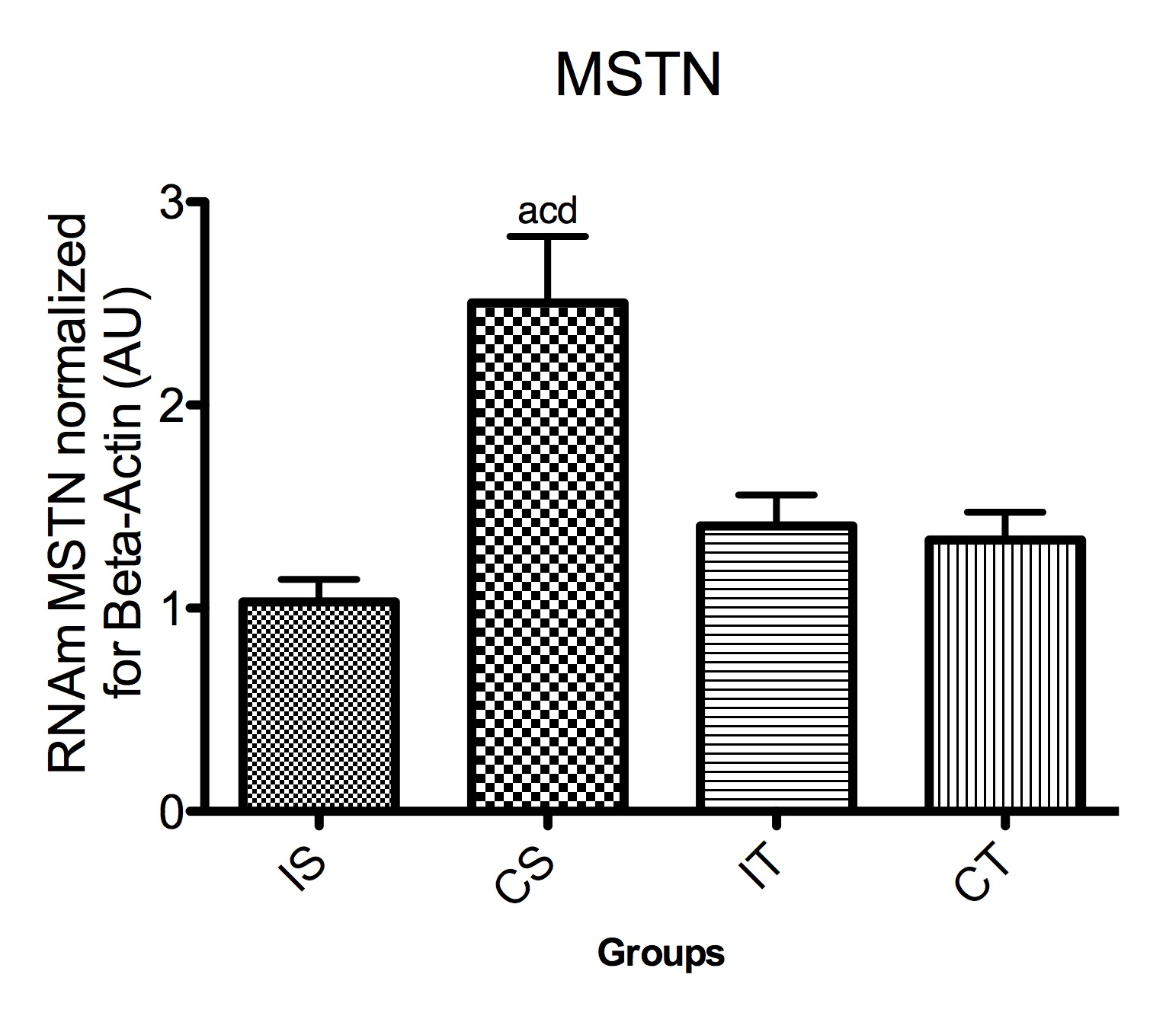
Figure 2. MSTN mRNA Expression in White Gastrocnemius Muscle. ªDifference between CS and IS, ^{c}Diference between CS and IT, ^{d}Difference between CS and CT. P<0.05.
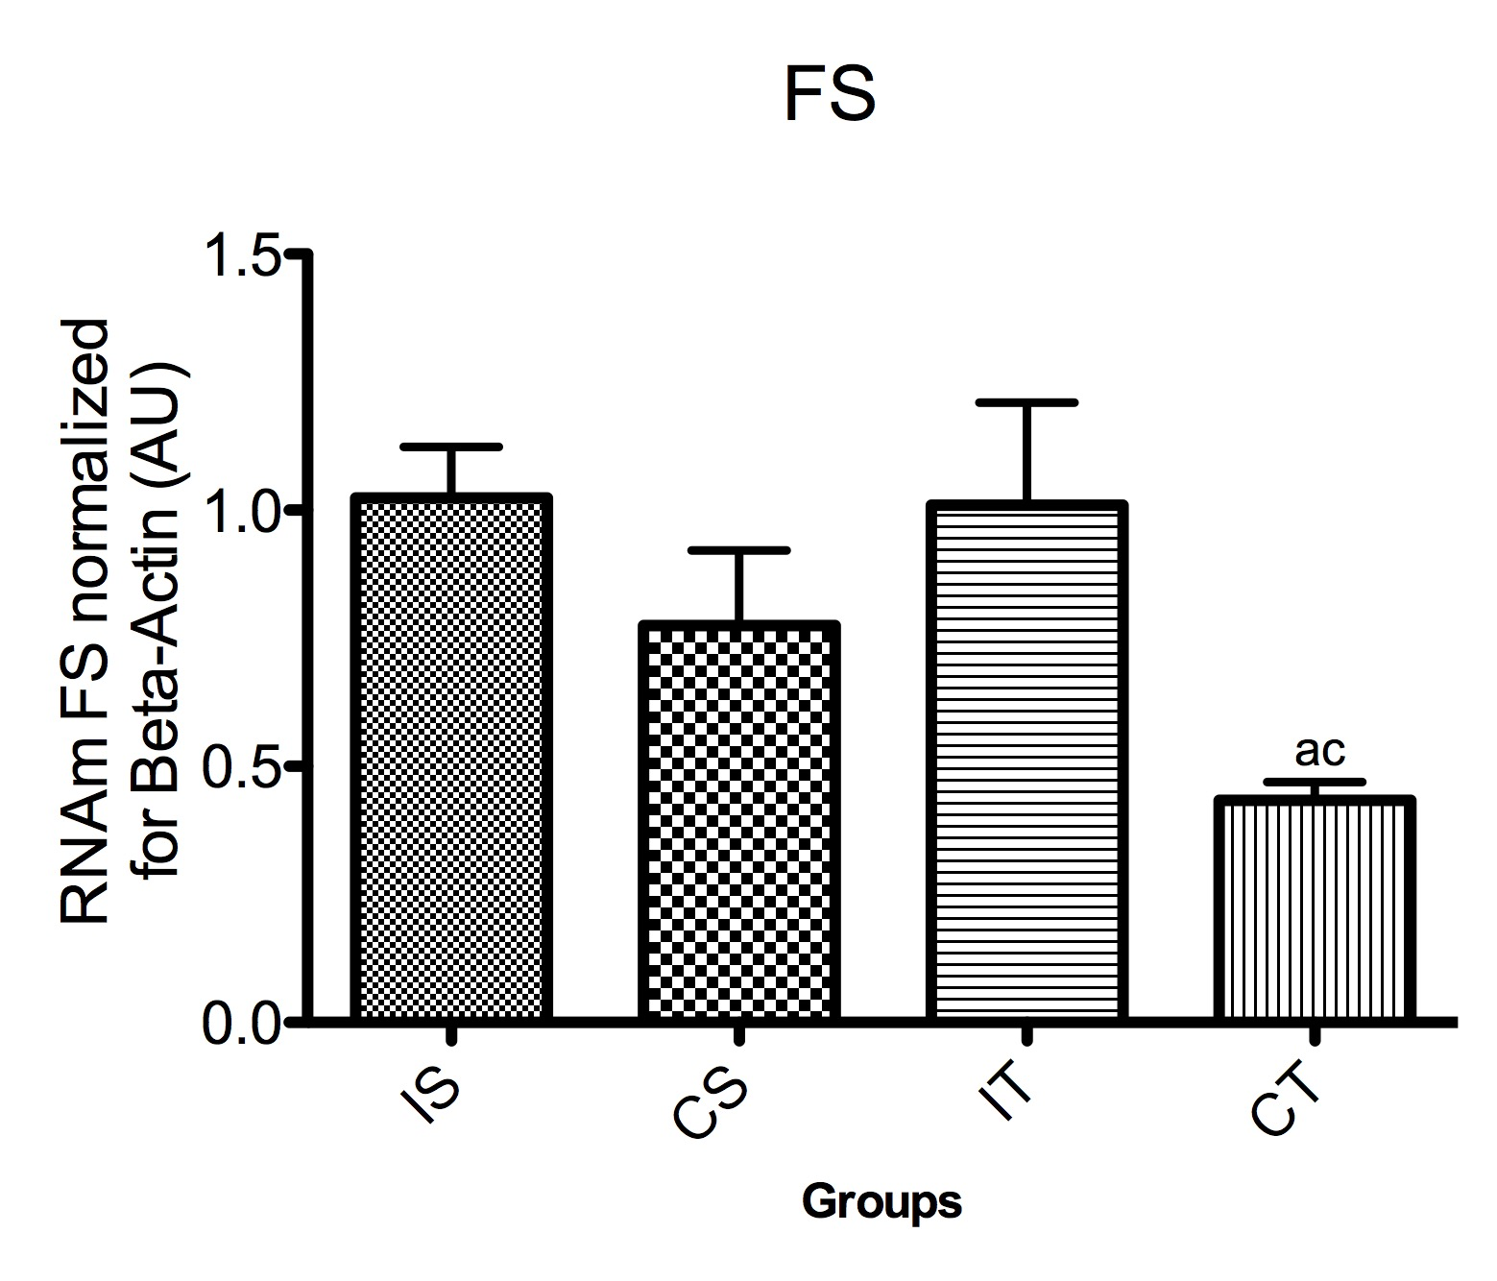
Figure 3. FS mRNA Expression in White Gastrocnemius Muscle. P<0.05, ªDifference between CT and IS, ^{c}Difference between CT and IT. P<0.05.

DISCUSSION

The difference in relative loading of the load found between the first and last training session was expected because of the adaptation to loads during training. However, there was no difference between the groups trained (6). In this sense, other anabolic hormones may have been responsible for acting in the absence of testosterone and increasing muscle strength. One limitation of this study was not to have evaluated other anabolic hormones, such as IGF, GH, and insulin that may be associated with the training adaptation.

The increase in MSTN mRNA expression in the CS group compared to the other groups demonstrates the effect of testosterone on the expression of MSTN. This result goes against the study of Mendler et al. (23) who evaluated MSTN expression after 7, 11, and 14 d of castration of prepubertal rats with and without testosterone treatment, and there was no difference between the control group and the castrated group. The absence of testosterone causes increased expression of MSTN, which may contribute to the atrophic process and consequent loss of muscle mass (11). In the present study, castrated animals were exposed to the effects of the absence of testosterone for slightly more than 10 wks that is likely the reason for the increase of MSTN in the CS group. We did not have a group using testosterone, but we demonstrated the influence of testosterone on MSTN in playing an important role in the regulation of hypertrophy and cell cycle that are inhibited by MSTN.

Resistance training did not decrease the MSTN expression between the trained groups and the IS group, although there are other studies that have demonstrated the decrease in MSTN after resistance training (13,20,25,26). However, it is clear that our findings confirm the results of several studies (1,9,16,27) that have demonstrated resistance training being unable to decrease MSTN expression. Nevertheless, of these studies, only Adams et al. (1) worked with rats, and used a different training protocol from the present study. So, the present study demonstrated new results on testosterone, MSTN, and FS in rat resistance training. Although we did not find a statistically significant difference in the MSTN of the CT group in relation to IT, the findings indicate that even in the absence of testosterone resistance training, the animals were able to regulate MSTN expression.

According to Hulmi et al. (9), there was a decrease in the MSTN expression 1 hr after the training session, and 48 hrs after training the concentration was in the normal resting level. These findings are due to the signaling of the mTOR gene being active after resistance training causing a decrease in MSTN activity and its gene expression. This observation by mTOR demonstrates that resistance exercise is an instrument capable of modulating the expression of key molecules important for hypertrophy and to contribute for regulation of the MSTN gene. In the present study, the animals were euthanized after 48 hrs of the last training session, and we did not evaluate after 1 hr of the last training session to verify if the MSTN would have decreased as described by Hulmi et al. (9). However, the present study confirmed that after 48 hrs MSTN expression returned to resting levels that is in agreement with Hulmi et al. (9).

Mascher et al. (20) showed a significant increase in mTOR after 15 min of resistance training and 2 hrs of rest without Akt activation, which suggests an independent exercise pathway to promote hypertrophy. One limitation of our study was not evaluated as an expression of hypertrophic related proteins such as Akt and mTOR and another time of MSTN evaluation.

In addition to the fact that we did not have euthanasia in the same periods of the studies cited above, it is likely that it may have contributed to having no difference between the trained and sedentary groups for resistance training. Hence, this consideration may have led to the synthesis and secretion of glucocoticoids that have an atrophic effect and is influenced by the gene expression of MSTN. According to Ma et al. (19), dexamethasone applications in rats lead to increased expression and protective concentration of MSTN in relation to control, and when applied MSTN antagonist the increase was not observed.

The lower expression of FS mRNA in the CT group in relation to the IT and IS groups of this study goes against Diel et al. (5) that before and after resistance training there was no statistical difference in FS in humans. There was also no difference in the present study between IT and IS but Diel et al. (5) demonstrated that bodybulders have higher levels of MSTN and FS and lower relative levels of MSTN/FS. They also compared the effect on rats and demonstrated a lower FS level in castrated rats and dihydrotestosterone application. In the present study, the CT group did not receive any type of anabolic to influence the expression of the FS and still the group decreased in relation to the intact group. This result is in agreement with the findings of Jensky et al. (10), since they did not find statistical difference with resistance training in women in concentric or eccentric exercise in the expression of FS. They reported that other anabolic hormones may affect FS expression, since they were performed with healthy people.

According to Rodino-Kaplac et al. (24), FS inhibits the synthesis and secretion of the follicle-stimulating hormone (FSH) of the Hypothalamus-Hypophysis-Gonadal axis. FS binds to the actin receptor, promoting negative feedback and inhibition of FSH. According to the authors, the FS is synthesized by the ovaries, testicles, and pituitary, so castration caused the animals to have only small production of FS by the pituitary. Therefore, in the present study, the gonadal axis was altered with the absence of testosterone, losing the negative feedback of the axis, strengthening the stimulation of FSH, and FS in the hypothalamic-pituitary glands. Also, training with castration promotes the stimulation of other anabolic hormones to replace FS and testosterone. These hormones are stimulated by the active gonadal axis and, therefore, without negative feedback.

CONCLUSIONS

Resistance training was not able to inhibit or decrease MSTN expression in the white gastrocnemius rat muscle of this study, but resistance training may have regulated the expression of the MSTN in the CT group in relation to the SI. It may have influenced FS regulation also in the CT group preserving other axes of anabolic hormone. It is also reasonable that castration promoted the increase in MSTN expression that highlights the influence of testosterone on its expression.

There was no inverse relationship between the expression of MSTN and FS because other anabolic hormones can act in the absence of testosterone, and the training helps in this stimulation. Therefore, our study with resistance training is not the best protocol to verify this inverse relationship between MTSN and FS. Other studies will be needed to better answer these questions, and still understand the signaling pathway of MSTN and FS.

ACKNOWLEDGMENTS
We thank Capes, CNPQ and UFSCar for the financial and technological support to complete this research.

Address for correspondence: Diego A. Marine, Departamento de Educação Física, Universidade Federal de São Carlos, São Carlos, São Paulo, Brasil, rod. Washington Luis Km 235, CEP 13562-905. Email: diegomarine@gmail.com

REFERENCES

- Adams GR, Haddad F, Bodell PW, Tran PD, Baldwin KW. Combined isometric, concentric, and eccentric resistance exercise prevents unloading-induced muscle atrophy in rats. J Appl Physiol. 2007;103(5):1644-1654.

- Amthor H, Otto A, Vullin A, Rochat A, Dumonceaux J, Garcia L, et. al. Muscle hipertrophy driven by Myostatin blockade does not require stem/precursor-cell activity. PNAS. 2010;106(18):7479-7484.

- Aoki MS, Soares AG, Miyabara EH, Baptista IL, Moriscot AS. Expressioin genes related to Myostatin signaling during rat skeletal muscle longitudinal growth. Muscle & Nerve. 2009;40(6):992–999.

- Bhasin S, Woodhouse L, Casaburi R, Singh AB, Bhasin D, Beman N, et. al. Testosterone dose-response relationships in healthy young men, Am J Physiol Endocrinol Metab. 2001;281(6):1172-1181.

- Diel P, Schiffer T, Geisler S, Hertrampf T, Mosler S, Schulz S, Wintgens KF, Adler M. Analysis of the effects of androgens and training on myostatin propeptide and follistatin concentrations in blood and skeletal muscle using highly sensitive Immuno PCR. Endocrinol. 2010;330(1-2):1-9.

- Domingos MM, Rodrigues MF, Stotzer US, Bertucci DR, Souza MV, Gatto CD, et. al. Resistance training restores the gene expression of molecules related to fat oxidation and lipogenesis in the liver of ovariectomized rats. Eur J Appl Physiol. 2012;112(4): 1437-1444.

- Goto K, Nagasawa N, Yanagisawa O, Kisuka T, Ishii N, Takamatsu K. Muscular adaptations to combinations of high and low-intensity resistance exercises. J Strength Cond Res. 2004;18(4):730-737.

- Haidet AM, Rizo L, Handy C, Umapathi P, Eagle A, Shiling C, et. al. Long-term enhancement of skeletal muscle mass and strengh by single gene administration of Myostatin inhibitors. PNAS. 2008;115(11):4318-4322.

- Hulmi JJ, Tannerstedt J, Selanne H, Kainulainen H, Kovanen V, Mero AA. Resistance exercise with whey protein ingestion affects mTOR signaling pathway and myostatin in men. J Appl Physiol. 2009;106(5):1720-1729.

- Jensky NE, Sims JK, Dieli-Conwright CM, Sattler FR, Rice JC, Schoreder ET. Exercise does not influence myostatin and follistatin mRNA expression in young women. J Strength Cond Res. 2010;24(2):522-539.

- Jones TE, Stephenson KW, King JG, Knight KR, Marshall TL, Scott WB. Sarcopenia – Mechanisms and treatments. J Geriatr Phys Ther. 2009;32(2):39-45.

- Kim J, Cross JM, Bamam MM. Impact of resistance loading on Myostatin expression and cell cycle regulation in young and older men and women. Am J Physiol Endocrinol Metab. 2005;288(6):1110-1119.

- Kim J, Petrella JK, Cross JM, Bamman MM. Load-mediated downregulation of myostatin mRNA is not sufficient to promote myofiber hypertrophy in humans: A cluster analysis. J Appl Physiol. 2007;103(5):1488-1495.

- Kolias HD, McDermott JC. Transforming growth factor-β and Myostatin signaling in skeletal muscle. J Appl Physiol. 2008;104(3):579-587.

- Kovacheva EL, Hikim APS, Shen R, Sinha I, Sinha-Hikim I. Testosterone supplementation reverses sarcopenia in aging through regulation of Myostatin, c-Jun NH₂-terminal kinase, notch, and Akt signaling pathways. Endocrinology. 2010;151 (2):628-638.

- Kvorning T, Andersen M, Brixen K, Schjerling P, Suetta C, Madsen K. Suppression of testosterone does not blunt mRNA expression of myoD, myogenin, IGF, myostatin or androgen receptor post strength training in humans. J Physiol. 2007;578(2):579-593.

- Leal AMO, Moreira AC. Daily variation of plasma testosterone, androstenodione, and corticosterone in rats under food restriction. Horm Behav. 1997;31(1):97-100.

- Lee S, McPherron AC. Regulation of myostatin activity and muscle growth. PNAS. 2001;98(16):9306-9311.

- Ma K, Mallidis C, Artaza J, Taylor W, Gonzales-Cadavid N, Bhasin, S. Characterization of 5’-regulatory region of human myostatin gene: Regulation by dexamethasone in vitro. Am J Physiol Endocrinol Metab. 2001;281(6):1128-1136.

- Mascher H, Tannerstedt J, Brink-Elefegoun T, Ekblom B, Gustafsson T, Blomstrand E. Repeated resistance exercise training induces different changes in mRNA expression of MAFbx and MuRF-1 in human skeletal muscle. Am J Physiol Endocrinol Metab. 2008;294(1):43-51.

- Matsakas A, Friedel A, Hertrampf T, Diel P. Short-term endurance training results in a muscle-specific decrease of Myostatin m RNA content in the rat. Acta Physiol Scand. 2005;183(3):299-307.

- Mendler L, Baka Z, Kovács-Simon A, Dux L. Androgens negatively regulate myostatin expression in an androgen-dependent skeletal muscle. Biochem Biophy Res Commun. 2007;361(1):237-242.

- Morissete MR, Stricker JC, Rosemberg MA, Buranasombati C, Levytan EB, Mittleman MA, and Rosenweig A. Effects of Myostatin deletion in aging mice. Aging Cell. 2009;8 (5):573-583.

- Rodino-Kaplac LR, Haidet AM, Kota J, Handy C, Kaspar BK, Mendel J R. Inibhition of Myostatin with emphasis on Follistatin as a therapy for muscle disease. Muscle Nerve. 2009;39(3):283-296.

- Roth SM, Martel GF, Ferrel RE, Metter J, Hurley BF, Rogers MA. Myostatin gene expression is reduced in humans with heavy-resistance strength training: A brief communication. Exp Biol Med. 2003;228(6):706-709.

- Ryan AS, Ivey FM, Prior S, Li G, Hafer-Macko C. Skeletal muscle hypertrophy and muscle myostatin reduction after resistive training in stroke survivors. J Am Heart Assoc. 2011;42(2):416-420.

- Schiffer T, Geisler S, Aperlich B, Struder HK. Myostatin mRNA after varying exercise modalities in humans. Int J Sports Med. 2011;32(9):683-687.

- Schroeder ET, Singh A, Bhasin S, Storer TW, Azen C, Davidson T, et. al. Effects of an oral androgen on muscle and metabolism in older, community-dwelling men, Am J Physiol Endocrinol Metab. 2003;284(1):120-128.

- Sinha-Hikim I, Artaza J, Woodhouse L, Gonzalez-Cadavid N, Singh A B, Lee MI, et. al. Testosterone-induced increase in muscle size in healthy young men is associated with muscle fiber hypertrophy. Am J Physiol Endocrinol Metab. 2002;283(1):154-164.

Disclaimer
The opinions expressed in JEMonline are those of the authors and are not attributable to JEMonline, the editorial staff or the ASEP organization.

