Journal of Exercise Physiologyonline

December 2016
Volume 19 Number 6



JEPonline
Editor-in-Chief
Tommy Boone, PhD, MBA
Review Board
Todd Astorino, PhD
Julien Baker, PhD
Steve Brock, PhD
Lance Dalleck, PhD
Eric Goulet, PhD
Robert Gotshall, PhD
Alexander Hutchison, PhD
M. Knight-Maloney, PhD
Len Kravitz, PhD
James Laskin, PhD
Yit Aun Lim, PhD
Lonnie Lowery, PhD
Derek Marks, PhD
Cristine Mermier, PhD
Robert Robergs, PhD
Chantal Vella, PhD
Dale Wagner, PhD
Frank Wyatt, PhD
Ben Zhou, PhD

Official Research Journal of the American Society of Exercise Physiologists

ISSN 1097-9751

Official Research Journal of the American Society of Exercise Physiologists

ISSN 1097-9751

The Acute Effect of Intermittent Fasting on Resting Energy Expenditure in College-Aged Males

Ruth A. Stauffer¹, Cory T. Beaumont¹, Tania S. Flink²

¹Department of Health and Physical Education, Edinboro University, Edinboro, PA USA, ²Department of Sport and Exercise Science, Gannon University, Erie, PA, USA

ABSTRACT

Stauffer RA, Beaumont CT, Flink TS. The Acute Effect of Intermittent Fasting on Resting Energy Expenditure in College-Aged Males. JEPonline 2016;19(6):170-179. The purpose of the study was to examine the short-term effect of fasting for three different time-points on resting energy expenditure (REE) in active college-aged males. This study was a cross-over design where 11 subjects (mean age, 21.55 ± 1.33 yrs), who were instructed to consume a eucaloric diet, fasted for 10 to 12, 16, and 20 hrs separated by a 1-wk to 2-wk wash-out period. REE was measured after each fast via a ventilated hood technique. The results for REE for the 10 to 12, 16, and 20 hrs of fasting are 2048.53 ± 274.31 kcal·d⁻¹, 1976.64 ± 181.42 kcal·d⁻¹, and 2064.00 ± 254.54 kcal·d⁻¹, respectively. The statistical analysis indicated that no significance was found between the conditions, though REE did decrease slightly for the 16-hr fast, and increased slightly for the 20-hr fast. The results suggest that 1 day of fasting while maintaining a eucaloric diet for up to 20 hrs does not negatively impact REE in active, college-aged males.

Key Words: Fasting, Resting Energy Expenditure, Intermittent fasting, Metabolic Rate

INTRODUCTION

Intermittent fasting, which is the practice of time restriction of food intake, has become a popular method for weight loss and fat reduction (5). It has been marketed as an alternative to traditional dieting practices where instead of reducing the number of calories per meal, followers skip meals or even skip an entire day of eating in order to achieve similar caloric deficits per week (19). The most common protocols are: (a) limiting daily intake of food to 8 hrs for every day of the week; and (b) restricting for 24 hrs just once per week (5,19). Some of the claims regarding intermittent fasting include similar decreases in body weight and body fat when compared to traditional caloric restriction (11,19), and the improvement in blood markers such as the reduction in overall cholesterol and LDL cholesterol (11,20).

The effect of meal frequency on weight loss and fat reduction has been examined due to the popular belief that eating more often, and in smaller amounts, leads to improved weight management. Recent meta-analyses point out that the majority of research supporting this idea is based on epidemiological studies demonstrating an inverse relationship between meal frequency and adiposity (9,16). However, when examining the results of the randomized, controlled trials comparing the effects of varying meal frequencies on weight and fat loss, these meta-analyses present mixed findings (9,16). Of these findings, three studies found significant improvements in weight and/or fat loss with more frequent meals (2,7,10). This suggests that there may be other mechanisms present that provide a better explanation for the mixed findings in the literature.

One of the proposed mechanisms affected by meal frequency and/or meal timing is the rate of energy expenditure, or the energy expended while a person is at rest, measured in kcal·d⁻¹ (14). It has been observed that a reduced rate of energy expenditure is associated with a slowing in weight and/or fat loss (18). While there are numerous methods used to measure a person’s caloric expenditure, resting energy expenditure (REE), or the number of calories a person burns per day at rest, has become accepted as a reliable method to evaluate energy expenditure in the laboratory setting (1)

While there are numerous studies that conclude meal frequency does not impact REE (10,17,22), a limited number of studies have examined the effect of fasting on REE. In the majority of studies, REE was examined in individuals who consumed 2 to 3 meals·d⁻¹, which included breakfast and dinner versus 3 to 9 meals·d⁻¹ (10,17,22). The result of this was negation of a prolonged fasting period since the subjects did not abstain from eating food for more than 12 hrs, which may have influenced the REE levels. Additionally, a number of these studies included subjects who were consuming a hypocaloric diet (10,21,22) that has been found to decrease REE (12).

The mixed methodology and lack of control of caloric consumption in previous research renders further examination of how fasting influences REE levels. Therefore, the purpose of this study was to examine the effect of fasting at time intervals of 10 to 12, 16, and 20 hrs on REE while following a eucaloric diet. The fasting time intervals were varied in an attempt to determine the instance the resting expenditure was reduced as a result of fasting. In addition, the subjects’ caloric intake was not restricted to minimize changes in REE as a result of a prolonged hypocaloric state. It was hypothesized that fasting for longer periods of time would result in a reduced REE.

METHODS
Subjects
The subjects consisted of 11 active college-aged males with a mean age, 21.55 ± 1.33 yrs. They were recruited by word of mouth and advertisement flyers posted in the athletic facility on the campus of Edinboro University. The subject pool was somewhat limited, given that the data collection was performed over the summer break. Inclusion criteria were male subjects between 18 and 25 yrs of age who were not currently in caloric deficit and, therefore, followed a pattern of regular meals. The exclusion criteria were based on a simple health history questionnaire (Physical Activity Readiness Questionnaire) that identified any individual with a medical condition (e.g., cardiovascular, pulmonary, or diabetes). Also, any individuals taking medications (such as thyroid drugs) that would influence REE were also excluded. The majority of subjects were athletes. Eight subjects were football players, 2 subjects were former wrestlers, 1 subject was a swimmer, and 2 subjects were physically active according to recommendations for Healthy People 2010 (e.g., 3 or more days of at least 20 min of vigorous activity and/or 30 min of moderate physical activity most days of the week).

Sample size was determined using average number of subjects used in similar studies (10,17,22), which averaged 10 subjects tested. For this study 15 individuals were recruited, but only 11 successfully completed all tests for analysis. All subjects signed a consent form prior to experimentation. All experimental protocols were approved by the Edinboro University Institutional Review Board prior to testing.

Procedures
This study was a cross-over design where subjects fasted for 10 to 12, 16, and 20 hrs prior to the measurement of REE with a 1- to 2-wk wash-out period between conditions. The order of conditions was not randomized. Instead, the subjects underwent fasting conditions in the following order: 10 to 12, 16, and then 20 hrs. This order was chosen for two reasons: (a) to minimize the possibility of effects of the 20-hr fast impacting results of the shorter fasting periods; and (b) to minimize risk to the subjects through observation of potential side effects during shorter fasting periods before exposing the subjects to longer fasting periods.

Subjects were asked to abstain from consuming all food and drink aside from water for the pre-determined time-frame prior to data collection. The subjects were also asked to avoid caffeine, nicotine, alcohol, other stimulants and/or depressants, and vigorous activity for 24 hrs prior to data collection as these factors have been found to affect measurement of REE. Aside from the time period of fasting, the subjects were asked to remain in a eucaloric state, which is defined as eating the same calories on average to allow for weight maintenance. Subjects were also asked to track their food intake on an online or app-based food tracker, “myfitnesspal” to ensure a eucaloric diet, and to allow the investigators the opportunity to view the subjects’ daily caloric intake for 1 wk prior to each REE measurement. Subjects were questioned verbally prior to each measurement to confirm that they had adhered to the requirements for each condition.

Measurement of REE required that each subject’s height and weight were measured using a Detecto Balance Beam scale. Prior to data collection, the subjects were instructed to lie on an exam table for approximately 15 min to allow for heart rate and breathing rate to assume resting levels. During the data collection period, each subject was asked to lie down in a comfortable position with his head on a pillow with the body elevated at ~45° and remain as relaxed and still as possible. REE was measured using indirect calorimetry via a ventilated hood technique, where a plastic canopy was placed over the subject’s head. It contained a one-way valve at one end that allowed room air to enter the canopy and a second one-way valve at the other end that allowed the expired air to exit the canopy as shown in Figure 1. The one-way valve for expired air was attached to a hose that directs the expired air to a metabolic chamber, thus allowing for the detection of ventilation, percent of O₂, and percent of CO₂. The measurement period lasted approximately 10 min of which the last 5 min of data were used to calculate REE. It has been found that a data collection period of 10 min with the first 5 min deleted and a coefficient variation of no more than 10% yields accurate results (6).

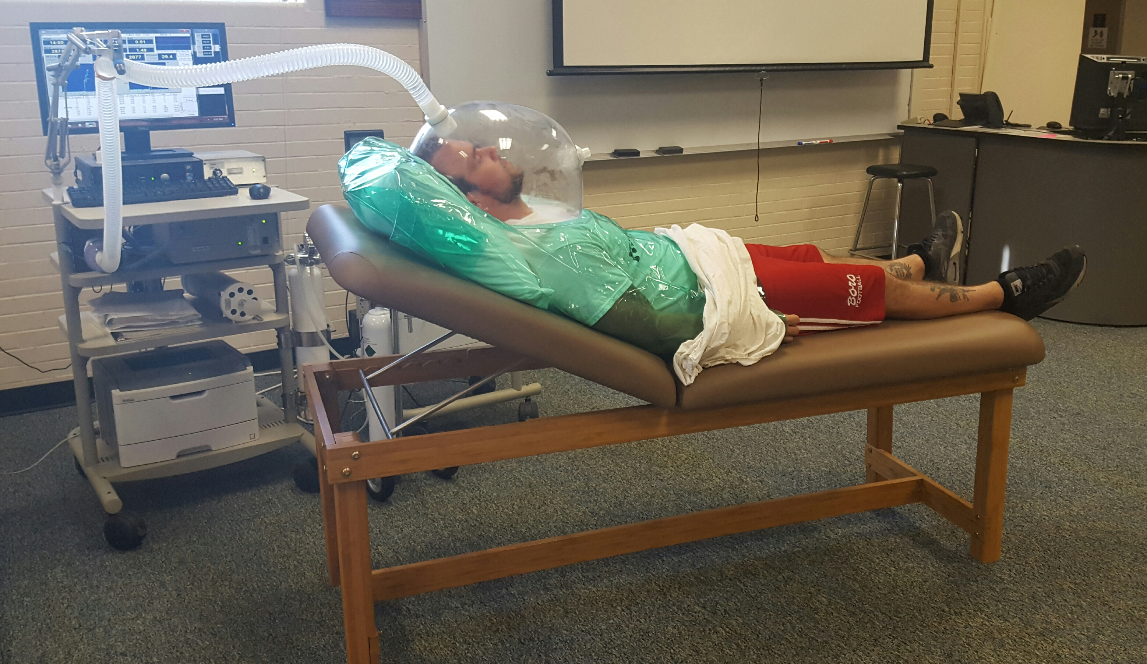
Figure 1. Experimental Set-up Using Ventilated Hood Technique.

Statistical Analyses

For this study, REE was described as the average amount of kcal expended at rest based upon the amount of oxygen consumed. REE was computed as follows: REE (kcal·d⁻¹) = 5.616 x VO₂ (mL) + 1.584 x VCO₂ (mL). In addition, the following variables were examined: (a) fractional content of expired carbon dioxide (FECO₂) was computed as the percentage of air expired that is CO₂); (b) respiratory quotient (RQ) was computed as a fraction of the volume of CO₂ expired over O₂ consumed; (c) average reported kilocalories consumed per day computed from the food tracker; and (d) body weight in kg.

The collected data were analyzed using the Statistical Analysis in Social Science Statistics 20 software (SPSS, Chicago, IL). Descriptive statistics were calculated for all experimental data. A multivariate analysis of variance (MANOVA) was used to determine significant differences across the three fasting conditions (10 to 12, 16, or 20 hrs) for REE, FECO₂, RQ, reported calories, and body weight. In addition, a linear multiple regression analysis was performed to determine which variables (FECO₂, RQ, reported calories, and/or body weight) significantly predicted REE. For all statistical tests, statistical significance was set at P<0.05 and all post-hoc analyses for the MANOVA were examined using Tukey HSD corrections.

RESULTS

Descriptive data for each of the dependent variables tested are presented in Table 1. Results from the MANOVA revealed no significant effect of the fasting condition on REE, FECO₂, reported calories, and weight (P≥0.05). A significant effect of fasting condition was observed for RQ, F(2,23) = 4.33, P<0.05. Post-hoc analysis revealed that significant differences were found between the 10- to 12-hr fasting condition and the 20-hr fasting condition, where RQ significantly declined in the 20-hr condition compared to the 10- to 12-hr condition.

Table 1. Descriptive Data at Each Fasting Condition.
Conditions | 10 to 12 Hr Fast |  | 16 Hr Fast | 20 Hr Fast
REE (kcal·d⁻¹) |  | 2,048.5 ± 272.3 | 1,976.6 ± 181.4 | 2,064 ± 254.3
FECO₂ (%) |  | 1.0 ± 0.08 | 0.95 ± 0.08 | 0.98 ± 0.02
RQ |  | 0.79 ± 0.04 | 0.78 ± 0.04 | 0.74 ± 0.03
Calories (kcal·d⁻¹)  Weight (kg) |  | 2,482.1 ± 347.2  90.6 ± 13.7 | 2,246.1 ± 368.6  87.4 ± 10.6 | 2,702.6 ± 550.0  89.2 ± 2
Data are reported as Mean ± SD; REE = Resting Energy Expenditure; FECO₂ = Fraction of Expired CO₂; RQ = Respiratory Quotient
While no significance was found between conditions for REE, a trend existed that showed increases in REE for the 20-hr fasting condition compared to the 10- to 12-hr in the majority of the subjects tested (7 out of 11 subjects, see Figure 2).

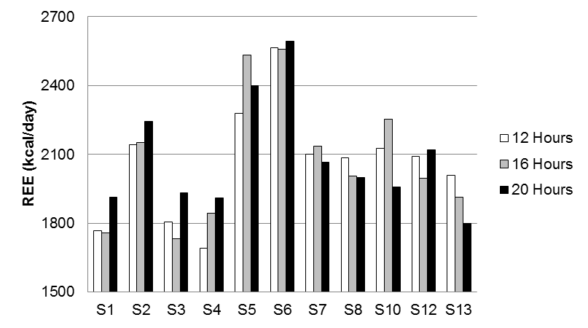

Figure 2. Average REE across Three Fasting Conditions for all Subjects. S1, S2, etc. refers to Subject 1, Subject 2, etc.
The results from the regression analysis revealed a significant regression equation was found, F(5,20) = 13.8, P<0.05, with an R² of 0.77. Of all variables examined, weight was found as the only significant predictor of REE (β = 0.97, P<0.05).

DISCUSSION

In this study, the changes in REE, FECO₂, RQ, weight, and reported calories in college-aged males after fasting for three different time periods were measured. The first fasting period was for 10 to 12 hrs, which was chosen to represent a “normal” fast between the last meal or a snack and breakfast. The second fasting period was for 16 hrs. It was chosen to match the recommended fasting time for popular intermittent fasting diets, such as the “Leangains” diet and “Engineering the Alpha” (3,15). The 20-hr fast was chosen as an additional measure because there are some diets, such as “The Warrior Diet,” and “Eat. Stop. Eat.” diet that recommend fasting for longer than 16 hrs (8,13). These diets are marketed to the masses via popular press media without research oriented justification regarding the effects on REE.

REE

The statistical findings indicate no significant differences in REE between the three different time periods of fasting. According to these results, it appears that fasting for 16 to 20 hrs for 1 day does not significantly impact REE more so than fasting for 10 to 12 hrs in active, college-aged males.

When compared to the 10- to 12-hr fast, the mean REE was slightly reduced for the 16-hr fast (2048.53 ± 274.31 to 1976.64 ± 181.42), which is what would be expected. However, the mean REE actually increased slightly (though non-significantly) during the 20-hr fast (2048.53 ± 274.31 to 2064.00 ± 254.54). This may be explained by the expected variability in repeated measures of REE, which has been found to be up to 3% if measured on separate occasions within a few days or up to 10% if the time between measurements is ~1 wk (6). However, 7 of the 11 subjects demonstrated an increase in REE during the 20-hr fast. It is only possible to speculate what may have caused this finding, as measurements of other factors that may influence this result were not taken into consideration (such as the subjects’ hormone levels).

Since the subjects’ food intake was not controlled in a laboratory setting and the adherence to the fast was self-reported, it is possible that some of the subjects broke the fast and did not report it. Additionally, some of the subjects reported feelings of anxiety or crankiness during the 20-hr fast. It is possible that this emotional response may have caused changes in the subjects’ cortisol levels that may have influenced the REE levels, though not explicitly measured. Brillon and colleagues (4) found that infusion of hydrocortisone leading to an increase in the subjects’ cortisol levels in the blood resulted in a temporary increase in resting energy expenditure (4). It is possible that the slight increase in REE after the 20-hr fast may be part of the subjects’ compensatory response as a result of depriving the body of food for longer periods of time than what the subjects were accustomed to.

WEIGHT

The regression analysis revealed that body weight was the only factor that significantly predicted REE. This would be expected since the majority of prediction equations use body weight to estimate REE. As mentioned, the subjects were instructed to maintain a eucaloric diet to maintain body weight throughout the duration of the study. The results showed no significant change in body weight in the study (90.64 ± 13.77 kg, 87.37 ± 10.59 kg, and 89.18 ± 12.06 kg) for the 10- to 12-, 16-, and 20-hr, respectively. Thus, this demonstrates that the changes in REE were not influenced by the subjects’ changes in weight across the three different conditions.

CALORIC INTAKE
The subjects were instructed to maintain a eucaloric diet for the duration of the study. The results showed no significant change in caloric intake between the three conditions, which suggests that the subjects adhered to the instructions given to them.

FECO₂
During the REE test using the Parvo Medics system, the protocol requires adjustment of a dilution pump to control air flow through the canopy so that FECO₂ is between 0.8 to 1.2%. Further, significant variations in FECO₂ appear to influence the measurement of REE due to the influence on the subjects’ apparent use of oxygen. As such, FECO₂ was recorded during REE tests for each of the conditions in order to control for this as a confounding factor. The results showed no significant change in FECO₂ between the 10- to 12-, 16-, and 20-hr fasts, which suggests that it is unlikely the REE results were influenced by changes in FECO₂.

RQ

The only variable that showed a significant change between conditions was RQ, which was computed as follows: VCO₂/VO₂. Results for RQ were statistically significant between the 10- to 12-hr fast and the 20-hr fast, which were 0.78 ± 0.04 and 0.74 ± 0.03, respectively. RQ may be used to predict the energy substrate(s) used for energy in a well-fed individual. It is possible to differentiate utilization of carbohydrates versus fats using RQ because there is a known amount of oxygen necessary to oxidize fats versus carbohydrates for energy. In other words, more oxygen is required to oxidize fat versus carbohydrates, which results in a lower RQ value (14). The RQ, also referred to as the respiratory exchange ratio (RER), is often considered as a non-protein RER because the oxidation of protein is not taken into consideration. This is due to the assumption that protein contributes less than 5% of energy at rest in a well-fed individual (14,23). The reduction in RQ most likely represents an increased reliance on fat for energy, which may have been the result of a lower availability of carbohydrates due to depletion during the longer fast.

Limitations

There are several possible limitations to this study that may have impacted the results. The first limitation was sample size. Previous studies regarding REE examined an average subject pool of 10 subjects. Since these studies did not find significant changes in REE due to various fasting regimens, the present study set out to evaluate 15 male subjects. But, due to schedule limitations as well as exclusionary criteria, the final sample size was 11 subjects. This small number of subjects tested may have reduced the statistical power needed to observe significant findings between the conditions.
An additional limitation to this study is the fact that subjects were studied under free-living conditions in which food intake and physical activity were not controlled. Since caloric intake was self-reported, it is possible that subjects did not record portion sizes accurately and/or omitted food items from the dietary logs resulting in inaccurate data. Similarly, the subjects were asked not to make any changes to their current fitness routines, but it is not known for certain if the subjects adhered to this recommendation.

Finally, this study examined the effects of 1 day of fasting on REE. Currently, it is not known how daily fasting for several consecutive days would impact REE levels. In the future, it may be beneficial to examine the long-term effects of such diets on REE.

Implications

Since up to 20 hrs of fasting does not appear to significantly reduce REE, the findings may support the practice of fasting for up to 20 hrs for one day in order to reduce caloric intake in an active population. However, it may not be practical unless the fast could be scheduled on a rest day since some of the subjects reported feelings of fatigue and/or light-headedness on the day of the 20-hr fast.

Further, regarding application of the findings, although the investigators discuss trends toward changes in REE, a change of +16 kcal·d⁻¹ from the 10- to 12- to the 20-hr fast is not practically significant when compared to an average mean reported caloric intake of approximately 2,477 kcal·d⁻¹, which is found by averaging the mean caloric intake across the 3 time-points. A difference of -72 kcal·d⁻¹ from the 10- to 12-hr fast to the 16-hr fast may or may not be considered practically significant as this is a reduction by approximately 3% of the average mean daily caloric intake.
.

CONCLUSIONS

While intermittent fasting has recently become a popular technique for individuals interested in weight loss, there has been a lack of scientific investigation on how intermittent fasting may affect one’s metabolism. The present study appears to be one of few where an individual’s REE is measured after undergoing a 1-day fast of up to 20 hrs while consuming a eucaloric diet. At the conclusion of this study, no significant changes in REE were observed after fasting periods of 16 and 20 hrs compared to the first measurements taken after a 10- to 12- hr fast. Therefore, the hypothesis of a reduced REE after 16 and/or 20 hrs of fasting was not supported. It may be that 1 day of fasting for 16 to 20 hrs is not long enough to affect REE. Further research is necessary to examine the REE of individuals who engage in intermittent fasting over a longer course of time.

Address for correspondence: Ruth A. Stauffer, PhD, Department of Health and Physical Activity, Edinboro University, Edinboro, PA, USA, 16444, Email: rstauffer@edinboro.edu

REFERENCES

- Ainslie PN, Reilly T, Westerterp KR. Estimating human energy expenditure: A review of techniques with particular reference to doubly labeled water. Sports Med. 2003;33 (9):683-698.
- Arciero PJ, Ormsbee MJ, Gentile CI, Nindl BC, Brestoff JR, Ruby M. Increased protein intake and meal frequency reduces abdominal fat during energy balance and energy deficit. Obesity. 2013;21(7):1357-1366.
- Berkhan M. The Leangains Guide. http://www.leangains.com/2010/04/leangains-guide.html, 2010.
- Brillon DJ, Zheng B, Campbell RG, Matthews DE. Effect of cortisol on energy expenditure and amino acid metabolism in humans. Am J Physiol. 1995;268(3):E501-513.
- Collier R. Intermittent fasting: The next big weight loss fad. Can Med Assoc J. 2013; 185(8):E321-E322.
- Compher C, Frankenfield D, Keim N, Roth-Yousey L. Best practice methods to apply to measurement of resting metabolic rate in adults: A systematic review. Journal of American Dietetic Association. 2006;106:881-903.
- Garrow JS, Durrant M, Blaza S, Wilkins D, Royston P, Sunkin S. The effect of meal frequency and protein concentration on the composition of the weight lost by obese subjects. Br J Nutr. 1981;45(1):5-15
- Hofmekler Ori. The Warrior Diet. Berkley, CA. North Atlantic Books, 2007.
- Hutchison AT, Heilbronn LK. Metabolic Impacts of altering meal frequency and timing – Does when we eat matter? Biochimie. 2016;124:187-197.
- Iwao S, Mori K, Sato Y. Effects of meal frequency on body composition during weight control in boxers. Scand J Med Sci Sports. 1996;6: 265-272.
- Klempel MC, Kroeger CM, Bhutani S, Trepanowski JF, Varady KA. Intermittent fasting combined with calorie restriction is effective for weight loss and cardio-protection in obese women. Nutr J. 2012;11:98.
- Martin CK, Heilbroon LK, de Jonge L, DeLany JP, Volaufova J, Anton SD, Redman LM, Smith SR, Ravussin E. Effect of calorie restriction on resting metabolic rate and spontaneous physical activity. Obesity. 2007;15(12):2964-2973.
- Pilon B. Eat. Stop. Eat. (5th Edition). Egg Harbor Township, NJ. Strength Works, Inc., 2012.
- Powers SK, Howley ET. Exercise Physiology: Theory and Application to Fitness and Performance. (9th Edition). New York, NY: McGraw-Hill Education, 2015.
- Romaniello J, Bernstein A. Engineering the Alpha 2.0. New York, NY. Harper Collins, 2013.
- Schoenfeld BJ, Aragon AA, Krieger JW. Effects of meal frequency on weight loss and body compositon: A meta-analysis. Nutr Rev. 2015;73(2):69-82.
- Smeets AJ, Westerterp-Plantenga MS. Acute effects on metabolism and appetite profile of one meal difference in the lower range of meal frequency. Br J Nutr. 2008;99:1361-1321.
- Tremblay A, Royer MM, Chaput JP, Doucet E. Adaptive thermogenesis can make a difference in the ability of obese individuals to lose body weight. Int J Obesity. 2013;37:759-764.
- Varady AK. Intermittent versus daily calorie restriction: Which diet regimen is more effective for weight loss? Obes Rev. 2011;12(7):E593-601.
- Varady KA, Bhutani S, Church EC, Klempel MC. Short-term modified alternate-day fasting: a novel dietary strategy for weight loss and cardioprotection in obese adults. Am J Clin Nutr. 2009;90(5):1138-1143.
- Verboeket-van de Venne WP, Westerterp KR, Kester AD. Effect of the pattern of food intake on human energy metabolism. Br J Nutr. 1993;70(1):103-115.
- Verboeket-van de Venne W. Frequency of feeding, weight reduction and energy metabolism. Int J Obesity. 1993;17(1):31-36.
- Williams MH, Anderson DE, Rawson ES. Nutrition for Health, Fitness & Sport. (10th Edition). New York, NY: McGraw-Hill Education, 2015.

Disclaimer
The opinions expressed in JEPonline are those of the authors and are not attributable to JEPonline, the editorial staff or the ASEP organization.

