Journal of Exercise Physiologyonline

August 2016
Volume 19 Number 4

JEPonline
Editor-in-Chief
Tommy Boone, PhD, MBA
Review Board
Todd Astorino, PhD
Julien Baker, PhD
Steve Brock, PhD
Lance Dalleck, PhD
Eric Goulet, PhD
Robert Gotshall, PhD
Alexander Hutchison, PhD
M. Knight-Maloney, PhD
Len Kravitz, PhD
James Laskin, PhD
Yit Aun Lim, PhD
Lonnie Lowery, PhD
Derek Marks, PhD
Cristine Mermier, PhD
Robert Robergs, PhD
Chantal Vella, PhD
Dale Wagner, PhD
Frank Wyatt, PhD
Ben Zhou, PhD

Official Research Journal of the American Society of Exercise Physiologists

ISSN 1097-9751

Official Research Journal of the American Society of Exercise Physiologists

ISSN 1097-9751

Lactate Response To Brazilian Jiu-Jitsu Matches Across Time

César C. Abad¹, Steven R. McAnulty², Marcelo P. Barros³, Andre L. Almeida⁴, Rubens B. Santos-Junior⁵, André C. Smolarek^{5,6}, Luis P. Mascarenhas⁶, Tácito P. Souza-Junior^{2,5}

¹Department of Physical Education, SENAC – Santo Amaro, São Paulo, SP, ²Department of Health and Exercise Sciences, Appalachian State University, Boone, NC, ³Institute of Physical Activity and Sports Science (ICAFE), Cruzeiro do Sul University, São Paulo, ⁴Inforfisic, ⁵Research Group on Metabolism, Nutrition and Strength Training, Department of Physical Education, Federal University of Parana, Curitiba, ⁶Biochemestry of exercise Laboratory, Universidade Estadual do Centro Oeste, Paraná Brazil

ABSTRACT

Abad CC, McAnulty SR, Barros MP, Almeida AL, Santos-Junior RB, Smolarek AC, Mascarenhas LP, Souza-Junior TP. Lactate Response to Brazillian Jiu-Jitsu Matches Across Time. JEPonline 2016;19(4):12-20. The purpose of this study was to investigate the lactate response to two Brazilian Jiu-Jitsu (BJJ) matches and to determine whether there is a correlation in the lactate responses across both matches. Twenty-one BJJ black belt athletes performed two 8-min matches separated by 48 hrs. To assess lactate responses, blood samples were obtained at rest, post warm-up, and after the BJJ matches (1 min, 5 min, and 10 min post-match). There was a statistically significant increase in blood lactate concentrations after both matches compared to the pre-values (Match 1: Pre-value, 0.9 ± 0.2 mmol·L⁻¹; Peak-value, 10.1 ± 1.7 mmol·L⁻¹, and Match 2: Pre-value, 0.9 ± 0.1 mmol·L⁻¹; Peak-value, 9.6 ± 0.9 mmol·L⁻¹) (P<0.05). No significant difference in blood lactate concentration was detected for the same moments after both matches. There were weak but significant correlations in blood lactate responses at 1 min (r = 0.47), 5 min (r = 0.44), and 10 min (r = 0.47) post-match for both matches (P<0.05). High peak blood lactate concentrations of similar magnitude were detected after both BJJ matches that indicates a strong energy contribution from glycolytic metabolism. Also, the lactate responses to each match were correlated, which suggests similar individual responses across successive matches of equal duration. Still, the metabolic and physiological responses to matches may vary in actual competition due to the unpredictability of combat sports and differences in match durations.

Key Words: Lactate, Intensity, Brazilian jiu-jitsu, Martial arts, Training, Performance

INTRODUCTION

Brazilian Jiu-Jitsu (BJJ) is a popular martial art that emphasizes ground grappling derived from Japanese jujutsu. The match duration in official championships for adults graded as brown and black belts is 8 min and 10 min, respectively. The main goal is the submission of the opponent through the application of a stranglehold or joint locks. BJJ is classified as a grappling combat sport that is characterized by high and low intensity-intermittent-efforts (1-4). The points are scored by means of specific BJJ actions, such as “take downs”, “passing the guard”, “knee on the belly”, “mount”, “back control”, and “sweep” (12,15). However, the matches can be decided not only by points, but also "submission", "disqualification", and/or "unconsciousness", before the end of the match.

Despite the growing popularity of this sport on a world stage, there is still little information available regarding the physiological effects of BJJ matches. Moreira et al. (18) compared the salivary cortisol and IgA responses to official and training matches. These authors reported that official matches induce greater responses in cortisol, as compared to training matches, thereby suggesting greater psychological and physiological strain. However, there is little direct information regarding the physiological demands of a BJJ match.

The analysis of blood lactate concentration has been used as a marker of exercise intensity in different types of martial arts (7,9,16,21). Recently, da Silva et al. (7) compared blood lactate response of two BJJ groups with different graduation levels and training experience after three simulated matches. Their findings showed no statistically significant differences (P>0.05) in blood lactate responses when comparing the advanced and non-advanced groups at rest, Pre, and Post. Compared to rest, blood lactate increased significantly (P<0.05) in both groups at 1 min and 15 min after the simulated matches. Also, lactate decreased significantly (P<0.05) at 15 min Post in both groups (after simulated matches) compared to 1 min. Blood lactate concentrations increase with a greater reliance on glycogenolysis and the glycolytic pathway for energy metabolism, especially when performing physical exercise at very high intensities and with little or no recovery periods. Considering the physical demands of BJJ, it is reasonable to conclude that glycolysis is an important energy source.

Therefore, the purpose of the present study was to investigate the lactate response to two BJJ matches and assess the reproducibility of these responses across both matches. A greater understanding of the physiological responses to BJJ training and competition is relevant for the prescription and periodization of training loads to improve performance.

METHODS

Subjects
Twenty-one male BJJ athletes (27.8 ± 8.0 yrs; 166 ± 3.9 cm; 74.1 ± 18.3 kg; IMC = 24.1 ± 5.8; %G = 14.5 ± 5.2; Lean Body Mass = 62.7 ± 15.1 kg; Fat Mass = 11.6 ± 4.8 kg) were recruited for the present study. All athletes were classified as black belt level and affiliated with the Jiu-Jitsu Federation of São Paulo, Brazil. The subjects took part at least in 1 national or international championship 6 months prior to the study. In general, the athletes trained 3 to 4 d·wk⁻¹ totaling approximately 6 to 10 hrs·wk⁻¹. All procedures were approved by the local ethics committee. Each athlete provided written informed consent, and this study was performed in accordance with international ethical standards.

Body Composition Assessments
Body composition and anthropometric assessments consisted of body mass (Filizola scales with accuracy of 0.01 kg), height (Sanny stadiometer with accuracy of 0.001 m), and skinfold thickness [chest, abdomen, thigh, triceps, subscapular, supra iliac, and axillary (scientific adipometer – Cescorf®)]. All measurements were performed in accordance with the International Society for the Advancement of Kinanthropometry (20). Body density was estimated from the Jackson and Pollock equation (14). Body fat was estimated with the Siri equation (26). Lean mass and fat mass were obtained in proportion to body mass.

BJJ Matches
The two BJJ matches were performed against the same opponents (based on weight categories) at the same training facility. All subjects arrived at the facility about 1 hr before their fights commenced. After a standardized warm-up (5 min of general stretching, 10 min of general aerobic exercise performed at low to moderate intensity, and BJJ technique exercises), the first match was performed. The second match occurred 48 hrs later. Both matches had a total duration of 8 min and were conducted using BJJ Confederation rules (14). To ensure each match lasted 8 min, the match was not stopped even when a submission took place. Consequently, it was not possible to determine winners or losers. Coaches were present to provide guidance, technical advice, and encouragement. To provide further motivation and aid in replicating actual competition, spectators were allowed to cheer for each athlete. Between the first and second matches, subjects were informed to not engage in any type of training and to maintain their normal diet, sleep, and daily routines.

Blood Sampling and Lactate Analysis
Blood sample volumes of 25-microliters were collected from the subjects’ earlobes (after a small incision was made with a commercial lancet) and immediately stored in a 2% NaF solution at approximately 2 ºC. The samples were analyzed in the Yellow Springs Sport 1500 device (Yellow Springs CO, USA). Samples were obtained at rest, immediately after the warm-up, and at 1, 5, and 10 min after each match.

Statistical Analyses
The Kolmogorov-Smirnov test was applied to test for normality, which indicated normal data distribution. The blood lactate responses across each match were assessed using a repeated measures analysis of variance and the Tukey post hoc test. To assess for blood lactate differences (at the same moments) between each match, a paired Student t-test was used. The lactate relationships at each moment were examined using Pearson correlations. For all analyses, the significance level was set at P≤0.05. Data were analyzed using the statistical package Instat® and are presented as means and standard deviations.

RESULTS

The anthropometric profile of the BJJ athletes (n = 21) are shown in Table 1. There was a significant increase in blood lactate concentration after both matches as compared to pre-values (Peak values: Match 1, 10.1 ± 1.7 mmol·L⁻¹ and Match 2, = 9.6 ± 0.9 mmol·L⁻¹). However, no significant difference in blood lactate concentration was detected for the same moments across both matches (Figure 1).

Table 1. Anthropometric and Body Composition to Characterize the Sample.
 | Age  (yrs) | Height  (m) | Weight  (kg) | BMI (kg·m⁻²) | BF  (%) | LM  (kg) | BF  (kg)
Mean | 28.33 | 1.75 | 78.07 | 25.37 | 14.29 | 66.75 | 11.31
SD | ±6.45 | ±0.07 | ±9.40 | ±2.41 | ±4.79 | ±7.65 | ±4.47
SD = Standard Deviation; BMI = Body Mass Index; BF = Body Fat; LM = Lean Mass

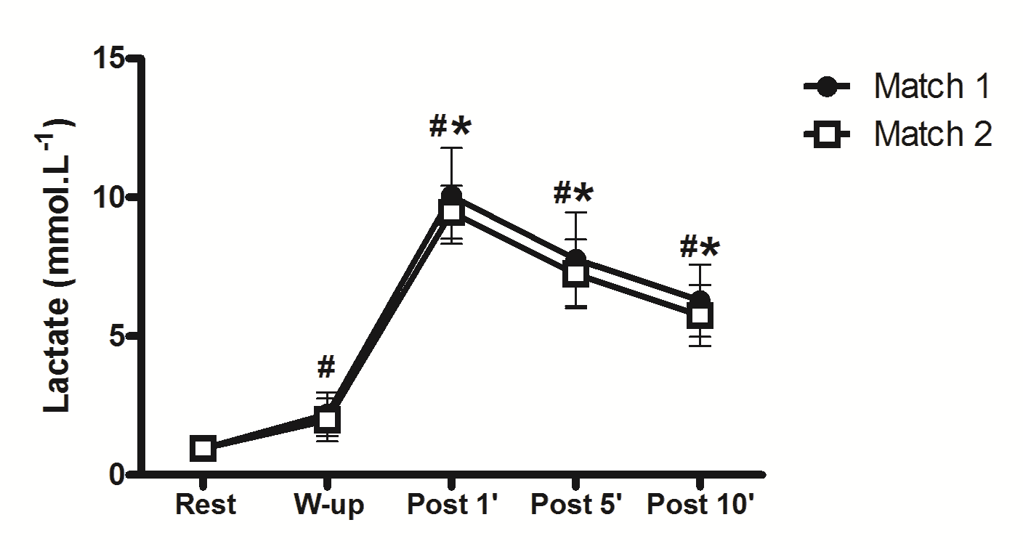
Figure 1. Blood Lactate Responses Before and After the 2 Brazilian Jiu-Jitsu Matches.
#Significantly different from the rest values for Match 1 and Match 2. *Significantly different from the warm-up values for Match 1 and Match 2. W-up = warm-up

A moderate and significant correlation was detected between blood lactate levels before the BJJ matches (Figure 2A). There were significant but weak correlations in blood lactate responses at 1, 5, and 10 min post-match for both matches (see Figure 2B, 2C, and 2D).

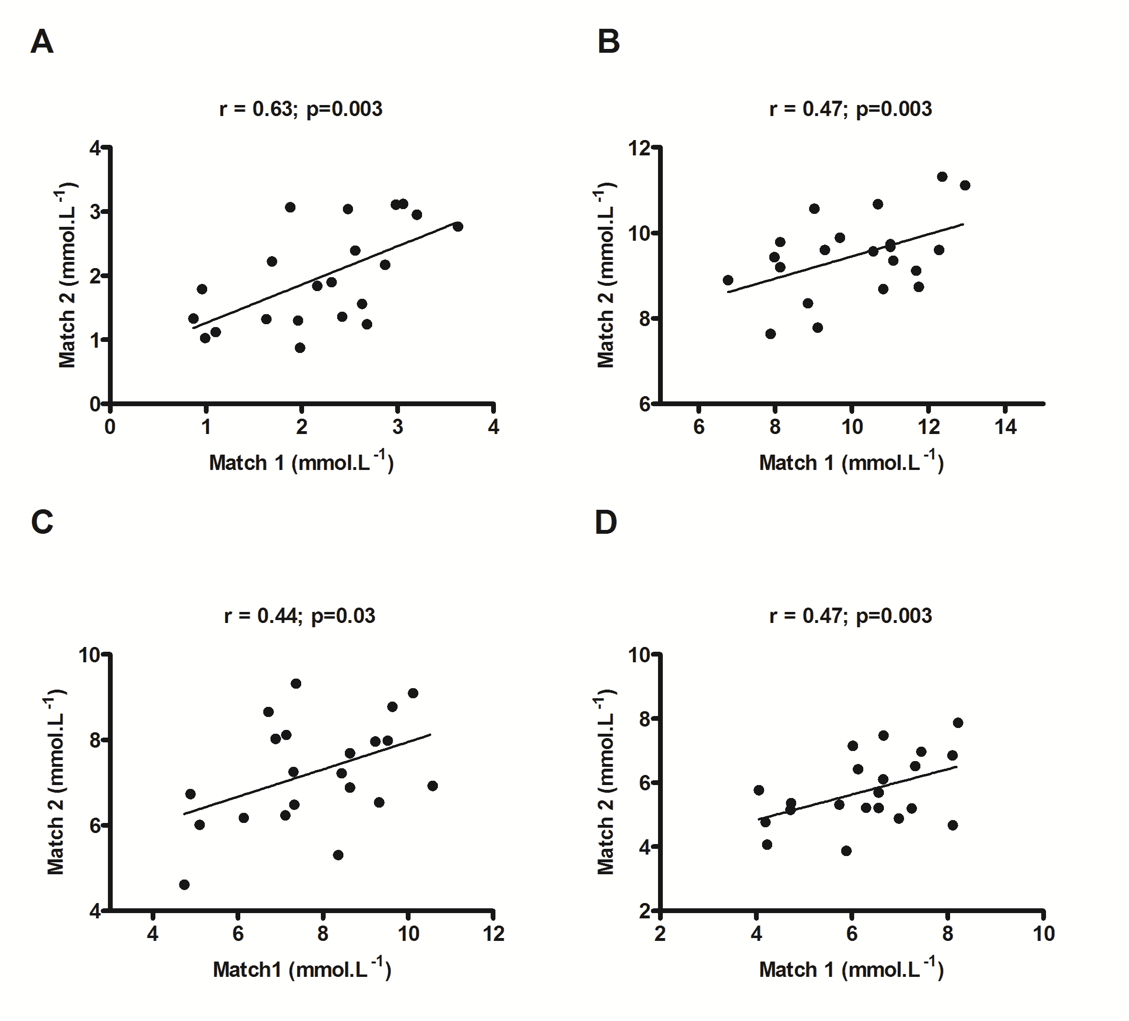

Figure 2. Correlations Between the Blood Lactate Responses to the 2 Brazilian Jiu-Jitsu Matches. 2A = warm-up; 2B = 1 min post-match; 2C = 5 min post-match and 2D = 10 min post-match.

DISCUSSION

The purpose of this study was to investigate blood lactate responses after two BJJ training matches and assess the reproducibility of the lactate changes. The main results are a similar mean (peak) lactate concentration for both training matches and significant correlations between the lactate responses to the BJJ matches. Moreover, it seems that the training matches were predominantly anaerobic, given that the blood lactate concentration was considerably higher than the anaerobic threshold (4 mmol·L⁻¹) (13).

The study results are comparable to other combat sports. In Judo, for instance, Thomas and colleagues (27) reported similar lactate responses to 3 simulated matches (9.87 ± 2.01; 9.79 ± 2.10; 9.27 ± 1.38 mmol·L⁻¹). In addition, Sbriccoli et al. (24) monitored a group of Olympic athletes during 5 min of Judo matches and reported a lactate peak of 10.3 ± 2.6 mmol·L⁻¹ after the match. Franchini et al. (11) also compared the effect of active and passive recovery on blood lactate kinetics after Judo matches. These authors showed lower peak lactate value at 10 min of active recovery when compared to passive recovery (8.09 ± 3.94 vs. 9.92 ± 4.77 mmol·L⁻¹, respectively).

In the present study, the lactate concentration after 10 min of passive recovery was lower (7.5 mmol·L⁻¹) and the peak value (10 mmol·L⁻¹) was reached at the first min post the BJJ match. The peak lactate values reported by Sbriccoli et al. (24) also occurred immediately after the Judo match. The blood lactate concentrations are consistent with other BJJ studies after a simulated fight (2,10). Pereira et al. (22) reported lactate values as high as 14.2 ± 5.9 mmol·L⁻¹ after the completion of specific bouts of the BJJ. In general, lactate concentrations have been found to be in the range of 13.23 mmol·L⁻¹ or greater (e.g., 20.0 mmol·L⁻¹) after wrestling matches (4,19) compared to Judo (11) and BJJ (2,10).

One possible explanation for the discrepancies between the cited studies may be the competitive level of the subjects tested. The study conducted by Sbriccoli et al. (24) was conducted on Olympic athletes and the other studies were conducted with athletes participating a lower competitive level, with each likely to exhibit differing levels of aerobic and anaerobic fitness that could subsequently influence lactate production and removal. In support of this, Degoutte et al. (8) examined the lactate response to simulated Judo matches (5 min) in a group of regional-level athletes. The authors observed a much higher lactate concentration (12.3 ± 1.8 mmol·L⁻¹) than the previous investigations.

Differences in methodological procedures may limit comparisons across studies. As an example, Degoutte et al. (8) measured lactate from venous plasma samples and the other studies employed lactate measurements from arterial blood. Moreover, the only measure of lactate was performed at 3 min post-match, which does not allow interpretation of lactate removal during the recovery period. The study by Bonitch-Dominguez et al. (5) analyzed the lactate response of 11 athletes during 4 matches (5 min duration each) interspersed with 15 min of passive recovery. Interestingly, a higher lactate concentration was detected in the first match, as compared to the fourth match (14.6 vs. 12.6 ± 3.5 mmol·L⁻¹, respectively, P˂0.05). Nevertheless, it appears that the overall lactate response patterns observed in Judo (5,11,27) are similar to the findings reported herein. Based on the large and consistent lactate changes in this study, it is reasonable to speculate that BJJ matches require a significant contribution of the glycolytic pathway to address the high energy demand.

It is important to acknowledge that the current study, along with previous studies in this area, were conducted using simulated competition. It is possible that official matches may impose greater physiological strain and thereby elicit greater lactate responses. In fact, Sikorski and Mickiewicz (25) reported a higher peak lactate response in Polish elite athletes during official competition (16.2 ± 2.6). Moreira et al. (21) reported greater cortisol release after official matches when compared to training matches, further indicating greater psychological and physiological demands during official competition. The profiling of lactate and other variables (e.g., stress hormones, heart rate, and perceived exertion) across both training and official matches may provide useful information for trainers and coaches, such as setting simulated intensities to mimic actual match demands or as a measure of training adaptability.

There were weak correlations between the lactate responses to the BJJ matches, indicating similar individual responses against the same opponents in matches of identical duration. However, these responses are likely to vary in actual competition, due to the unpredictability of combat sports and differences in match durations. One may expect different offensive and defensive strategies to be employed against an opponent, especially when competing against the same individual in successive matches, thereby resulting in different physiological responses. This could explain the weaker post-match correlations. Also, it highlights the need to consider several variables under different competitive conditions to accurately quantify the physiological changes.

CONCLUSIONS

High peak blood lactate concentrations of similar magnitude were detected after the BJJ matches, which indicates a strong contribution of glycolytic metabolism as a relevant energy source. The lactate responses to each match were also correlated, thereby suggesting similar individual responses across successive BJJ matches of equal duration. Further studies are needed to profile lactate kinetics and other variables (e.g., stress hormones, heart rate, and perceived exertion) across official and training matches.

ACKNOWLEDGMENTS
Tácito P. Souza-Junior, is supported by a CNPq fellowship #216382/2014-9.

Address for correspondence: Tacito P. Souza-Junior, PhD, Department of Health and
Exercise Sciences, Appalachian State University, Boone, NC, USA, Email: desouzatp@ appstate.edu

REFERENCES

- Amtmann JA, Amtmann KA, Spath WK. Lactate and rate of perceived exertion responses of athletes training for and competing in a mixed martial arts event. J Strength Cond Res. 2008;22(2):645-647.

- Andreato LV, Franzói de Moraes SM, Del Conti Esteves JV, Araújo R, Pereira R, Gomes TLM, Andreato T. Physiological responses and rate of perceived exertion in Brazilian Jiu-Jitsu athletes. Kineziologija. 2012;44(2):173-181.

- Artioli GG, Gualano B, Franchini E, Batista R N, Polacow VO, Lancha-Jr AH. Physiological, performance, and nutritional profile of the Brazilian Olympic Wushu (kung-fu) team. J Strength Cond Res. 2009;23(1):20-25.

- Barbas I, Fatouros IG, Douroudos II, Chatzinikolaou A, Michailidis Y, Draganidis D. Physiological and performance adaptations of elite Greco-Roman wrestlers during a one-day tournament. Eur J Appl Physiol. 2011;111(7):1421-1436.

- Bonitch-Dominguez J, Bonitch-Gongora J, Padial P, Feriche B. Changes in peak leg power induced by successive judo bouts and their relationship to lactate production. J Sports Sci. 2010;28(14):1527-1534.

- Chiodo S, Tessitore A, Cortis C, Lupo C, Ammendolia A, Iona T, et al. Effects of official Taekwondo competitions on all-out performances of elite athletes. J Strength Cond Res. 2011;25(2):334-339.

- Da Silva BC, Marocolo-Junior M, de Monteiro GG, Junior LOM, de Moura Simim MA, Mendes EL, da Mota GR. Blood lactate responses after Brazilian Jiu-Jitsu simulated matches. JEPonline. 2013;16(5):63-67.

- Degoutte F, Jouanel P, Filaire E. Energy demands during a judo match and recovery. Br J Sports Med. 2003;37(3):245-249.

- Doria C, Veicsteinas A, Limonta E, Maggioni MA, Aschieri P, Eusebi F, et al. Energetics of karate (kata and kumite techniques) in top-level athletes. Eur J Appl Physiol. 2009;107(5):603-610.

- Franchini E, Bezerra P, Oliveira R, Souza L, Oliveira D. Blood lactate concentration, heart rate and handgrip strength during a combat jujitsu. Corpoconsciência. 2005;9 (1):35-44.

- Franchini E, de Moraes Bertuzzi RC, Takito MY, Kiss MA. Effects of recovery type after a judo match on blood lactate and performance in specific and non-specific judo tasks. Eur J Appl Physiol. 2009;107(4):377-383.

- Gracie R, Gracie R, Danaher J, Peligro K. Brazilian Jiu-Jitsu: Theory and Technique. Invisible Cities Press LLC; 1st Edition (October 1, 2001).

- Heck H, Mader A, Hess G, Mucke S, Muller R, Hollmann, W. Justification of the 4-mmol/l lactate threshold. Int J Sports Med. 1985;6(3):117-130.

- http://cbjj.com.br/wp-content/uploads/2015/03/RegrasIBJJF_v4_pt-BR.pdf (accessed June 21, 2015).

- http://www.ibjjf.org (accessed June 21, 2015).

- Iide K, Imamura H, Yoshimura Y, Yamashita A, Miyahara K, Miyamoto N, et al. Physiological responses of simulated karate sparring matches in young men and boys. J Strength Cond Res. 2008;22(3):839-844.

- Jackson AS, Pollock ML. Generalized equations for predicting body density of men. Br J Nutr. 1978;40(3):497-504.

- Jones NB, Ledford E. Strength and conditioning for Brazilian Jiu-Jitsu. J Strength Cond Res. 2012;34(2):60-69.

- Karninčić H, Tocilj Z, Uljević O, Erceg M. Lactate profile during Greco-Roman wrestling match. J Sport Sci Med. 2009;8(3):17-19.

- Marfell-Jones M, Olds T, Stewart A, Carter L. International Standards for Anthropometric Assessment. Potchefstroom, 2006; South Africa: ISAK.

- Moreira A, Franchini E, de Freitas CG, Schultz de Arruda AF, de Moura NR, Costa, EC, Aoki MS. Salivary cortisol and immunoglobulin a responses to simulated and official Jiu-Jitsu matches. J Strength Cond Res. 2012;26(8):2185-2191.

- Pereira RF, Lopes CR, Dechechi CJ, Silva BV, Ide BN, Navarro AC. Lactate removal kinetics on Brazilian Jiu-Jitsu athletes. Athletes of the Brazilian Jiu-Jitsu. 2011;5 (25):34-44.

- Pereira RF, Lopes CR, Dechechi C J, Silva BVC, Ide BN, Navarro AC. Cinética de remoção de lactato em atletas de Brazilian Jiu-jitsu. Rev Bras Prescr Fisiol Exerc. 2011;5(25):34-44.

- Sbriccoli P, Bazzucchi I, Di Mario A, Marzattinocci G, Felici F. Assessment of maximal cardiorespiratory performance and muscle power in the Italian Olympic judoka. J Strength Cond Res. 2007;21(3):738-744.

- Sikorski W, Mickiewicz G. Physiologic Assessment of Training Methods Applied to Judo. In: Portuguese federation of Judo: 1991.Technical Bulletin.
- Siri WE, Body composition from fluid spaces and density: Analysis of methods. In: Henschel JBA. (Editor). Techniques for Measuring Body Composition. Washington, DC, 1961, National Academy of Science.

- Thomas PH, Goubault C, Beau C. Judokas lactate evolution in successive randoris courses. Med Sport. 1990;5:234-236.

Disclaimer
The opinions expressed in JEPonline are those of the authors and are not attributable to JEPonline, the editorial staff or the ASEP organization.

