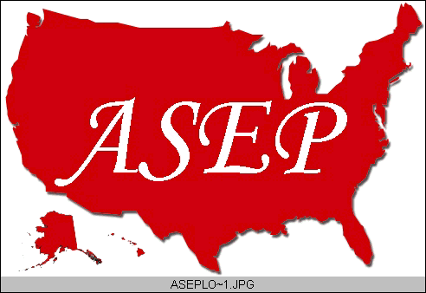ASEPNewsletter
ISSN 1097-9743

September 2014
Vol 18 No 8

Dr. Frank Wyatt, EPc
Board Certified Exercise Physiologist
Editor, ASEPnewsletter

One Purpose

The month of September is one that reminds us of beginnings. For most, this is the beginning of a new academic school year. This has always been one of my favorite times of the year because of the aforementioned connotation of “beginning”. It is a reminder to me that our field of Exercise Physiology is an exciting and relatively new field that appeals to the next generation. It is also a reminder that I have a tremendous responsibility in teaching this new generation with sound physiological concepts and, at the same time, inspiring them to move our profession forward. This is not an easy task.

But let me begin this story by going back prior to that first day of classes and the aforementioned first meeting with my undergraduate students in Exercise Physiology. In those previous months, I experienced a Summer in which the “learning curve” associated with Exercise Physiology was one that could only be described as exponential in shape. The 2014 Summer taxed my knowledge of Exercise Physiology on many levels.

I am an avid cyclist and one that practices what I preach in my classes within the major of Exercise Physiology. A good lesson unto itself in that modeling for others has been shown to have a tremendous impact on those around us. Each year I strive to not just maintain my fitness, but to improve it. I apply physiological principles to my training to increase my endurance as well as my power on the bike. To do this, I incorporate many modes of exercise as well as utilizing a periodized plan to facilitate the adaptation process. This is no easy task if you take into account that I am nearing 60 yrs of age and have limited time to train between work and family. It is the type of challenge our students may face in a career associated with Exercise Physiology. As such, this experience allows me to bring something extra to my classes that transcend a text book.

A second challenge for me came in the form of my daughter. She is currently 13 yrs of age and active in many sports. Soccer is her favorite sport. While she runs cross-country in the Fall, she wanted to do a long ride with me in the summer during our local ride called The Hotter-N-Hell Hundred. As it indicates, this is a ride of varying distances (the optimum is 100 m) that takes place in the third week of August in Wichita Falls, Texas. The temperatures at this time of the year can only be described as “Hotter-N-Hell”. Between the two of us, we decided to do the 50 mile course. I am now faced with training a female of 13 yrs with undeveloped thermogenic responses, in a venue of sport that she is unaccustomed to doing. Another challenge and learning experience for an Exercise Physiologist.

The next challenge came as a result of the aforementioned two challenges I just described. As I put myself though my personal training program, I would then train with my daughter to provide encouragement in her program. I noticed that the increased volume of work led to immune system dysfunction. In other words, I was getting sick and breaking down. If you read my article published in The Journal of Exercise Physiologyonline, Vol. 16 (2): 12-23, you might come to the same conclusions that I did, with my occurring sickness and lack of recovery: I was over-trained. I had to re-assess my program from a physiological point of view as well as scrutinize the issues that lead to proper training and recovery. Once again, I used my knowledge in Exercise Physiology to address this issue.

I tell you of these personal experiences to bring to light how our knowledge in the field of Exercise Physiology may go beyond our career. I am an academic. I teach and do research at the university level. My knowledge goes beyond that sphere in the application to my life experience. This attainment of knowledge is but “One Purpose” that we have as Exercise Physiologists. I totally understand the students in my class that strive for the grade only. Or, perhaps they take a class, motivated ONLY by the fact that the class is part of their degree plan. But the career Exercise Physiologist is one that seeks the knowledge that our field offers. This knowledge propels us to new levels within our field but facilitates the validity of our profession. At a recent conference I attended I posed the question to a Doctor of Physical Therapy (DPT) when he stated that he relied on Exercise Physiologists in his work environment: My question, “Are you saying that those with a Bachelor’s degree in Exercise Physiology have a knowledge base that DPT’s do not?” His response: “Yes.” I appreciate his honesty.

We as Exercise Physiologists have a unique and invaluable knowledge base. It is through this knowledge base that our profession is validated, that makes our profession unique and that allows our profession to remain strong. As career Exercise Physiologists, it is imperative that the search for knowledge in our field is unyielding. Through that search, we continue to provide new paradigms for health care, sport performance and longevity. As for me personally: I moved through my over-trained state and my daughter and I successfully rode 50 miles on our bicycles at the Hotter-N-Hell Hundred.

