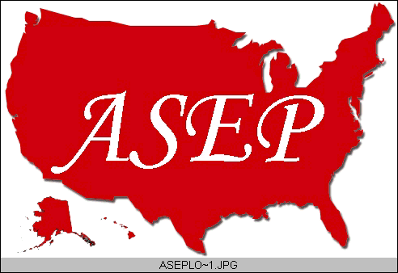ASEPNewsletter
ISSN 1097-9743

November 2014
Vol 18 No 10

Dr. Frank Wyatt, EPC
Editor, ASEPNewsletter
Board Certified Exercise Physiologist
Professor of Exercise Physiology
Department of Athletics and Exercise Physiology
Midwestern State University
Wichita Falls, TX 76308
“An ASEP Undergraduate and
Graduate Accredited Degree Programs”

A Time to Reflect
The 13th Annual Meeting of The American Society of Exercise Physiologists (ASEP) has come to a close. It was an excellent meeting. The setting in Charlotte, NC was the Olympic Whitewater Training Center, which looked like an adult version of some play-land. Those in attendance were both new and old members. Yet all of those in attendance were engaged at a high level. Were you there?

During the meeting, the attendees were fortunate to see presentations of research findings, stories of personal triumph in the private practice of an Exercise Physiologist, and an incredible journey of Human Anatomy led by ASEP Founder, Dr. Tommy Boone. The personal stories, the professorial scientific presentations, the student presentations, and involvement were enough to inspire any and all that were in attendance. Were you witness to this?

Inherent to this meeting and past meetings are presentations on the state of ASEP, the professional organization. This included the current operation of the organization and speculation on the future of ASEP. It is a necessary component of any meeting for any organization. One main difference with ASEP as opposed to other professional organizations is the transparency of the discourse on the organizations state of affairs. Everyone in attendance is privy to where ASEP is and where it is going. What is always apparent during these times of reflection is that ASEP has come a long way and it has a long way to go. The operative word here is “long”. Organizations are like physiological adaptations: they require persistence, discipline, and effort over a period of time before adaptation (i.e., change) occurs. To continue the analogy, would you classify yourself as an ASEP athlete or a couch potato?

Reflection and introspection are good. They allow us to recognize the progress that has taken place while at the same time accept the failures that invariably come with any venture involving risk. And we, as an organization and professionals within the organization need to accept the fact that ASEP is a risky venture. Risky, in that ASEP has pushed the boundaries for Exercise Physiologists. Risky, in that ASEP has maintained ethical qualities that other professional organizations have fallen prey to. And risky, in that through continued scrutiny and criticism, the organization and members have remained steadfast in the support and ethical advancement of Exercise Physiologists. Are you a risk taker?

I have attended many ASEP meetings through the years. Through it all, I can honestly say that I have never been disappointed in the level of presentations and the camaraderie of those in attendance. Every year I try to bring students to this meeting because I know it will inspire and educate them. The students I bring often provide a presentation as part of the itinerary. I do this because I know it will be a positive experience for them. These students always…ALWAYS, come away with confidence and excitement. This is a testament to the organization. In addition, every year I meet NEW members that have been openly accepted into the ASEP organization. Yet every following year, I don’t see those same members in attendance. Where are you?

I cannot write this newsletter about the Annual Meeting of ASEP without expressing my disappointment in the number of attendees. It is a common thread over the years. So often it seems, those not in attendance are the very “new” attendees alluded to earlier. The very members that were welcomed with such open arms and, perhaps, those who needed my attendance at their site the previous year are nowhere to be seen. Those involved with organizing, presenting and attending just one or two years previous are absent. I have been involved in organizing an ASEP meeting, and I will be hosting next year’s meeting as well. It is an exhausting venture, but it is a fulfilling venture as well. And, it is a necessary component needed to move the ASEP organization forward. One time attendance is analogous to those starting a new exercise program as part of their “New Year’s Resolution” only to quit after one or two attempts. In both instances, the adaptation response to your fitness condition as well as your professional career will not occur. Is this message resonating?

I will conclude this month’s newsletter on a positive note and a note to those that have persevered in the mission statement of The American Society of Exercise Physiologists: “You are making a difference!” What other organization could boast that each and every meeting was a positive experience? Read the aforementioned questions at the end of each paragraph in this newsletter and reflect on your answers. Take time to consider your involvement in ASEP. Consider what ASEP has done for you and your students. It will be time well spent and hopefully, I will see you next year.

