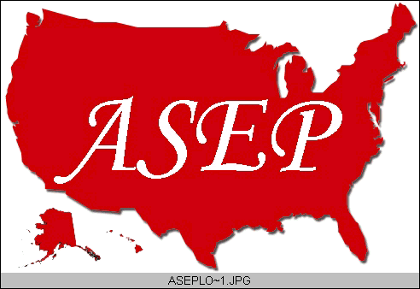ASEPNewsletter
ISSN 1097-9743

January 2015
Vol 19 No 1

Dr. Frank Wyatt, EPC
Editor, ASEPNewsletter
Board Certified Exercise Physiologist
Professor of Exercise Physiology
Department of Athletics and Exercise Physiology
Midwestern State University
Wichita Falls, TX 76308

A New Year’s Message

No series of newsletters would be complete without a New Year’s Edition. With that in mind, this qualifies as the first American Society of Exercise Physiologists (ASEP) Newsletter for 2015. And with that, the obligatory resolutions we all face at this time of the year.

Generally, at this time of the year, our profession gets a lot of attention. Rarely is there a new year where a resolution somewhere, by someone does not include a resolution made with the intention of changing one’s body: weight loss, health related eating habits, smoking cessation, beginning or enhancing an exercise program incorporated into a daily routine.

Now please understand that I am not discounting these fine and noble resolutions. In fact, I applaud them. I encourage them. I will work with anyone that asks, in helping them through any of the aforementioned resolutions…and more. As I return to the fitness centers, walking paths and produce area of the grocery store, and see the abundance of new participants, a smile crosses my face. I am not cynical in realizing that so many of these will drop out after only a few weeks. I am, instead, hopeful that these individuals will come to know what I know after all these many years of exercise: a fit life is an awesome (i.e., quality), long life.

As I see it, a crowded fitness center, an overused walking/cycling trail, and multiple individuals picking over the fresh produce is how it should be. As Exercise Physiologists, this is our moment. This is a time when those that know us and come calling for our expertise, should receive that information from us in abundance, freely and without hesitation. The New Year provides not only a time for us to showcase our profession, but also a time for us as professionals to re-evaluate our direction.

As part of ASEP, this is a time for me (and you) to reflect on my part in moving the profession of Exercise Physiology forward. During my time between semesters, I generally travel. This break was no different. I have an active family. We take trips that incorporate movement. During the Winter break, we go skiing. During the Spring and Summer, we bike, hike or body surf, and during these travels, there is always that moment (generally several moments) when someone asks, “What do you do?” My first response is to say that I am a Professor at a university. With that response they generally ask, “In what field?” My response of “Exercise Physiology” seems to always garner the same response: “Oh, that’s cool” and, then, I always say the same thing: “Yea, it is” because it is.

This New Year, perhaps, you and I and all of us in Exercise Physiology need to realize that we work in a “Cool” field. It is fun, exciting, and one that is imperative to a high quality and longer life in today’s society. Not only is Exercise Physiology “Cool” … it is extremely important in the health care and sport performance industries.

In that same vein, I have noticed that so many of the individuals I have encountered in ASEP carry the same attitude. Is it any wonder that to know these individuals tends to inspire you to advance the profession of Exercise Physiology? These are the individuals whose names you see repeated throughout the website: Presidents, past Presidents, Board of Directors, Editors, and authors. Their names continue to pop up over and over again. Ask them if Exercise Physiology is “Cool” and you will see their eyes light up. They are inspiring. This provides for a great resolution for the New Year: Be inspiring.

We all follow routines throughout our days, weeks, months, and years. I believe we are such a diverse creature as humans that while we thrive on adventure and spontaneity, we also draw comfort in our routines. What should be noted is that routines do not necessarily mean, mundane. Routine exercise programs lead us to adaptations of increased physiological function. Routine work schedules provide financial stability and routine studies advance our knowledge base. Routines can be (and is) inspiring.

However, routines like exercise programs and areas of study must be altered. Variety in these areas provides additional adaptation and personal and professional growth. Think about it. What routine change can you make towards your profession that will advance the profession and facilitate the field? Is it possible for you to make a routine contribution to ASEP? For example, to know what contribution you can make, simply ask any of the ASEP individuals whose names you see on a continual basis on the website. They will let you know by saying:
- Why not volunteer to be on the Board (great for the resume)?
- Why not write a professionalism article for PEPonline or JPEP or submit a research manuscript to JEPonline?
- Why not become a Board Certified Exercise Physiologist?
- If you are a professor, why not encourage your students to become Board Certified Exercise Physiologists?
- Why not join ASEP and help to advance the Exercise Physiology program at your university by seeking accreditation through ASEP?
- Why not go to the annual meeting (Oklahoma City, 2015) and present material?
- Why not take students to attend or present at the annual meeting?

There are so many “routine” things you can do to advance our profession. Now that is truly, “Inspiring.” New Year’s is a great time. It is a time of new beginnings, and new hope, and new inspiration. It is a time for reflection and making promises to ourselves to correct the things in our lives that will lead us down a better path. This is another great thing about us as humans: we seek that better path.

Life is busy, I get it. So add a little “something” to your routine. We tell others that to continue on an exercise program it MUST work into your daily schedule. It must become part of the routine. Otherwise, we drop it.

Make a contribution to the profession. Pick an object that can be added to your daily (or weekly) routine that will facilitate the professional organization, ASEP. Make a correction in your involvement that will lead you down a path of inspiration to others around you and be part of The American Society of Exercise Physiologists for 2015.

Happy New Year!

