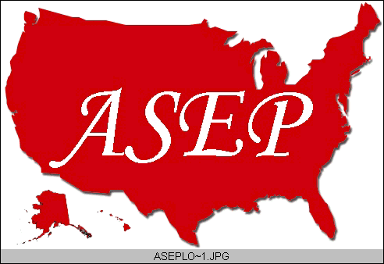ASEPNewsletter
ISSN 1097-9743

December 2014
Vol 18 No 11

Dr. Frank Wyatt, EPC
Editor, ASEPNewsletter
Board Certified Exercise Physiologist
Professor of Exercise Physiology
Department of Athletics and Exercise Physiology
Midwestern State University
Wichita Falls, TX 76308

Words…or Actions!
I love intellectual discourse. Pushing the boundaries of thought through expression of known paradigms and the dismantling of old theories is paramount in the progression of the human species. It separates us from the other animals within the kingdom.

I have done considerable reading on “Complexity” and “Chaos” Theory, which are fascinating mathematical correlates to patterns and disturbances within those patterns as they relate to complex adaptive systems. Why would I, an Exercise Physiologist, be interested in these concepts? The answer is because we (i.e., humans) are complex adaptive systems. The more I read of these theories the more I understand the so-called anomalies that seem to occur as we train our athletes or work toward better health with our general population. To examine physiological thresholds or patterns of response during steady-state conditions connects us to the world of complexity and chaos. Working with an individual to provide an exercise adaptation to ensure greater vaso-activity and reduced blood pressure is an understanding in mathematical predictions for eventual greater health. These theories are, indeed, complex. But, they are just words unless you connect the dots from math function to human adaptation to the reality of a greater performance or greater health.

One of my responsibilities as an academic professor is to teach graduate level Research and Design and Statistics. Statistics along with Research and Design are classes I love to teach, which is only surpassed by my love for Exercise Physiology. As I move through the process of research with my students, one concept is referred to as “Paradigm Crises Phenomenon” in which you question a current paradigm and refute the model based on the findings of research. I thrive on this conceptual phenomenon as it establishes the framework of progress. We must continually search for answers and dismiss old models if they cannot withstand the scrutiny of continued research within the field. Yet, these words ring hollow unless one questions status quo and then acts to provide an alternative paradigm.

Lastly, an intellectual framework in human development and the development of other systems is referred to as “Dynamic Systems Operation” (DSO): an operation of systems that are dynamic (i.e., moving, progressing, never static). I have often refuted the term “homeostasis” as it relates to the human body. The human is NEVER static, in my opinion. In fact, I believe a better term would be “homeo-dynamic”. Needless to say it hasn’t caught with the popular vernacular in our field. But a DSO is a concept actually described in motor development and motor learning. In fact, it is closely synonymous to the aforementioned Complex Adaptive System theory. In both, it is recognized that the human species is an operation of many systems. And these systems are both dynamic and complex as they adapt to the many stressors presented in a lifetime. Both are fascinating concepts that when applied to the field of Exercise Physiology, make for a very messy outcome. It is difficult to predict outcomes as you continue to provide layer after layer of possible causal mechanisms. So much so, that we rarely state that “mechanism A causes outcome B”. There are too many interfering “systems” that could contribute to the outcome “B”. So, even though we may recognize these two system theories (i.e., Dynamic and Complex), do we avoid their application because things get “messy” in the process?

Where do I go from here in this current ASEPNewsletter? The organization of The American Society of Exercise Physiologists is one in which I have had many roles: member, President, Board Member, Certified Exercise Physiologist, Accredited Undergraduate and Graduate Programs and now, Newsletter Editor. I encourage others to join and listen to the message that ASEP provides for Exercise Physiologists as well as programs of Exercise Physiology. Do I make a difference? Does anyone, past and present, make a difference? The aforementioned concepts provide an answer to these questions. If we associate Chaos and Complexity Theories to ASEP, we will see a system that has ebb and flow. A system influenced by the efforts of its members.

According to these theories, small perturbations in a system can result in massive outcomes. Thus, when this thinking is taken into account, one person can make a difference in the operation and growth of ASEP, and what of this model or paradigm of ASEP? The focus through the years has been consistently in favor of Exercise Physiologists and the profession of Exercise Physiology. This is in opposition to other professional organizations that tend to provide some broad system of a mission that covers many professions that are somewhat connected. The ASEP model is a paradigm in crisis in that it continues to push the boundaries associated with the profession of Exercise Physiology. The organization is dynamic and complex. As such, it continues to adapt to the structure of health care, athletic performance, and academic standards that make it a “homeo-dynamic” organization. The “same” in homeo is Exercise Physiology and the “dynamic” is the continual ebb and flow of ASEP.

I conclude by pointing out the following. We are inundated with theories and principles. As individuals, we can espouse these wonderful concepts in our intellectual discourse. But are we applying them? In our profession it seems essential to continue to contest the theories through application. Our very acts as members of ASEP are mechanisms of change and growth. Our contribution to the field is not just in our words, but in our actions. We can talk a good game, or we can work (i.e., action) to be a small perturbation in a dynamic, complex system to provide an eventual new paradigm within the American Society of Exercise Physiologists.

