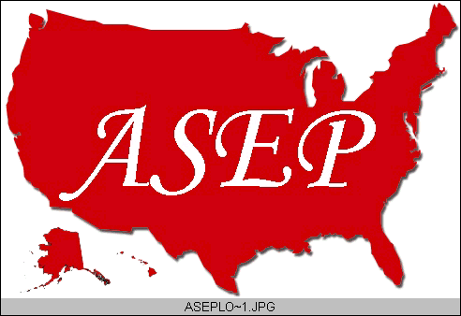ASEPNewsletter
ISSN 1097-9743

March 2014
Vol 18 No 2

-From the Editor-
Frank B. Wyatt, Ed.D., EPc
Professor
Department of Athletic Training and
Exercise Physiology
Midwestern State University
Wichita Falls, TX 76308

Did you catch the Winter Olympics? I am assuming that the answer is “yes.” I base this assumption on the fact that as Exercise Physiologists, you appreciate not only the athleticism exhibited by these individuals, but you scrutinize the physiological mechanisms that allow for the different performances. This is but one application of our field.

As an individual in academia, I feel that one of my responsibilities is to provide my students with the scientific knowledge of exercise related stress and adaptation. In fact, one of the many things I point out to my students is that if I know Exercise Physiology, I can train anyone. However, being a practitioner in our field goes beyond the training of elite level athletes.

Recently, a friend of mine expressed frustration at his lack of weight loss even though he is an avid exerciser. He had gone to his primary care physician for blood work to determine if abnormalities existed that would indicate some sort of reasoning behind his inability to lose weight. In our conversation, we discussed at length and in detail various metabolic considerations related to exercise, his age and his diet. All are considerations his physician neglected to consider. As an Exercise Physiologist, this is what we do.

Following this I sat at home (authors note: after my 3 hour bike ride) during the weekend flipping back and forth on the television between the NFL combine and the Winter Olympics. As it turns out, what I witnessed was an incredible physiological performance span of the differences between high level football players running a blistering 40 yd sprint, and endurance athletes competing in a 50 kilometer cross country race at altitude. What diversity in terms of athletic prowess! I couldn’t help but think how in depth I could personally witness these two spectrums of performance because of my knowledge in Exercise Physiology.

These examples illustrate the different paths we may take in applying our knowledge as Exercise Physiologists (EPs). These different applications of our knowledge point to the wide variation of jobs available with a background knowledge in Exercise Physiology. Yet, I believe that most EPs already know this. We have argued for years about the legitimacy and validity of our field only to have someone ask us, “Are you a “Personal Trainer?” or “Isn’t that Physical Education?” My answer to both questions is always the same: “Yes.”

But, as an Exercise Physiologist, I am more than just a personal trainer or a physical educator. I am a scientist, health care provider, and an expert in the relationship between exercise stress and adaptation. I do not despair that many do not understand my field or my knowledge base. I do not despair that our area of study has not reached the professional level that we should be at in relation to other scientists and health care providers. I say this because ours is a new discipline.

Think about how many years medical doctors or nurse practitioners have been around. The answer is in the hundreds of years. Now think about how long Exercise Physiology has been around and your answer will be “decades.” Ours is a new area of scientific research and application. We are continually seeking our path, our way as part of the same network that provides a greater understanding of our species.

To my fellow Exercise Physiologists: Do not despair. Explain to those sitting next to you the incredible physiological occurrences taking place with the NFL combine vs. the Winter Olympic competition. Explain to your aging neighbors how raking the leaves will provide them with a stronger, healthier body. And most importantly, work within the professional system (ASEP), the academic setting, and in the workplace to enlighten the public that ours is a legitimate and valid health care profession.

I long to accomplish a great and noble task, but it is my chief duty to accomplish humble tasks as though they were great and noble. The world is moved along not by the mighty shoves of its heroes, but the aggregate of the tiny pushes of each honest worker.

-- Helen Keller
(1880-1968)

-- Helen Keller

