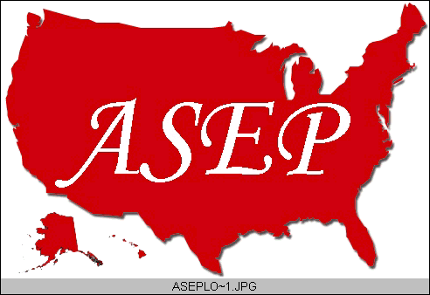ASEPNewsletter
ISSN 1097-9743

May 2014
Vol 18 No 4

Dr. Frank Wyatt, EPc
Board Certified Exercise Physiologist
Editor, ASEPnewsletter

One More Thing…

Introduction
I have been in the field of Exercise Physiology for almost thirty (30) years. In that time, I have taken on the role of health club hourly worker, director of fitness at a sports medicine institute, private trainer, academic and researcher. Suffice it to say that I can speak from experience about the many facets an Exercise Physiologist can encompass. In that time, there is an underlying theme to my work as an Exercise Physiologist: to enlighten people to the wonders of chronic exercise.

Physiological Benefits
It should be noted that the field of Exercise Physiology is still an infant compared to other scientific and health fields such as Medicine, Nursing and Biological Sciences. To that end, we as Exercise Physiologist are continually informing the public of the benefits associated with a life that incorporates exercise.
Currently, one of the greatest health issues in the United States is adult and childhood obesity. As a mechanism, obesity is shown to facilitate cardiovascular disease, type II diabetes, metabolic disorders and skeletal joint issues. One way to combat this health and functional lifestyle issue is to exercise. A regimen of exercise reduces markers of cardiovascular disease, allows for facilitated glucose entry into the cell to reduce the medical consequences of diabetes, increase normal metabolic and hormonal responses to stress and reduce the process of degenerative joint disease.

If you are like me, you have probably noticed the increased number and use of shopping scooters at your local Wal-Mart. Granted that those experiencing ambulatory issues related to aging need these apparatus to function in a shopping center, the majority of participants I witness on these scooters are there because of obesity and a loss of normal function. One thing I emphasize to my classes at the university is that exercise provides enhanced function during activities of daily living. With a sedentary lifestyle comes a lack of function. When activities of daily function become an issue, anything else requiring movement is lost. If this is the case, not only is it difficult to walk up a flight of stairs or carry your groceries to the car, but involvement in play is diminished. For me, that would mean giving up my daily bike rides, walking across the campus where I work, going for a run with my daughter, snow skiing with my family and taking the dogs out for their evening walk. A loss of function is a loss of life experience. Through exercise, my life is enhanced.

About a decade ago an animal study was done that looked at role exercise and caloric restriction had on longevity. As it turns out, the stresses of exercise and reduced calories in the diet up-regulate immune system responses. This heightened immune reaction facilitated the lifespan of the animals. It was one of the first studies that actually confirmed that exercise not only enhances the quality of your life, but increases that life as well. The conclusion of this study was that the human genome was capable of a lifespan of 120 years of age. WOW! That means that at my current age of 58 y, I am not even considered middle aged.

As Exercise Physiologists, coupled with Physical Educators we have known for many years that exercise enhances cognitive processes in youth. The ability to think is greatest following a bout of movement, i.e., exercise. That is why it seems imperative that Physical Education remains in all curriculums of education (including high school and higher education).

One More Thing…
More recent research is showing that exercise diminishes the dementia brought on by the aging process. It is now being investigated as a treatment for early onset of Alzheimer’s Disease. Apparently exercise enhances synaptic growth and firing within certain regions of the brain. And a concept related to brain function known as “brain plasticity” is not only maintained with exercising, aging populations, but is increased. Listening to a recent interview on National Public Radio (NPR) on the topic of mental health with aging, a Neuro-Scientist stated that the number one thing someone could do to facilitate brain function was exercise. NUMBER ONE! As you can imagine, when I heard this while driving my car I was pumping my fist in the air from excitement.

Conclusion
As Exercise Physiologists, we have a wonderful insight into the quality and longevity of the lives of our fellow human beings. But ours is a tough sell. It is not enough that we can express to others the many, many health benefits associated with exercise. We must explain that physical work and fatigue should not always be seen in a negative light. That movement is not a luxury but an essential component of our species. That being out of breath and sweating are both natural and good things to experience on a daily basis. And one more thing, exercise makes us smarter. And that…is a good thing.

The best way to predict the future is to create it.
– Peter Drucker

